

APT REPORT

On

FIXED MOBILE CONVERGENCE BUSINESS MODEL

No. APT/AWG/REP-20
Edition: September 2011

Adopted by

The 11th APT Wireless Group Meeting
14 – 17 September 2011
Chiang Mai, Thailand

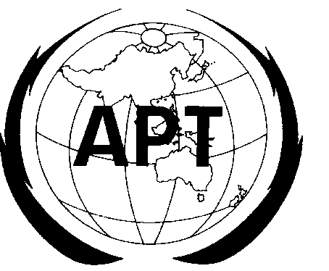 | ASIA-PACIFIC TELECOMMUNITY
 | The APT Wireless Group
Source: AWG-11/OUT-04

APT REPORT ON
FIXED MOBILE CONVERGENCE BUSINESS MODEL

- Purpose of the Document

During the AWF-7 meeting in Phuket Thailand, it has been decided that the study of the FMC Business Model would be included in the Convergence WG-A scope of work. Since organization restructuring and rebranding AWF to AWG [AWF-9/OUT-03], the scope of work of Convergence Working Group that related to study and identification FMC business model is handled in the Task Group Fixed Mobile Convergence (TG-FMC) within Working Group Service and Application (WG-SA).
The Term of Reference of TG–FMC are:
- To study of the standardization roadmap for Fixed Mobile Convergence (FMC)
- To study the regulatory aspect of FMC; and
- To study the business model of FMC

This document will illustrate the business model of FMC based on several input documents and presentations which were received and presented in the WG-SA, as well as some more other references.

This document is also related to other documents which were developed by Convergence WG, i.e. Report on the Regulatory Aspect of Fixed Mobile Convergence [AWF-7/OUT-07] and Report of the Standardization Progress of Fixed Mobile Convergence [AWF-7/TMP-21].

- Motivation & Various Scenarios of FMC

There are two main drivers for fixed mobile convergence, namely business and service perspective. Figure-1 illustrates Fixed, Mobile & its ecosystem and the basic idea of what is FMC and why it is happened.

Since the mobile communication era was begun, the phenomenon of FMS (Fixed Mobile Substitution) was started, where consumers use their mobile phone to make calls rather than their fixed-line phone. Consequently, the rate of fixed-line usage declines.

Figure-1: Fixed, Mobile & Its Ecosystem

Then, with Fixed Mobile Convergence scenario, fixed operators try to take the traffic back. Nevertheless, the mobile operators can also utilize this scenario to extend their traffic. This trend can be seen as follows [Ovum 2004]:
- In Fixed Operator (with no Mobile assets) perspective, FMC could:
  - reverse the loss of voice-service minutes and revenue to mobile providers (MNVOs),
  - reduce CAPEX and OPEX (harmonized network),
  - offer new value-added services,
  - reduce churn rate,
  - attract new customers,
  - as market “Brand”
- In Fixed Operator (with Mobile assets) perspective, FMC could:
  - reduce CAPEX and OPEX (harmonized network)
  - offer new value-added services / increase revenue
- In Mobile Operator perspective, FMC could:
  - reduce CAPEX and OPEX (harmonised network),
  - offer new value-added services
  - improve coverage (indoor /outdoor – WiFi, UMA/GAN, Femtocell)

From the operators’ service solution point of view, FMC solutions represent defences against FMS ([Ovum 2004], [AWF-IM2/INP-41], [AWF-IM2/INP-36]). There is several approach of fixed mobile convergence, i.e.:
- FMC bundles / Commercial convergence: fixed and mobile services are bundled together often as flat-rate packages with a single bill.
- Service Convergence: some services can be accessed from the fixed and mobile subscriber (e.g. the use of single voice mailbox for both fixed and mobile subscriber, etc.)
- Network-based FMC: uses intelligent converged platforms (e.g. NGN, IMS, Integrated Service Convergence Platforms, Multi Access Platforms, etc.) to route calls to the fixed or mobile phone as the customers choose.
- FMC in terminal/device: combines cellular and Bluetooth/WLAN technologies in a handset. The device acts as a normal mobile phone until the user is within the range of a Bluetooth/WLAN base station when the calls are routed to them through the fixed line.

From service point of view, as described by [Q.1762/Y.2802], FMC should answer:
- Seamless services operation from the user perspective across the heterogeneous fixed and mobile networks
- Seamless service provisioning from the operator perspective across the heterogeneous fixed and mobile networks
- Ubiquity of service availability where the end-users can enjoy virtually any application, from any location, on any terminal device
- Support of multiple user identifier and authentication/authorization mechanisms

It should be noted that fixed mobile convergence addresses various services which is not only voice but also other services.

Next, the following sections will discuss various fixed mobile convergence models/scenarios, particularly from the business model point of view.

- Home Tariff Model
This first model mainly aims to provide the customers lower tariff. Example of this approach is done in Ireland, where the scheme called “Home-Zone” was introduced [ICCR 2006]. This scheme enables mobile phone customers to make and receive calls in or near their homes at fixed line prices. A mobile customer has both a fixed (geographic) telephone number and a mobile number for a single mobile handset. Calls from and to the home-zone service subscriber are managed with the following approach:
  - Calls to the home-zone service subscriber:
    - Calls to the mobile number: normal rates that apply for calls to mobiles.
    - Calls to the fixed number that has been provided to the home-zone service subscriber: fixed line rates (or mobile to fixed rates, if calling from a mobile).
  - Calls from the home-zone service subscriber
    - Calls made from the home-zone: charged at fixed line rates
    - Calls made from outside their home-zone: charged at the normal mobile call tariffs

Another example of this home-zone concept is the deployment of O2 Germany “Genion”, where a cheaper “PSTN-like” tariff applies when calling from within a selected “home zone” [AWF-4/INP-39].

There is another similar approach where a GSM/UMTS/CDMA solution is applied to substitute PSTN service. With this approach, GSM/UMTS/CDMA devices can be an ordinary mobile phones or it can be utilized with PSTN “look and feel”, including dial tone as well as PSTN emulation “boxes” with telephone and data connection (RJ45 / RJ11). This scheme is bundled with specific “at home” tariffs, locked into a defined cell cluster (no mobility) [AWF-4/INP-39].

An example of this approach is the TELKOM Indonesia case which uses CDMA20001x for serving areas with no wireline network (brand name is Flexi). The tariff is similar with PSTN/home service and by regulation, it is fixed and no mobility is allowed. However, the operator answers this problem by innovate this product so that it can be used in other cities, by providing other cities’ new number (temporarily). The impermanent number is simply requested by the users via SMS before he goes to another city.

- Indoor system / Access Point based Model
This second model needs additional access point in customer’s building. Examples of this scheme are UMA/GAN and femtocell solution. Services covered by this method are not only voice traffic, but also other services such as data, internet, and multimedia.

As described by [Markendahl 2008] there are some common themes that are used to motivate the use of indoor systems, e.g. the UMA concept and femtocells solutions. The main motivation from a technology perspective is the improved indoor coverage. With higher radio frequencies than the 800 - 900 MHz bands used for GSM the impact of wall and floor attenuation is larger for 3G systems using outdoor base stations.

From the business perspective two other main motivations are often mentioned:
- User deployed access points or “home base stations” are used for mobile telephony at home in order to offer lower prices. The driver for operators is to increase the customer loyalty and/or to move customers from fixed to mobile telephony.
- Femtocell deployment in order to off-load the traffic of heavy data users from the outdoor wide area network to the indoor local area network. With this approach the investments in more costly macro cellular networks can be reduced.

[Markendahl 2008] also claims that indoor systems can be used to position the service offer. User deployed access points, femtocells and home base stations are all solutions that enable the provider to compete at the market for internet access provisioning.

Besides, [AWG-10/INP-73] addressed that multimedia services can be one of the drivers in deploying femtocell, so they conducted a research of MBMS in femtocell.

One or several market actors can be involved in the provisioning of the access service but the end-user should get one service offer. Mobile Network Operators (MNO´s) with own broad band networks can provide offers of their own especially in the consumer segment. MNO´s without broadband networks need to cooperate with ISP´s. For the provisioning of broadband access at offices and public areas, an MNO can cooperate with companies providing municipality area networks or with hot spot.

Table-1 shows a variety of users which can access the network. Operator of the indoor network can be house/facility owner or an operator, whereas the access can be closed or open. Open access can be further classified into subscribers to the operator and all users including roaming users.

Table-1: Type of users that can access the network [Markendahl 2008], [Roche 2010]

 |  | Closed Access / Private users only | Open Access
 |  | Closed Access / Private users only | All subscribers to the operator | All users, also roaming users
Operator of the indoor network | Facility owner | A | B | C
Operator of the indoor network | Operator | D | E | F

The Femtocell concept is usually presented as the case A, the user or a party representing the users deploys femtocells where the access is restricted to own users only. The facility owner can take care of the deployment and operation (case A) or outsource this to a third party or to the operator, the latter is case D. Example of case D is femtocell implementation in Softbank Japan, where femto equipment is under operator’s control [doc. AWF-8/INP-66].

In late 2008 and in 2009, a number of commercial W-CDMA femto small cell network launches
were announced worldwide: three in Asia (NTT DoCoMo and Softbank in Japan, China Unicom), one in the United States (AT&T) and three in Europe (Vodafone UK, SFR in France and Optimus in Portugal). [AWF-10/INP-19].

As described by [Roche 2010], in closed access, only a subset of users, defined by the femtocell owner, can connect to the femtocell. This model is referred to as closed subscriber group (CSG) by the 3GPP [Ovum 2004].

A subscriber of a femtocell is a user registered in it. Subscribers are thus the rightful users of the femtocell, and they are usually mobile terminals that belong to the femtocell owner, their family, or their friends.

The closed access femtocell deployments occurred in homes where coverage from macrocells was poor, but broadband connectivity sufficiently deployed. For example, in the middle of North American Sprint has deployed femtocells since the end of 2008. Nevertheless, this solution is only aimed at the home market, where in this case interference is not an important issue due to the low population density and the large distances to macrocells.

However, recent deployments have also been proposed in Europe, where femtocells are aimed at homes in cities and where interference could be a challenge. This is the case, for example, in the United Kingdom, where home femtocells started to be commercialized by Vodafone in July 2009.

[Roche 2010] also shows that in the future femtocells will also be available to enterprises, and it is thus expected that closed access femtocells could be deployed in small to medium-sized enterprises (SMEs)/offices, where a limited number of users would be authorized to access them.

One example of case D is the Swedish operator Springmobil (recently acquired by Tele2) that operates indoor GSM networks for companies using the fourth GSM license in Sweden [Markendahl 2008].

A privately deployed and operated local network can in principle be opened up for public access. In cases B and E all other subscribers of the involved operator can access the local network.

Case E exists today where indoor coverage is offered by mobile operators, either with outdoor macro or micro base stations illuminating the buildings or by provide indoor picocell solutions. The business model in case E is the traditional one for mobile operators. In case B some kinds of revenue sharing schemes need to be used in order to compensate the facility owner for the traffic generated by external users.

The public access can be extended to also allow roaming users, i.e. customers of other operators, to access the indoor network. Technically the cases C and F are the same as cases B and E, the difference is the access rights and roaming capability. An operator providing cellular indoor coverage today allows roaming users from other countries, i.e. international roaming. However, today customers of another operator with poor indoor coverage in a specific building cannot use an existing indoor network belonging to another operator unless there is a national roaming agreement in place.

It is believed by [Markendahl 2008] that operators soon will need to consider national roaming solutions in buildings and areas with demand for high capacity. In many cases it will not be economically feasible to deploy a multitude of indoor networks. Sharing of networks resources by local roaming or by commonly deployed network, like in rural areas need to be considered for cost-efficient operation.

Case C where roaming users are allowed is an extension of case F where the revenue sharing between the facility owner and the operator also would include roaming users.

For the cases D, E and F, where the operator is responsible for the network operation all business roles except the customer acquisition are fully controlled by the operator. Similar cases are happen for the cases A, B and C but here the facility owner also take care of the network operation.

There are some business model issues in the closed access [Roche 2010]. According to recent surveys [Carlaw 2008], closed access is the preferred access method of customers for home femtocells. The main reason is that most customers would only accept having a femtocells at home if they had full control over the list of authorized users.

Moreover, femtocells must allow all types of users to perform emergency calls by law. This implies that some resources have to be released by each femtocell access point (FAP) in order to ensure that nonsubscribers are also able to perform emergency calls.

Concerning the pricing of femtocells solutions, different approaches have been proposed. The first option is that operators provide the FAP for free or sell is it a fixed price, in order to improve only their radio coverage.

But to increase their revenue and compete with the landline market, it is expected that operators will also try to offer special rates (or free calls) to femtocells subscribers. Moreover, to attract new customers, manufacturers and operators are currently putting a lot of effort into developing new killer applications for femtocells.

The competitive landscape includes a number of key parameters for the overall femto home cell
business case, such as:
- Competition in the market
- Existing complementary products and their pricing plans
- The percentage of voice and data traffic that users consume when they are at home
- The average household population [doc. AWF-10/INP-19].

This set of factors impacts a number of other factors. For example:
- The higher the number of competitors in the market, the smaller the Total Addressable Market (TAM) a service provider can address
- The more competitive the existing pricing plans, the lower the willingness to pay for femto applications
- The higher the percentage of voice and data traffic consumed at home, the higher the benefits of macro offload [AWF-10/INP-19].

The Total Addressable Market (TAM) is the maximum customer base a service provider can address with the femto home cell offer. The service provider will eventually manage to penetrate a proportion of the TAM that will translate into femto home cell subscribers in its own network. These could be subscribers within its existing subscriber base that are willing to adopt the service or new subscribers migrating from other networks.
There are a number of factors that can scale TAM, such as:
- Service providers’ existing 2G and or 3G subscriber base
- Service providers’ existing fixed broadband and voice subscriber base
- Overall broadband penetration in the market
- The availability in the market of a competitive product that is eroding the TAM for femto
- The number of service providers that are competing to launch femto small cells
Other factors taken into account when calculating TAM include the migration rate of current 2G subscribers to 3G subscribers and the service provider’s interest in accelerating this migration. [AWF-10/INP-19].

As explained before, the commercialization of open access femtocells is not currently preferred by home customers. However, [Roche 2010] shows that open access reduces the negative impact of femtocells on marcrocells, where open access scheme offers higher throughput compared to closed access scheme. [Roche 2010] also suggest that in the future, when most of the technical challenges are solved, operators may try to promote open access femtocells for the home market.

Another major market for femtocells resides in industry, SMEs or larger companies. In this scenario femtocells are deployed by either the operator or self-installed by the end customer; taking advantage of the low price of FAPs compared to other solutions like picocells, indoor repeaters, or distributed indoor systems.

Furthermore, if femtocells are self-configurable, such deployments are interesting for the operator since maintenance is minimized. In a similar manner femtocells can, following careful planning, be deployed in public areas such as airport, parks, and train stations in order to improve coverage and user experience.

There are some business model issues in this open scenario. In the first instance commercialization of open access femtocells is mainly targeted at the enterprise market. In this business model emergency calls are not an issue because all passing users are allowed to make use of the FAPs.

Depending on the scenario, it is not always clear who should cover the costs of the femtocells and their maintenance. In many situations the FAP owner, knowing than its neighbours will use its femtocells, will not be keen on paying the same price as if the femtocells reduce the load of the macrocell network, and are thus advantageous for operators, who can either support new customers or save money in macrocell maintenance (e.g., power). Therefore, it is expected that these femtocells will be partially or fully paid for and maintained by network operator.

Table-2 shows the main features of the closed and open access scenarios.

Table-2: Closed vs. Open Access (taken from [Roche 2010])

Closed Access | Open Access
Higher interference | More handovers
Lower network throughput | Higher network throughput
Serves only indoor users | Increased outdoor capacity
Home market | SMEs, hotspot
Easier billing | Security needs

- Survey Result of the Femtocell Busineess Model Aspects

In order to understand the adoption FMC scenario, specially utilizing Femtocell, study of technical, regulatory and business model from regulator, operator, vendor, and other institutions within APT region are desirable. The survey results of the Femtocell that related to business model aspect are illustrated as follows.

Survey results show that regulators mostly are not intending to regulate pricing issues on Femtocell (Figure 2). All of pricing Femtocell regulation seems to be offered to operators in each country.

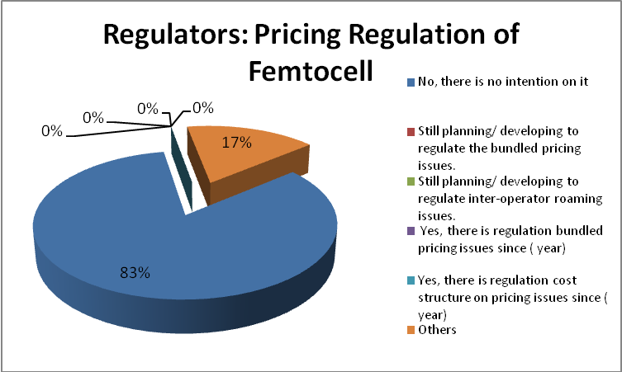

Figure 2. Regulation plan for pricing issues on Femtocell

A service covered by the indoor systems/access point based model is not only voice traffic but also other services such as data, internet, and multimedia. Opportunity to charge various services in femtocell services is potential new revenue for operators and vendors.

Survey results show that operators and vendors convince that the basic service, data access and application, and location aware based service/application are service drivers to monetize Femtocell deployment (Figure 3). Moreover, operators planed to charge the customer in various applicable costs. Monthly costs of Femtocell service or wireline broadband and Femto-based service are kind of common fee for this service (Figure 4).

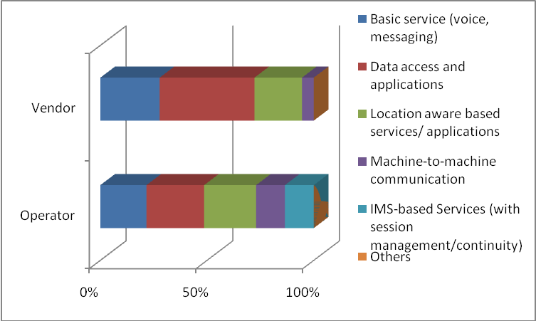
Figure 3. Services of Femtocell

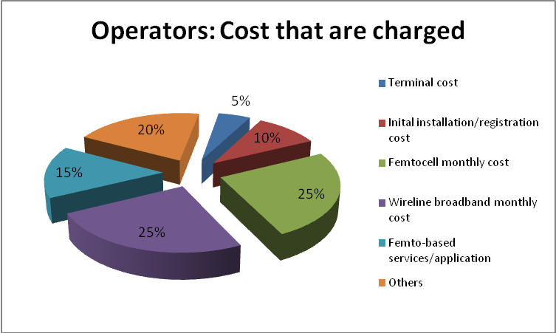

Figure 4. Applicable cost that are charged by operator

There are so many varieties of users which can access the network. Operator of the indoor network can be house/facility owner or an operator, whereas the access can be closed or open. Open access can be further classified into subscribers to the operator and all users including roaming users. Survey results show that operators are not intend to open the access to all customers that include other operator customers (Figure 5).

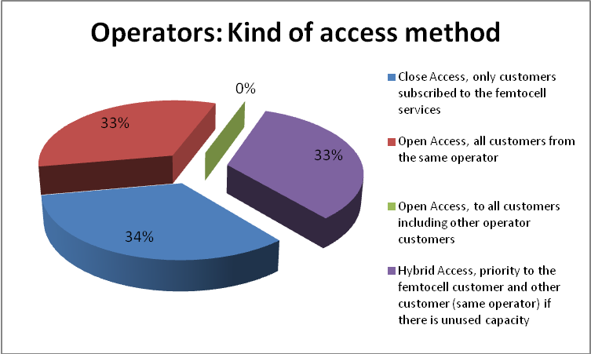

Figure 5. Kind of access method for Femtocell customer

Even though, different pricing approaches for femtocells solutions have been proposed, such as a fixed rate service, survey results shows that the free calls is more considered by Femtocell operators. Almost all of operators are not intend to charge their Femtocell customer by this new pricing scheme and they would like to offer the cellular scheme for their customer and let the wireline service free of charge (Figure 6). Since handle of the end user pricing issues is not decide yet, some operators selected Others option.

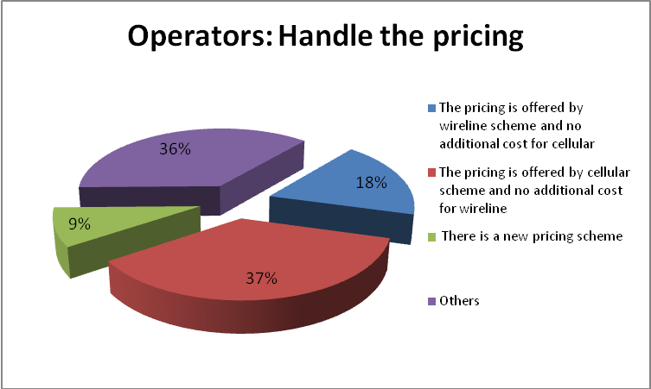

Figure 6. Operator handling on the end user pricing on Femtocell

- Conclusion

Fixed Mobile Convergence is a transition point in the telecommunications industry that will finally remove the distinctions between fixed and mobile networks. Appropriate business model that satisfy all of stakeholders who participate in the FMC are required to guarantee FMC solution provide a superior experience to customers by creating seamless services using a combination of fixed broadband and local access wireless technologies. Home Tariff Model and Indoor System/Access Point Based Model, included their variant, could be important reference for FMC business model. In order to understand the adoption FMC scenario, specially utilizing Femtocell, study of technical, regulatory and business model from regulator, operator, vendor, and other institutions are integrated in this report. It is expected that this report can help to understand the current situation that illustrate possible business model for FMC industry.

References

[AWF-4/INP-39] | : | Dirk Wolter (Alcatel-Lucent), “Technology and Deployment of FMC”, AWF-4 input presentation, doc. AWF-4/INP-39
[AWF-IM2/INP-36] | : | EngLee TAN (Siemens), “Fixed Mobile Convergence (FMC)”, Doc. AWF-IM2/36
[AWF-IM2/INP-41] | : | Fred Sabour (Huawei), “Fixed Mobile Convergence (FMC)”, Doc. AWF-IM2/41
[AWF-8/INP-66] | : | Mr. Yoshihiko Nodera, Softbank Mobile Corp., Japan, “Convergence in Softbank Mobile”
[AWF-9/OUT-03] |  | Dr. Kohei Satoh, “Meeting Report of the Correspondence Group on Restructuring and Rebranding of the AWF”
[AWF-10/INP-19]  [AWG-10/INP-73] | :  : | Andrew Mckay, Alcatel Lucent, Singapore, “Response to the questionnaire on Heterogeneous Network including Femtocell”, AWF-10 input, doc. AWF-10/INP-19  PT Telekomunikasi Indonesia, “Multimedia Broadcast Multicast Services (MBMS): Potential Femtocell Driver”
[Carlaw 2008] | : | S. Carlaw, “IPR and the Potential Effect on Femtocell Markets”, FemtoCells Europe, London, UK, June 2008
[ICCR 2006] | : | Ireland Commission for Communications Regulation, August 2006
[Markendahl 2008] | : | Jan Markendahl, Analysis of Cost Structure and Business Model options for Wireless Access Provisioning using Femtocell solutions, 19 European Regional ITS Conference, 2008
[Ovum 2004] | : | Ovum, Defending Against Fixed-Mobile Substitution, 20 February 2004
[Q.1762/Y.2802] | : | ITU Rec. Q.1762/Y.2802 “FMC General Requirements“
[Roche 2010]  [AWG-11/INP-79(Rev.1)] | :  : | Roche et al, Access Control Mechanism for Femtocells, IEEE Communications Magazine, January 2010  PT Telekomunikasi Indonesia, “Proposed Update to the Working Document towards Draft Report of Fixed Mobile Convergence Business Model”

