

APT REPORT

On

“IMPLEMENTATION ISSUES ASSOCIATED WITH USE OF THE BAND 698-806 MHZ BY MOBILE SERVICES”

No. APT/AWG/REP-24
Edition: September 2011

Adopted by

The 11th APT Wireless Group Meeting
14 – 17 September 2011
Chiang Mai, Thailand

 | ASIA-PACIFIC TELECOMMUNITY
 | The APT Wireless Group

Source: AWG-11/OUT-10

APT REPORT ON
IMPLEMENTATION ISSUES ASSOCIATED WITH USE OF THE BAND 698-806 MHZ BY MOBILE SERVICES

- Purpose
The purpose of this report is to present the results of studies related to appropriate IMT User Equipment (UE) out-of-band emission limits and associated implementation issues relating to usage of the band 698-806 MHz.

This report does not include the results of studies on the co-existence of 698/806 MHz IMT systems with broadband applications expected to operate above 806 MHz; however, co-existence studies with narrow band applications have been completed.

This document introduces studies by APT members to assist administrations in implementing the band 698-806 MHz for use by the Mobile Service, including by IMT systems, and to provide guidance to external organizations for development of associated technical standards. Specific guidance on the IMT UE out-of-band emission levels is provided in the conclusions to this document.

Scope
In view of the conventional duplex arrangement, this document addresses the UE out-of-band emission limits applicable to the lower boundary of the band 698-806 MHz. Furthermore, technical considerations for channel planning and other implications are also addressed.

Background
The harmonized frequency arrangement agreed by APT members for the band 698-806MHz was defined at the ninth meeting of the APT Wireless Forum (AWF-9) and is contained in APT Report 14 – Consensus agreement was reached on two harmonized frequency arrangements for IMT systems in the 698-806 MHz frequency band see Figure 1 and Figure 2. The AWF-9 meeting also invited further studies to determine the appropriate User Equipment (UE) out-of-band emission limits and related implementation issues. These studies serve to provide useful information for national planning for the implementation of these band plans.
45 MHz
45 MHz
698 MHz
806 MHz
694 MHz
PPDR/LMR
DTTV
10 MHz centre gap
5 MHz
3 MHz

Figure 1. Harmonised FDD Arrangement of 698-806 MHz band

PPDR/LMR
806 MHz
DTTV
698 MHz
694 MHz

Figure 2. Harmonised all-TDD Arrangement of 698-806 MHz band

For TDD arrangement: taking into account the external 4 MHz guard band (694-698 MHz), a minimum internal guard-band of 5 MHz at the lower edge (698 MHz) and 3 MHz at the upper edge (806 MHz) needs to be considered.

Depending on the television planning arrangements established by national administrations, a guard-band of at least 5 MHz or 9 MHz will exist between the uppermost television channel and the lower end of the FDD uplink block. Moreover, differing digital television technologies have been adopted by various APT countries, including DVB-T and ATSC for example. These differences in national circumstances may need to be considered in the interference analyses reported in this report.

Relevant Sharing Studies and Analyses
This section describes the three approaches to interference analysis and determination of maximum emission levels, and summarises the key parameter values used in these analyses.

Consistent with ITU-R common practice, deterministic studies are used to derive threshold values to establish co-ordination trigger values for the purposes of initiating cross-border negotiations between sovereign nations. As such, deterministic studies are often characterized as deriving ‘worst case’ values in order to stimulate more detailed investigation of the particular cross-border situation. However, the normal ITU-R approach to determining technical sharing conditions, such as out-of-band emission limits, is to undertake probabilistic studies of the relevant sharing scenarios.

Scenarios Considered
In order to assess the adjacent channel interference caused by the unwanted emissions from the UE in the Mobile Service to the digital television receiver, Table 1 summarizes possible interference scenarios to be considered.

Table 1: Possible interference scenarios
Scenario |  | UE location (Interferer) | Digital television receiver type/  Antenna location (Interfered)
(a) | 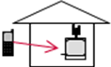 | Outdoor | Fixed reception/Indoor
(b) |  | Outdoor | Fixed reception/Outdoor rooftop
(c) |  | Outdoor | Portable reception/Outdoor
(d) |  | Indoor | Fixed reception/Indoor
(e) |  | Indoor | Fixed reception/Outdoor rooftop
(f) |  | Indoor | Portable reception/Indoor

Deterministic analysis was performed for all the above cases, and probabilistic and empirical analyses were performed for selected cases.

Practical considerations and policies in some Administrations may contemplate the protection of DTV reception using outdoor roof antennas and in these Administrations only scenarios b) and e) may be applicable.

Methodology & Parameters
For efficient discussion, it is necessary to have consensus on the methodology(ies) associated with each study approach, and any assumptions including key parameter values before undertaking the studies

Agreed sharing parameters that define power levels, path loss models, ranges, threshold values, geometry etc. and their respective values are attached in the Annex for reference.

Following the presentation of a range of deterministic studies it was agreed to seek results of probabilistic studies addressing the likelihood of interference from LTE user devices having impact on television reception below 694/698 MHz as the case may be to provide additional assurance for respective administrations.

Power spectral densities are defined in a measurement bandwidth. IMT UE emission spectra falling within the DTV receive bandwidths may not be linear across the entire bandwidth. This leads to two possible ways of quantifying the power spectral density i.e. power integrated over the entire DTV channel bandwidth, or average interference power per measurement bandwidth.

Deterministic sharing analysis methodology
There were several analyses undertaken and they each take a slightly different approach. These are referred to as Study D1, and Study D2.

Deterministic Study D1
Study D1 aimed at characterizing the required minimum coupling loss (MCL) to mitigate any interference arising around the 694/698 MHz boundary between an indoor standards compliant LTE User Equipment (UE) and a digital television receiver based on the DVB-T 8 MHz standard with outdoor antenna occupying the uppermost adjacent television channel. This scenario is illustrated in Figure 3 below:

Figure 3. Interference scenario

In collaboration with a number of other major global vendors and two national operators the results of deterministic studies of the potential interference scenario between 700 MHz LTE devices and cable-TV systems, based on the proposed band plan for Region 3 were presented. These studies indicated negligible risk to cable-TVs and set-top termination devices for physical separations of around 0.5m provided these devices met existing minimum electromagnetic immunity (IEC) protection standards. In addition, the results of empirical testing of several randomly selected commercial digital television receiver devices were presented, which showed that (even in the case of an indoor TV antenna) the actual selectivity performance of real TV receiver devices was already sufficient to protect television reception down to a wireless range of about 1m or so. Given these results, there seemed to be growing consensus that determination of a specific out-of-band emission limit applicable to IMT devices would assist in implementing the band plan.

Deterministic Study D2
In the deterministic study, interference from an LTE UE into the digital TV reception band around the 694 and 698MHz boundary (i.e., the guard-band of 9 and 5 MHz, respectively) is evaluated by calculating the coupling loss between the LTE UE and the digital TV receiver for the scenarios described in Section 4.1. The results are assessed by the additional attenuation required for LTE UE out of band emission level to meet the allowable interference level of the digital TV receiver.

Probabilistic sharing analysis methodology
There were several analyses undertaken and they each take a slightly different approach. These are referred to as Study P1, Study P2, Study P3, Study P4, Study P5, and Study P6.

Probabilistic Study P1
Study P1 undertook a Monte Carlo study of LTE emissions impact on digital television reception around 694 MHz and 698 MHz, using statistical modeling of both the LTE uplink signals and broadcast television signals, in conjunction with system parameters agreed by the Correspondence Group and sourced from relevant ITU-R Recommendations and 3GPP specifications/reports. Study P1 considered both indoor and outdoor fixed television receiver scenarios, and concludes with graphical presentation of likelihood of compromising television Signal-to-interference-plus-noise (SINR) objective along with recommended values for the LTE device out-of-band emission limit applicable at each of the 698 MHz and 694 MHz boundary.

Probabilistic Study P2
Study P2 performs the system level simulation based on Monte Carlo methodology for the statistical analysis on the interference from the LTE UE to DTV receiver. Cells of LTE system fills in the DTV coverage, and LTE UE’s are randomly dropped with the given density of 18 UE’s per square Km. The DTV Rx’s are located in a fixed grid of 50 meter separation, and the outdoor DTV Rx’s are considered. The simulation parameters are aligned with the agreed parameters in the attachment. As the definition for DTV deployment environment such as the coverage has not been clearly defined yet, three nominal DTV coverage scenarios from ATSC standard are considered. The result of simulation only shows how much probability of DTV outage is caused by the interference from LTE UE according to ACIR for three kind scenario of DTV coverage which is formally uncertain for DTV deployment.

Probabilistic Study P3
Study P3 LTE simulation methodology follows that specified in 3GPP TR 36.942 “Radio Frequency (RF) system scenarios”, with deviations to align with the agreed Parameters as attached in the Annex. The Study performed static system-level simulations to assess the LTE UE interference impact on the associated DTV Rx SNR outage probability for a given guard band and LTE bandwidth scenarios.

Probabilistic Study P4
To investigate the impact of LTE UE interference on DTV Reception, a system level probabilistic analysis by means of Monte Carlo simulations which apply the methodology defined in 3GPP Technical Report 36.942 was performed. The methodology and its corresponding algorithms, which have been developed to assess coexistence between LTE and other cellular mobile networks, are extended to the scenario under consideration consisting of a 10 MHz LTE interfering system with 5MHz guard band to a DTV interfered system. The parameters agreed by the Correspondence Group are used in the simulations. The metric for assessing the impact of interference is the statistics (Cumulative Distribution Function) of DTV Rx SNR (Signal to Noise ratio) without LTE UE interference and DTV Rx SINR (Signal to Interference + Noise Ratio) with LTE UE interference. The CDFs provide the outage probability of DTV receiver without and with the presence of LTE UE emissions.

Probabilistic Study P5
A probabilistic methodology was used in the analysis of interference between IMT UE transmitters and adjacent broadcast DTV receivers. Wherever possible, the agreed input parameters have been used.

Probabilistic Study P6
This probabilistic study determines the probability of reducing location availability by exceeding a certain value of adjacent channel protection ratio (PR) or range of PR values in various situations where a PR is defined as the ratio of carrier (DVB-T) to interference (IMT UE) below which the DVB-T service fails. One benefit of using the PR technique is that the issue of LTE out-of-band emission can be set aside and investigated independently in a separate study.

Only the case of interference from an LTE UE located outdoors to a fixed television receiver is considered in this study. The agreed were used as a basis for this study but different values were used in some instances.

The location of a DVB-T receivers and LTE UEs are randomised within a 100m x 100m pixel located at the edge or within the DVB-T coverage area. For each combination of location of a DVB-T receiver and position of an LTE UE, interference power from the LTE UE to the DVB-T receiver is calculated. This is then checked against the respective interference power threshold of the DVB-T receiver. The average interference probability is then calculated by dividing the number of occasions that interference power thresholds of all receivers in all pixels are exceeded by the overall total of combinations of location of a DVB-T receiver and position of a LTE UE. This average interference probability is the probability that a DVB-T receiver receives interference from a LTE UE at a certain location.

The primary objective of this empirical measurement study was to collect protection ratio (PR) data using conductive tests of LTE UE emissions into DVB-T receivers using a sample set of ‘old’ and ‘new’ integrated digital TVs (IDTVs), personal video recorder (PVR) and set-top-boxes (STBs) that use both ‘can’ and silicon tuners. A number of interference scenarios were considered:

- Varying UE emissions:
  - Bandwidths (5 and 20 MHz)
  - Resource block usage (pulsed and frequency hopping)
  - Transmit power control profiles (representative of low and moderate fading profiles)
- Varying frequency separation between UE emission and DVB-T receiver (guard bands of 9, 14 and 19 MHz)
- Various combinations of the above

A secondary objective was to undertake a basic statistical analysis of the PR data collected in order to gain insight into the overall PR performance of DVB-T receivers.

Empirical sharing analysis methodology
This is referred to as Study E1.

Empirical Study E1
Measurements on three sample digital TV receiver devices were reported to AWG-10 (INP-47) to determine, in a practical context, the level of IMT (LTE) UE interference necessary to cause unacceptable television reception. These measurements of maximum LTE interference level were undertaken for a range of frequency offset (guard-band) values and ‘wanted’ television input signal levels.

In the absence of any minimum technical performance standards applicable to television receivers, the threshold sensitivity level of each of the sample TV receiver devices was experimentally determined in the absence of any interfering signals. These measurements illustrated the differing performance of the sample receivers, with threshold sensitivity levels ranging from -75dBm to -70 dBm.

A simulated LTE signal was derived, fully compliant with 3GPP specifications, using an Agilent vector signal generator specifically developed for LTE signal emulation. The tests included the case of a 15 MHz LTE carrier and a 1.4 MHz LTE carrier. The ‘wanted’ digital TV signal was generated by demodulating a good quality ‘live’ off-air signal and re-modulating the CVBS stream onto TV Channel 51 (centre frequency = 690.5 MHz).

As a starting point for the measurements, the lowest ‘wanted’ television input signal level was derived from ITU-R Recommendation BT.1368, based on a 90-percentile (by location) value of 54 dB(µV/m). This minimum TV signal level was initially incremented in two 15dB steps to model receiver performance, in the presence of interfering LTE signals, for ‘average’ and ‘good’ TV input signal levels. In later wireless-connected testing, the minimum TV input signal was incremented in 1dB steps over the 30dB range.

Study Results

Deterministic sharing studies

Deterministic Study D1

To determine the LTE UE worst case emissions in the DTV receive band, the specification 3GPP TS 36.101 User Equipment (UE) radio transmission and reception was used. The allowable interference level was derived from the Recommendation ITU-R BT.1368-8 Planning criteria for digital terrestrial television services in the VHF/UHF bands. The coupling loss between the LTE UE and the DTV receiver in this scenario was derived from parameters in the Recommendation ITU-R BT.419-3 Directivity and polarization discrimination of antennas in the reception of television broadcasting. The following table summarises the results for all the scenarios studied:

Table 2. Summary of results for various LTE Channel BW and DTV Guard-bands

Where:
- PR = Protection Ratio of DTV signal to LTE UE signal at the DTV receiver
- MCL = Minimum Coupling Loss from LTE UE to DTV Receiver
- AAR = Additional Attenuation Required for this scenario

Deterministic Study D2
The following table summarizes the additional attenuation required for LTE UE out of band emission level to meet the allowable interference level of the digital TV receiver. In the tables, the two cases with the guard-band of 5 or 9MHz between the uppermost TV channel and the lower end of the UE uplink channel are considered for the different LTE UE transmission bandwidths and digital TV channel bandwidths. It should be noted that, in the studies, the following conservative conditions are assumed in the calculations.

- LTE UE is transmitting with full channel bandwidth and full power,
- LTE UE to digital TV receiver antenna coupling loss is assumed to be minimum,
- Digital TV receiver is operated at the minimum planning reception level.

Table 3. Additional attenuation required in dB for LTE UE out of band emission level for the different scenarios;

Scenario (a): LTE UE outdoor → Fixed digital TV reception with indoor antenna (Separation distance between UE and digital TV receiver = 3 m)
Guard band | LTE UE transmission bandwidth | Digital TV channel bandwidth
Guard band | LTE UE transmission bandwidth | 6 MHz | 7 MHz | 8 MHz
5 MHz | 5 MHz | 24.1 dB | 24.3 dB | 24.5 dB
5 MHz | 10 MHz | 30.0 dB | 30.1 dB | 30.2 dB
5 MHz | 15 MHz | 30.8 dB | 31.5 dB | 32.0 dB
5 MHz | 20 MHz | 30.8 dB | 31.5 dB | 32.0 dB
9 MHz | 5 MHz | 18.0 dB | 18.6 dB | 19.2 dB
9 MHz | 10 MHz | 24.2 dB | 24.4 dB | 24.5 dB
9 MHz | 15 MHz | 30.8 dB | 30.8 dB | 30.9 dB
9 MHz | 20 MHz | 30.8 dB | 31.5 dB | 32.0 dB

Scenario (b): LTE UE outdoor → Fixed digital TV reception with outdoor rooftop antenna (Separation distance between UE and digital TV receiver = 10 m)
Guard band | LTE UE transmission bandwidth | Digital TV channel bandwidth
Guard band | LTE UE transmission bandwidth | 6 MHz | 7 MHz | 8 MHz
5 MHz | 5 MHz | 10.0 dB | 10.2 dB | 10.4 dB
5 MHz | 10 MHz | 15.9 dB | 16.0 dB | 16.1 dB
5 MHz | 15 MHz | 16.7 dB | 17.4 dB | 17.9 dB
5 MHz | 20 MHz | 16.7 dB | 17.4 dB | 17.9 dB
9 MHz | 5 MHz | 3.9 dB | 4.5 dB | 5.1 dB
9 MHz | 10 MHz | 10.1 dB | 10.3 dB | 10.4 dB
9 MHz | 15 MHz | 16.7 dB | 16.7 dB | 16.8 dB
9 MHz | 20 MHz | 16.7 dB | 17.4 dB | 17.9 dB

Scenario (c): LTE UE outdoor → Portable digital TV outdoor reception
(Separation distance between UE and digital TV receiver = 0.5 m)
Guard band | LTE UE transmission bandwidth | Digital TV channel bandwidth
Guard band | LTE UE transmission bandwidth | 6 MHz | 7 MHz | 8 MHz
5 MHz | 5 MHz | 33.8 dB | 34.0 dB | 34.2 dB
5 MHz | 10 MHz | 39.7 dB | 39.8 dB | 39.9 dB
5 MHz | 15 MHz | 40.5 dB | 41.2 dB | 41.7 dB
5 MHz | 20 MHz | 40.5 dB | 41.2 dB | 41.7 dB
9 MHz | 5 MHz | 27.8 dB | 28.4 dB | 29.0 dB
9 MHz | 10 MHz | 34.0 dB | 34.2 dB | 34.3 dB
9 MHz | 15 MHz | 40.6 dB | 40.6 dB | 40.7 dB
9 MHz | 20 MHz | 40.6 dB | 41.3 dB | 41.8 dB

Scenario (d): LTE UE indoor → Fixed digital TV reception with indoor antenna
(Separation distance between UE and digital TV receiver = 2 m)
Guard band | LTE UE transmission bandwidth | Digital TV channel bandwidth
Guard band | LTE UE transmission bandwidth | 6 MHz | 7 MHz | 8 MHz
5 MHz | 5 MHz | 38.6 dB | 38.8 dB | 39.0 dB
5 MHz | 10 MHz | 44.5 dB | 44.6 dB | 44.7 dB
5 MHz | 15 MHz | 45.3 dB | 46.0 dB | 46.5 dB
5 MHz | 20 MHz | 45.3 dB | 46.0 dB | 46.5 dB
9 MHz | 5 MHz | 32.5 dB | 33.1 dB | 33.7 dB
9 MHz | 10 MHz | 38.7 dB | 38.9 dB | 39.0 dB
9 MHz | 15 MHz | 45.3 dB | 45.3 dB | 45.4 dB
9 MHz | 20 MHz | 45.3 dB | 46.0 dB | 46.5 dB

Scenario (e): LTE UE indoor → Fixed digital TV reception with outdoor rooftop antenna (Separation distance between UE and digital TV receiver = 10 m)
Guard band | LTE UE transmission bandwidth | Digital TV channel bandwidth
Guard band | LTE UE transmission bandwidth | 6 MHz | 7 MHz | 8 MHz
5 MHz | 5 MHz | -1.0 dB | -0.8 dB | -0.6 dB
5 MHz | 10 MHz | 4.9 dB | 5.0 dB | 5.1 dB
5 MHz | 15 MHz | 5.7 dB | 6.4 dB | 6.9 dB
5 MHz | 20 MHz | 5.7 dB | 6.4 dB | 6.9 dB
9 MHz | 5 MHz | -7.1 dB | -6.5 dB | -5.9 dB
9 MHz | 10 MHz | -0.9 dB | -0.7 dB | -0.6 dB
9 MHz | 15 MHz | 5.7 dB | 5.7 dB | 5.8 dB
9 MHz | 20 MHz | 5.7 dB | 6.4 dB | 6.9 dB

Scenario (f): LTE UE indoor → Portable digital TV indoor reception
(Separation distance between UE and digital TV receiver = 0.5 m)
Guard band | LTE UE transmission bandwidth | Digital TV channel bandwidth
Guard band | LTE UE transmission bandwidth | 6 MHz | 7 MHz | 8 MHz
5 MHz | 5 MHz | 33.8 dB | 34.0 dB | 34.2 dB
5 MHz | 10 MHz | 39.7 dB | 39.8 dB | 39.9 dB
5 MHz | 15 MHz | 40.5 dB | 41.2 dB | 41.7 dB
5 MHz | 20 MHz | 40.5 dB | 41.2 dB | 41.7 dB
9 MHz | 5 MHz | 27.8 dB | 28.4 dB | 29.0 dB
9 MHz | 10 MHz | 34.0 dB | 34.2 dB | 34.3 dB
9 MHz | 15 MHz | 40.6 dB | 40.6 dB | 40.7 dB
9 MHz | 20 MHz | 40.6 dB | 41.3 dB | 41.8 dB

Based on these deterministic studies, the following key observations are derived:

Scenarios (a), (b) and (c)

These scenarios correspond to the case where a user of the digital TV receiver might not recognize a LTE UE user in close proximity.

- The additional attenuations required to meet the allowable interference level of the digital TV receiver become around 30 dB, 20 dB, and 40 dB for Scenarios (a), (b) and (c), respectively, when the LTE UE transmission bandwidths are 15 and 20 MHz.
- Some interference mitigation measures would be expected which are not taken into account in the deterministic studies:
- LTE UE may not always be transmitting at full power.
- LTE UE may not always be transmitting at full channel bandwidth. For example, several dBs (for the guard-band of 5MHz case) and about 10 dB (for the guard-band of 9MHz case) improvement is observed when the LTE UE transmission bandwidth is reduced to 5MHz.
- LTE UE to digital TV receiver antenna coupling may be larger depending on the direction of the TV antenna.
- Received digital TV signal levels might be higher than those used in the analysis

The effect of some of these interference mitigation measures could be taken into account in the probabilistic studies, which are discussed in the following section.

Scenarios (d), (e) and (f)

These scenarios correspond to the case where a user of the digital TV receiver and a LTE UE user are in the same room.
- With regard to Scenario (e), the additional attenuation required to meet the allowable interference level of the digital TV receiver is several dBs, when the LTE UE transmission bandwidths are 15 and 20MHz. In this scenario, when the LTE UE transmission bandwidths are reduced to 5MHz (for the guard-band of 5MHz case) and to 10MHz (for the guard-band of 9MHz case), no additional attenuation is required.
- Meanwhile, in Scenarios (d) and (f), the additional attenuations required to meet the allowable interference level of the digital TV receiver become around 40 to 45 dB, when the LTE UE transmission bandwidths are 15 and 20MHz.
- Some mitigation measures would be also expected as discussed in scenario (a), (b) and (c) above

Probabilistic sharing studies
This section summarises the conclusions of probabilistic studies that model the interference scenario using probability distributions for wanted and unwanted signal elements, and the propagation channel.

Unlike deterministic studies that typically model worst-case scenarios, probabilistic studies aim at a more practical analysis reflecting the likelihood of interference from LTE UE to DTV Rx in a real field. Normally, this practical case analysis is derived through a statistical approach that is based on a System-Level Simulation (SLS).

Probabilistic Study P1
Study P1’s probabilistic simulations showed that for a fully-deployed network and multiple LTE UEs, each assigned 25 Resource Blocks (RBs - equivalent to 5MHz uplink signal) and mean uplink power of +3dBm, there is negligible (<1%) impact to DTV reception - even in the case of a 5MHz guard-band between the upper boundary of television broadcasting and the lower edge (703MHz) of the 700MHz Region 3 band plan. For the case of a newly-deployed network and multiple LTE UEs assigned 25RBs and mean uplink power of +13dBm, the impact to DTV reception is still no worse than about 2% of cases for a minimal 5 MHz guard-band, and less than 1% for a 9 MHz guard-band. See following table:

 |  |  |  | Outdoor LTE UE to Rooftop DTV antenna | Indoor LTE UE to Rooftop DTV antenna |  |  | Outdoor LTE UE to Indoor DTV antenna |  | Indoor LTE UE to Indoor DTV antenna
UE Tx mean uplink power (dBm) |  |  |  | +3/+13 |  | +13 | +3/+13 |  | +13
DTV Bandwidth | Guard-band* | UE RB assignment | UE eff. uplink BW | Probability of Impact to TV Reception  Pr[S/I Margin < PR]  [UE Tx µ = +3 / +13 dBm]
Case 1 – 698 MHz upper DTV boundary - 5 MHz guard-band
6 MHz DVB-T | 5 MHz | 25 RBs | 5 MHz | 0.7% / 2.1% | 0.1% |  |  | 0.7% / 2.4% |  | 0.9%
6 MHz DVB-T | 5 MHz | 50 RBs | 10 | 1.4% / - | - |  |  | - |  | -
6 MHz DVB-T | 5 MHz | 75 RBs | 15 | 1.4% / - | - |  |  | - |  | -
Case 2a – 694 MHz upper DTV boundary – 9 MHz guard-band – 7 MHz DTV channels (eg. Australia)
7 MHz DVB-T | 9 MHz | 25 RBs | 5 MHz | 0.1% / 0.6% | 0.2% |  |  | <0.1% / 0.5% |  | 0.7%
7 MHz DVB-T | 9 MHz | 50 RBs | 10 | 0.4% / - | - |  |  | - |  | -
7 MHz DVB-T | 9 MHz | 75 RBs | 15 | 1.2% / - | - |  |  | - |  | -
Case 2b – 694 MHz upper DTV boundary – 9 MHz guard-band – 8 MHz DTV channels
8 MHz DVB-T | 9 MHz | 25 RBs | 5 MHz | 0.1% / 0.3% | 0.1% |  |  | <0.1% / 0.5% |  | 0.5%
8 MHz DVB-T | 9 MHz | 50 RBs | 10 | 0.6% / - | - |  |  | - |  | -
8 MHz DVB-T | 9 MHz | 75 RBs | 15 | 0.9% / - | - |  |  | - |  | -
Case 3 – other scenarios
6 MHz ATSC | 5 MHz | 25 RBs | 5 MHz | 0.7% / - | 0.3% |  |  | - |  | 0.8%
6 MHz ISDB-T | 5 MHz | 25 RBs | 5 MHz | 0.7% / - | 0.3% |  |  | - |  | 0.9%
* Guard-band is measured downwards from 703 MHz.

Importantly, a UE assignment of 25 RBs is noted as a ‘worst-case’ UE uplink signal bandwidth in the context of a shared LTE channel bandwidth of 10, 15 or even 20MHz. Therefore, the 3GPP spectral emission mask for a 5MHz LTE signal provides the key reference for determining a maximum allowable out-of-band emission limit to protect DTV receivers.

The Study P1 simulation also calculated the average level of LTE UE out-of-band emissions falling within the relevant top most television channel. NOTE: It is unclear which (if any) Region 3 administrations will implement arrangements consistent with Case 1 above – ie. national usage of 6MHz DTV systems operating below an upper boundary of 698MHz.

In regard to a upper boundary of 694 MHz for television broadcasting, Case 2a is expected to apply to Australia (7MHz DTV systems) and Case 2b (8MHz DTV systems) is envisaged to apply to New Zealand and many other Region 3 nations.

Probabilistic Study P2
Figure 4 and Figure 5 shows DTV outage probabilities due to the interference from 5MHz and 10MHz LTE UE according to ACIR in three nominal DTV coverage’s. ACIR is defined as the harmonic mean of ACLR of LTE UE to DTV band and ACS of DTV Rx from LTE UE band.

Three DTV coverage’s are derived from three minimum receiver sensitivity levels with the propagation loss - DTV coverage is the distance calculated with P.1546 propagation loss model so that ATSC receiver receives the given minimum sensitivity level in second column from maximum transmitter power of ATSC (-92dBm/6MHz).

Table 4. DTV planning scenario: DTV Coverage
DTV Coverage | ATSC Rx Min. sensitivity level | Note for ATSC Rx minimum sensitivity level
68 km | -69 dBm | - Weak signal level in ATSC Standard a64 (-68dBm)
85 km | -78 dBm | - 6dB sensitivity degradation based on minimum sensitivity level in AWGN
97 km | -84 dBm | - Minimum sensitivity level in AWGN

Figure 4(a) and Figure 5(a) are the total DTV outage probability due to 5MHz and 10MHz LTE UE, respectively. Figure 4(b) and Figure 5(b) are the increased DTV outage probabilities by the interference from 5MHz and 10MHz LTE UE from the case of no interference. The DTV outage probability in a larger DTV coverage is high than that in a smaller DTV coverage. It means the impact of the interference from LTE UE to DTV Rx is less in a smaller DTV coverage. Figure 4(b) and Figure 5(b) also present that the DTV outage probabilities exponentially decreases according to the ACIR values. It means that ACIR should be required as exponentially higher value when the allowable DTV outage is linearly lower.

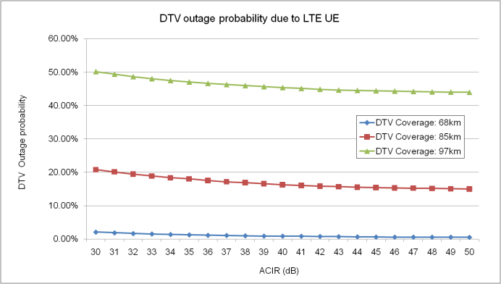 | 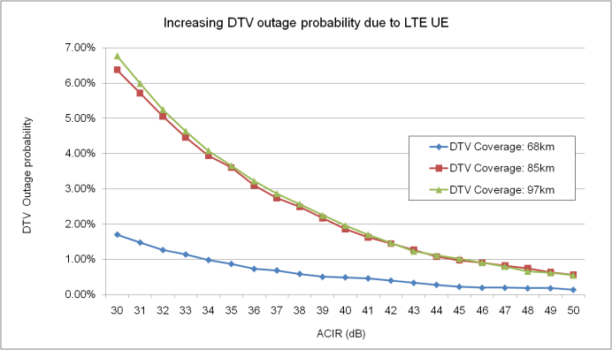
(a) DTV outage probability when LTE UE causes the interference to DTV Rx | (b) Increasing DTV outage probability occurred by the interference from LTE UE
Figure 4. DTV outage due to the interference of 5MHz LTE UE

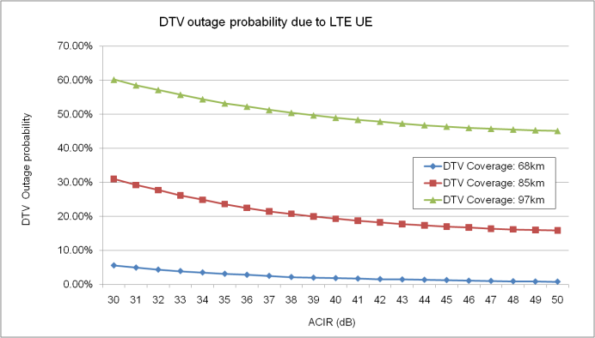 | 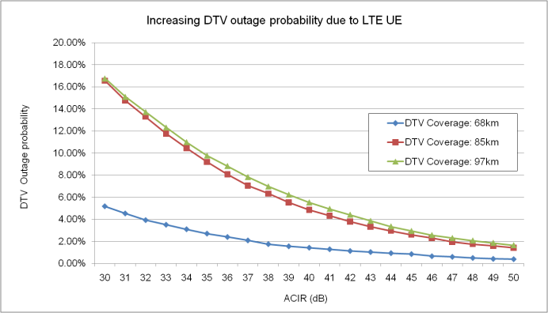
(a) DTV outage probability when LTE UE causes the interference to DTV Rx | (b) Increasing DTV outage probability occurred by the interference from LTE UE
Figure 5. DTV outage due to the interference of 10MHz LTE UE

LTE UE power distribution is showed in Figure 6.

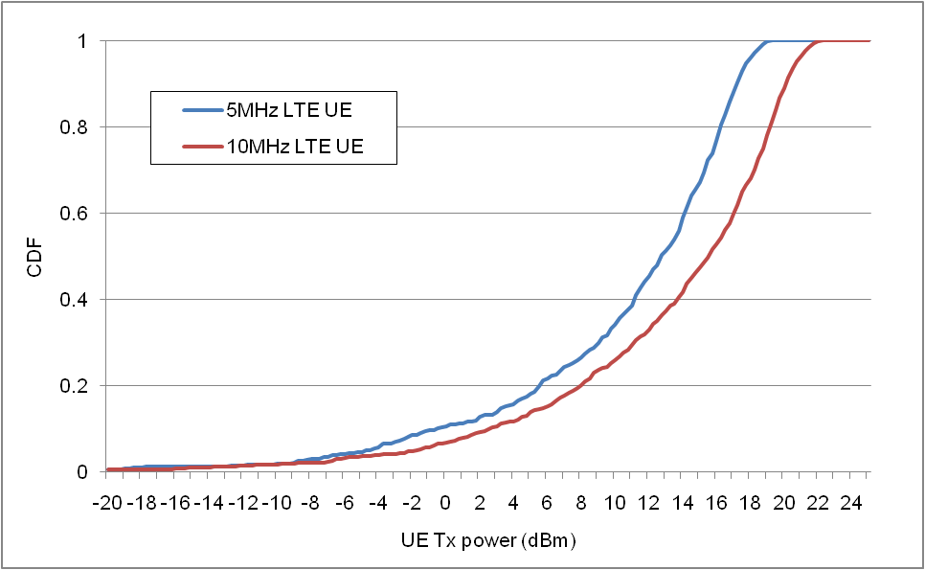

Figure 6. LTE UE power distribution

The table below addresses the DTV outage under ACLR of LTE UE and ACS of DTV Rx defined in CG parameter assumption. ACIRs for 5MHz / 10MHz LTE UE system to 6MHz DTV system (ATSC) are 39dB / 33dB in 5MHz guard band between LTE UE and DTV Rx, respectively. DTV outage probability for each LTE UE bandwidth is addressed as follows:

DTV Coverage | DTV Outage probability
DTV Coverage | 5MHz LTE UE  (ACIR: 39dB) | 10MHz LTE UE  (ACIR: 33dB) | No interference
68km | 0.9% | 3.9% | 0.4%
85km | 16.6% | 26.2% | 14.4%
97km | 45.1% | 55.8% | 43.4%

If DTV outage in DTV planning of a country is considered lower than DTV outage above, ACIR to protect DTV Rx can be determined from Figure 1 and Figure 2. And then, OOBE of LTE UE is calculated with the determined ACIR and maximum transmitter power of LTE UE.

Probabilistic Study P3
Simulation results indicate:

- Interference impact on DVB Rx is more significant for larger LTE transmission bandwidths where the DVB coverage is weaker (lower baseline SNR).
- Worst case assumptions for LTE UE OOB emissions, power control implementation and UE scheduling were used. The use of more conservative assumptions typical of LTE deployments would reduce the observed interference impacts in these results.
- The impact of LTE UE OOB emissions on DVB SNR was reduced to be negligible in the cases of 5MHz LTE UE transmission bandwidth (25 resource blocks).
- The increase in DVB location probability of SNR < 20dB for each case was observed :

Table 5. Summary of simulation results sets
Ref | Band Plan | LTE UE ACLR (dBC) | LTE UE Max ACL Level (dBm/8MHz)* | Relative increase in DVB location with SNR <20dB
1 | 5 MHz GB, 5 MHz LTE (25 RBs) | -38.5 | -15 | 0.9%
3 | 5 MHz GB, 15 MHz LTE (75 RBs) | -31.0 | -8.0 | 4.5%
5 | 9 MHz GB, 5 MHz LTE (25 RBs) | -43.8 | -21 | 0.4%
7 | 9 MHz GB, 15 MHz LTE (75 RBs) | -32.1 | -9.1 | 4%
 | * Maximum OOB emission level limit when UE is at maximum power with no power control back-off (i.e. at coverage edge).

Figure 7. UE OOB limit versus probability of DVB SNR degradation < 20dB

Based on this probabilistic simulation scenario (Outdoor LTE UE to 8MHz DVB-T Rx with outdoor antenna) and the fact that the number of simultaneously transmitting LTE UEs in real implementation will be less than 25 per sector, an appropriate UE out-of-band emission level limit for protection of DTV Rx quality is -21 dBm/8MHz.

Probabilistic Study P4
The simulation results for different numbers of active UEs per cell per sub-frame and different power control models are summarized in the following table.

Table 6. DTV SINR CDF for different numbers of UEs per cell and different Power Control models
Scenario | DTV SNR outage[%] | Relative DTV SNR outage increase [%]
1: DTV with no external interference | 0.8 | 0
2: DTV with LTE interference, 6 active UEs per cell, PC set 1 | 1.9 | 1.1
3: DTV with LTE interference, 6 active UEs per cell, PC set 2 | 1.0 | 0.2
4: DTV with LTE interference, 3 active UEs per cell, PC set 1 | 1.4 | 0.6

Probabilistic Study P5
In any coverage area, a receiving location is regarded as covered if the required performance parameters (carrier-to-noise and carrier-to-interference values) are achieved or exceed a threshold value for a given percentage of the total area of coverage. There are two probabilities to consider. Location probability is the probability that the performance parameters exceed the required threshold on the edges of coverage. Area coverage probability is the probability that the performance parameters exceed the required threshold over the entire coverage area. The location probability and area coverage probability are inter-related.

The assessment has been made on the basis that DVB broadcast service is available to greater than 95% of receiving locations at the edge of coverage and greater than 98.8% of the area that makes up the overall coverage of the broadcast transmitter.

It is noted that the term “coverage area loss” describes the loss of covered area resulting from the introduction of an interfering source.

In assessing the impact of interference to the broadcast DTV service from IMT UE services, a loss of 1% in the area that makes up the overall coverage of the broadcast transmitter is considered appropriate.

The initial results obtained show:
- The impact of interference from IMT UE services using a 5MHz channel reduces the availability of the DVB broadcast service within the coverage area from 98.8% to 98.3%. This is a coverage area loss of 0.52% and has an acceptable effect to the DTV broadcast service in the coverage area; and
- The impact of interference from IMT UE services using a 15MHz channel reduces the availability of the DVB broadcast service within the coverage area from 98.8% to 94.2%. This is a coverage area loss of 4.6% and has an unacceptable effect to the DTV broadcast service in the coverage area.
Using the agreed ACLR values, and assuming the use of maximum transmit power of 23 dBm, the interference level in the DTV receive band is shown in Table 1 below:

UE bandwidth  (MHz) | Number of resource blocks  (RBs) | ACLR  (dBc) | Maximum Interference level in the DTV  receive band  (dBm/8 MHz) | Maximum Interference level in the DTV receive band  (dBm/MHz)
5 | 25 | -43.8 | -21 | -30
10 | 50 | -38.5 | -15 | -24
15 | 75 | -32.1 | -9.1 | -18.1
20 | 100 | -31.0 | -8.0 | -17.0
Table 1: Interference level based on UE transmit power of 23 dBm
From the table it can be seen that the lowest level of out of band emissions at maximum UE power is -21 dBm/8MHz (with a 9 MHz guard band) or -30 dBm/MHz. We have already observed that UEs with a 5 MHz channel results in a coverage area loss of 0.52% to the DTV service. Therefore, an interference level of -30 dBm/MHz will only cause a 0.52 % loss of coverage area for the case of 5 MHz UE channels.

On the basis that an out-of-band emission level of -30 dBm/MHz results in an acceptable coverage area loss, the probabilistic analysis was re-calculated with the 15 MHz channel configuration and the out-of-band emission level reset to -30 dBm/MHz.

These re-calculated results show that the impact of interference from IMT UE services using a 15MHz channel, and with an out-of-band emission level of -30 dBm/MHz, reduces the availability of the DVB broadcast service within the coverage area from 98.8% to 97.8% for a user density of 13 users/km2. This is a coverage area loss of 1.0% and may be regarded as having an acceptable effect on the DTV broadcast service in the coverage area.

UE Bandwidth | UE density (UEs/km²) | Without interference |  | With UE interference (OOB level: -30dBm/MHz)
UE Bandwidth | UE density (UEs/km²) | CDF Value @ 20db SINR | Overall Area Coverage (%) | CDF Value @ 20db SINR | Overall Area Coverage (%) | Coverage Area Loss (%)
5 MHz | 13 | 1.20% | 98.8 | 1.72% | 98.28 | 0.52
10 MHz | 13 | 1.20% | 98.8 | 1.87% | 98.18 | 0.67
15 MHz | 13 | 1.20% | 98.8 | 2.20% | 97.80 | 1.00
Table 2: Results of probabilistic analyses
As part of the analysis, it was noted that the agreed input parameters in relation to IMT user density may not reflect resource scheduling likely to be employed by operators. In addition, handset duplexer operation will provide additional attenuation of out of band emissions. These two effects, although not quantified in this analysis, provide additional protection of the DVB broadcast service.

Probabilistic Study P6
The results of the probabilistic study for various scenarios for different protection ratio values or range are presented below for rural, suburban and urban environments. The scenarios covered are locations at the edge or inside the DVB-T coverage area, different number of UEs (UE#1 = 1 UE), different DVB-T antenna and UE heights (ie Rx 10m), different size coverage areas corresponding to different DVB-T transmitter ERPs (ie P1 =1k Watt ERP) and for UE Tx power varying according to 3GPP TR 36.942 V10.2.0 Figure 9.2 power control set 1 simulation case 1 (ie UE Prange).

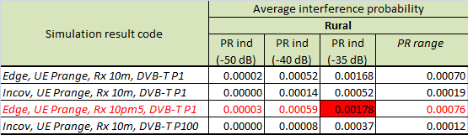
Table 1: Summary of results – Rural

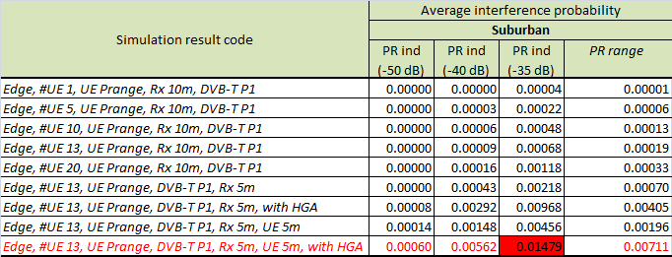
Table 2: Summary of results – Suburban

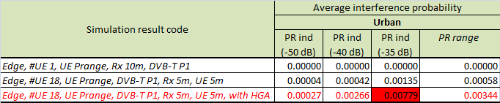
Table 3: Summary of results – Urban

Based on the empirical study a number of observations were made, including:

- Achievable protection ratio with a static LTE UE emission (average between ACP and EVM filtering) and a 9 MHz guard band:
  - 5 MHz LTE emission: 90% of receivers can achieve PR of -40 dB while only 10% of receivers can achieve PR of -50 dB.
  - 20MHz emission, 90% of receivers can achieve PR of -20 dB while only 10% of receivers can achieve PR of -30 dB.

- The impact of LTE baseband filtering:
  - 5 MHz LTE emission: there is no significant difference between ACP and EVM filtering. Among all devices tested, the mean PR is -45 dB for both ACP and EVM filtering.
  - 20 MHz LTE emission: there is around an 8 dB difference between ACP and EVM filtering. Among all devices tested, the mean PR is -22 dB for ACP filtering and -30 dB for EVM filtering.

- Difference between static and dynamic emission types:
  - Slow power control scenario:
    - 5 MHz LTE emission: 9 MHz guard band PR is 4 dB worse
    - 20 MHz LTE emission: No impact on PR for 9 MHz guard band
  - Fast power control scenario:
    - 5 MHz LTE emission: 9 MHz guard band PR is 10 dB worse
    - 20 MHz LTE emission: 9 MHz guard band PR is 7 dB worse
  - Frequency hopping scenario:
    - 5 MHz LTE emission: 9 MHz guard band PR is 4-5 dB worse
    - 20 MHz LTE emission: 9 MHz guard band PR is 2-3 dB worse
  - Frequency hopping with slow power control:
    - 5 MHz LTE emission: 9 MHz guard band PR is 5-7 dB worse

Empirical Sharing Studies

Empirical Study E1

Using a cable-connected test configuration, minimum protection ratio (C/I) values ranging from about 16dB for no guard-band to 8dB for 9MHz guard-band were measured for the case of a 15 MHz LTE carrier – although the poorest receiver device was observed to be unstable when operating close to its threshold sensitivity level. For the case of a 1.4 MHz LTE carrier, where in-band power spectral density is higher but out-of-band emissions extend over a narrower bandwidth, the minimum protection ratio (C/I) values ranged from 16dB for no guard-band to 0dB for a guard-band of only about 3 MHz. For larger guard-band offsets, the interfering signal has no impact and TV receiver performance is constrained only by the ‘wanted’ C/N threshold. Again the poorest receiver device showed signs of instability when operating close to its threshold sensitivity level.

The same testing program was then repeated, using an indoor wireless-coupled scenario (calibrated 0dBi UE antenna into a 5dBi set-top ‘rabbit-ears’ antenna), and over physical antenna separation distances of 0.5m to 1.5m. In general, it was observed that no picture degradation was discernable in the case of a 15 MHz LTE carrier with 5 MHz guard-band offset and 1m physical separation, provided an ‘average’ (40~50dBµV input) TV signal level was present. In the case of a 1.4 MHz LTE carrier, it was not possible to cause any TV picture degradation whatsoever, even at 0.5m physical separation, where the guard-band offset was greater than about 3 MHz due to limited UE output power.

Comparisons of the cable-connected results and wireless-connected results also indicated that the indoor propagation loss was greater than conventional the free-space assumption. While reference is made in ITU-R Recommendation P.1328 to the indoor scattering environment giving rise to increased losses, it offers only a minimum loss estimation method. The test results above prompted further specific indoor propagation path measurements that indicated an average path loss of 10~20 dB greater than free-space, even for physical separations of around 1m, but with a standard deviation of 5~8 dB. It was thus concluded that the free-space propagation assumption was not appropriate for indoor interference scenarios.

Finally, the stochastic nature of many of the variables involved in the LTE-DTV interference scenario was noted, including: probability of one or more UEs being close to TV receiver; probability of UE active and transmitting in the 700 MHz band; probability of TV using the uppermost channel; and probability of UE assigned the lower Resource Blocks. Therefore, a generalized statistical model was outlined to estimate the actual likelihood of interference, resulting in a probability of interference of 0.004% in those areas where the uppermost TV channel is assigned, and effectively zero elsewhere. This result compares favorably with several other statistical studies undertaken by European administrations.

Outcome of studies
This section gives a summary of the key observations and recommendations of these various studies undertaken.

Deterministic Study D1
The key conclusions of Study D1 were;

- This is a worst case deterministic analysis for this scenario (indoor UE and outdoor DTV antenna) when;
  - Television uses the uppermost adjacent television channel.
  - LTE UE OOB emissions at the limit of the standard requirements
  - LTE UE to DTV Rx antenna coupling based on BT standard assumptions
  - DVB-T system operating at the minimum planning receive level

- The maximum additional attenuation required is no more than 11dB for all LTE bandwidths, for which the LTE UE Tx filters will easily provide due to their duplex band-pass nature.

- The probably of LTE UE to DTV interference of unacceptable levels in this scenario will be low for real-world situations
  - UE will not always be transmitting, and when it is, rarely at full power
  - UE to DTV antenna coupling will frequently be larger than that assumed, e.g. in the case of Urban environments with longer DTV antenna systems
  - The majority of DTV signal levels will be higher then those used in this analysis

- Actual testing and measurements should be used to show the real conditions (UE to DTV receiver coupling) where noticeable receive quality is degraded.

Deterministic Study D2
The required OOB emission level for LTE UE to protect digital TV receiver can be calculated by subtracting the “additional attenuation required” from the “LTE UE OOB emission level in the digital TV receiver bandwidth”. For example, for LTE UE using the 15MHz transmission bandwidth and 9MHz guard band, the required OOB emission level becomes around;

- -25.9dBm/6MHz~-25.9dBm/8MHz for the scenario (b) (i.e., LTE UE outdoor → Fixed digital TV reception with outdoor rooftop antenna) and
- -54.5dBm/6MHz~-54.5dBm/8MHz for the scenario (d) (i.e., LTE UE indoor → Fixed digital TV reception with indoor antenna).

Thus, the required OOB emission level is highly dependent on the scenarios to be considered. Furthermore, since the deterministic studies are based on the conservative assumptions, The required OOB emission level could be further relaxed taking into more practical assumptions, such as LTE UE may not always be transmitting at full power and full channel bandwidth, more coupling loss between LTE UE to digital TV receiver depending on the separation distance and direction of the TV antenna, received digital TV signal levels might be higher, and so on. Thus, it is essential to consider the practical scenarios and assumptions to be selected in order to suit national considerations of each country.

Probabilistic Study P1 related to a 5MHz and 9 MHz Guard Band
Study P1 has concluded that;

- The LTE uplink channel is shared between multiple UE(s), so each UE will thus occupy much less than the full nominal channel bandwidth. While accurate models of the varying mix of service types and categories are not yet available, current assumptions of likely active user density suggest that a UE uplink signal of 5MHz bandwidth (representing 25 Resource Blocks) is representative of the worst-case UE uplink signal for nominal LTE channels of up to 20MHz.

Study P1 (Monte Carlo) simulations of the interaction between LTE UEs in the vicinity of a DTV receiver, on the basis of assumptions indicate that 5 MHz LTE uplink signals will have negligible impact on DTV reception irrespective of 5 MHz or 9MHz guard-band.

Probabilistic Study P2 related to a 5 MHz Guard Band
Study P2 concludes;
- The DTV deployment environment such as the coverage is not clearly defined. Therefore, our simulation result only shows how DTV outage is affected by the interference from LTE UE. With the proposed (probability analysis) methodology, similar results can be obtained with the harmonized simulation methodology for DTV.
- according the ACLR of LTE UE increases for three assumption of DTV by considering undefined parameters of DTV.
- In aspect of OOB emission level of LTE UE to protect DTV receivers, the DTV configuration such as the coverage (or the minimum sensitivity level) and the allowable interference level should be clear before.

Study P2’s simulation result, in Figure 4 and Figure 5 of section 4.3.2.2, can be utilized to define OOB emission level of LTE UE. If the conservative condition of DTV environment is considered such as wide DTV coverage, OOB emission level of LTE UE may be more stringent than the general OOB emission in 3GPP.

Probabilistic Study P3 related to a 9 MHz Guard Band
Study P3 concludes that;
- For a 9 MHz guard-band, 5 MHz LTE UE transmission bandwidth case as having negligible impact on 8 MHz DVB receive quality. It is noted that in a realistic LTE deployment the number of simultaneously transmitting LTE UEs would not exceed 25, and the transmit bandwidth at coverage edge would not exceed 5 MHz (25 RBs).

Therefore we consider the corresponding UE OOB maximum emissions from this scenario, -21dBm/8MHz, is an appropriate limit for protection of adjacent DVB reception for all band scenarios. To account for other DVB system bandwidths in the region this level would translate to -21.4dBm/7MHz and -22dBm/6MHz.

Probabilistic Study P4 related to a 9 MHz Guard Band
As the above table shows (Scenarios 2 and 4), for a given channel bandwidth (in this case 10 MHz), the higher the number of active LTE UEs per cell per sub-frame (in other words the smaller the number of resource blocks allocated to active UEs), the bigger the average interference impact on DTV receiver in terms of DTV SNR outage rate. Therefore, a realistic assumption on the number of resource blocks (or bandwidth) allocated to active UEs has a considerable impact on the conclusion regarding the relative DTV SNR outage increase due to LTE UE interference. In practical broadband applications, typical numbers for resource blocks scheduled per UE will be in the order of 16 (i.e. for 10 MHz channel, 3 active UEs per cell per sub-frame) to 25 (i.e. for 10 MHz channel, 2 active UEs per cell per sub-frame). In the former case, our simulation results demonstrate 0.6% relative DTV SNR outage increase.

The applied power control model has impact on the relative DTV SNR outage increase. The above table shows that the conservative power control Set 2 results in 0.2% relative DTV SNR outage increase whereas the corresponding figure for more aggressive power control Set 1 is 1.1%.

In the simulations it was assumed that ACLR = 33dBc is flat for all active UEs irrespective of the offset of the resource blocks allocated (resulting in -10dBm/8MHz leakage power in the adjacent DVB-T channel). In addition, the ACLR value is derived from the spectrum emission mask defined in 3GPP technical specifications for LTE UE (TS 36.101) by integration over the DVB-T receive band. These are absolute worst case assumptions due to the following two reasons.

- The ACLR value specified in TS 36.101 for an LTE adjacent channel is few dB tighter than that calculated by the integration of the spectrum emission mask over this channel. Therefore, the real ACLR of LTE UE in the DVB-T channel should be a few dB better than that calculated by the integration of LTE UE spectrum emission mask over DVB-T channel.

- The ACLR defined in 3GPP specifications and used in our simulations is based on the assumption that all UEs transmit with the maximum number of resource blocks allocated, i.e. 50 for 10MHz channel. 3GPP specifications don’t specify out-of-band emissions for sub-band resource allocation. The following 3 figures present the results of simulations performed by Nokia to determine ACLR for different resource block allocations based on a realistic power amplifier (PA) model for a 10MHz LTE UE. The PA model is adjusted to just meet 3GPP LTE ACLR requirements as defined in TS 36.101 with full channel allocation to UE, Figure 8. The results of ACLR simulation for partial resource block allocation are shown in Figure 9 and Figure 10 by keeping the PA model unchanged for these allocations. The achieved LTE UE ACLR figures for DVB-T channel suggest that using these realtistic values in our LTE UE – DTV coexistence simulations would have not resulted in any increase in relative DTV SNR outage.
Figure 8. ACLR for full band allocation (5 RBs) to UE

Figure 9. ACLR for partial band allocation (25 RBs, offset 25) to UE

Figure 10. ACLR for partial band allocation (25 RBs, offset 0) to UE

Probabilistic Study P5 related to a 9 MHz Guard Band
As a result of the analyses undertaken, it can be concluded that a UE out-of-band emission level of -30 dBm/MHz has an acceptable impact on the outage probability of the DTV coverage and may be considered as a suitable out-of-band emission level, regardless of the UE channel bandwidth employed.

Probabilistic Study P6 related to a 9 MHz Guard Band
The results of the probabilistic study showed that, for a range of adjacent channel PRs (i.e. -35 dB to -50 dB) considered valid for interference from a simulated 5 MHz LTE UE emission into a DVB-T receiver the probability of interference is less than 1% for all practical cases considered.

The results of the empirical studies indicate that an additional margin of around 10 dB is required on calculated out of band emission limits derived from studies that do not take into account dynamic interferer effects.

As a result of the studies and analysis undertaken, the study concludes that a UE out- of-band emission limit of -40 dBm/MHz be set within the broadcast band (i.e. below 698 MHz) for all LTE UE emission bandwidths to ensure coexistence with adjacent broadcasting services.

Empirical Study E1
The overall conclusions of Study E1 were:

- DTV receiver devices are available today that are capable of satisfactory operation in the presence of LTE signals offset by a minimum guard-band of 5 MHz
- LTE devices should, as a minimum, comply with current 3GPP specifications to ensure satisfactory DTV reception in an adjacent channel separated by a 5 MHz guard-band.
- The lack of recognized DTV receiver minimum performance specifications allows for some receivers in the market to exhibit poor input sensitivity, low selectivity and a susceptibility to interference when the incident DTV signal level is close to the device threshold sensitivity level. But, the probability of interference may be relatively low.

It was also noted that the minimum 5 MHz lower guard-band, coupled with current 3GPP out-of-band emission limits may be sufficient to satisfactorily protect DTV receivers.

Technical Considerations for Channel Planning
This section outlines the technical considerations associated with channel planning, and the implications for administrations, operators and end-users.

The uplink/downlink block size of the 698-806 MHz FDD band plan has already been determined as 45 MHz. The associated uplink/downlink duplexing filter could therefore be implemented in the form of a single or dual duplexer. The current state-of-the-art allows for a maximum duplexer size of around 3-4% of the center frequency of the band. This results in a duplexer bandwidth in the order of 30 MHz. Therefore two overlapping duplexers are currently expected to be required. However, It should be noted that a dual-duplexer implementation is just one option (although the most likely one in the near future) and that other filter implementations, which fulfill the minimum performance requirements defined by the relevant 3GPP specifications and facilitate seamless roaming in different countries, could be possible.

In order to facilitate seamless roaming, it is also appropriate to assign a single 3GPP ‘band number’ for the entire band. The two filters will necessarily overlap since only one filter can be used at a time, and entire operational channel must be accommodated within this filter. An optimum design would implement the same bandwidth (BW) for both duplexers and, therefore, the largest BW is needed in the case when the widest possible LTE channel is positioned in the middle of the band.

The channel bandwidths are not yet defined for this band but it is likely that the widest (20 MHz) LTE channel option will be allowed. Current 3GPP specification 36.101 mandates a 100 kHz channel raster, which would enable a 20 MHz channel to be positioned practically in the middle of the band. This scenario requires a full 20 MHz overlap of duplexers, and leads to a requirement for 2 x 32.5 MHz duplexer pass bands.

Figure 11. 20 MHz channel in the middle of the band

The case of a 20 MHz channel positioned in the centre of the 45 MHz block leaves 12.5 MHz spectrum on either side, which is not fully consistent with LTE channel bandwidths. For efficient spectrum usage, a 5 MHz raster is very likely to be implemented in practice. Thus, on the basis of a 5 MHz raster, the 20 MHz channel will be positioned 2.5 MHz below the block centre-frequency (case 1 in Figure 11) or 2.5 MHz above the block centre-frequency (case 2 in Figure 11).

From Figure 11 it can therefore be seen that a 15 MHz overlap is adequate in this case, and a 2 x 30 MHz duplexer arrangement could be implemented.

Given this overlap arrangement, a number of alternative channel plans can be readily adopted by administrations: Figure 11 below shows how 5, 10, 15 and 20 MHz channels can be adopted. Further examples showing the different positioning of channels of differing bandwidths are candidate topics for further contributions.

Figure 12. 20 MHz channel positions with 5 MHz raster

Finally, in regard to carrier aggregation (CA) functionality it should be noted that carriers can only be aggregated within a single duplex filter window, and cannot be aggregated across both filter windows. Consideration of this operational CA limitation may be relevant to national planning of contiguous channel allocations and assignments to network operators.

Conclusions

Out of band emission limits

As a result of the probabilistic, deterministic and empirical studies it is considered that the probability of interference to adjacent digital television receivers below 694 MHz from IMT UE would be low when the UE maximum out-of-band emissions were between -30 and -40 dBm/MHz (averaged over the DTV bandwidth).

Considering technical and economic factors associated with UE equipment, it was concluded that the average out of band emissions of IMT UE, measured over the bandwidth of the applicable television channel in the country of deployment, must not exceed -34 dBm/MHz below 694 MHz .

To further reduce the probability of interference in certain cases, such as where digital television broadcasting services are operating immediately below 694 MHz, Administrations may wish to implement, on a local basis, network and operational deployment measures. This discretionary approach would have the effect of further lowering the emissions into the adjacent broadcast band below 694 MHz by up to 6 dB. This would have no impact on the IMT UE handset specifications or roaming requirements and can be achieved solely through network implementation by operators.

For countries which have 6 MHz broadcast channel raster, if it is found that additional coexistence conditions are needed, they should be considered in an amendment to this report.

Channel Planning
The technical considerations outlined for channel planning include a 5 MHz channel raster and the need for contiguous band allocations to support wideband IMT systems.

Annexes

Agreed Parameter assumptions:

The protection ratio is the value of carrier (DVB-T) to interference (UE emission) below which failure of the wanted (DVB-T) service occurs.
Previous ACMA internal tests had shown that LTE emission ingress (i.e. not through the receive antenna) into DVB-T receivers was not a significant issue.
This level is sourced from Document JTG 5-6/180 (Annex 9). Report on the fifth and final meeting of Joint Task Group 5-6 (30 April to 7 May 2010).

