

APT SURVEY REPORT

On

“COGNITIVE RADIO SYSTEMS (CRS) AND SOFTWARE DEFINED RADIO (SDR)”

No. APT/AWG/REP-29
Edition: April 2012

Adopted by

The 12th APT Wireless Group Meeting
10 – 13 April 2012, Xiamen, People’s Republic of China

 | ASIA-PACIFIC TELECOMMUNITY
 | APT Wireless Group
Source: AWG-12/OUT-07

APT SURVEY REPORT on cONNITIVE RADIO sYESTEMS (CRS) & sOFTWARE dEFINED rADIO (SDR)

Content

1. Background 2
2. Summary of the questionnaire 2
3. Questionnaire Results 3
3.1 Software defined radio 3
3.2 Cognitive radio system 4
4. Conclusion and further work 6
ANNEX 7
PART A: SDR 7
PART B: CRS 9

1. Background

During the AWF-9 meeting held in Seoul, Korea in September, 2010, the former SWG-7 which renamed as TG on CRS and SDR in WG Technology Aspects made the questionnaire on CRS&SDR in APT Region based on the received input contributions (the questionnaire can be found in the document of AWF-9-OUT-18).
The content of the questionnaire is followed the TOR (Terms of References) of TG on CRS and SDR, and in order to enable the AWG to have a better understanding of the current stage of CRS and SDR implementation and development or relevant topics concerned in the region, more than eleven questions were made in this questionnaire.TG CRS&SDR has completed the work during -AWG-12meeting. The feedback or answers from administrations suppose be collected and analyzed as a basis for the further study on CRS&SDR within APT region.

2. Summary of the questionnaire

This questionnaire was made during the AWF-9 meeting by former SWG-7; more than eleven questions were made. According to the questions, the administrations will introduce their attitude and the relevant research activities on CRS&SDR in their country. The administrations attitudes suppose to be included the information such as:
If there is any research and development on CRS & SDR related topics in their country; they believe the CRS will be a technology to improve the spectrum efficiency or not; the possible applications or scenarios for the improvement of the spectrum efficiency by implementing CRS and SDR; the time is needed for commercial deployment of CRS; consideration on the possible frequency band(s) for the systems or services implementing CRS; main issues or challenges in face of the CRS&SDR deployment from the technical and regulatory perspective respectively, etc.
It is hoped that based on the feedback information from administration on these questions, the current situation of CRS&SDR could be figure out in APT region.
During the AWG-10 meeting held in Bangkok, AWG-11meeting held in Chiang Mai and AWG-12 meeting held in Xia Men, eight administrations responded the questionnaire, they were: Australia, Brunei, China, Indonesia, Japan, Korea, New Zealand and Singapore. The detailed response could be found in the following input contributions:
AWG-10 | http://www.apt.int/2011-AWG10-DOCS-INPUT
Australia | AWG-10-INP-11
Japan | AWG-10-INP-14
Brunei | AWG-10-INP-67
New Zealand | AWG-10-INP-70
Indonesia | AWG-10-INP-75
AWG-11 |  | http://www.apt.int/2011-AWG11-DOCS-INPUT
Korea |  | AWG-11-INP-30
China |  | AWG-11-INP-64
AWG-12 |  | http://www.apt.int/2012-AWG12-DOCS-INPUT
Singapore |  | AWG-12-INP-17

3. Questionnaire Results

This chapter has summarized the replies from the administrations. The detailed information provided by each administration can be found in the annex.

3.1 Software defined radio
1: Are there any organizations or institutes that carried out the research and development on SDR or related topics in your country? (Q2)

Eight APT administrations replied to this question, 86 percent of which have carried out the research and development on CRS.

No | Country | in research | organizations or institutes
1 | Australia | yes | Universities and other research organizations
2 | Brunei Darussalam | yes | Authority for Info-communications Technology Industry of Brunei Darussalam
3 | China | yes | Operators, manufactures, institutes and universities
4 | Japan | yes | Telecommunication Operators, Manufacturers, Research institutes and Universities
5 | New Zealand | yes | University
6 | Indonesia | no
7 | Korea | yes | Institute and universities
8 | Singapore | yes | National research organizations

2: Which systems have used the SDR technology at the current stage in your country? (Q5)

Seven APT administrations replied to this question, the considered systems and their supported situations are summarized below.

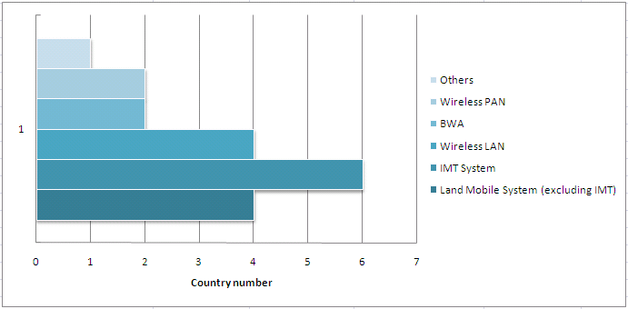

3: From the technical aspects, what are the main issues or challenges in face of the SDR deployment? (Q9)

The Brunei and New Zealand administration point out that the main challenges in deployment of SDR are approving appropriate technical standards by telecommunication regulators. Indonesia considers that the performance stabilities and interference issues are the main challenge. Chinese administration list the main technical issues they considered are wideband RF, wideband/high speed/high resolution A/D D/A converter and high performance signal processing devices. Japan states no technical issues can be seen in face of the SDR deployment in their reply. Korean administration believes that main challenges are power consumption in modem part and multi-band in RF part for both handset and BS, multi-band/multi-standard RF device. Singapore said the main issue will be the power and size of the SDR.

4: From regulatory perspective, what are the main issues or challenges in face of the SDR deployment? (Q11)

Australia, China, Japan and Korea state that there is no regulatory issue or challenges in face of the SDR deployment. Brunei point out that the main challenges are ensuring that the regulatory framework covers all aspects of SDR capabilities as well ensuring SDR compliance with the regulatory framework. New Zealand thinks that a practical enforcement problem might arise if there are many developers world-wide marketing software separately from the hardware, with some of these products not conforming to local standards. Singapore also thinks that new regulatory framework may be needed to facilitate deployment as well as potential challenges in monitoring and enforcement actions.

3.2 Cognitive radio system
1: Are there any organizations or institutes that carried out the research and development on CRS or related topics in your country? (Q1)

Eight APT administrations replied to this question, 86 percent of which have carried out the research and development on CRS.

No | Country | in research | organizations or institutes
1 | Australia | yes | Universities and other research organizations
2 | Brunei Darussalam | yes | Authority for Info-communications Technology Industry of Brunei Darussalam
3 | China | yes | Operators, manufactures, institutes, universities or organizations in China
4 | Japan | yes | Telecommunication Operators, Manufacturers, Research institutes and Universities
5 | New Zealand | yes | Industrial Research institute and university
6 | Indonesia | no
7 | Korea | yes | Institute, manufactures and universities.
8 | Singapore | yes | National research organizations

2: Are you considering the CRS will be a technology to improve the spectrum efficiency? (Q3)

The CRS technologies are expected to improve the spectrum efficiency by all the replied APT administrations.

3: Which systems do you think can improve the spectrum efficiency by implementing CRS? (Q4)

Eight APT administrations replied to this question, the considered systems and their supported situations are summarized below.

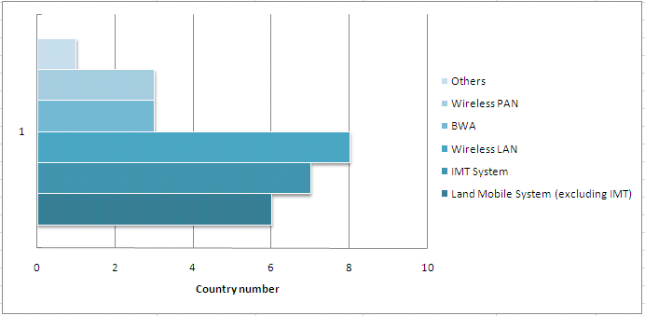

4: For such systems, what kind of applications and scenarios do you think can be envisaged? (Q4bis)

Based on feedbacks, the administrations show their interests on this question, but the views emphases on different aspects and most administrations still need further study on the applications and scenarios of CRS. More details can be found in the annex.

5: In your opinion, the time for commercial deployment of CRS in your country is: (Q6)

Eight APT administrations replied to this question, their considerations on the commercial deployment time are summarized below.

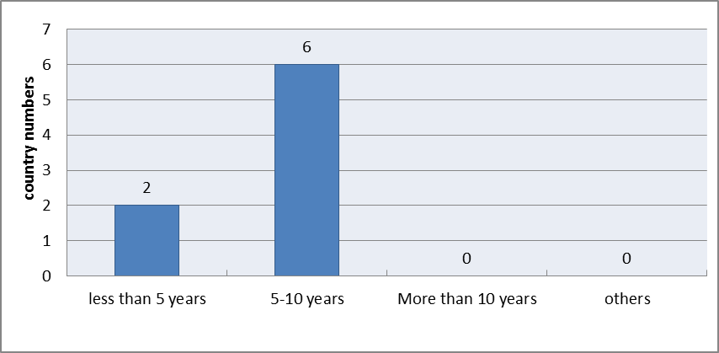

6: Are you considering possible frequency band(s) for the systems or services implementing CRS in your country? (Q7)

Eight APT administrations replied to this question, six of them (Australia, Brunei, China, Korea, New Zealand and Singapore) are considering or going to consider possible frequency band(s) to implement CRS, while other administrations did not yet.

7: Are you considering any limitations on band(s) for the systems or services implementing CRS in your country? (Q7bis)

Eight APT administrations replied to this question, seven of them (Australia, Brunei, China, Indonesia, Korea, New Zealand and Singapore) are considering or going to consider some limitations, such as to grant different levels of protection from CRS to different bands/services, to cause no harmful interference to the existing systems or services, to limit the transmit power and used for short range operation only, etc.

8: From the technical aspects, what are the main issues or challenges in face of the CRS deployment? (Q8)

Based on feedbacks, the administrations show their interests on this question, but the views emphases on different aspects and most administration still need further study on the main issues or challenges in face of the CRS deployment. More details can be found in the annex.

9: From regulatory perspective, what are the main issues or challenges in face of the CRS deployment? (Q10)

Seven APT administrations replied to this question. Brunei point out that the main challenges faced in deployment of CRS are ensuring that the regulatory framework covers all aspects of CRS capabilities as well ensuring CRS compliance with the regulatory framework. Australia, Korea and New Zealand think that the main challenge will be the protection of existing services while allowing CRS systems to operate within their limitations. Korea also thinks that licensing method (licensed/unlicensed), frequency band (for example: TV White Space, IMT band, ISM band, etc.) are the main issues in face of the CRS deployment. Singapore point out that new regulatory framework may be needed to facilitate deployment as well as potential challenges in monitoring and enforcement actions. Although there are some challenges in face of the CRS deployment, China and Japan point out that there is no need to change the Radio Regulations at the current stage.

4. Conclusion and further work

Considering the feedback from APT administrations, with regard the answers to the SDR, it seems that SDR is a relatively mature technology which has been successfully deployed.

APT administrations also hold the views that CRS technology could be treated as an evolving and promising technology to improve spectrum efficiency and may see commercial deployment in ten years, meanwhile relevant studies is carried on in their countries respectively.

Furthermore, CRS still need to face some challenges not only from technical aspects but also regulation and policy aspects which are reflected on questions such as Question 4bis and Question 8. Further study on CRS is needed, and it’s proposed to draft a new report on CRS in AWG. This questionnaire result could also be a reference to the new CRS report.

ANNEX

PART A: SDR

1: Are there any organizations or institutes that carried out the research and development on SDR or related topics in your country? (Q2)

Australia | Yes, Universities and other research organizations have carried out research on various aspects of CRS and related topics.
Brunei | AITI is currently studying the technical standards for SDR as well as following international developments on its Regulatory Framework.
China | Yes, SDR has been researched by operators, manufactures, institutes and universities; and the relevant implementation has been realized.
Indonesia | No comment
Japan | Yes, Telecommunication Operators, Manufacturers, Research institutes and Universities.
Korea | Yes, ETRI has carried out research on SDR and related topics and developed SDR-based dual mode base station. Hanyang University has implemented a few SDR-based systems as follows: (1)Multi-mode base station system using GPU as MODEM processor covering WiBro, LTE, etc, (2)Multi-mode handset on which any waveform can be ported from an external Radio App. store with a full degree of freedom, (3)reference code for smart antenna which runs on OSSIE.
New Zealand | Yes, Canterbury University –Cross layer optimization
Singapore | Yes, National research organizations are carrying out R&D on SDR

2: Which systems have used the SDR technology at the current stage in your country? (Q5)

Australia | Land Mobile System (excluding IMT), IMT System, Wireless LAN
Brunei | None
China | Land Mobile System (excluding IMT), IMT System, Wireless LAN
Indonesia | IMT System
Japan | SDR technology is currently operating in some systems in radio communication services, including but not limited to the LMS
Korea | IMT System
New Zealand | Land Mobile System (excluding IMT), IMT System, Wireless LAN, BWA, Wireless PAN
Singapore | Nil

3: From the technical aspects, what are the main issues or challenges in face of the SDR deployment? (Q9)

Australia | No comment
Brunei | The main challenges faced in deployment of SDR are ensuring SDR operates within operating parameters and technical standards approved by telecommunication regulators. This will give rise to certification and conformity issues.
China | Technical issues for a software radio transmitter and/or receiver  (1) Wideband RF;  (2) Wideband/high speed/high resolution A/D D/A converter;  (3) High performance signal processing devices (DSPs, FPGAs, uPs);
Indonesia | The performance stabilities and interference issues
Japan | No technical issues can be seen since SDR technology is currently operating in some radio communication systems and networks.
Korea | Power consumption in modem part and multi-band in RF part for both handset and BS, multi-band/multi-standard RF device.
New Zealand | A potential area of concern is that of compliance with technical and regulatory standards due to the inherent ability of SDR devices to reconfigure their technical parameters. The ability to reconfigure does not itself constitute a breach of standards. It is rather a matter of each configuration needing to conform to an appropriate standard.
Singapore | The main issue will be the power and size of the SDR which will result in high implementation cost.

4: From regulatory perspective, what are the main issues or challenges in face of the SDR deployment? (Q11)

Australia | There are few issues from a regulatory point of view with SDR deployment given many systems have already implemented SDR in some form.
Brunei | The main challenges faced in deployment of SDR are ensuring that the regulatory framework covers all aspects of SDR capabilities as well ensuring SDR compliance with the regulatory framework.
China | There is no regulatory issue or challenges in face of the SDR deployment
Indonesia | The implementation of SDR will improve the flexibility of frequency adjustment and it causes operators may change the frequency easily based on the availability of spectrum rather than allocated spectrum.
Japan | No regulatory issues can be seen since SDR technology is currently operating in some radio communication systems and networks.
Korea | There are few regulatory issues at present since SDR technology has already been implemented in some radio communication systems and networks without regulatory issues.
New Zealand | A practical enforcement problem might arise if there are many developers world-wide marketing software separately from the hardware, with some of these products not conforming to local standards. There are already instances of non-conforming radio equipment being imported. Software is even more portable than hardware and can even be downloaded over the Internet. This is an area the New Zealand intends to closely monitor from a compliance perspective, including educating equipment suppliers and border control officers.
Singapore | Regulation on “over-the-air” programmable/change of equipment parameters. New regulatory framework may be needed to facilitate deployment as well as potential challenges in monitoring and enforcement actions

PART B: CRS
1: Are there any organizations or institutes that carried out the research and development on CRS or related topics in your country? (Q1)

Australia | Yes, Universities and other research organizations have carried out research on various aspects of CRS and related topics.
Brunei | Yes, AITI is currently studying the possible bands for CRS as well as following international developments on its Regulatory Framework.
China | Yes, discussions on CRS-related topics have been carried out by operators, manufactures, institutes, universities or organizations in China, such as one of the national science and technology major projects --"The key technologies and validation of efficient use of spectrum for WRC-12", one of the Chinese high technology research and development Projects (863 project)--"Integration of key technologies for personal area networks & wide area networks and development of validation and demonstration systems based on CRS", one of the Chinese National Basic Research Program (973 Program) --"Basic Research on Cognitive Wireless Networks", a series of projects on cognitive radio under the umbrella of NSFC(Natural Science Foundation of China) Program, study items of China Communications Standards Association (CCSA) on WRC-12 AI1.19 and CRS relevant technical & spectrum & regulation issues and so on.
Indonesia | No comment
Japan | Yes, Telecommunication Operators, Manufacturers, Research institutes and Universities
Korea | Yes, ETRI, Samsung Electro-Mechanics Co. and Universities have carried out research and development on various aspects of CRS and related topics including RF chips and test-bed to verify algorithms.
New Zealand | Yes,  Industrial Research Limited – Spectrum Sensing  Canterbury University – Capacity information  Victoria University – Capacity information  Auckland University – Interference mitigation
Singapore | Yes, National research organizations are carrying out R&D on CRS

2: Are you considering the CRS will be a technology to improve the spectrum efficiency? (Q3)

Australia | Yes, Reason: CRS allows a greater level of spectrum sharing as well as allowing a licensee to more efficiently use their spectrum holdings, as a result it will therefore be useful especially in urban areas where spectrum is in high demand.
Brunei | Yes, CRS is capable of detecting un-used spectrum in which it will operate thus making use of spectrum that is readily available.
China | The frequency resource is limited and some bands have not been efficiently used or can even be idled in certain time or certain place. By introducing CR capability, some frequency bands which are not fully utilized can be used by those CR-capable wireless systems.
Indonesia | Yes, Reason: Useful for reducing operational complexity and opex.
Japan | Yes, Reason: The CRS technologies are expected to provide additional flexibility and offer improved efficiency to the overall spectrum use, for example, (1) CRS technologies can give a measure to utilize the multiple Radio Access Networks/RANs (operated in different wireless access technologies) simultaneously by switching or aggregating their connections. CRS terminals can be accommodated to the suitable RANs, therefore spectrum usage of the RANs can be well balanced and overall spectrum use can be improved. (2) CRS technologies have a potential to further facilitate coexistence of radio systems without causing harmful interference in the future.
Korea | Yes, Reason: CRS can increase geographical spectrum reuse and improve overall spectrum efficiency.
New Zealand | Yes, The ability to improve geographic reuse of spectrum
Singapore | Yes, It is able to utilize “unused” whitespace

3: Which systems do you think can improve the spectrum efficiency by implementing CRS? (Q4)

Australia | Land Mobile System (excluding IMT), IMT System, Wireless LAN, BWA
Brunei | Land Mobile System (excluding IMT), Wireless LAN, Wireless PAN
China | Land Mobile System (excluding IMT), IMT System, Wireless LAN, BWA, Wireless PAN
Indonesia | IMT System, Wireless LAN
Japan | Any radio systems of radio communication services defined in ITU-R Radio Regulations.
Korea | IMT System, Wireless LAN
New Zealand | Land Mobile System (excluding IMT), IMT System, Wireless LAN, BWA, Wireless PAN
Singapore | Land Mobile System (excluding IMT), IMT System, Wireless LAN, BWA, Wireless PAN and Broadcast (Localized)

4: For such systems, what kind of applications and scenarios do you think can be envisaged? (Q4bis)

Australia | Implementing CRS in land mobile systems will allow greater spectrum use and potentially allow a greater number of users to operate in a particular band. Similarly, implementing CRS in wireless LAN will facilitate a greater level of spectrum sharing between users.  Implementing CRS in IMT and BWA systems would potentially allow operators to better manage and increase spectral efficiency in their networks.
Brunei | For Wireless LAN & PAN, low power applications for indoor use are envisaged. As for the land mobile system, it is expected to be low power voice applications.
China | There are multiple possible applications and scenarios.  For example, by introducing CR-capabilities, IMT systems can be further implemented at lower priority in the inefficiently utilized frequency bands of other systems.  In another scenario, sharing spectrums by introducing CR capabilities could make one RAT utilize the idle spectrum in an opportunistic spectrum access manner, which would not interfere with the RAT that owns the idle spectrum, to improve overall spectrum efficiency.
Indonesia | location awareness applications
Japan | As for the land mobile service, ITU-R is now identifying potential applications and scenarios as its work of developing CRS Report ITU-R [LMS.CRS].
Korea | Hot spot service, local information service/broadcasting/ advertisement , traffic management
New Zealand | No comment
Singapore | Wireless Broadband services, remote metering, backhaul and fixed services

5: In your opinion, the time for commercial deployment of CRS in your country is: (Q6)

Australia | 5 to 10 years
Brunei | Less 5 years
China | 5 to 10 years
Indonesia | 5 to 10 years
Japan | 5 to 10 years
Korea | Less 5 years
New Zealand | Some technologies already exhibit cognitive radio techniques but we expect wider commercial deployment to be in 5 to 10 years
Singapore | 5 to 10 years

6: Are you considering possible frequency band(s) for the systems or services implementing CRS in your country? (Q7)

Australia | Yes, the ACMA (Australian Communications and Media Authority (ACMA) the Australian regulator.) is considering a holistic approach to CRS access to spectrum and is considering regulatory and technical arrangements for the spectrum as a whole rather than a band by band approach.
Brunei | Yes, 5GHz band for RLAN sharing with radiolocation
China | Yes, we are considering the bands which are not fully utilized.
Indonesia | No
Japan | No
Korea | Yes, TV White Space (under study)
New Zealand | Yes, We are still considering bands and are planning to conduct a review.
Singapore | Yes, UHF band

7: Are you considering any limitations on band(s) for the systems or services implementing CRS in your country? (Q7bis)

Australia | Yes, the ACMA (Australian Communications and Media Authority (ACMA) the Australian regulator.) is considering a holistic approach to CRS access to spectrum and is considering regulatory and technical arrangements for the spectrum as a whole rather than a band by band approach.
Brunei | Yes, without limitations, a user may chose to program their CRS to use unauthorized bands which may lead to harmful interference with existing systems.
China | Yes, do not cause harmful interference to the existing systems or services.
Indonesia | Yes, Should be based on current allocation frequency to control complexity of spectrum management.
Japan | No (at least, in current stage)
Korea | Under study
New Zealand | Yes, We will be considering this when we conduct a review as mentioned in question 7
Singapore | Yes, There will be limitations on the transmit power; it can be used only on a secondary basis and used for short range operation only.

8: From the technical aspects, what are the main issues or challenges in face of the CRS deployment? (Q8)

Australia | Sensing, database access or other techniques to create awareness of other spectrum users, including both CRS and non-CRS users.
Brunei | The main challenge faced in deployment of CRS is ensuring CRS operates within designated band including avoiding users to freely program their CRS to freely use unauthorized bands.
China | Technical issues for CRS deployment  (1) How to detect the status of primary service(s) timely and reliably, especially, when there are multiple RATs/applications used.  (2) How to guarantee no harmful interference to the primary service when introducing CRS.  (3) How to maintain an acceptable QoS level for CRS service. And, how to transfer CRS from current spectrum to a new available spectrum quickly and seamlessly whenever the primary service is detected, in order to ensure the protection to primary service as well as the service connectivity of CRS.  (4) How to support wide range of spectrum bands by RF/IF devices. How to quickly reconfigure the physical parameters and system protocol for baseband processing unit.
Indonesia | The SON functionality is not well standardized
Japan | Some technical challenges would be seen, relating to the deployment of CRS technology, if these technologies, among others, are used in the deployment, for example (1) Achieving a fair accuracy level of sensing, e.g. low SNR signal detection, completion of the sensing in short time/limited duration, (2) Development of network architectures and MAC protocols supporting CRS capabilities in existing and future radio communication systems.
Korea | Cost effective technology development to protect primary user from secondary users (TV White Space), inter-carrier interference management(WLAN), traffic management of interworking between IMT and WLAN
New Zealand | The problem of hidden nodes
Singapore | The main challenge will be to achieve effective sensing

9: From regulatory perspective, what are the main issues or challenges in face of the CRS deployment? (Q10)

Australia | Protection of existing services while allowing CRS systems to operate within their limitations.
Brunei | The main challenges faced in deployment of CRS are ensuring that the regulatory framework covers all aspects of CRS capabilities as well ensuring CRS compliance with the regulatory framework.
China | It seems there is no need to change the Radio Regulations at the current stage.  On the other hand, for the deployment of CRS, the corresponding regulatory implementation measures need to be taken into account domestically in future.
Indonesia | No comment
Japan | No regulatory issues can be seen at this stage. Therefore no changes would be needed to the provisions of the Radio Regulations.
Korea | Licensing method (licensed/unlicensed), frequency band (for example: TV White Space, IMT band, ISM band, etc.), scheme to protect primary user (for example: DB, sensing, both, etc.)
New Zealand | If operating licensed spectrum then there are some specific restrictions to protect incumbents  If licensed in unlicensed spectrum the challenges are far less.
Singapore | New regulatory framework may be needed to facilitate deployment as well as potential challenges in monitoring and enforcement actions

____________

