

APT REPORT

On

“TELECOMMUNICATION BROADCASTING CONVERGENCE”

No. APT/AWG/REP-30
Edition: September 2012

Adopted by

The 13th APT Wireless Group Meeting
12 – 15 September 2012, Da Nang, Socialist Republic of Vietnam

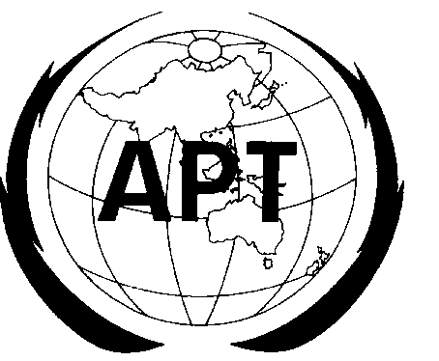 | ASIA-PACIFIC TELECOMMUNITY
 | The APT Wireless Group
Source: AWG-13/OUT-01

APT REPORT ON TELECOMMUNICATION BROADCASTING CONVERGENCE

- Background
After organization restructuring and rebranding AWF to AWG (doc.AWF-9/OUT-03), the scope of work of Convergence Working Group that related to study on telecommunication broadcasting convergence was handled in the Task Group of Radiocommunication Convergence (TG RC) within the Working Group Service and Applications (WG S&A). The ToR of TG RC is the as following:
  - To identify the wide range of current and future activities on the radiocommunication convergence technologies and also possible application scenarios including M2M;
  - To review survey on economic issues such as business model of convergence service; and
  - To review survey on regulatory issues to facilitate convergence service
Based on several input documents and presentations which were received and presented in the WG-SA, as well as some more other references, this document will illustrate the following aspects related to telecommunication broadcasting convergence:
  - Motivation of telecommunication broadcasting convergence
  - Standardization
  - Services
  - Technology
  - Regulatory issues
This document is also related to other documents which were developed by Convergence WG, i.e. Report on the Regulatory Aspect of Fixed Mobile Convergence (doc. AWF-7/OUT-07 and adopted as doc.APT/AWF/REP-09) and Report of the Standardization Progress of Fixed Mobile Convergence (doc. APT/AWF/REP-17).

- Motivation of Telecommunication Broadcasting Convergence

New broadcasting trends and technical aspects:
As identified by (doc.AWG-10/INP-28-rev1):The Internet “coverage” now reaches more consumers, than the coverage provided by the terrestrial broadcasting network in several countries, meaning that anyone with an Internet access can take part of Internet based media services. The significant increase of the Internet penetration is probably the single largest change in the media market in recent years. For broadcasting TV, content on new “Play-based” services are among the most popular programme contents on the Internet. Broadcasting TV content in the future is expected to fill an equally important role for consumers on the Internet anywhere and anytime as that on the linear reception on TV screens in living rooms.

In a converging world and thanks to the new “Play-based” services on Internet, also those consumers interested in culture, folklore, local traditions, music and sports no longer dependent on tableau programme schedules to watch the drama, theatre, concerts and events. The range of sport programmes have been developed by offerings of simulcasting of sports in the context of the major events and thus could be made available to everyone and everywhere in a simple and transparent manner. The newly available “Play-based” content is expected to further stimulate the demand for broadband access to include other and new groups of consumers, than the early adopters, creating opportunities for countries to accelerate fixed and mobile broadband deployments.

Broadcasting TV programmes such as news, society, community affairs and factual programming available and based on Internet can be used in schools, also for schools located in more remote areas, for educational purposes. For the societal information TV programmes, the Internet can make room for more interactive discussions and explanations. Although, some content such as news coverage program, which can easily be made available very quickly on the Internet, still requires editors with sizeable resources and trustworthy information, which broadcasters can provide.

In a changing media landscape fixed, mobile and broadcasting service providers will be offering services on the Internet as an integral part of their core businesses of broadcasting and telecommunications; accordingly.
The convergence between telecommunication and broadcasting has been accelerated by the development of ubiquitous network technologies, such as broadband, mobile communication, digital broadcasting and internet technologies, which produce Media Ubiquitous. The elimination of borders between Telecommunication and Broadcasting has been realized and triggered by the growth of technological innovation.

Besides, there are some other motivations of telecommunication broadcasting convergence. As identified by (doc.AWF-8/INP-65), there are two factors involved, i.e. improving user experience and enhancing service efficiency. These can be achieved because of media ubiquitous (lots of accessibility/connectivity, various terminals/devices, many suppliers and many service choices). The convergence of terminals, shows that variety of ubiquitous terminals such as home appliance themselves are used for both communication and broadcasting like Telephone, TV and PC. Another point is raised by (doc.AWF-7/INP-54), where network simplification by minimizing the number of infrastructures, network nodes and service nodes is also important in the telecommunication broadcasting convergence. This means that both telecommunication and broadcasting services can use the same network infrastructure.

It was also pointed out that a unified network approach can be more efficient, both technologically and economically. Technological aspects include higher spatial reuse factor of frequencies, lower infrastructure costs in sparsely populated rural area ^{[16]}.
Economic efficiency is increased on the one hand by the possibility of eliminating redundant broadcasting infrastructure and by increasing social welfare from higher capacities available.
Another view ^{[17]} identified that drivers for convergence can be categorized into four areas: technological evolution, business and market concerns, users’ demand, and regulatory policies. From the technology point of view, digitization of all types of signals facilitates duplication, transmission, and manipulation of any type of information and hence makes convergence possible. As business concerns, faced with market saturation and the prospect of stagnation, the telecomm industry is now seeking new opportunities through convergence. Users’ needs related to mobility, portability, and high speed also contribute to the progress of convergence. In Internet Protocol TV (IPTV) various data services based on interactive two-way communication are available, which allows, for instance, users to watch films while searching for information in the background or executing other tasks such as home shopping. The convergence between telecommunications and broadcasting is heavily dependent on regulatory arrangements, especially on the degree to which broadcasting and telecoms are regulated by a single body.

IPTV and its variant are the examples of the telecommunication broadcasting convergence. Some definitions of these services are as follows ^{[11]}:
  - IPTV is defined as multimedia services such as television /video/ audio/ text/ graphics/data delivered over IP based networks managed to provide the required level of QoS/QoE, security, interactivity and reliability.
  - IPTV 2.0 is the Next Generation IPTV defined as multimedia services delivered over IP based wire & wireless converged networks managed to provide the required level of QoS/QoE, security, interactivity, reliability and openness, and for any contents to be optimally consumed and generated by users at anywhere, anytime, with any devices.
  - Mobile IPTV is a technology that enables users to transmit and receive multimedia traffic including television signal/video/audio/text/graphic services through IP-based the wired and wireless networks with support for QoS/QoE, security, mobility, and interactive functions. Through Mobile IPTV, users can enjoy IPTV services anywhere and even while on the move.

Besides IPTV, Internet TV or OTT (Over the Top) TV should also be taken into account. IPTV has matured (in the few countries where it has been able to grow) into another form of pay TV, and involves the delivery of high quality video content to a captive consumer device over a managed network. On the other hand, Internet TV (or Over-the-Top TV), defined as the distribution of video content to a wide range of IP-enabled devices (TVs, PCs, mobile phones and tablets) over the unmanaged Internet, has the potential to shift the existing balance of power within the broadcast sector and the wider communications industry.

- Standardization
There are several standardization organizations involved, and some examples are identified in the following Table:

Table-1 Related Standardization Bodies
SDO | Wireline | Broadcast | Wireless | Cable
ITU-T | √ | √ | √ | √
ATIS | √ |  | √
Cablelabs/SCTE |  |  |  | √
CCSA | √ |  | √ | √
ETSI | √ | √ | √ | √
OIPF | √ | √ | √
DVB | √ | √ |  | √
HbbTV | √ | √
TTC/ARIB | √ | √ | √ | √
IPTVF Japan | √ | √
TTA | √ | √ | √ | √
IPTVF Korea | √
3GPP |  |  | √
The following section will provide a summary of the telecommunication-broadcasting related standards:
  - 3GPP/LTE (IMB)
In 3GPP Release 8 the Integrated Mobile Broadcast (IMB) service has been standardised.
  - 3GPP/LTE (eMBMS)
In 3GPP Release 9, LTE was extended with broadcasting functionality, termed evolved Multimedia Broadcast Multicast Service (eMBMS) ^{[18]}. Unlike the 3G broadcast technology IMB, which is an overlay network using dedicated hardware, eMBMS uses the regular LTE shared channel. Consequently, eMBMS may be deployed without adding new hardware in the RAN.
  - ITU-T
ITU-T has been spearheading the standardization in IPTV for NGN since 2006. Responding to market demands, the Focus Group on IPTV concentrated on architecture, QoS, security, end-system and multimedia applications. After the first set of draft was published in 2007, `the focus group was substituted by IPTV-GSI (IPTV Global Standardization Initiative). IPTV-GSI is a coordinator of all ITU-T’s IPTV related activities, as its work is connecting six Study Groups (SGs 9, 11, 12, 13, 16, 17) together and covering end-to-end solutions including multimedia, QoE/QoS, network architecture, security, signalling protocols and secondary distribution.

- Services
- Current State of Telecommunication & Broadcasting Services
Telecommunication and broadcasting will be converged mainly in the service layer, so that there should be a business model which can take the advantage of the resource from both sides and protect the mutual interest. Home based TV services can provide diverse digital media services through broadband cable network using Internet protocol and present to the end user on TV. AS these services integrate different features from different networks, it is regarded as the most appropriate candidate for the merging business model.

Telecommunication services come away back from the implementation of telegraph networks, invention of telephone, implementation of switched network until the booming of internet as one of telecommunication media these days. Telecommunication services were engineered from voice communication services, data communication services and they would reach the multimedia era where all kind information (voice, video, data, text, picture, even applications) can be transferred inside the networks to fulfill not only the communication needs of users, but also their needs of transactions and even entertainment.

Telecommunication services were changing from just telephony services towards the ubiquitous services. Some factors ^{[19]} are driving those changes such as the emerging of advanced applications in terms of advanced telecommunication capabilities and spur developments of computing platforms and capabilities. Telecommunication services as offered by telecommunication operators (fixed and mobile) can be classified in general view as follows:
- Fixed Telephony Services, which are mainly delivered by Public Switched Telephone Network (PSTN) and its features (e.g. call waiting, call forwarding, call transfer, etc.). PSTN.
- Mobile Telephony Services, which are delivered by Public Land Mobile Network (PLMN) or mobile telephone network. The services include also text messaging services
- Broadband internet access services, which can be divided into fixed and mobile broadband internet access.
- Leased line services or Virtual Private Network (VPN) services, which are the services to connect corporate networks
- Interconnection services, which are the services offered to other licensed operators.
- Application and Content services, which deliver applications and contents to the end users.

On the other side, broadcasting services can be viewed as a service to distribute information from source to all audiences which usually done electronically. Broadcasting services distribute the information in an audio visual form to the receiving parties that can be a general public or a relatively large subset of thereof. Broadcasting services also considered as one form of electronic media services.

In recent years, television or TV broadcasting services are the common broadcasting services that can deliver multimedia contents to their audiences. TV broadcasting services can be classified as follows:
- Free to Air (FTA) TV service, which is the first and most common TV broadcasting service delivers TV content freely to all audiences. Usually this service utilizes analog terrestrial network.
- Cable TV (CATV) Service, which is the closed network TV broadcasting services, offers the TV content (free and premium) to the subscribed audiences only. The service utilizes coaxial cable network to connect its subscribers.
- Direct to the Home (DTH) service. IT offers similar service like cable TV by using satellite network.
- Mobile TV service. Such service enables TV content to be viewed by mobile subscribers. The service usually utilizes mobile communication networks.

In recent years, telecommunication, Internet and broadcasting services have been vertically integrated as businesses and facilities (denote hardware and software required to provide services). It was described ^{[20]}, the integration is depicted by a silo or stovepipe metaphor, as shown in Figure 1.

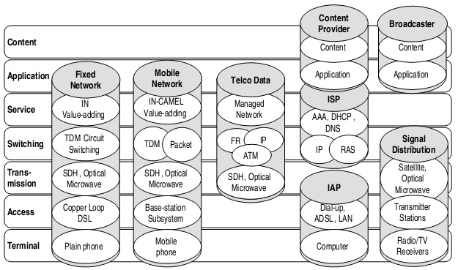

Figure-1 Vertically integrated traditional telecommunications and broadcasting businesses

Broadcasting service has been a one to many, one-way service, but it progressively becoming two-way utilizes telephone service and short message service to allow the audience to respond and react to programme material. Broadcasting service starts to gain its interactivity in this case. The use of digital broadcasting technology empowers this capability trough broadband network. ^{[20]}

- Telecommunication and Broadcasting Convergence Services
In the last decade, telecommunication, internet and broadcasting technologies were developed in a huge speed which shows new requirements for advanced services. In telecommunication services, some technologies push the services to the convergences, i.e. mobile communication technologies and all-IP based technologies.

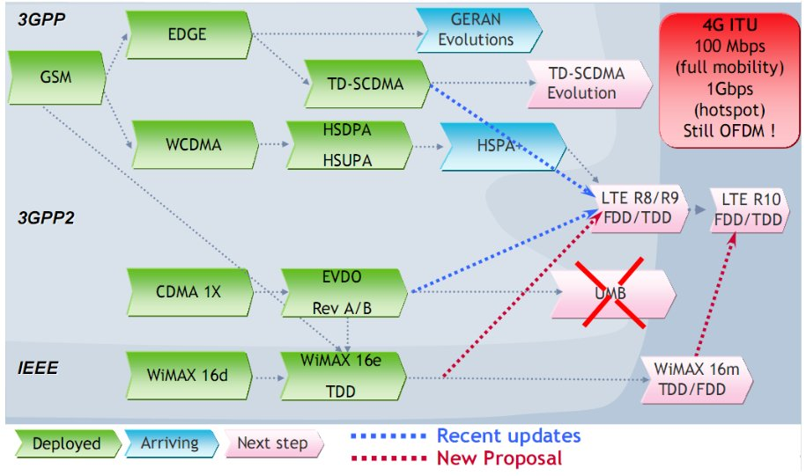

Figure-2 Mobile communication technologies evolution

All-IP technologies also drive the telephone services towards a new generation telephony services based on IP, known as Next Generation Networks (NGN) services, based on IP Multimedia Subsystem (IMS) architectures. This will enable the convergence in both fixed and mobile services which will support the implementation of Fixed Mobile Convergence (FMC).
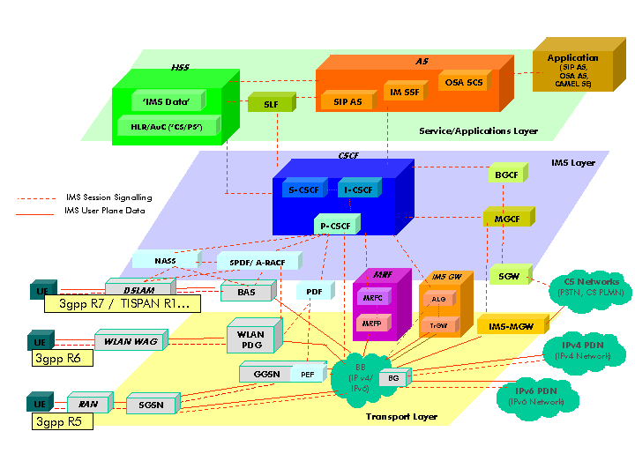

Figure-3 3GPP/TISPAN IMS architectural overview

On the Broadcasting side, many efforts in developing advanced technologies were targeted to achieve high efficiency in transmission resources. Digital transmission methods were introduced to deliver TV contents to audiences. Those technologies enable broadcasting services to use telecommunication facilities as their transmission media. New challenges arisen for broadcasting services, i.e. Quality of Services (QoS), Quality of Experience (QoE), interoperability, user mobility and network management. Technologies such as Digital Multimedia Broadcasting (DMB), Digital Audio Broadcasting (DAB/DAB+), Integrated Services Digital Broadcasting (ISDB), Digital Radio Mondiale (DRM), variants of Digital Video Broadcasting (DVB-x), Media Forward Link Only (MediaFLO), Multimedia Broadcast and Multicast Services (MBMS), Internet Protocol Television (IPTV) and internet based TV are known technologies that changes the broadcasting services.

As mentioned earlier, evolution happens in both telecommunication and broadcasting sides. Digitalization and IP based technology open the possibility of the convergence between telecommunication and broadcasting technologies, which lead to the deliverable of convergence services. Next generation broadcasting services can be obtained from anywhere, any time and by any means. Some telecommunication and broadcasting convergence services can be described as follow, i.e.:

- Mobile TV Service
Mobile TV service is a service that enables the use of mobile phone devices as TV receivers. It may be a paid TV service or free-to-air TV service. This service can be delivered using cellular network infrastructure, mobile broadcasting network or the combination of both networks. Technologies supporting this service can be divided into two categories, i.e. mobile cellular technologies and mobile broadcasting technologies.

Mobile TV service in cellular networks starts to establish along with the increasing capability of data transmission in the cellular networks. The implementation of 3GPP’s WCDMA technologies (HSDPA, HSUPA and HSPA) and the potential of 3GPP’s OFDMA based network (LTE and LTE Advanced) drive the launch of mobile TV service for mobile users. Multimedia Broadcast and Multicast Service (MBMS) was defined by 3GPP in UMTS Release 6, as the architecture to enable the efficient transmission of multimedia data through mobile network. MBMS keeps evolving along with the evolution of 3GPP’s physical layer towards LTE-Advance and is called e-MBMS (enhanced MBMS).

On the other side, the mobile TV using mobile broadcasting technologies are more competitive than the mobile TV based on cellular technologies, due to its nature focusing on delivering multimedia services to the users. This service uses one way dedicated broadcast network and has relatively small screen on its device, with mobile and low power consumption capability. Digital Video Broadcasting-Handheld (DVB-H) as extension of DVB-T technology is already approved by European Union as preferred technology for mobile terrestrial broadcasting services. Terrestrial Digital Multimedia Broadcasting (T-DMB) is a digital radio transmission system for sending multimedia (radio, TV, and data casting) to mobile devices such as mobile phones. It is an extension to the Digital Audio Broadcasting (DAB) standard and this technology was first developed in South Korea. This standard is adopted in South Korea and DMB trials are currently taking place in several European countries. To increase spectrum efficiency of the T-DMB, Advanced T-DMB (AT-DMB) system has been developed. The AT-DMB guarantees backward compatibility with the T-DMB using hierarchical modulation mechanism. Integrated Services Digital Broadcasting-Terrestrial (ISDB-T) is a satellite-to-tower system used in Japan to provide digital service to TV sets and handheld mobile units. China is also currently entering into the mobile broadcasting arena with its own mobile Television and multimedia industry standard known as the China Multimedia Mobile Broadcasting (CMMB).

- IPTV Services
IPTV is defined as multimedia services such as television/video/audio/text/graphics/data delivered over IP based networks managed to provide the required level of QoS/QoE, security, interactivity and reliability. It is clear that IPTV aims neither to enhance the viewing of TV channels in the audience side nor to increase the efficiency of delivering TV services on the provider side^{[21] [22]}. Two general objectives of IPTV are to provide personalized TV service and enable other services such as voice communication and internet access which act as triple play bundled services (voice, data and video). IPTV utilizes broadband IP connections and most of the implementation uses fixed broadband network (xDSL or optical network).

The IPTV infrastructure can be deployed either with centralized or distributed video server architectures. The centralized IPTV is simply the content delivery network used in today’s VOD service. However, the architecture is only good for relatively small network and requires adequate core and edge bandwidth. The distributed IPTV is ideal for large network deployment by using P2P method. It is a scalable architecture that has advantage in bandwidth usages, but it requires content distribution system for effective delivery over scattered network nodes. IPTV employs IP multicasting for the delivery of digital TV services. IP Multicast is a method in which information can be sent to multiple computers at the same time. The playback of IPTV requires either a personal computer or a set-top box connected to a TV. Video content is typically compressed using either a MPEG-2 or a MPEG-4 codec.

IPTV offers some benefits compared to traditional TV services such as personalization, interactivity and security for both subscribers and providers. Some features of IPTV are from ^{[22]}:
  - Multicast Video based on subscription, which allows the subscriber to watch as they desire any of the channels included in their subscription package.
  - A la Carte Channels, which is similar in concept to subscription, except that each viewer is allowed to select exactly the channels they want to view so he or she does not pay for the undesired channels. As described earlier, the subscriber receives a monthly bill from the service provider, but only for the specific channels that have been chosen. The service provider in turn uses the revenue to pay content providers.
  - Advertising, involves inserting advertisements from merchants that are targeted to local residents into network feeds before they are distributed to local viewers. The technology for doing this is well established—many national content providers include special indicators in their programming feeds that tell the local providers when to insert their local ads.
  - Video on Demand (VOD). The basic concept of VOD is based on video programming that is stored and then delivered to a viewer when it is requested. This storage can either take the form of a centralized server equipped to send programming simultaneously to hundreds of viewers or take the form of more distributed storage throughout the network. At the limit, individual storage devices for each viewer can be located inside STBs. There are some types of VOD shown in Table 2 below.

Table-2 Types of Video-on-Demand Service

No. | Type | Description
1 | True Video on Demand | This is the purest form of VOD, where each viewer receives an individual video stream that they have complete control over. Viewers are able to start, stop, pause, rewind, and fast-forward the content. Viewers typically pay a fee for each title viewed; the charges are either debited from a prepaid account or included on a monthly bill.
2 | Digital Video Recorders  (DVRs) | These devices take incoming video programming, compress it, and record it to a hard disk that is typically located either in an STB or a standalone device. Viewers then control the DVR to play back content, including pause, fast-forward, and rewind capabilities. Also called time-shifting, viewers normally program their DVRs to record specific programs at specific times.
3 | Subscription Video on Demand (SVOD) | Same delivery technology and viewer control as VOD with a different payment system. In SVOD, subscribers pay a fixed monthly fee for unlimited access to a library of titles.  In many systems, the library is updated monthly.
4 | Free Video on Demand (FVOD) | A variation on VOD where payment is eliminated. In most systems, this content is restricted to long-form advertisements, how-to guides, and other low-cost content.
5 | Everything on Demand (EOD) | For some technology visionaries, this is the ultimate form of video delivery system, where all programming is available to all viewers at all times.
6 | Near Video on Demand  (NVOD) | Similar to true VOD without the individual video stream control capabilities. One common form of NVOD is sometimes called stagger casting, in which multiple copies of a program are played starting at five-minute intervals, thereby limiting any individual viewer to no more than a five-minute wait before his or her program begins to play.
7 | Networked Digital Video Recorders (NDVRs) | Offers similar functionality to DVRs, but recording is performed inside the service provider’s network rather than in the viewer’s location. Some content owners contend that this technology is so similar in capability to true VOD that it needs to be licensed as such.
8 | Pay-per-View (PPV) | This precursor technology to VOD is used primarily to deliver live paid programming, such as concerts or sporting events. It is technically not VOD since the viewer has no control over the playback.

- Implementation Cases of Telecommunication & Broadcasting Convergence Services

- Mobile TV Service
In the area of terrestrial broadcast mobile TV, also, there are three broad streams of technologies that have evolved^{[26]}:
  - Mobile TV broadcasting using modified terrestrial broadcasting standards: DVB-T, which is widely being implemented for the digitalization of broadcast networks in Europe, Asia, and other parts of the world, can be used with certain modifications such as DVB for handhelds or DVB-H. This is a major standard based on which many commercial networks have started offering services. ISDB-T used in Japan is a similar case.
  - Mobile TV broadcasting using modified Digital Audio Broadcasting (DAB) standards: The DAB standards provide a robust medium of terrestrial broadcasting of multimedia signals including data, audio, and music and have been used in many parts of the world. These standards have been modified as DMB standards. The advantage is that the technologies have been well tested and spectrum has been allocated by the ITU for DAB services. The Terrestrial Digital Multimedia Broadcast (T-DMB) is such a broadcasting standard.
  - Terrestrial broadcasting using new technologies: In countries such as the United States, where ATSC is the digital TV transmission standard, there is no easy way for terrestrial broadcast mobile TV. Even the digital audio broadcasting services are in the 2.3 GHz band using proprietary technology or use standard FM band (IBOC) for digital radio services. Hence terrestrial transmission networks for mobile TV need to be developed from scratch. FLO is a new technology using CDMA as interface, which can be used for broadcasting and multicasting by adding capabilities to the CDMA networks.

An example of convergence implementation is FMBC (Fixed, Mobile and Broadcast Convergence) by KDDI Japan ^{[14]}, where customers can enjoy various services and contents anywhere and anytime without concern for using different devices.

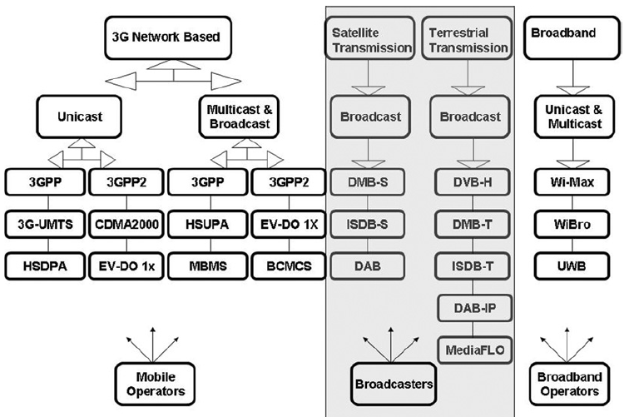

Figure-4 Mobile TV technologies

- DVB-H
Mobile TV using broadcast technologies is being operated in various countries using different bands for transmission and different technologies. For example, Modeo (formerly Crown Castle Media) has pioneered the DVB-H trials in the United States and has also launched a commercial service using 5-MHz capacity in the L-band. The trials were held in Pittsburgh, followed by the launch of the commercial service. It uses Windows Media technology as the basic technology for delivery of video and audio and its phones support the corresponding players. In contrast, DVB-H in Europe is offered using the UHF band and having the codecs as per DVB-H, i.e., H.264 and MPEG-4 visual simple profiles.

The American digital TV scene is dominated by the extensive use of the ATSC transmission system on which over 1200 stations are now active. The DVB-H standard, which relies on the basic DVB-T transport as a physical layer, can thus not be added onto the existing ATSC digital TV networks. However, the U.S. mobile TV offerings have been characterized by variations from some of the global standards for technologies such as DVB-H, for which the operator Modeo is adopting the Windows Media technology codecs instead of H.264 and Microsoft proprietary DRM as opposed to OMA DRM 2.0. At the same time, Qualcomm is offering its MediaFLO technology to CDMA operators. This implies that the market will have a mix of technologies in the foreseeable future. The DVB-H services of Modeo in the 1600 to 1675-MHz band will compete with the CDMA operators’ offerings of FLO technology (700MHz band) as well as the 3G networks (with HSDPA and 1xEV-DO).

The ETSI has adopted the DVB-H standard for Europe, which has also adopted the DVB-T standard for digital television, making the potential launch of services straightforward. Commercial DVB-H service has been launched by Italia and a number of trials have been concluded. Many of these commercial trials are now being developed as full-fledged DVB-H service. After the Broadcast Mobile Convergence (Bmco) trial in Germany, four telecom operators (T-Mobile, Vodafone, O2, and E-Plus) launched a DVB-H trial in June 2006 coinciding with the FIFA 2006, which would be developed into a full-fledged launch. Digita in Finland is also launching DVB-H service.

Italy has the distinction of having launched the world’s first commercial DVB-H network on the June 5, 2006. The service was launched using a new DVB-H network created by the company across Italy in the UHF band with coverage of 75% of the population (2000 towns and cities). The service was branded as Walk-TV. The initial launch comprised 9 channels, which are slated to grow to 40 by 2008. At the time of the launch the mobile TV service was offered at 3 euros per day or 29 euros per month. Alternatively packaged voice call (1 hour per day) and mobile TV were offered at 49 euros per month. The initial channels included RAI1, Canale 5, and Sky TG24. Italia is producing La3 Live, a channel specifically designed for mobile TV.
The Netherlands is one of the few European countries where analog TV transmissions were phased out by the end of 2006. DVB-T based terrestrial transmissions are being sent by KPN even though it is primarily a Telecom operator.
The major operators offering 3G services in The Netherlands are Vodafone, Orange, KPN, and T-Mobile. KPN introduced video telephony in October 2004 using its 3G UMTS network and Sony’s Z1010 phone. Mobile TV (i-mode) service is being offered by KPN using its 3G network. DVH-H trials were also carried out by KPN (along with Nokia, Nozema Services (a broadcasting company), and Digitenne as partners).

The broadcast-based mobile TV scene in the United Kingdom has been partly influenced by the availability of spectrum. Owing to the digitalization of the terrestrial broadcast network spectrum has not been available for the DVB-H services in the United Kingdom so far.

In India the digital terrestrial broadcasting service has not yet been opened up for private operators and the state-owned Doordarshan remains the sole terrestrial operator. All terrestrial transmissions are analog, with a few exceptions in the metro areas where DVB-T transmissions have commenced as free-to-air transmissions. Trials have been conducted for DVB-H services using the DVB-T platform in New Delhi and proved successful.

- T-DMB
T-DMB service was launched in Korea as a result of six operators being licensed by the government, each with approximately 1.54MHz of bandwidth. This enables 1.15 Mbps per carrier and can carry VCD quality (352x288 pixels) video at 30 fps (for the NTSC standard). The video is coded using the H.264 compression protocol. It also carries CD-quality audio (DAB MUSICAM). The terrestrial DMB standards also have provision for carriage of interactive data or presentations. More than seven broadcasters in Korea are taking part in this service, with sharing of transmitters and providing free-to-air services. AT-DMB is the extended system of guaranteeing backward compatibility with T-DMB, which increases channel capacity of T-DMB by applying hierarchical modulation mechanism. Basic parameters of AT-DMB such as channel bandwidth, number of carriers, symbol duration, guard interval duration, etc., are the same as those of T-DMB.

Commercial services using the DMB-T technology have been launched in Europe as well. Mobile operator Debitel has launched T-DMB services in Germany (Berlin, Cologne, Munich, Stuttgart, and Frankfurt) in cooperation with the broadcaster MFD. This service is expected to be expanded rapidly.

- ISDB-T
Integrated Services Digital Broadcasting, developed by Japan in 2006 as its digital terrestrial television standard, provides some modes that are suitable for broadcasting for handheld reception. Mobile TV service using ISDB-T in Japan uses 1 segment of the 13 in a 5.6-MHz channel. As part of its original digital television strategy, the government has allocated 1/13 of the digital television transmission network for mobile broadcasting to portable and handheld devices. The ISDB-T standard provides audio, video, and multimedia services for the terrestrial television network including mobile reception and HDTV. The bandwidth size in ISDB-T (one segment) is 433 kHz.

- DAB-IP
The DAB standard has seen another extension for providing mobile services through the DAB-IP standard. The DAB-IP standard is based on the use of an IP layer that carries all the data streams of audio, video, and IP. The content is delivered by IP multicast. The standard has flexibility in the use of the types of audio and video codec. For instance, these can be H.264 or Windows Media 9 for vide and AAC+ or BSAC.

Using this standard it is possible to provide mobile TV service with 1.5MHz spectrum slots available for DAB. Virgin Mobile of the United Kingdom is the first mobile operator to sign up with BT Movio to offer services based on the DAB-IP standard. DAB-IP is important owing to the spectrum-related issues that are preventing the rollout of services based on DVB-H.

- IPTV Service
The number of global IPTV subscribers was expected to grow from 28 million in 2009 to 83 million in 2013. Europe and Asia are the leading territories in terms of the over-all number of subscribers. But in terms of service revenues, Europe and North America generate a larger share of global revenue, due to very low average revenue per user (ARPU) in China and India, the fastest growing (and ultimately, the biggest markets) is Asia. The global IPTV market revenues are forecast to grow from US$12 billion in 2009 to US$38 billion in 2013. While all major western countries and most developed economies have IPTV deployments, the world's leading markets for IPTV were Germany (by Deutsche Telekom), France (led by Free, then Orange, then Neuf Cegetel (now SFR); total of over 4 million subscriptions), South Korea (5 million subscriptions as of May 2012), United States (by AT&T), Hong Kong, Japan, Italy, Spain, Belgium, Luxembourg, Austria, China, Singapore, Taiwan, Switzerland and Portugal (with meo, Optimus Clix and Vodafone Casa).

Services also launched in Bosnia and Herzegovina, Pakistan, Canada, Croatia, Lithuania, Republic of Moldova, Macedonia, Montenegro, Poland, Mongolia, Romania, Serbia, Slovenia, the Netherlands, Georgia, Greece, Denmark, Finland, Estonia, Czech Republic, Slovakia, Hungary, Norway, Sweden, Iceland, Lithuania, Turkey, Colombia and Chile. The United Kingdom launched IPTV early and after a slow initial growth, in February 2009 BT announced that it had reached 398,000 subscribers to its BT Vision service. Claro has launched his own IPTV service called "Claro TV". This service is available in several countries in which they operate, such as Dominican Republic, El Salvador, Guatemala, Honduras, Nicaragua. IPTV is just beginning to grow in Central and Eastern Europe and Latin America, and now it is growing in South Asian countries such as Sri Lanka, Pakistan and especially India, but significant plans exist in countries such as Russia. Kazakhstan introduced its own IPTV services by the national provider Kazakhtelecom JSC and content integrator Alacast under the "iD TV" brand in two major cities Astana and Almaty in 2009 and is about to go nationwide starting 2010. Australian ISP iiNet launched Australia's first IPTV with fetchtv.

The first IPTV service to launch on the Chinese mainland sells under the "BesTV" brand and is currently available in the cities of Shanghai and Harbin. In India, IPTV was launched by Airtel and the government service provider MTNL and BSNL and is available in most of the major cities of the country. Meanwhile, UF Group which is the franchise owner for UFO movies in Southern India plans to offer multiple hosts of services such as customer's movies on demand, shopping online, video conferencing, media player, e-learning on their single IPTV set top box branded as Emagine. In Pakistan, IPTV was launched by PTCL, under brand name Smart TV, which is available in most of the major cities of Pakistan.

In Malaysia, a few operators have been granted licences to provide IPTV service. Some of the licensees have rolled out and have offered commercial IPTV service where else the others have yet to embark on the roll out of IPTV service. Malaysian Communications and Multimedia Commission (MCMC) as the regulatory body is closely monitoring the progress on the rollout of the IPTV service of each license.

In Turkey, TTNET launched IPTV service under the name IPtivibu in 2010. It was available in pilot areas in the cities of Istanbul, İzmir and Ankara. As of 2011, IPTV service is launched as a large-scale commercial service and widely available across the country under the trademark "Tivibu EV". Superonline plans to provide IPTV under the different name "WebTV" in 2011. Türk Telekom started building the fiber optic substructure for IPTV in late 2007.

Another example of implementation was addressed^{[12]}, where Korea Telecom (KT) by 2010 already launched a more "open" version of its IPTV service 'Qook TV' which adds that it plans to provide a platform for content developers to create and market their products over its broadcast network. KT hopes that establishing a stronger developer network for television content available on the service will help it to cement its IPTV leadership and create new revenue models. Therefore KT will be focus on openness for the project, allowing any company or content developer to sell their programmes on Qook TV. Korea had more than 2.2 million subscribers for its IPTV service by the 2010.2Q, which the first 1M achieved in 9 months, and the second 1 million achieved in 6 months.

- Internet TV Service

Internet television (otherwise known as Internet TV, or Online TV) is the digital distribution of television content via the Internet. It should not be confused with Web television - short programs or videos created by a wide variety of companies and individuals, or Internet protocol television (IPTV) - an emerging internet technology standard for use by television broadcasters. Some Internet television is known as catch-up TV. Internet Television is a general term that covers the delivery of television shows and other video content over the internet by video streaming technology, typically by major traditional television broadcasters. It does not describe a technology used to deliver content (see Internet protocol television). Internet television has become very popular through services such as RTÉ Player in Ireland; BBC iPlayer, 4oD, ITV Player (also STV Player and UTV Player) and Demand Five in the United Kingdom; Hulu in the United States; Nederland 24 in the Netherlands; ABC iview and Australia Live TV in Australia; Tivibu in Turkey.

- Hybrid Broadcast Broadband TV (HbbTV)

HbbTV (Hybrid Broadcast Broadband TV) is a new industry standard providing an open and business neutral technology platform that seamlessly combines TV services delivered via broadcast with services delivered via broadband and also enables access to Internet only services for consumers using connected TVs and set-top boxes.

The founding members of the HbbTV consortium together with a large group of supporters jointly developed the HbbTV specification to create a global standard for hybrid entertainment services. Version 1.1.1 of this specification had been approved by ETSI as ETSI TS 102 796 in June 2010. Latest release of HbbTV specification was version 1.5 on 4 April 2012.

Some defined services of HbbTV are Electronic Program Guide with program preview and access to catch-up TV, start screen with interactive service elements, Individual news application, visual radio application, catch up TV service, variant of a videotext application with embedded graphics and video, and advanced teletext service.

Some European countries already launch these services as pilot projects. Latest launch is done by Danish national broadcaster “DR”. It launched a pilot project of convergence services based on HbbTV with Danish company Nordija on March 2012.
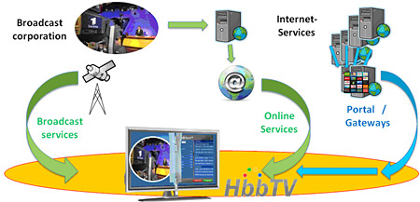

Figure-5 HbbTV illustration (www.hbbtv.com)

- Roadmap of Telecommunication & Broadcasting Convergence Services
In building the roadmap for convergence services between telecommunication and broadcasting, we can consider some trends from service perspective ^{[21] [22] [25]} i.e.:
- Everything on Demand - this is a trend which transforms the broadcasting TV service as a when-you-want-it experience service. All TV content will be made on demand and there should also have general business model as paid services or free with advertisement services. Demographically targeted advertising is also the future. Custom advertising will exercise by its sights on fragmenting age, culture, economic, and geographic subgroups and on viewing constituencies.

- Mobile IPTV - this trend was driven by the rise of smart mobile devices and their broadband capability. Mobile IPTV is a technology that enables users to transmit and receive multimedia traffic including television signal, video, audio, text and graphic services through IP-based the wired and wireless networks with support for Quality of Service/QoE, security, mobility, and interactive functions. Through Mobile IPTV, users can enjoy IPTV services anywhere and even while on the move.

- Interactive and Personalized TV - the convergence of digital TV has made it possible to incorporate feedback into the traditionally one-way form of TV communication by combining video, audio, and data within the same signal, epitomizing the TV world. In a nutshell, interactive TV brings a range of new multimedia services that enables users to browse information on topics of interest, play interactive games, conduct e-commerce related activities Personalized Television would become a very common trend in the near future. Personalization would spread beyond interactive Television features and services to include TV programs too. Television has been designed to accommodate single user interaction and selection of services. However in most households several users actually interact with their TV sets and set-top boxes and each one of them has a different set of preferences in terms of programs and services.

- Television Commerce (T-Commerce) - the T-commerce can be explained as an abbreviation of “Television Commerce,” or “E-commerce on TV.” As it can be known from the term, it means TV-based commerce, and especially online commerce occurring on digital TVs basically equipped with a two-way communication function. T-commerce is defined as terminal system incorporating the Internet, TVs, and input devices such as remote controllers, wireless keyboard and mouse, and so on, which make services and products easy to use at home. Because it is utilized by a familiar device, a remote controller, even groups who are not familiar with the Internet or computers can easily participate in commerce process. Unlike home-shopping, it can build VOD databases, and employ a way for consumers to search and to order a product, thus have an ability to indefinitely expand the number of sales items. Also, a search function is able to absorb users who have a reasoned purchase tendency without impulse buying. In the IPTV, the success of T-commerce is strategically critical. The reasons is that revenue creation by usage fees will have limitations because, by far, contents clearly differentiated from existing broadcasting are deficient, and due to the pre-IPTV strategy of operators, a stereotype free of charge service is widely spread.

- Technology

Along with the user demand, technology is the main driving force for the future development of telecommunications and broadcasting convergence trend, which includes three aspects: digitalized transmission content, IP based bearing networks, optical driven broadband on transmission bandwidth. It's not realistic to make the convergence happen in the physical layer under the current circumstances, while it will be quite possible to achieve the sharing and convergence of high level services for different networks through the interconnection and seamless coverage.

Figure-6 Key Factors of Radiocommunication Broadcasting Convergence

The key of digitalized transmission content is to transform any information (voice, data, image, video) into bit stream, so those information can be safely transmitted and exchanged. The transmission in the bearing networks is the interaction between point to point and point to multipoint, based on TCP/IP and independent IP address, enabling the service interoperation between different networks. The enabler for broadband in the networks is fibre-optic communication technology, which is the only solution to provide enough speed for access and transmission, and also to guarantee the quality of transmission signal.

- System
Based on the RATs, the wireless access technologies can be divided into 5 types:
- RAT1: Cellular Mobile (2G, 3G, E3G, 4G etc.)
- RAT2: WLAN/WMAN (WiFi, WiMAX etc.)
- RAT3: Broadcast (CMMB, DVB-H etc.)
- RAT4: Global coverage (Satellite, HAPS etc.)
- RAT5: Short Range Device (Zigbee, Bluetooth etc.)

Considering RAT1 RAT2 and RAT3 are the main technology to be considered for convergence, the specific convergence scenarios can be classified as in following chapter of implementation cases.

- Implementation cases

- Scenario 1:Inter RAT1
In China, some operators have done some convergence trials between CDMA and LTE, and studied the HetNet, i.e. the convergence between different types of base stations of LTE.

- CDMA+LTE
There are two types of handoff from E-UTRAN to CDMA, optimized handoff and non-optimized handoff.
- Optimized handoff/handover involves the movement of the UE from E-UTRAN to eHRPD or vice-versa using tunnelled signalling (i.e., S101 signalling) between the source access network and the target access network. While still on the source access network, the UE tunnels signalling to the target access network to pre-register through the source access network, i.e., to create both a radio and an IP context on the target system. After pre-registration, the UE performs a radio-level handoff/handover to the target technology per specified procedures. Optimized Handoff/Handover applies to both Active and Idle (dormant) UEs.

- Non-optimized handoff/handover involves the movement of the UE from E-UTRAN to eHRPD or vice-versa without the use of tunnelled signalling (i.e., S101 signalling) between the source access network and the target access network. The UE leaves the radio environment of the source access network and performs a radio-level attachment to the target access network (e.g., creates an eHRPD session for the case of the UE moving from E-UTRAN to eHRPD), and then performs a handover attach procedure to the Packet Data Network(s) it had been communicating with over the source access network. Non-optimized Handoff/Handover applies to both Active and Idle (Dormant) UEs.

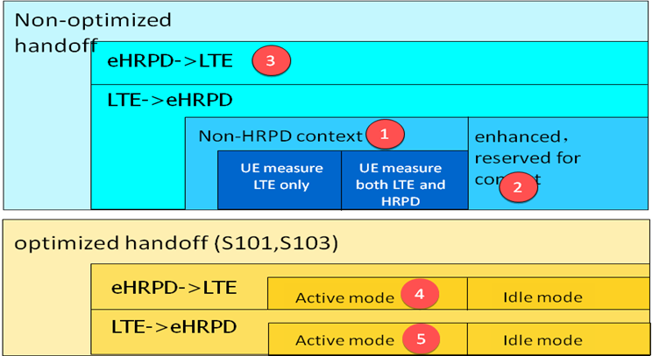

Figure-7 Category for handoff between E-UTRAN and eHRPD

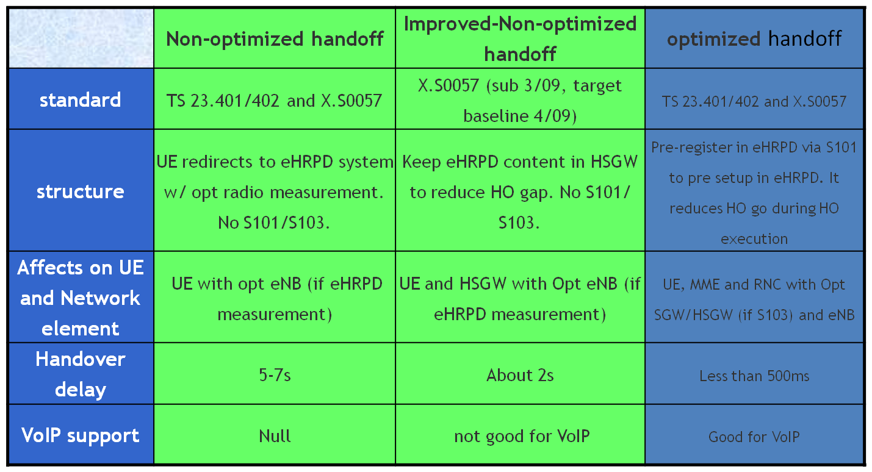

Figure-8 Comparison for handoff mechanism between E-UTRAN and eHRPD

- HetNet
The Major Challenges of HetNet can be summarized as CHASE:
- Clean：Interference
- Handover：Smooth Handover is required
- Administration：Unified Management Platform
- Security：No fraud
- Experience：Keep QoS consistency

With all the challenges of CHASE in the field of HetNet research，the future is still bright as depicted below:

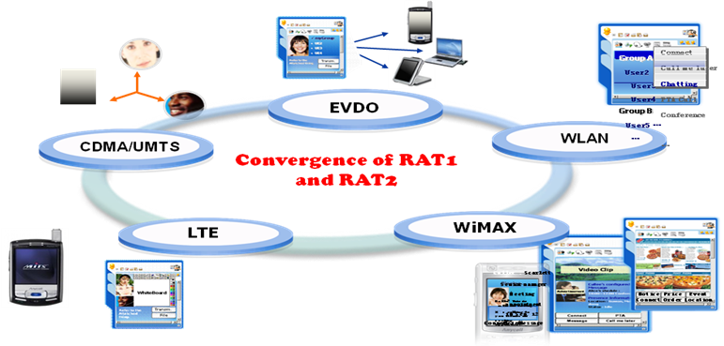

Figure-9 Future image of HetNet

- Scenario 2: RAT1 and RAT2
There are some convergence applications between CDMA and WiFi, the convergence between C+W+LTE was also studied.

- CDMA+WLAN
There are two cases studied in C+W research filed as follows：

Case Study1: Increase capacity by sector split
- Challenge:
  - Both traffic and signaling are driven up by various services from students;
  - Radio resources are precious and limited and couldn’t extend anymore;
  - Difficulties in site acquisition as well.

- Advantage:
  - Combined split antenna occupy less platform;
  - No need to add new BS site;
  - Split antenna can accomplish better coverage and increase capacity more effectively.

- Value
  - Boost Capacity of 1X and DO
  - Congestion can be mitigated;
  - Soft handover is more likely to happen.

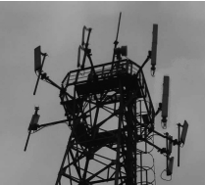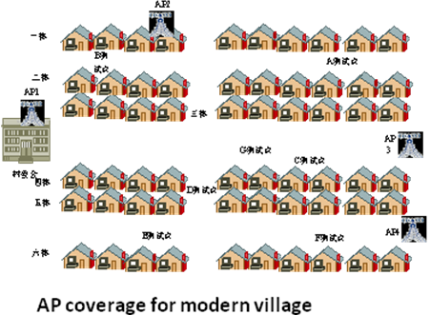
Figure-10 Two scenarios studied in C+W

Case Study2: WiFi in modern village
- Challenge:
  - Setup internet connection
  - Resolve the coverage issue for the country
  - Balance the cost by using an appropriate solution.

- Advantage:
  - Less cells around the modern village needed for coverage
  - Good network and resource design based on building location, and user number to fulfill DL 1Mbps outdoor and 250kbps indoor.(Beyond 100kbps anticipation)
  - Closer to AP switch and fiber as a backhaul solution for the village.

- Value
  - Internet connection available now.
  - Offered wideband access.
  - Save investment.
Moving Forward: C+W+LTE

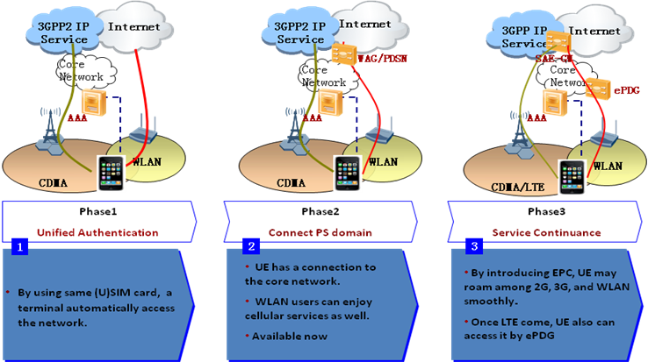

Figure-11 Future image of C+W+LTE

- DPI analysis
DPI analysis can be used to address the unbalanced growth of signalling and user traffic of different services.

Figure-12 DPI analysis architecture

What can be done if DPI information can be transferred back from PDSN to RAN side：
Wireless strategy can be made with service and traffic if DPI information can be obtained in BSC side

- Scenario 3: RAT1 and RAT3
In 3GPP, the standard of MBMS and eMBMS also realize the function of Mobile TV.

There are several possible options to realize convergence.

- Option 1 (high power nodes + low power nodes + interworking)
  - A few high power transmitters carry CMMB/T-DMB/ISDB-T on carrier 1, and low power transmitters cover blind spots and weak spots on carrier 2 by mixed-carrier-MBMS
  - Broadcast service continuity (dashed) is guaranteed by Interworking between CMMB/ T-DMB /ISDB-T and MBMS/eMBMS
  - There are simply two channels in terminals side.
  - Characteristics: two core networks and two RATs for broadcast

- Option 2 (convergence of unicast and broadcast in on RAT)
  - No high power transmitters
  - Use low power cells to carry both unicast and broadcast by carrier aggregation;
  - Broadcast can be carried on dedicated carriers by CMMB/ T-DMB/ISDB-T
  - Characteristics: one core networks and one RAT for broadcast

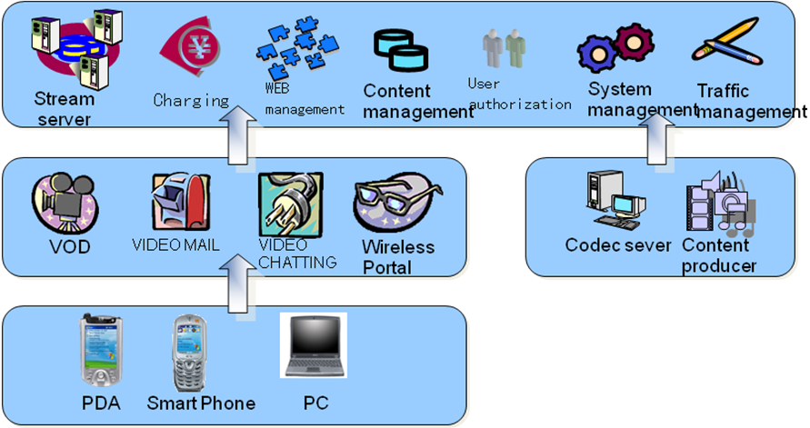

Figure-13 Example solution of carrier-grade multimedia service support system

- Scenario 4: RAT1 and RAT4
Cellular mobile and satellite systems convergence could achieve communication in anywhere by means of the followings:
- Cellular could realize coverage enhancement by using satellite backhaul, which would be especially useful in rural area, where the traditional cable/fiber may not be available. This implementation solution is already being used in many operator networks

- In some private network, satellite module is also mounted in mobile phone for special/emergency communication.

In this scenario, terminals could be multi-mode or not based on convergence method, while RAN should be independent. CN and SDP could be same or different.

- Scenario 5: RAT1 and RAT5 converged terminal in mobile applications
Converge of short-range network and cellular network could benefit the users. Different networks would serve different user communication requirements, e.g., using short-range network to share file/movie with friends nearby while using cellular network to access various Internet services. Multi-mode mobile phone with SRD module is necessary for this scenario, such as CDMA2000 + GSM + BT, WCDMA + GSM + BT terminal, while this converged scenario is sharing a single RAN, CN and SDP.

- Regulatory Issues

Different country has different way for the development of broadcasting and telecommunication industries. In some countries, broadcaster emphasizes on audio and video program production, content regulatory and TV channel management, while telecom operators have the advantage of network infrastructure. It is crucial important to rationalize the related policies, and to formulate the rules and regulations, so as to make the merging environment mutual benefit.

The convergence of telecommunication and broadcasting also impacts the regulatory aspects. An example of this case, which is the Comprehensive Legal System
for Communications and Broadcasting in Japan, was discussed by (doc.AWF-6/INP-54). At the time when this input document was presented, the new legal framework was reviewed, as shown in the following Figure.

Figure-14 Reviews for new legal framework

Some general issues regarding legal framework was identified^{[15]}, i.e.:
- Consider generalization of disciplines as much as possible
  - Disappearing rational grounds for differentiating networks for each individual service

- Examine how to secure standardized competitive conditions, and user protection by applying the same discipline to the same services.

- Change to a rational legal framework with an overall design based on the three categories: contents services, transmission services and transmission facilities.
- Pursue the goals of
  - promoting free distribution of information
  - promoting flexible business management
  - securing safety and reliability of information communications
  - protecting general public and individual users.

- Conclusion

The end user enjoys the benefit in the trend of radiocommunication broadcasting convergence, by receiving the interactive, rich content service in a reasonable price. In this sense, industries stakeholders from telecommunication and broadcasting are cooperating together in network infrastructure evolution and service delivery, standard bodies are facilitating the maturity of the convergence eco-system. It is expected that this report can help to understand the current situation for this emerging convergence industry.

References:

[1] AWG-13/INP-92, “Working Document towards Preliminary Draft New Report of Telecommunication Broadcasting Convergence”, Mr. SooHak Kim , the Republic of Korea
[2] AWG-12/INP-15, “Proposed Additional Text to the Working Document towards Preliminary Draft New Report of Telecommunication Broadcasting Convergence”, Mr. F.X. Ari Wibowo, DR. Andri Qiantori , PT Telekomunikasi Indonesia
[3] AWG-12/INP-53, “Proposed Modifications to the Working Document Towards Preliminary Draft New Report of Telecommunication Broadcasting Convergence”, Mr. Li Jianyu, China Unicom
[4] AWG-12/INP-54, “Proposed Modifications to the Working Document Towards Preliminary Draft New Report of Telecommunication Broadcasting Convergence”, Mr. Yue Tianheng, ZTE Corporation
[5] AWG-12/INP-55, “Proposed Technology and Implementation Cases to the Working Document Towards Preliminary Draft New Report of Telecommunication Broadcasting Convergence”, Mr. Songpu and Dr. Zhenqiang Sun, China Telecom
[6] AWG-11/INP-63, “Proposals on the Working Document towards Preliminary Draft New Report of Telecommunication Broadcasting Convergence”, Ms. Dong Zhao, China Telecom
[7] AWG-11/INP-74, “Text proposal for the Report of Telecommunication Broadcasting Convergence”, Ms. Boya Lu, Huawei Technologies, China
[8] AWG-11/INP-94, “Proposed Additional Text to the Working Document towards Preliminary Draft New Report of Telecommunication Broadcasting Convergence”, Dr. Wiseto Agung, PT Telekomunikasi Indonesia
[9] AWG-10/INP-26, “Some Application Scenarios in Radiocommunication Convergence”, Dr. Zhenqiang Sun, China(People's Republic of)
[10] AWG-10/INP-28-rev1, “Proposed Modifications to the Working Document towards Preliminary Draft New Report of Telecommunication Broadcasting Convergence”, Mr.Lasse Wieweg, Ericsson Australia
[11] AWF-9/INP-41, “Mobile IPTV Development Trends in Korea”, Young il Kim, Won Ryu (ETRI)
[12] AWF-9/INP-42, “Convergence Business in Korea”, Minzheong Song (KT)
[13] AWF-8/INP-65, “Approach Of Fujitsu On Evolution Of Combined Telecommunication And Broadcasting Technologies”, Hisayuki Sekine (Fujitsu)
[14] AWF-7/INP-54, “Operator View on Convergence”, Yoshio Takeuchi (KDDI Labs.)
[15] AWF-6/INP-54, “Discussion Agenda On Comprehensive Legal System For Communications And Broadcasting In Japan”, Yoshiyuki Kato (MIC, Japan)
[16] Jondral et al, “Convergence of Mobile Communications and Broadcasting: A long term perspective”, Friedrich K. Jondral, Dennis Burgkhardt, Jens Elsner, http://www.wip.tu-berlin.de/typo3/fileadmin/documents/infraday/2009/papers/16b_grove_paper.pdf
[17] Seongcheol Kim et al, “Research in Convergence: A Literature Analysis”, Journal of Research and Practice in Information Technology, Vol. 42, No. 3, August 2010, Seongcheol Kim, Heejin Lee, Myeong Ho Lee
[18] Bøhagen & Binningsbø, “HSPA and LTE – Future-proof Mobile Broadband Solutions”, Telenor ASA 2010, Frode Bøhagen, Jørgen Binningsbø
[19] Goleniewski2002, “Telecommunications Essentials”, Addison-Wesley Professional, 2002, Lillian Goleniewski
[20] Hanrahan2007, “Network Convergence”: services, applications, transport, and operations support, John Wiley & Sons Ltd, 2007, Hu Hanrahan
[21] Tsekleves et al, “Converged Digital TV Services: The Role of Middleware and Future Directions of Interactive Television”, International Journal of Digital Multimedia Broadcasting, Hindawi Publishing Corporation, Volume 2009, Emmanuel Tsekleves, John Cosmas, Amar Aggoun, and Jonathan Loo
[22] Simpson-Greenfield, “IPTV and Internet Video: Expanding the Reach of Television Broadcasting, 2nd edition, Focal Press, 2009, Wes Simpson, Howard Greenfield
[23] DVBTFS082011, DVB-T Facts Sheet, August 2011
[24] DVBT2FS022012, DVB-T2 Facts Sheet, February 2012
[25] KimKo2011, “Investigating User Adoption of T-commerce”, 2011 First ACIS/JNU International Conference on Computers, Networks, Systems, and Industrial Engineering Proceeding, Eunjin Kim, Seongpil Ko
[26] AmitabhKumar2007, Mobile TV: DVB-H, DMB, 3G Systems and Rich Media Applications, Focal Press Media Technology Professional - Elsevier, 2007
[27] IPTV Standardization at ITU-T, IDA and APT IPTV Standardization Forum, Singapore, February 2010
[28] Goleniewski2002, “Telecommunications Essentials”, Addison-Wesley Professional, 2002, Lillian Goleniewski
[29] Hanrahan2007, “Network Convergence”: services, applications, transport, and operations support, John Wiley & Sons Ltd, 2007, Hu Hanrahan
[30] Tsekleves et al, “Converged Digital TV Services: The Role of Middleware and Future Directions of Interactive Television”, International Journal of Digital Multimedia Broadcasting, Hindawi Publishing Corporation, Volume 2009, Emmanuel Tsekleves, John Cosmas, Amar Aggoun, and Jonathan Loo
[31] Simpson-Greenfield, “IPTV and Internet Video: Expanding the Reach of Television Broadcasting, 2nd edition, Focal Press, 2009, Wes Simpson, Howard Greenfield
[32] KimKo2011, “Investigating User Adoption of T-commerce”, 2011 First ACIS/JNU International Conference on Computers, Networks, Systems, and Industrial Engineering Proceeding, Eunjin Kim, Seongpil Ko
[33] AmitabhKumar2007, Mobile TV: DVB-H, DMB, 3G Systems and Rich Media Applications, Focal Press Media Technology Professional - Elsevier, 2007

