APT REPORT

on

REGIONAL SPECTRUM REQUIREMENTS ESTIMATES
RELATED TO WRC-15 AGENDA ITEM 1.1

No. APT/AWG/REP-39
Edition: September 2013

Adopted by

The 15th APT Wireless Group Meeting
27 – 30 August 2013
Bangkok, Thailand
(Source: AWG15/OUT-11)

APT REPORT ON
REGIONAL SPECTRUM REQUIREMENTS ESTIMATES
RELATED TO WRC-15 AGENDA ITEM 1.1

1 Introduction
This Report considers estimation of spectrum bandwidth requirements for IMT and other terrestrial mobile broadband applications in Region 3 related to WRC-15 agenda item 1.1. Spectrum bandwidth requirements contributed from each country are summarized in the main body of this Report and their details are annexed to this Report.

2 Market Trend and Technology Development
In 2012, APT Wireless Group (AWG) developed the APT Report on “Survey of trend and forecast on mobile communications in APT countries,” which is based on the responses to the Questionnaire from some APT member countries (APT/AWG/REP-28). This APT Report gathers information that includes some facts and data on subscriptions, network deployment and traffic as well as forecast of mobile communications. According to this Report, market trend and technology development in APT countries are summarized as follows:
– “A continuous growth on the number of mobile subscriptions has been observed in the last several years.”
– “A continuous growth on the mobile data traffic has been observed in the last several years and this trend is expected to continue because of the increased penetration of various kinds of mobile devices and Internet-based mobile applications, evolution of mobile network, and so on.”
– “It is also expected that further evolution and innovation of mobile communications will provide more enhanced existing services (e.g., voice, streaming, social networking) and inspire various kinds of new services (e.g., for improved life quality, security and safety, education, etc.).”

2.1 IMT Development in China
IMT subscribers in China have maintained rapid growth and the increase in 3G users keeps steady. The total number of IMT subscribers in China reached 1.18 billion by the end of 2013Q2. Through four and a half years development, 3G industry in China has come into a benign stage and 3G market is accelerating. By Q2 2013, the total number of 3G Subscribers was over 318 million with penetration rate of over 27%.
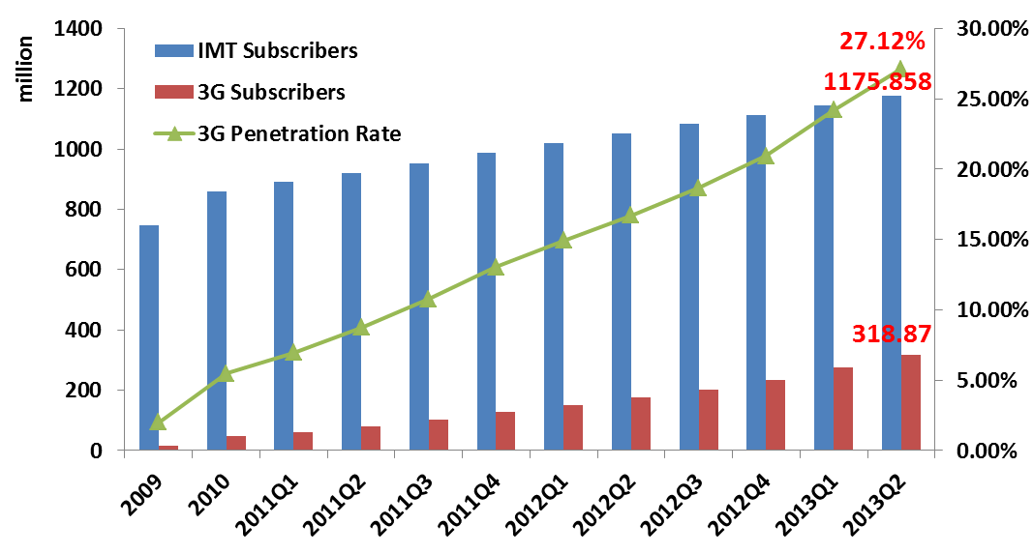
Figure 1
Mobile Subscriptions Growth in China (Source: MIIT of China)
Mobile internet has become the most popular service among IMT users. By the end of 2013Q2, nearly 70% of IMT subscribers in China uses mobile internet, i.e., about 800 million mobile internet subscribers.
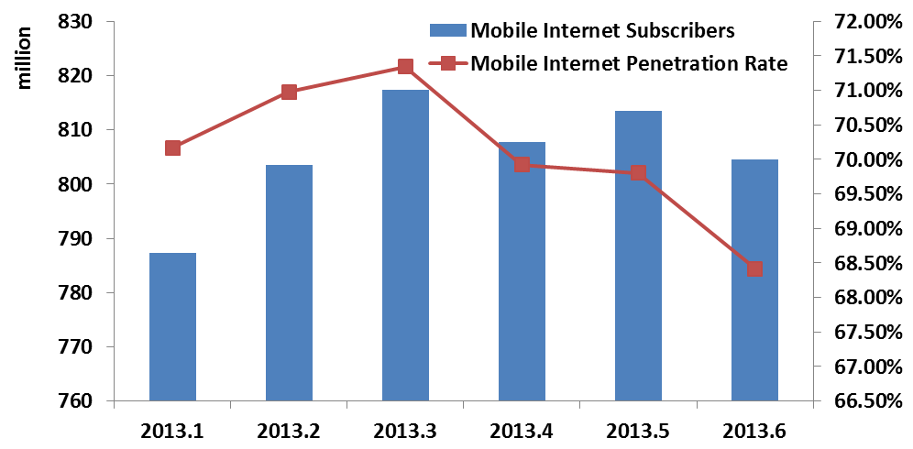
Figure 2
Mobile Internet Subscribers (Source: MIIT of China)
According to the statistical data in the first half of 2013, the total mobile internet traffic currently in China is nearly 100 PB per month, and one mobile internet subscriber consumes nearly 120MB data traffic per month.
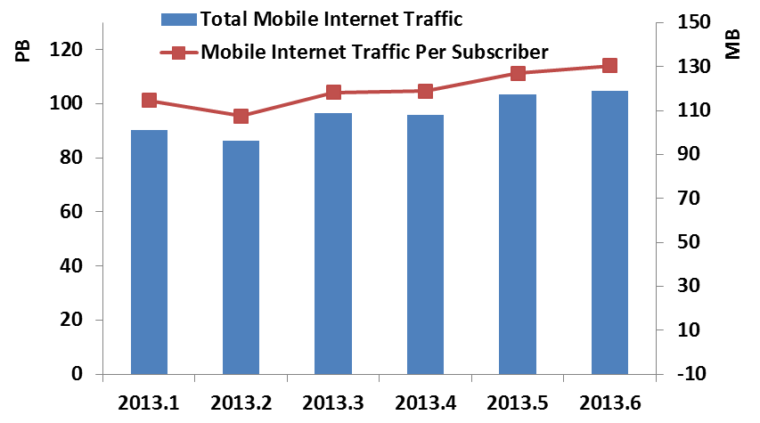
Figure 3
Mobile Internet Traffic (Source: MIIT of China)
On July 18 2012, Ministry of Industry and Information Technology (MIIT) of China officially approved the deployment plan of TD-LTE expanded trial in china. The number of cities and network scale are much larger compared with the TD-LTE large-scale trial that finished during May 2012. At this phase, the trial will focus on the pre-commercial deployment, network operation and friendly user test.
China is currently preparing for the commercial deployment of LTE networks.

3 Methodology Overview

3.1 Methodology 1 – Recommendation ITU-R M.1768-1
Recommendation ITU-R M.1768 was firstly released in 2006. Based on detailed service/traffic/environment categories, the methodology in M.1768 estimates the future traffic per cell within different scenarios, and then takes the number of networks, network performance, spectrum efficiencies and other practical deployment factors into consideration to calculate the total spectrum requirement.
In April 2013, this Recommendation was updated to M.1768-1, which includes the following two changes in the methodology itself and several editorial updates:
– Introduction of the granularity concept of spectrum deployment per operator per radio environment for improved increments.
– Due to the enhancement of network deployment in IMT-Advanced, the spectrum sharing approach between different radio environments in IMT-Advanced (RATG 2) is changed to allow macro cells and micro cells to use the same frequencies. This change may impact the spectrum efficiencies which have to be taken into account in the input parameter values.
The generic flow of M.1768-1 methodology is given below. More detailed descriptions of the methodology could be found in (1).

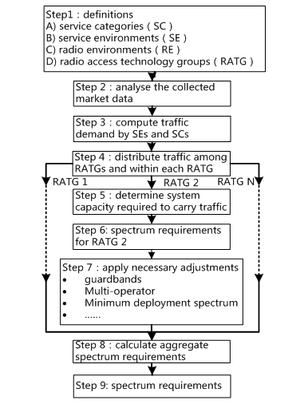
Figure 4
Flow chart of Recommendation ITU-R M.1768-1 Methodology
At the 16th meeting of WP 5D, work commenced on updating the user guide for the IMT spectrum requirements estimation tool using the methodology described in Recommendation ITU-R M.1768-1. A section of the User Guide outlines the sensitivities related to the application of the methodology in regards to the input parameters and the methodology itself. It is recognised in the User Guide that that methodology is general in nature and that the chosen values for a number of the input parameters are interdependent. Therefore, the output spectrum requirements are sensitive to the resultant changes to these parameters. Furthermore, it should be noted that there are a range of other factors that can have an impact on spectrum requirements. The tool should be employed with this in mind.
The following studies utilize the methodology in M.1768-1 to estimate the future spectrum requirements for IMT:
- Spectrum requirements for IMT related to WRC-15 agenda item 1.1 by ITU-R WP 5D
- China, People’s Republic of
- Spectrum requirements for IMT related to WRC-15 agenda item 1.1 by ITU-R WP 5D
At its 16th meeting, ITU-R WP 5D developed spectrum requirements for IMT in 2020 related to WRC-15 agenda item 1.1 and liaised to ITU-R Joint Task Group (JTG) 4-5-6-7. The following Table shows the calculated spectrum requirements by ITU-R WP 5D for both RATG 1 (i.e. pre-IMT, IMT-2000, and its enhancements) and RATG 2 (i.e. IMT-Advanced) in the year 2020. It should be noted that in the spectrum requirements calculation the deployments-related parameters of IMT, such as the cell area parameter, characterise a generalised situation for RATGs operating below 6 GHz based on the analysis in Report ITU-R M.2074.
TABLE 1
Total spectrum requirements in the year 2020 calculated by ITU-R WP 5D
 | Spectrum requirements |  | Total spectrum requirements
 | for RATG 1 | for RATG 2
Lower user density settings | 440 MHz | 900 MHz | 1 340 MHz
Higher user density settings | 540 MHz | 1 420 MHz | 1 960 MHz
However in real situation spectrum requirement can be lower or even higher than above calculated estimation results, since estimation can be different according to assumed parameters. Therefore, it is desirable for APT Members to estimate their specific demands for IMT spectrum taking into account their traffic and market trend, radio environment, user density, deployed technologies, etc.
The methodology was developed to estimate total spectrum requirements of IMT assuming respective user density, average traffic demand and mobility ratio corresponding to each different teledensity (i.e., Dense urban/Sub-urban/Rural) and radio environment (i.e., Macro/Micro/Pico/Hot Spot) of IMT networks characterized based on the analysis in Report ITU-R M.2074. Furthermore, this estimation is based on average traffic demand (user density, session arrival rate per user, average session duration, and mean service bit rate) and does not address peak traffic demand in a specific area or at a specific time when a number of users access simultaneously.
- China Spectrum Requirement Estimation by ITU-R M.1768-1
The IMT spectrum requirement of China is estimated by the methodology in Recommendation ITU-R M.1768-1 with some modifications.
According to the latest IMT market trends and market characteristics of China, some parameters are modified and adjusted including cell area, mobility ratio, population coverage percentage and market input parameters.
Detailed descriptions and parameter values are given in Attachment 1 to Annex.

3.2 Methodology 2 – Parametric (Australia)
Firstly, a baseline for the spectrum demand was determined. This is the point in time where it is assumed that the demand for spectrum for IMT was met. The amount of spectrum available, the average spectral efficiency and data demand were determined for this point in time. Additionally, the actual and projected data demand from the baseline year out to the year 2020 was determined, along with the predicted spectral efficiency for future years.
The data demand was normalized to 1 in the baseline year. For subsequent years, the data demand figure was divided by that of the baseline year to determine the percentage increase in data with reference to the baseline year.
The spectral efficiency was normalized to 1 in the baseline year. For subsequent years, the spectral efficiency figure was divided by that of the baseline year to determine the percentage increase in spectral efficiency with reference to the baseline year. Where figures are not available for each individual year, a linear increase in efficiency was assumed.
A spectrum reuse/infrastructure deployment factor was also determined and normalized to 1 in the baseline year. This figure represents the increasing use of additional infrastructure and use of increasingly smaller cells. Where figures are not available for each individual year, a linear increase in spectrum reuse/infrastructure deployment was assumed.
By applying the spectral efficiency and spectrum reuse/infrastructure deployment factor to the normalized data demand, a figure representing the percentage of spectrum required for each subsequent year, with reference to the baseline year, was determined.
The application of this methodology to the Australian case is shown in Attachment 2 to Annex.

3.3 Methodology 3 (Japan)
In Japan, the “Action plan for spectrum reallocation to realize wireless broadband” was developed in November, 2010. This plan presented the following basic policies to secure spectrum towards the years 2015 and 2020, respectively:
– Secure additional spectrum exceeding 300 MHz bandwidth below 5 GHz frequency ranges for mobile communications systems and wireless sensor network systems by 2015;
– Secure additional spectrum exceeding 1 500 MHz (including the above mentioned 300 MHz) bandwidth for IMT-Advanced systems and for broadband deployment in airplanes, ships, trains, etc.
The MIC also annually updates the “Action Plan for spectrum reallocation” to describe specific actions for a smooth and steady follow up toward the reallocation of the radio spectrum, based on the evaluation results of the survey on actual radio spectrum use. This Action Plan also indicates several target frequency bands for use by mobile communications including IMT.
Based on the information on the current use of spectrum for mobile communications as well as the future spectrum allocation described in the Action Plan, the total spectrum requirements for mobile communications in Japan is estimated.
The details of the above information are shown in Attachment 3 to Annex.

3.4 Methodology 4 (India)
India, in its National Telecom Policy 2012 (NTP-2012) has envisioned leveraging telecom infrastructure for “Broadband on Demand” and to enable all citizens and businesses, both in rural and urban areas, to participate in the Internet and web economy facilitating inclusive growth. With nearly one billion wireless mobile subscribers at the end of June 2012, India is today the second largest and fastest growing telecom market in the world in terms of number of wireless connections. A significant part of this growth is now taking place in smaller cities and rural areas. India has already initiated its ambitious plans on its National Broadband Policy to take the ICT/ broadband revolution to rural India, which constitutes 70% of India’s population and promote convergence between mobile and other services such as e-health, e-education, e-Governance, e-infotainment etc. on a large scale. IMT technologies will be the likely prime technology drivers for the future broadband market in India. Presently India has only 14.50 million broadband subscribers. Current subscribers using wireless technology for broadband being less than 1%, explosive growth of mobile broadband is expected in the country. The Indian Regulator has projected that wireless-base figures will be over 1000 million subscribers by March 2014. The number of mobile subscribers in urban and rural areas are estimated to be 572 million (urban) and 468 million (rural) respectively. Usage would be shifting progressively to more data intensive applications. Given the continued predominant role of wireless technologies in delivery of services in the ICT sector, NTP-2012 suggests the availability of spectrum for the telecom services including triple play (voice, video and data) for which the broadband is the key driver. Recognizing this growth of IMT services and considering the future requirements, the NTP 2012 highlights the need of adequate availability of spectrum with a target of making available additional 300 MHz spectrum for IMT services by the year 2017 and another 200 MHz by 2020.

3.5 Methodology 5 – Recommendation ITU-R M.1651
1) Spectrum Requirement Estimation for Broadband Wireless Access (excluding IMT) related to WRC-15 agenda item 1.1 by ITU-R WP 5A
At the 11th meeting of ITU-R WP 5A, the spectrum requirements of broadband RLANs using the 5 GHz frequency range for the year 2018 have been developed and liaised to ITU-R JTG 4-5-6-7. These are based on methodology in Recommendation ITU-R M.1651 “A method for assessing the required spectrum for broadband nomadic wireless access systems including radio local area networks using the 5 GHz band” This methodology considers the home, corporate and public access environments.
TABLE 2
Total spectrum requirements of broadband RLANs
using the 5 GHz frequency range for the year 2018 calculated by ITU-R WP 5A
 | Corporate (MHz) | Home (MHz) | Public (MHz)
Low | 880 | 640 | 880
High | 2080 | 1040 | 1280
NOTE - It should be noted that the RLAN spectrum requirements utilizing the methodology of Recommendation ITU-R M.1651 are derived from a sum of the spectrum required to support up to 5 categories (applications) per cell, which has multiple users, in a particular operating environment (corporate, home and public).
The results of this analysis estimate the spectrum requirement for broadband RLANs using the 5 GHz frequency range in the year 2018 to be a minimum of 880 MHz: this figure includes spectrum already utilized by broadband RLANs operating in the 5 GHz frequency range. Note that this figure is the largest environment (Corporate) of the lower bound, which would also satisfy the lower bound of the other environments.

3.6 Methodology 6 – GSM Association
The model uses a country specific approach and as such, it is sensitive to assumptions about population distributions, the number of base stations assumed for a typical operator, as well as the data demand per subscriber in the busy hour (as opposed to data traffic per connections). The range of numbers chosen is in part based on what we have seen in other markets as well as the recent report and workshop that the GSMA commissioned. The data demand per subscriber typically ranges from 4 GB to 7 GB per month per subscriber for developing countries and 10 GB to 16 GB per month per subscriber for developed countries in 2020.
The model uses a conservative approach on several aspects, including the efficiency for multiple operators, guard bands between operators, quality of service, the use of picocell offload, and the assumption that new spectrum will be assigned in a asymmetric way, to match internet traffic.
Application of the model to several countries in Asia indicates that a total spectrum required for IMT of 1 600 to 1 800 MHz for the year 2020.
The detailed description of the methodology and example application to some countries can be found in Attachment 4 to Annex.

4 Spectrum Requirements in APT countries

4.1 Spectrum requirements contributed from each APT Member
The Table below summarizes the estimated spectrum requirements in some APT countries contributed by corresponding APT Members.
Table 2
Estimated spectrum requirements in some APT countries

Countries | China | Australia | Japan | India
Spectrum  requirements | Total spectrum requirements of 570-690 MHz  (Year 2015)  1490-1810 MHz  (Year 2020) | Total spectrum requirements of approximately  1 100 MHz  (Out to year 2020) | Total spectrum requirements of approximately  1 825 MHz  (by around year 2020) | Additional requirement of 300 MHz by 2017  Additional requirement of another 200 MHz by 2020

4.2 Frequency bands currently identified for IMT
At present, the following frequency bands are identified for IMT in the Radio Regulations (RR) Edition 2012. This identification does not preclude the use of these bands by any application of the services to which they are allocated or identified and does not establish priority in the Radio Regulations. It should be noted that different regulatory provisions apply to each band and that Regional deviations for each band are described in the different footnotes applying in each band, as shown in Table below
Table 3
Frequency bands identified for IMT in ITU Radio Regulations (Edition 2012)
Band (MHz) | Amount of Spectrum | Footnotes identifying the  band for IMT |  | Amount of spectrum identified for IMT in Region 3
 |  |  |  | All countries | Some countries
450-470 | 20 MHz | 5.286AA |  | 20 MHz | –
698-960 | 262 MHz | 5.313A, 5.317A |  | 170 MHz | 92 MHz
1 710-2 025 | 315 MHz | 5.384A, 5.388 |  | 315 MHz | –
2 110-2 200 | 90 MHz | 5.388 |  | 90 MHz | –
2 300-2 400 | 100 MHz | 5.384A |  | 100 MHz | –
2 500-2 690 | 190 MHz | 5.384A |  | 190 MHz | –
3 400-3 600 | 200 MHz | 5.430A, 5.432A, 5.432B, 5.433A |  | – | 200 MHz
 |  |  | Total | 885 MHz | 292 MHz
Among these bands in the Table 3 above, spectrum actually available in some APT countries can be found in the APT Report on “Information of Mobile Operator's Frequencies, Technologies and License Durations in Asia Pacific Countries” (APT/AWG/REP-15(Rev.1)).

5 Conclusion
This Report provides estimation of spectrum bandwidth requirements in some Region 3 countries related to WRC-15 agenda item 1.1 based on the contributions from APT countries received so far.
The estimated total spectrum requirements in some APT countries have similar ranges compared to those estimated by ITU-R WP 5D, i.e., between 1 340 and 1 960 MHz. It should be also noted that actual spectrum available for deployment of IMT is lower than the total allocated/identified bands, due to guard bands, uplink-downlink separation, different usage of some of the bands in some countries, etc.

Reference
(1) Recommendation ITU-R M.1768-1, “Methodology for calculation of spectrum requirements for the terrestrial component of International Mobile Telecommunications”.

Annex
Details of each methodology for spectrum requirements estimates

Attachment 1

Attachment 2

Attachment 3

Attachment 4

___________

http://www.dot.gov.in/ntp/NTP-06.06.2012-final.pdf.

