

**APT REPORT**

**on**

**VISUALIZATION SPECTRUM MONITORING**

**AND DF/LOCATION SYSTEM**

**No. APT/AWG/REP-43**Edition: March 2014

**Adopted by**

**16th Meeting of APT Wireless Group**

**18 – 21 March 2014  
Pattaya, Thailand**

***(Source: AWG-16/OUT-01)***

**APT REPORT ON VISUALIZATION SPECTRUM MONITORING**

**AND DF/LOCATION SYSTEM**

**Introduction**

Visualization techniques are revolutionary methods of technical drawing for engineering and scientific purposes which take advantage of the human eye’s broad bandwidth pathway into the mind to allow users to see, explore, and understand large amounts of information at once. It focused on the creation of approaches for conveying abstract information in intuitive ways.

The full-functional spectrum monitoring system comprises four sub-systems, including signal acquisition, analysis, evaluation and visualization, which could be described in table 1. Spectrum monitoring systems utilizing visualization techniques could help a monitoring operator or field staff to work more efficiently in searching, surveillance and direction finding of radio signals.

Table 1: the functionalities of spectrum monitoring system

|  |  |
| --- | --- |
|  | Description |
| Signal acquisition | Antennas and receivers, switch matrix/unit, feeder line system,  Function: Intercept and detect the radio signal and convert it to electric signal |
| Analysis | Signal Proceed: classify, recognition, demodulation, decoding;  DF data analyzer;  Signal Recording; |
| Evaluation | Communication profile intelligence;  Communication content analysis;  Location/language/textual analysis; |
| Visualization | Visualization of geo-spatial data;  Interactive map application;  Event Stream visualization;  Visualization in command and control; |

This Report collects information on these spectrum monitoring instruments or systems which utilize visualization techniques to increase system functionality or capacities. It could provide technical guidance to APT member states to research and development of spectrum monitoring and direction finding system in an efficient way.

**ANNEX 1**

**THE APPLICATION OF THE radio source visualizing system for SPECTRUM monitoring**

1. **Introduction**

**1.1 Feature and Operation Principle of the System**

The radio source visualizing system (hereinafter ‘RAVS’) is an equipment which can identify and display the exact location of an unknown radio source. This system receives the emitted radio wave using an antenna array, processes the radio wave signal, and indicates the location of the radio source on a two-dimensional display by combining the signal strength over a colored camera image, thereby visually identifying the radio emission source.

The main systems for spectrum monitoring in Japan are ‘DEtect Unlicensed RAdio Stations - Direction finder (DEURAS-D)’ and ‘DEtect Unlicensed RAdio Stations - Mobile (DEURAS-M)’. With these systems, the emission source area is estimated by direction finding using measurement data from multiple sensor stations.

This method of estimating the radio source can be used to identify a location on a map. However, it is difficult to estimate the height of the radio source. So, MIC staff always carry a portable direction finder on their field investigations to finally pinpoint exactly where the unlicensed radio source is.

RAVS can visually pinpoint the location of the emission source and therefore it is very useful in the final phase of identifying the exact emission source after the source area has been estimated and narrowed down by the DEURAS system.

Feature of RAVS is shown in Figure 1.

RAVS can receive a wide frequency range covering from 800MHz to 6GHz. RAVS can be used for rapid detection of the interference source because it is small and transportable allowing for prompt field investigations.

This document introduces an overview of the features of RAVS and provides actual application cases as well as some examples of how this system could be utilized in future spectrum monitoring activities.

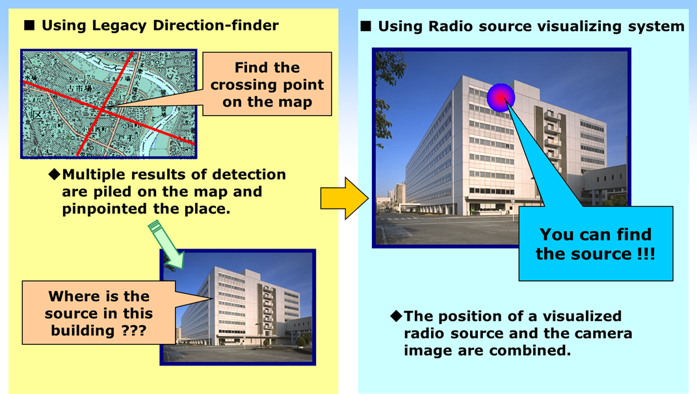

Figure 1 　Feature of RAVS

Figure 2 shows the system diagram of RAVS and some samples of visualized display.

RAVS has the following functions: 1) to receive radio wave signals by multiple antenna elements; 2) to calculate the electric field intensity distribution on a two-dimensional plane from the phase difference of the received signal; 3) to color code by signal intensity; 4) to display an image of the electric field intensity distribution. At the same time, it also displays a visualized image by combining the analysis results with an image obtained by a CCD camera.

In actual measurement, RAVS will display a visualized image of the emission source by selecting the wanted signal from the spectrum of the received signals.





Figure 2 An example of system diagram of RAVS and visualized display samples

**1.2 The appearance of RAVS**

Figure 3 shows the external appearance of RAVS.

RAVS consists of the following equipment: 1) Signal Processor, 2) Antennas and Receivers which are selectable by frequency, 3) Control and Display Unit, 4) Battery.

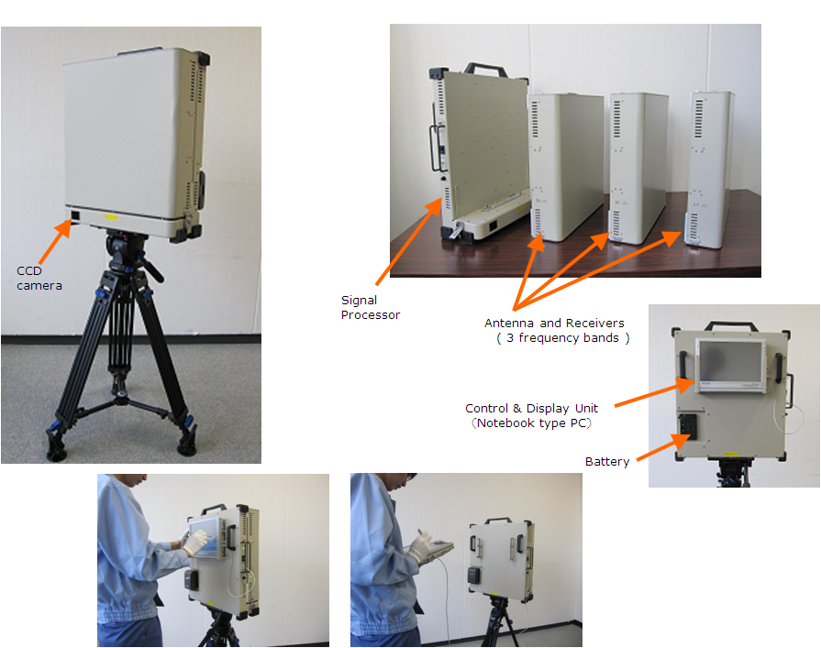

Figure 3 An example of external appearance of RAVS

**1.3 Typical Specification of RAVS**

Table 1 shows the specification of RAVS.

Table 1 RAVS typical specification



**2 Case examples of applications of RAVS**

**2.1 Detection of an illegal repeater station of a cellular phone system**

Figure 4 shows a case example of how an illegal repeater station in the downtown area was detected.

This repeater (circled in the yellow) in Fig.4 was illegally installed, and may cause interference to nearby cellular phone base stations.

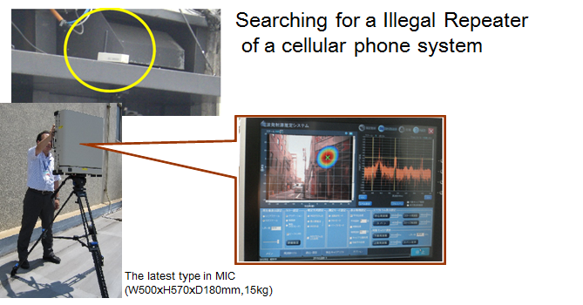

Figure 4 Detection of an illegal repeater located in downtown

**2.2 Detection of a personal wireless system**

Figure 5 shows a case example of how the location of a personal wireless system (Walkie-Talkie) was detected from a distance of nearly 100m. This personal wireless system was emitting radio waves at 900 MHz.

This figure shows how RAVS is capable of identifying not only the building but even the floor on which the emission source was located.

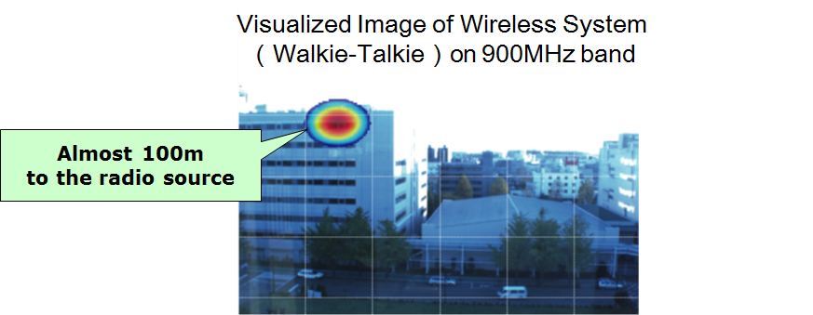

Figure 5 Example of visualized image: portable Walkie-Talkie

Figure 6 shows the visualized image of car-mounted personal wireless system.

In this case the target was moving while repeatedly transmitting and receiving radio signals at a distance approximately 1 km from the monitoring point. The visualized image of the emission source was intermittently displayed on the monitor screen showing how it moved.

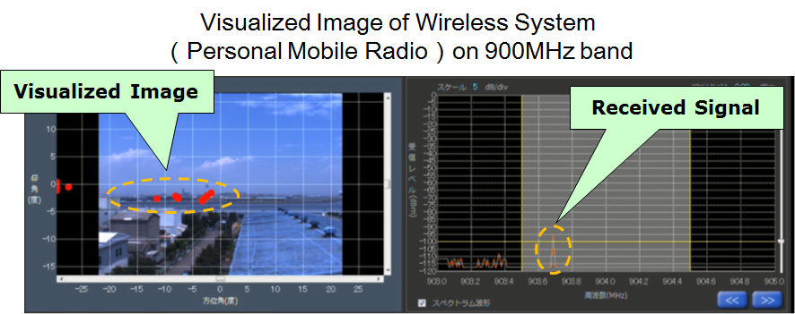

Figure 6 Example of visualized image: car-mounted Walkie-Talkie

**2.3 Some examples of other wireless equipments**

Figure 7 shows a case example of how emission from a car-mounted amateur radio was visualized.

In this case, the target was relatively close to the monitoring point, so the radio wave emitted from the amateur radio could be clearly distinguished.

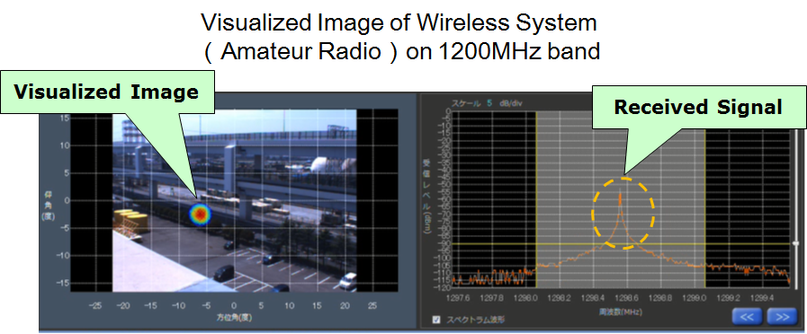

Figure 7 Example of visualized image: car-mounted amateur radio

**3 Application in the future**

**3.1 Detection of pulse waves (radar wave)**

RAVS also has the function of visualizing pulse radio waves. Therefore, RAVS is expected to be useful in detecting interferences with communication systems in the high frequency ranges above 3 GHz.

Figure 8 shows an example of a visualized image of waves transmitted from the Primary Surveillance Radar (PSR) system of Haneda Airport.

In this case, RAVS was set on a roof of a building 2 km away from the airport to monitor the pulse waves of the PSR.

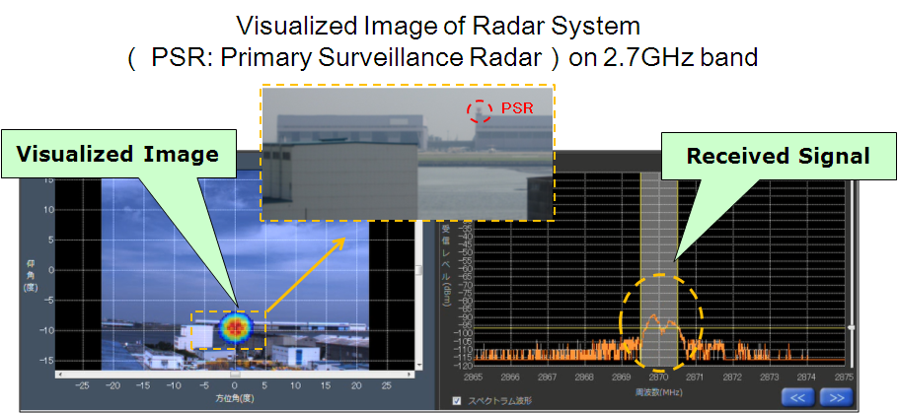

Figure 8 Example of visualized image: Primary Surveillance Radar

Figure 9 shows an example of a visualized image of weather radar emitted from Haneda Airport.

In this case, RAVS was set at a monitoring point 3 km away from the airport. The emission source (radar transmitter) could not be seen directly from the monitoring point due to buildings located in between, but RAVS was able to catch the radar travelling between the buildings.

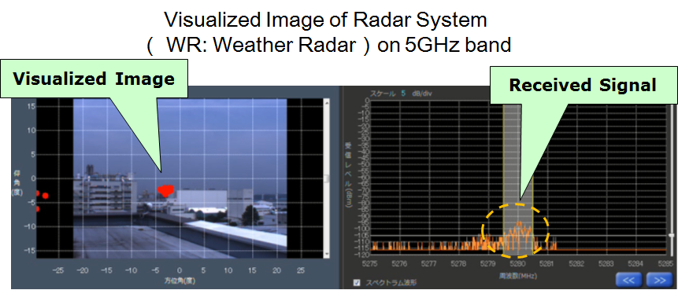

Figure 9 Example of visualized image: weather radar wave (pulse wave)

Figure 10 shows an example of a visualized image of transponder waves from an airplane.

In this case, an airplane taking off was emitting waves from its transponder to the Secondary Surveillance Radar (SSR) system.

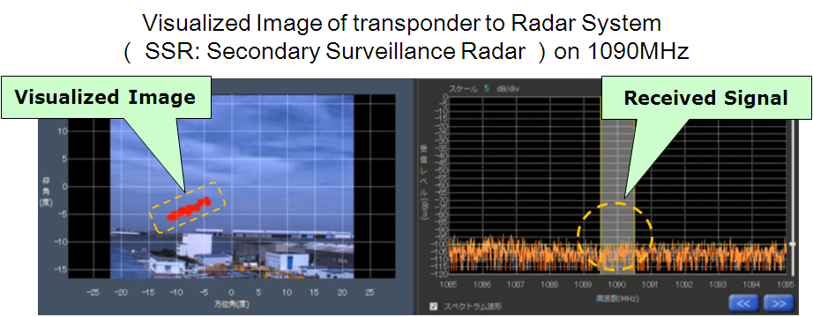

Figure 10 Example of visualized image: transponder waves sent to SSR system

from an airplane

**3.2 RAVS application to search and rescue missions**

RAVS is able to visualize radio signals from small transmitters such as cellular phones, so it is expected to be useful for applications in search and rescue missions.

Figure 11 shows images of application to search and rescue.

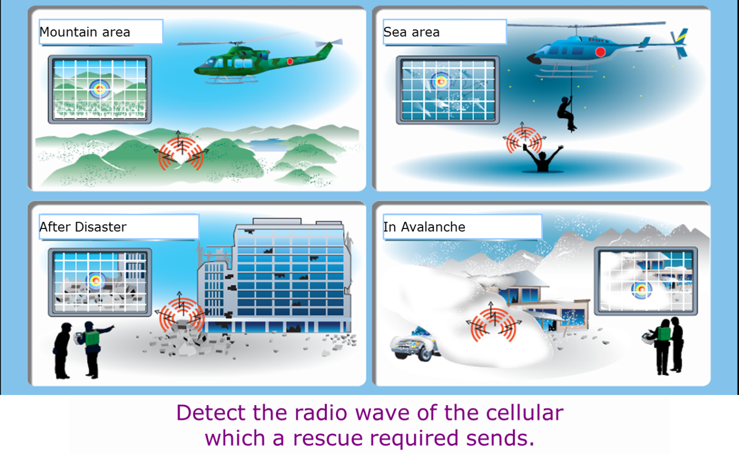

Figure 11 Images of application to search and rescue missions

**4 Conclusion**

RAVS has the ability to visualize and measure the exact location of the emission source, so it is effective in identifying the interference sources quickly. In japan, RAVS is a useful device that will effectively complement the existing DEURAS systems.

It also has possible uses in areas other than spectrum monitoring such as search and rescue missions.

**Annex 2**

**THE APPLICATION OF THE VISUALIZATION ON-SITE RADIO MONITORING SYSTEM**

1. **Introduction**

The coverage of fixed radio monitoring network normally focused on the urban area and interested area such as airport, harbor or other place where a variety of radio applications and/or a substantial number of radio equipment exist. To provide greater flexibility on monitoring activities, the mobile monitoring stations, transportable monitoring stations and handheld equipment are also necessary to determine the exact location of interference, or to verify compliance of radio equipment with the relevant technical parameters on site.

The visualization on-site radio monitoring system is composed of monitoring command center and monitoring facilities such as transportable monitoring stations and handheld monitoring equipment. The system could share and display the result of analysis of monitoring data between field group terminals and monitoring command center. Monitoring command center also used visualization technology to supervise the progress of task implementation.

1. **System Component**

**2.1 Monitoring command center**

Monitoring command center is a central place for carrying out orders and for supervising progress during performing radio monitoring task or in major events. Monitoring command center mainly carry out three general activities: inputs, processes and outputs. The inbound aspect collects intelligence and other field reports including situation reports of what is happening and progress reports relative to a goal that has been set from the field group. The process aspect involves a command element that makes decisions about what should be done about the input data. The outbound communications then delivers command decisions (i.e., operating orders) to the field group.

Monitoring command center’s components:

* Application Servers: dedicated to the efficient execution of procedures for supporting radio monitoring applications.
* Virtual private network (VPN) based on public digital mobile communications network including identification and authorization service.
* The client computers.
* The radio monitoring software including server and client software.
* Multi monitor display system: usage of multiple physical display devices, such as monitors, televisions, and projectors, in order to increase the display area and indicate multiple video sources.

**2.2 Radio monitoring facilities**

Three types of monitoring station could be used in the system, including fixed monitoring stations, mobile monitoring stations and transportable monitoring stations as well as handheld radio monitoring devices.

This handheld apparatus can be equipped with a small panorama display and small broadband antennas, which are well suited for portable applications. Some kind of handheld equipment with newly developed techniques used to locate interference or illegal radio transmitters in covert way are illustrated in the following parts.

**2.2.1 Handheld integrated monitoring and DF system**

The system structure is shown in Figure 1. The antenna, receiver, data processor and communication element (Wi-Fi) are integrated into one device to realize these functions such as direction finding, signal strength measurement and spectrum display. The client radio monitoring software could be operated on touchscreen mobile devices such as smartphones and tablet computers. Sophisticated monitoring and measurement capabilities including monitoring data exchange are achieved. And the real-time scene video signal could be transmitted to the monitoring command center by public mobile communication network.

**2.2.2 Concealed monitoring and DF system**

The system structure is shown in Figure 2. The direction finding antenna is installed into the satchel with the monitoring receiver and DF processor unit so that there is no remarkable sign of the field stuff. The electronic goniometer could measure the azimuth of receiving antenna precisely and calculate the slightest difference of azimuth when the antenna’s direction changes in a small time slot.

The system could give an angle-of-arrival when the stuff move forward or backward and the related information could be delivered to the operator by verbal signals which mean the operator could find out illegal radio transmitters without keeping their eyes on the screen. The smartphone can also be used to display the monitoring and direction finding results.

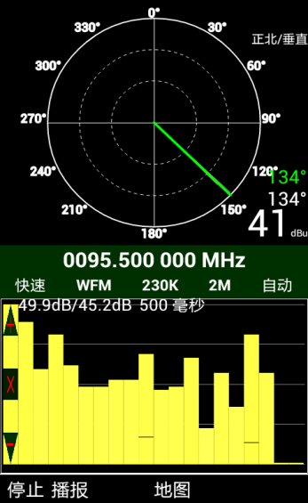

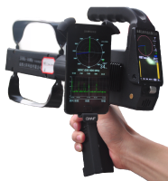

Integrated receiver

Smart phones

Azimuth

Figure 1: Handheld Integrated Monitoring and DF System

Signal strength via Time

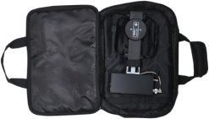

Smart phones

Figure 3: Operating interface of signal-strength-assisted location

Concealed system

Figure 2: Concealed Monitoring and DF System

1. **Improved Monitoring Technologies**

**3.1 Automatic amplitude comparison DF algorithm**

An improved amplitude comparison DF algorithm was developed to automatically calculate the incoming radio wave direction with higher accuracy (＜5 degree, typically) and more work efficiency than traditional manual method.

**3.2 Signal-strength-assisted location**

This method is a typical electromagnetic emissions location method associated with visualization technology. When the emission is in the near vicinity of the obstacles (i.e., buildings, mountains, trees) or inside the buildings, the traditional amplitude comparison DF method could not deliver one stable AOA result because radio wave reflection occur from these obstacles. However, the received signal strength changes fast with DF antenna moving. The display of changes of signal strength with time in the format of histogram will be one alternate emission location method in the near-field region. When the antenna point different direction, the changes of the color and volume of columns which represent the change of received signal amplitude will help operator to find out the exact location of the emission. The operating interface of signal-strength-assisted location was shown in figure 3.

1. **Utilization of visualization technology**

The visualization technology being used in on-site radio monitoring system is to provide following functionalities:

In monitoring command center, the system could

* Display and record the audio and video streams transmitting from field group.
* Display and record the geographic coordinates (including latitude, longitude and altitude) from mobile stations or members of field group carrying with handheld equipment to keep watch on the progress of the task, and plot trails in the electronic map with the combination of all the relative coordinates.
* Display and record the real-time radio monitoring and direction finding data, such as spectrum graph, spectrogram and angle-of-arrival.
* Access and display the inquiry result and statistics of the data extract from the national and/or regional frequency database, radio station database and radio monitoring database.
* Control the remote monitoring stations and handheld equipment in the electronic map.

The monitoring command center system interface are shown in figure 4-1 and 4-2.

In field group, the information terminals could

* Share and display the real-time radio monitoring and direction finding data from online remote monitoring facilities, including fixed stations, mobile and transportable stations and other handheld equipment.
* Access and display the inquiry result and statistics of the data extract from the national and/or regional frequency database, radio station database and radio monitoring database.
* Receive orders from command center with audio and/or video format.

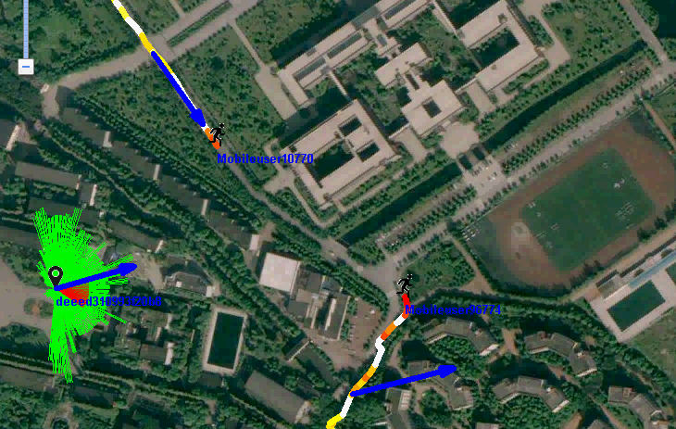

Geographic coordinates of mobile equipment

Results of DF

Figure 4-1: monitoring command center system interface (1)

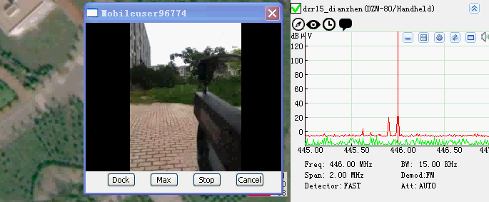

Measurement results

Audio and Video information

Figure 4-2: monitoring command center system interface (2)

____________