APT survey REPORT ON

AUTHORIZED/LICENSED SHARED ACCESS AS A NATIONAL SOLUTION TO ACCESS SPECTRUM FOR IMT

No. APT/AWG/REP-68
Edition: September 2016

Adopted by

20th Meeting of APT Wireless Group
6 – 9 September 2016
Bangkok, Thailand

(Source: AWG-20/OUT-17)

NEW APT REPORT ON AUTHORIZED/LICENSED SHARED ACCESS AS A NATIONAL SOLUTION TO ACCESS SPECTRUM FOR IMT

Introduction
Today, finding new spectrum that is unused is becoming more and more difficult. Often spectrum is encumbered with other users. Current spectrum allocation mechanisms are currently based on either exclusive licensing to an operator or unlicensed/licensed exempt operation. The former is commonly used because of its ability to provide predictable quality of service. The latter, unlicensed scheme, is based on best effort characteristics, since there are no limits on the number of users/operators in a given geographical area. Frequency bands that have been allocated to mobile on a primary basis in the Radio Regulations, may in some countries be difficult to be cleared of incumbents and thus this can cause delays in providing sufficient capacity to mobile operators. To provide access to bands which are licensed and in use in some other regions/countries for IMT and therefore already implemented in terminal devices, having IMT share the spectrum with the incumbent users may be possible, especially if the incumbent user is not using its spectrum all the time and/or using it in limited area(s). This is illustrated in Figure 1 where the different coloured areas show different levels of protection of the incumbent users whereas the white areas show areas where IMT users may have access.

Figure 1: Example of a frequency allocation where certain areas are in use (red and orange) by incumbents while the other overall area (white) is not used. Note that any similarity of an existing country is unintentional.
Currently, work is on-going globally to define a licensing approach that allows spectrum sharing where incumbent users and mobile operators would share spectrum resources under well-defined conditions. This regulatory approach is called Authorized Spectrum Access (ASA) or Licensed Shared Access (LSA). The decision to apply LSA would thus be on a national basis to provide a solution for that country to use a specific frequency band under specified LSA conditions. Noting that if this specific band is licensed and in use for IMT in some other regions/countries and therefore already implemented in IMT terminal devices, LSA would enable benefits from the existing IMT eco-system already available for that specific band and provide affordable economies of scale. LSA will provide:
- additional spectrum:
  - From bands allocated to the Mobile Service
  - When incumbents have infrequent or localized usage of spectrum
  - When additional spectrum is not readily obtainable due to incumbent use (e.g. military, radar, satellite)
- Benefits from the existing IMT eco-system already available for that specific band. Those benefits are:
  - That specific band is already implemented in IMT terminal devices
  - Existing eco-system enables various brands and makes of IMT terminals for users to choose from
  - Also affordability for users is enabled due to economy of scale in production
- Either-or usage between incumbent and licensee
- Predictable quality of service for IMT
- Protecting incumbent, lends investment security

The two main objectives of this Report are:
- to provide a general analysis of ASA/LSA, how it fits with regulatory framework(s) on the use of spectrum, current practices in terms of spectrum management and management of frequency authorisations;
- to explain how ASA/LSA can be implemented in an existing mobile frequency bands and to clarify implications on the requirements to be included in a regulatory “harmonisation measure”.

Scope
This report evaluates the potential of using Authorized/Licensed Shared Access (ASA/LSA) mechanisms for users / consumers in a country where an existing harmonized IMT frequency band cannot be fully vacated for IMT use but could be implemented based on agreed sharing conditions where the incumbent service can be maintained for a foreseeable period of time.

Vocabulary of terms

3GPP Third Generation Partnership Project
ASA Authorized Spectrum Access
CAF Contained Access Facilities
CBRS Citizens Broadband Service
CEPT European Conference of Postal and Telecommunications Administrations
DoD Department of Defence
ECC Electronic Communications Committee
ETSI European Telecommunications Standards Institute
FCC Federal Communications Commission
FS Fixed Service
FSS Fixed Satellite System
GAA General Authorized Access
IMT International Mobile Telecommunications
ITU International Telecommunication Union
LC LSA Controller
LSA Licensed Shared Access
LR LSA repository
LSRAI LSA Spectrum Resource Availability Information
MIFR Master International Frequency Register
MFCN Mobile/Fixed Communications Network
MNO Mobile Network Operator
NRA National Regulatory Authority
NTFA National Table of Frequency Allocations
OAM Operations, Administration and Management
PAL Priority Access Layer
PMR Private Mobile Radio
QoS Quality of Service
RR Radio Regulation
SAS Spectrum Access System
UE User Equipment
WRC World Radiocommunication Conference

References
[1] ITU-R WP 1B, “WORKING DOCUMENT TOWARDS PRELIMINARY DRAFT NEW
REPORT ITU-R SM.[INNOVATIVE REGULATORY TOOLS],” Annex 13 to Document 1B/51-E, 12 June 2016
[2] ECC report 172, “Broadband Wireless Systems Usage in 2300-2400 MHz,” March 2012
[3] ECC Report 205, “Licensed Shared Access (LSA), February 2014”
[4] CEPT Report 55, “Report A from CEPT to the European Commission in response to the Mandate on ‘Harmonised technical conditions for the 2300-2400 MHz (‘2.3 GHz’) frequency band in the EU for the provision of wireless broadband electronic communications services’ Technical conditions for wireless broadband usage of the 2300-2400 MHz frequency band,” Report approved on 28 November 2014 by the ECC.
[5] CEPT Report 56, “Report B1 from CEPT to the European Commission in response to the Mandate on ‘Harmonised technical conditions for the 2300-2400 MHz (‘2.3 GHz’) frequency band in the EU for the provision of wireless broadband electronic communications services’ Technological and regulatory options facilitating sharing between Wireless broadband applications (WBB) and the relevant incumbent service/application in the 2.3 GHz band,” Report approved on 6 March 2015 by the ECC.
[6] CEPT Report 58, “Report B2 from CEPT to the European Commission in response to the Mandate on "Harmonised technical conditions for the 2300-2400 MHz (‘2.3 GHz’) frequency band in the EU for the provision of wireless broadband electronic communications services". Technical sharing solutions for the shared use of the 2300-2400 MHz band for WBB and PMSE,” Report approved on 3 July 2015 by the ECC.
[7] ETSI TR 103 113, “Mobile broadband services in the 2300- 2400MHz frequency band under LSA regime”
[8] ETSI TS 103 154, “System requirements for operation of Mobile Broadband Systems in the 2 300 MHz - 2 400 MHz band under Licensed Shared Access (LSA)”
[9] ETSI TS 103 235, “System Architecture and High Level Procedures for operation of Licensed Shared Access (LSA) in the 2300– 2400 MHz Band,” V1.1.1, 2015-10
[10] ETSI TS 103 379, “Reconfigurable Radio Systems (RRS); Information elements and protocols for the interface between LSA Controller (LC) and LSA Repository (LR) for operation of Licensed Shared Access (LSA) in the 2300 MHz-2400 MHz band,” V0.0.2.
[11] ETSI TC RRS, “Liaison Statement on Licensed Shared Access (LSA) related Activities in TC RRS,” Tdoc RRS(14)028019, 15 December 2014
[12] 3GPP TR 32.855, “Technical Specification Group Services and System Aspects; Telecommunication management; Study on OAM support for Licensed Shared Access (LSA); (Release 13),” V1.0.0, 2016-03-09
[13] Draft ECC Report 254, “Operational guidelines for spectrum sharing to support the implementation of the current ECC framework in the 3600-3800 MHz range”

[14] FCC, “Proposes Creation of New Citizens Broadband Radio Service in 3.5 GHz”, April 2014 http://www.fcc.gov/document/proposes-creation-new-citizens-broadband-radio-service-35-ghz
[15] FCC 15-47, “REPORT AND ORDER AND SECOND FURTHER NOTICE OF PROPOSED RULEMAKING”, April 2015. https://apps.fcc.gov/edocs_public/attachmatch/FCC-15-47A1.pdf and https://www.fcc.gov/rulemaking/12-354

[16] FCC 16-55, “ORDER ON RECONSIDERATION AND SECOND REPORT AND ORDER”, issued May 2, 2016.
https://apps.fcc.gov/edocs_public/attachmatch/FCC-16-55A1_Rcd.pdf
https://www.fcc.gov/tags/35-ghz-0

[17] PCAST, “Report to the President: Realizing the Full Potential of Government-Held Spectrum to Spur Economic Growth,” July 2012. https://www.whitehouse.gov/sites/default/files/microsites/ostp/pcast_spectrum_report_final_july_20_2012.pdf.

[18] http://www.wirelessinnovation.org/

Regulatory Framework of Use of Radio Spectrum

International Telecommunication Union
The ITU legal instruments, at least those that are relevant to spectrum management, are the Constitution (CS), the Convention (CV) and, most important, the Radio Regulations (RR). These instruments are binding the States and are related to spectrum management as far as it has international implications. These instruments are not directly applicable to individuals, operators or others, concerned by spectrum utilisation. Compliance with those instruments therefore presupposes that each State will take the measures required (legislation, regulations, clauses in licenses and authorisations) to implement domestically those obligations to other spectrum users (operators, administrations, individuals, etc.).

The principle underpinning most of the provisions of ITU Radio Regulations is set out in No. 4.3, which stipulates that any new assignment (i.e. any new authorisation to operate a radio station) must be made in such a way as to avoid causing harmful interference to services rendered by stations using frequencies assigned in accordance with the Table of Frequency Allocations and the other provisions of the Radio Regulations, the characteristics of which are recorded in the Master International Frequency Register (MIFR). In particular, a new assignment can only be recorded in the MIFR after completion of a procedure (for instance, Articles 9 and 11) aimed at ensuring that it will not cause harmful interference to assignments made in accordance with the RR and previously recorded systems.

Article 5 of the RR, Section IV (Table of Frequency Allocations) allocates frequency bands for the purpose of their use by one or more terrestrial or space radiocommunication services or the radio astronomy service under specified conditions. A radiocommunication service is defined as the transmission, emission and/or reception of radio waves for specific telecommunication purposes. Terrestrial services and space services can themselves be subdivided in several different types of services (e.g. fixed, mobile, broadcasting). The list of the different services with corresponding definitions is given in Article 1 of the RR. Frequency bands are allocated to radiocommunication services on a primary or secondary basis. Stations of a secondary service shall not cause harmful interference to stations of primary services and cannot claim protection against harmful interference from stations of a primary service.

The RR as such provides an international framework for effective spectrum management that is primarily structured by the need for global harmonisation in various domains (e.g. satellite communication, maritime, civil aviation, and scientific research), coexistence capability between different types of radio communication networks and physical properties of frequency bands. It has major implications for the industry in terms of economies of scale and therefore for the design of radio products. As an international treaty, the RR is periodically revised by World Radiocommunication Conferences (WRC), which is typically held every four years and allow addressing new development in the field of radiocommunications and technological change as appropriate.

5.2 Typical National mechanisms

The authority responsible for frequency management within a country may be an Administration or a National Regulatory Authority or similar entity. Within this chapter Administration has been used. This could e.g. be regulated by the Law or other means in a country. The Administration submits a question, to e.g. a council or directly to the public, and seeks public comments in order to maintain the transparency in making standards or policies for frequency management.

The steps of the process to the license are as follows:
1) International decisions of frequency allocation in the ITU World Radiocommunication Conference
Experts and well-informed persons concerned make proposal on the frequency issues for WRC agenda item in the meetings held by the Administration based on the domestic and international research works. The Administration seeks public comments on the proposals. The international frequency allocation is decided through the discussion in WRC.

2) Decisions of national frequency allocation
Based on the latest decision of the frequency allocation in WRC, the National Radio Frequency Allocation is revised and modified, considering the state and local needs, the innovative use of the spectrum and new developments in technology and equipment.

3) Decisions of national frequency planning
Generally, frequency planning shall be consistent with the frequency allocation. The decisions and adjustments of frequency planning are motivated by service developments and technical innovations. The first stage of spectrum planning is to evaluate the spectrum requirement. Then, the sharing studies are conducted by interested parties, such as research institutions, industries and spectrum users, to protect the current spectrum usage from harmful interference.
Two more detailed examples how this can be done are:
- The preliminary proposals of national frequency planning, which include frequency band arrangement and radio frequency specifications, will be prepared and submitted to the Administration. After rounds of consultation and coordination with those concerned spectrum users, the draft national frequency planning will be decided and published to seek the public comments. After proper revision based on comments, the final decision on national frequency planning will be released.
- The Administration makes draft revision of the national frequency assignment plan.

4) Publication of a draft license policy
Some methods are available in APT countries from this point forward. Some examples are described as below.
- Following the national frequency planning approach, the draft license policy such as a revision of the examination basis of the license related to the radio requirements is made public and the public comments on the draft policy are sought. The trial network may need to be established in certain cities or areas by spectrum users in several frequency bands with the draft license. The radio requirements may be modified according to the results of field trials.
- The draft license policy such as a revision of the examination basis of the license related to the radio requirements is made public and the public comments on the draft policy are sought. The Administration makes guideline for establishing new stations using new allocated frequencies. Some applicants propose their establishment plan of new stations. The Administration reviews their submitted materials and decides allocation of frequency range for some applicants.

5) Establishment and publication of the license policy

6) Reception and examination of application for radio license
The application(s) for radio license is examined in compliance with related entities for establishing radio stations and licensing policy in accordance with relevant laws.

7) Issue of Radio license(s) / Publication of frequency assignments in the National Frequency Table

ASA/LSA as a complementary tool spectrum management
ASA/LSA could be a complementary solution for mobile network operators (MNO) for accessing spectrum for IMT-bands, within specified geographical, time or technical limits. ASA/LSA complements the traditional exclusive access based on individual authorisation when re-allocation / refarming of the spectrum is impracticable due to incumbent use. Thus, the purpose of ASA/LSA is not to replace the traditional exclusive access which is the preferred method. ASA/LSA would enable the sharing of spectrum with non MNOs incumbents based on national decision. ITU-R WP 1B has started to study Innovative Regulatory Tools, subject to Question ITU-R 208-1/1 on “Alternative methods of national spectrum management” where LSA is one method [1].

Status in other countries/regions outside of APT

Europe – CEPT/ECC
In Europe the first application of LSA is in the 2.3 GHz band, Band 40 in 3GPP. The incumbents in this band are FSS, Radar, and PMSE. The Electronic Communications Committee (ECC) has studied sharing in the 2.3GHz where the ECC report 172 [1] concluded that sharing between Broadband Wireless Systems (BWA) and other systems can be done. Currently CEPT is investigating the harmonised technical conditions for the use of the 2.3 GHz band and has issued Reports 55 [3], 56 [4] and 58 [5].

Regarding the details of the LSA architecture, a two-tier model has been defined where incumbents and authorised licensees share the spectrum [6].

Standardization activities in ETSI
Based on the ECC studies ETSI completed a technical report outlining a possible architecture and related function to enable a LSA system [7]. ETSI continued with developing a technical specification on system requirements for operation of Mobile Broadband Systems in the 2300- 2400 MHz band under LSA [8] and the architecture including associated procedures and functionality of the related interfaces [9]. It is currently working on the specification defining the content of the LSA Spectrum Resource Availability Information (LSRAI) and the protocols on the interface between LSA Controller (LC) and LSA Repository (LR), the so-called LSA₁ [10], with planned publication November 2016. The reference architecture is shown in Figure 1 and identifies the would-be specified interface, LSA₁, as well as two reference points LSA₂ and LSA₃. The two reference points are not target to be standardised interfaces. The two reference points consider interaction between LS and NRA and Incumbent respectively.

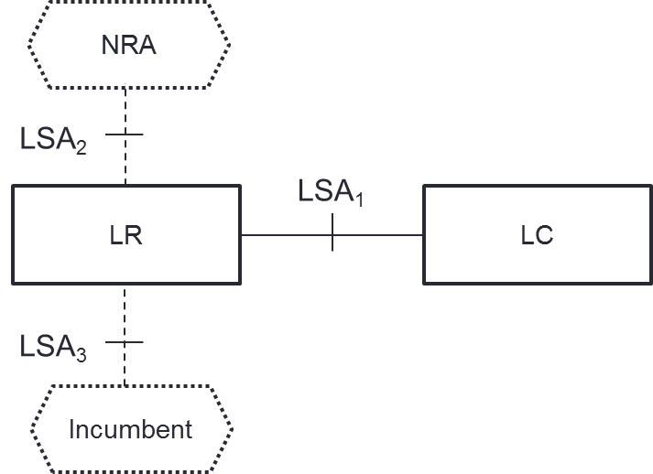

Figure 1: Architecture Reference Model as contained in [9]
The functionality can be summarised, taken from [9], as:

LSA Repository (LR): The LR supports the entry and storage of information describing Incumbent’s usage and protection requirements. It is able to convey the related availability information to authorised LSA Controllers, and is also able to receive and store acknowledgement information received from the LSA Controllers. The LR also provides means for the NRA to monitor the operation of the LSA System, and to provide the LSA System with information on the Sharing Framework and the LSA Licensees. The LR ensures that the LSA system operates in conformance with the Sharing Framework and the licensing regime, and may in addition realize any non-regulatory details of the Sharing Arrangement.

LSA Controller (LC): The LC is located within the the LSA Licensee’s domain, and enables the LSA Licensee to obtain LSA spectrum resource availability information from the LR, and to provide acknowledgment information to the LR. The LC interacts with the Licensee’s MFCN in order to support the mapping of availability information into appropriate radio transmitter configurations, and receive the respective confirmations from the MFCN.

Specification activity in 3GPP
Based on the work in ETSI, 3GPP needs to consider the impact on their specification. ETSI has sent an LS informing 3GPP about LSA concept and work done as well as ongoing work [11] asking 3GPP to consider the information provided. As study item in 3GPP WG SA5 has started that would result in a technical report, 3GPP TR 32.855 [12]. The report will include aspects related to the architecture, the interfaces and solutions with regards to Licensed Shared Access, LSA ETSI TS 103 154 [8], relevant to a 3GPP mobile network operator. There are also study item proposals submitted to 3GPP RAN that would study if it is beneficial to have some enhanced functionality to optimise the use of LSA spectrum but not approved.

Additional Frequencies
CEPT ECC has studied spectrum sharing to support the use of the 3.6 GHz – 3.8 GHz band between FSS/FS and mobile systems [13]. LSA is considered in that report.

US – FCC
In USA work is ongoing, by the process “Further Notice of Proposed Rulemaking (FNPRM)” [11] to use frequencies in the 3.5 GHz, 3550 MHz – 3650 (3700) MHz for a new Citizens Broadband Service (CBRS). A “Report and Order and Second Notice of Proposed Rulemaking” has been issued [15] followed by updates in a “Order on Reconsideration and Second Report and Order” [16]. The policy proposals corresponding to the formation of the CBRS were modeled on a report on dynamic spectrum sharing by the President’s Council of Advisors on Science and Technology (PCAST) in a report issued July 2012 [17]. The report recommended that the National Telecommunications and Information Administration (NTIA) collaborate with the FCC to define shared operation between the US Government and private users in Government-held spectrum. The sharing should be dynamic and managed in three tiers as described below. In the rulemaking this sharing system/mechanism is denoted Spectrum Access System (SAS), as introduced in the PCAST report. The SAS is expected to manage access to the spectrum and ensure appropriate interference protection. It is supposed to operate in a three-tier operation where:

1st tier: Incumbent Access. Existing primary operations including authorized federal users and Fixed Satellite Service (FSS) earth stations. Federal users, e.g. Maritime Radars, will be protected from harmful interference from the citizen broadband radio service users through geographic exclusion zones as well as dynamic blocking of CBRS use. FSS use will be protected by coordination zones around earth station installations, where CBRS use may be excluded or carefully monitored and regulated.

2nd tier: Priority Access Layer (PAL) users, such as Mobile operators and other private entities such as enterprises can seek to receive priority authorization to operate within designated geographic areas based on census tracts and protected from harmful interference from the other 2nd tier users as well as General Authorized Access (GAA) users. Such PAL users are authorized using geographically delineated licenses that have 1-year terms and can be extended for up to 5 such terms.

3rd tier: General Authorized Access (GAA). Entitled to seek authorization from the SAS to use the spectrum on opportunistic basis and is not entitled to license guarantees or interference protection from other users. Users within certain Contained Access Facilities (CAF) such as hospitals, public safety buildings and local government buildings can reserve up to 20 MHz of spectrum from the GAA pool and need not seek 2nd tier status. These CAF can additionally restrict or deny third party use of the same spectrum within their premises.

All PAL use is authorized independently within census tracts which according to the 2010 census number 73057 tracts in the United States and 74002 tracts with the inclusion of Puerto Rico. PAL use spectrum can admit GAA use, if the licensee has not deployed systems in portions of an authorized region. Geographically or spectrally adjacent PAL users can have reasonable expectation of interference protection according to the terms of the license. Incumbent operation can trigger blocking of PAL and GAA use for temporary periods or spectrum reassignments in specific precincts.

There are similarities between ASA/LSA and the CBRS. In particular, the operation of PAL user can be modeled as strongly similar to ASA/LSA, while GAA is in some respects similar to white space use. However, a PAL license is not associated with a fixed frequency block, and the SAS may reconfigure PAL usage based on incumbent activity or coexistence management goals.

Status of the US CBRS band
Industry discussions with the Department of Defence (DoD) have largely been around aspects related to detection of radar in coastal regions. The radars are operational in the lower part of the band spanning 3550-3650 MHz. A basic sensing mechanism that relies on energy detection would be needed, either in stand-alone or integrated with deployed infrastructure. Sufficient information exists in unclassified form in the public domain regarding the characteristics of the predominant radar in use, the AN/SPN-43, utilized for marshalling aircraft during takeoff and landing in aircraft carriers. The DoD may not declassify information about other radars that may be brought into operation in littoral waters at a future date. The right to deploy terrestrial radars continues to exist, but current use is limited to three sites operating between 3650-3700 MHz.

The upper portion of the band from 3600-3700 MHz is occupied by the Fixed Satellite Service and is occupied by commercial users. The operation of the CBRS will be contingent on protecting incumbent FSS users by means of a protection zone.

The management of the three tiers of the CBRS band can be architected in a manner very synergistic with LSA/ASA and discussions are ongoing between the Federal Communications Commission (FCC), the Department of Defence (DoD) and various industry players, with the view of containing the complexity of such a dynamic spectrum assignment model. It is believed possible to adapt the LSA/ASA architecture to serve these requirements posed by the US market, but the impact to the architecture is yet undetermined.

The Wireless Innovation Forum [18] represents a multi-stakeholder industry group, organized within a Spectrum Sharing Committee (SSC). The SSC is currently working on defining the required interfaces of the SAS with the Citizen’s Band Service Device (CBSD), an Environmental Sensing Component (ESC) meant to detect radars near the coastline, the regulator and incumbents.

Summary
The US model is more complex since it has three different types of users with different levels of protection between each other. It is possible to adapt LSA/ASA to adequately serve users that are controlled by managed networks, while the SAS would handle spectrum assignments to pure GAA assignees or to CAFs without licenses. The European model envisages only two levels operation with Incumbent users and IMT users.

Defining ASA/LSA as a complimentary solution for accessing IMT spectrum

Key features
Spectrum management
ASA/LSA is a complementary spectrum management tool that fits under an “individual licensing regime”, a fact which allows fine management of network deployment and effective control of the sharing arrangement, as opposed to licence-exempt regulatory approach.

ASA/LSA aims to ensure a certain level of guarantee in terms of spectrum access and protection against harmful interference for both the incumbent(s) and ASA/LSA licensees, thus allowing them to provide a predictable quality of service. Incumbent(s) and ASA/LSA licensees each have exclusive access to spectrum at a given location at a given time.

ASA/LSA excludes concepts such as “opportunistic spectrum access”, “secondary use” or “secondary service” where the applicant has no protection from primary user.

Management of authorisations
The regulatory authority (Administration) in each member state, herein known as the National Regulatory Authority (NRA), would set the authorisation process with a view to delivering, in a fair, transparent and non-discriminatory manner, individual rights of use of spectrum to ASA/LSA users, in accordance with the sharing framework defined beforehand. ASA/LSA does not prejudge the modalities of the authorisation process to be set by NRA taking into account national circumstances and market demand.

Sharing framework
The “sharing framework”, which is established under the responsibility of the Administration / NRA, can be understood as a set of “sharing rules” or “sharing conditions”. It is the central piece for the implementation of ASA/LSA at national level.

The “sharing framework” will materialise the change, if any, in the spectrum rights of the incumbent(s) and define the spectrum, with corresponding technical and operational conditions, that can be made available for alternative usage under ASA/LSA.

National administrations decide which existing applications need to be considered as incumbent uses within the sharing framework and maintained in the long term. Such decision should be made according to national policy objectives and taking into account international obligations.

ASA/LSA licensees require a certain level of guarantee in terms of spectrum access in order to incentivise and secure investments in network and equipment. The adequate level of guarantee is to be determined on a national basis taking into account user requirements and sharing constraints.

A review and negotiation process is required on a national basis to establish an effective “sharing framework”, which may vary significantly from country to country. It requires the involvement of all relevant stakeholders and should consider both the spectrum requirements of the incumbent(s) and the demand for alternative usage.

This concept is illustrated by the Figure 2 below. In the figure, the spectrum availability is based on geographical separation. In the area marked green, the “sharing framework” defines the spectrum availability to ASA/LSA users while the white area is spectrum rights of the incumbent under the National Table of Frequency Allocations (NTFA) with ASA/LSA. It should be noted that in ASA/LSA the sharing can be done in the three dimensions, namely, time, frequency and area. The sharing framework can also account for future needs of an incumbent, as depicted with grey stations in the figure:
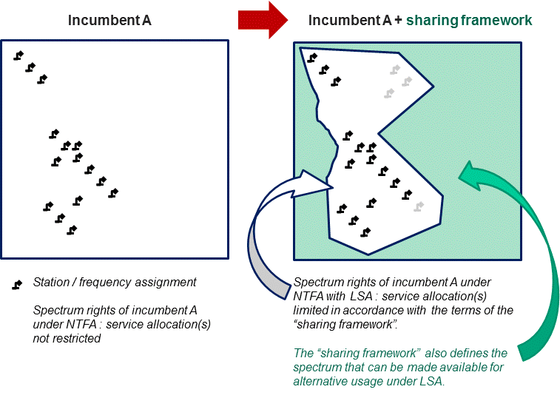
Figure 2: Sharing framework
The “sharing framework” strictly addresses the conditions of access to the ASA/LSA spectrum enabling the protection of the incumbents’ services.
The concept of “sharing framework” also implies that ASA/LSA should not be mixed with a conventional sharing arrangement that is applied for e.g. FS (microwave links) or PMR-like services. In such case, there is no “incumbent” having priority or exclusive spectrum access across a territory and new systems can be introduced on a first-come / first-served basis by applying appropriate geographic of frequency separation measures, possibly also applying some sharing rules.

Applicability criteria
Identifying additional harmonised spectrum for IMT is a main objective since economies of scale have been a key requirement for a specific frequency band to support successfully commercial IMT-network operation.

In order for ASA/LSA bands to be in a position to support successful commercial IMT-network services, a number of additional key conditions, named hereafter applicability criteria, have to be fulfilled. In the following a set of applicability criteria are presented that are necessary for the implementation of ASA/LSA for IMT-network.

Criterion 1: Identification of the incumbent(s) and their usage of the spectrum
National administrations decide which existing applications need to be considered as incumbent uses within the sharing framework and maintained in the long term according to national policy objectives and taking into account international obligations.

In order for the ASA/LSA licensee to consider making investments, first the ASA/LSA licensee needs to understand precisely where/when the band may be available, so that he knows exactly if the spectrum availability corresponds to his need for the delivery of the intended service.

This implies to know exactly who the incumbent(s) is (are), and what their statistical usage of the band is. Agreeing on a sharing framework under ASA/LSA approach also requires the incumbent(s) to inform the ASA/LSA Licensee not only of the current availability of spectrum in the band but also of the spectrum availability for the whole duration of the sharing framework. Long-term availability is one of the key enablers of ASA/LSA.

Criterion 2: Voluntariness
For a mobile communication network, the goal of ASA/LSA is to make available additional spectrum resource in specific bands used by incumbent applications through enabling more advanced sharing than what is possible through existing regulatory frameworks. Sharing through ASA/LSA requires close cooperation between the incumbent and the ASA/LSA licensee, due to the priority in the spectrum access right.

Furthermore, in order for ASA/LSA to bring spectrum to the market more quickly than through band clearance, it is necessary for the incumbent to be proactive in the process.
Therefore, ASA/LSA should be implemented on a voluntary basis.

Criterion 3: Based on market demand and incumbent’s interests
For ASA/LSA to support successful commercial services, it requires both a proactive incumbent (seeing benefits in sharing the band) and a clear business benefit for the ASA/LSA licensee. It is essential for ASA/LSA to leverage interests of parties involved, i.e. incumbents and ASA/LSA licensees. Extensive discussion between the incumbent and the future ASA/LSA licensee are essential in order to identify the sharing options that will provide the most benefits to both parties
.
The incumbent will be incentivised by the fact that spectrum access can be maintained in the longer term and by adequate compensation for sustained sharing in specific bands. ASA/LSA licensee motivation will be based on attractive sharing conditions and timely access to spectrum with supportive economies of scale and at a lower cost, such as the absence of coverage obligations.

ASA/LSA should be based on incentive and market demand.

Criterion 4: Exclusivity among ASA/LSA licensees
Mobile operators usually rely on dedicated spectrum (spectrum available to a single MNO). ASA/LSA will only bring benefits for the delivery of mobile broadband services if it allows provision of QoS at the same level as what dedicated spectrum supports, when and where spectrum is available. When it comes to coverage, QoS can only be provided through licensed spectrum where MNOs have full control/knowledge of the interference they face, and therefore have full understanding of the performance that will be delivered by their network.

MNOs also need to have full visibility over their future access to spectrum in order to be in a position to develop investment plans. Overall, the exclusivity among ASA/LSA licensees for a spectrum resource at a given place, at a given time, for a predictable future, is a critical aspect of the concept in order to trigger infrastructure investment and deliver services with coverage QoS.

The incumbent users also benefit from this exclusivity. The exclusivity guarantees to the incumbent that it can identify in a straightforward manner the particular ASA/LSA licensee that has right of access to the band at a given time, in a given location.

Criterion 5: Harmonisation
Maintaining opportunities for economies of scale remains a top priority for the mobile broadband industry. Identification of ASA/LSA opportunities without consideration of wider industry and standardisation may not lead to successful commercial deployment.

Inter alia, ASA/LSA could target spectrum that offers potential for effective global harmonisation (i.e. spectrum that has been identified for IMT and that may not have been made available due to the needs of specific incumbents on a national or regional level) and is supported by standardisation activities.

ASA/LSA addresses bands with significant potential for global harmonisation and supported by appropriate standardisation.

Stake holders, responsibilities and steps to establish ASA/LSA
Several stakeholders must cooperate closely together at national level in order to introduce

- IMT-network under ASA/LSA:
- The Administration / NRA;
- The incumbent(s) (i.e. non IMT-networks);
- The prospective ASA/LSA licensee(s) (i.e. IMT-networks).
The exact nature and implementation of ASA/LSA is likely to differ from country to country, in order to adapt to national circumstances. In any case, the introduction of IMT-networks under ASA/LSA will always require:
- a dialogue involving Administration / NRA, Incumbent(s) and prospective ASA/LSA Licensees, in order to define the sharing framework;
- the Administration / NRA issuing an individual right of use to the ASA/LSA Licensee, following a procedure that is compliant with the Authorisation Directive.

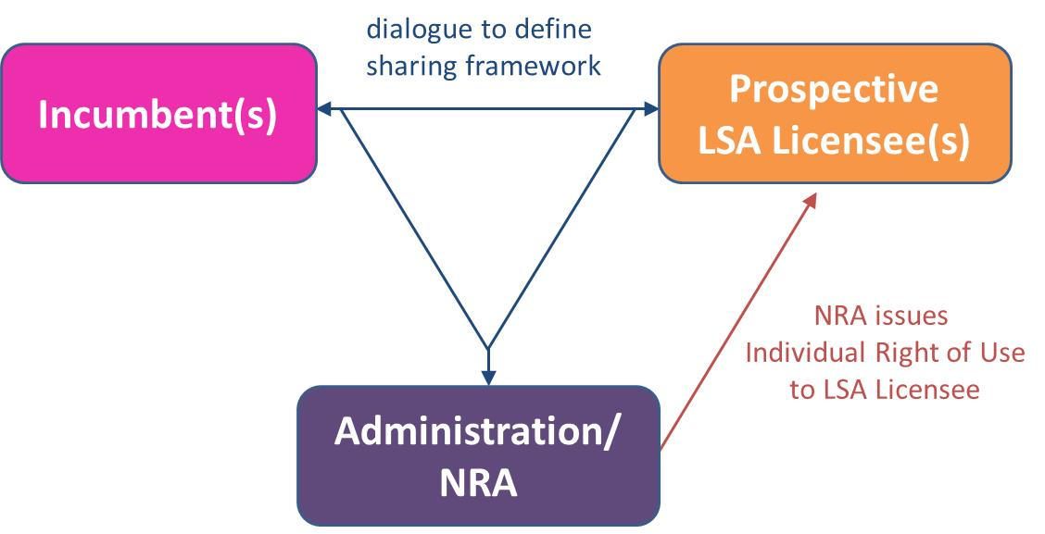
Figure 3: Regulatory process required before the introduction of IMT in a band under ASA/LSA

In setting up the sharing framework and issuing individual authorisations to ASA/LSA licensees, the following steps could be followed as an example:
- The initiative to introduce a mobile communication network in a band under ASA/LSA could be either triggered by the incumbent or requested by market driven demand.
- Administration / NRA should identify the relevant parties to be involved in the development of the sharing framework. A dialogue between Administration / NRA, incumbent(s) that are deemed to be protected under ASA/LSA and prospective ASA/LSA licensees is initiated, with the aim of determining the terms of the sharing framework:
  - The incumbent reports the conditions under which ASA/LSA will be facilitated. These should include its statistical current and future spectrum requirements in order to operate its services in the band. In particular, it may report frequency band, pre-defined time, geographical area, frequency use, level of protection.statistical use of the band or other technical conditions such as pre-emption conditions, in case of urgency, where the incumbent may retrieve use of the spectrum.
  - The prospective ASA/LSA licensees provide some indication of the minimum duration of the sharing framework required to enable adequate return on investment. It may also be useful for the ASA/LSA prospective licensees to report on the frequencies, locations and times where spectrum is most acutely required. These conditions are needed to ensure the proper spectrum usage by both the incumbent and the ASA/LSA licensee in adjacent time/space/frequency domain(s).
  - The Administration determines the relevant conditions in particular to ensure operations of the incumbent services to be protected. Based on these conditions, the Administration would set a sharing framework, which can be referenced under the National frequency allocation table, on the basis of which an ASA/LSA licensing process can be issued. The administration may also need to modify the incumbent authorisation accordingly.
- The NRA establishes a ASA/LSA licensing process. A prospective ASA/LSA licensee interested applies to the NRA for an ASA/LSA authorisation.
- Depending on the dynamic nature of spectrum access for which the incumbent has an authorisation, the ASA/LSA licensee may need to be provided (e.g. through a data base) with information on the area(s)/time of availability of the spectrum. If this information remains constant over time it can be provided when the ASA/LSA licensee applies for its ASA/LSA authorisation.
- When the incumbent needs to have access to (a part of) the band used by the ASA/LSA licensee, the ASA/LSA Licensee has to be informed by agreed means and has to modify its use. This must be in accordance with the conditions defined in its ASA/LSA authorisation. The dynamic nature of this request, and the urgency of the request, may influence the practical implementation by the ASA/LSA licensee.

Technical measures to support implementation

ASA/LSA functional blocks and interaction
The following functional blocks may be required when implementing ASA/LSA on a national basis.

A ASA/LSA repository is required to deliver the information on spectrum availability and associated conditions when this information is subject to changes over time. The ASA/LSA repository may be managed by the Administration, the NRA or the incumbent, or be delegated to a trusted third party.

The ASA/LSA controller manages the access to the spectrum made available to the ASA/LSA licensee based on sharing rules and information on the incumbent’s use provided by the ASA/LSA repository. It retrieves information about spectrum from the ASA/LSA repository through a secure and reliable communication path.

The ASA/LSA controller can interface with one or multiple ASA/LSA repositories as well as with one or multiple ASA/LSA licensee’s networks. The ASA/LSA controller may be managed by the Administration, the NRA, the incumbent, the ASA/LSA licensee(s) or be delegated to a trusted third party.

There could be one or more repositories and/or controllers per country, depending e.g. on the ASA/LSA band and the incumbents’ nature. The following figure depicts an example of implementation of ASA/LSA with repository and controller.

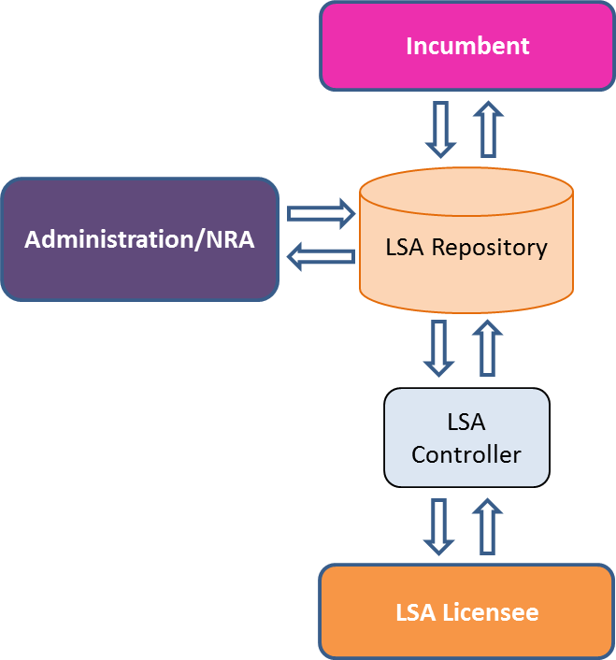
Figure 4: An example of ASA/LSA functional blocks and interactions
The ASA/LSA repository contains in particular the relevant information on ASA/LSA spectrum that must be protected together with the level of protection provided by the incumbent(s).

Possible Interfaces and contents
- Interface between ASA/LSA repository and ASA/LSA controller
  - Requirements for the technical information exchanged between the repository and the controller as well as requirements on security and reliability if such interface should be considered
- Interface between Administration / NRA and ASA/LSA repository
  - Requirements for the technical information exchanged between Administration / NRA and ASA/LSA repositories as well as requirements on security and reliability if such interface should be considered for interoperability.
- Interface between Incumbent and ASA/LSA repository
  - The Incumbent should provide the information on spectrum (frequencies, locations and times) that must be protected together with the level of protection.
  - Requirements for the technical information exchanged between the Incumbent and the ASA/LSA repository as well as requirements on security and reliability of such interface.
  - This Interface may be standardised in order to ensure harmonised markets, e.g. for Commercial PMSE applications.
- Interface between different ASA/LSA repositories
  - This interface is required in case those NRAs enter into dynamic cross-border agreements.
  - Requirements for the technical information exchanged between national ASA/LSA repositories as well as requirements on security and reliability.

Steps should be taken such that confidentiality and information sensitivity/security requirements are met.

Summary

This report provides an overview of the ASA/LSA concept being developed and deployed in various regions in the world including also ongoing work in ITU-R.

Frequency bands that have been allocated to mobile on a primary basis and identified to IMT by ITU in the Radio Regulations, may in some countries be difficult to be cleared by incumbents in foreseeable time and thus this can cause bottlenecks in providing sufficient capacity to mobile operators. Some existing IMT bands have encountered this problem in some countries. To provide access to those existing harmonized IMT frequency bands which are licensed and in use in some other regions/countries and therefore already implemented in terminal devices, spectrum sharing with the incumbent users could be one way forward, if e.g. the incumbent user is not using its spectrum all the time and/or using it in limited area(s).

This regulatory approach to define a licensing approach that allows spectrum sharing where incumbent users and mobile operators would share spectrum resources under well-defined conditions is called Authorized Spectrum Access (ASA) or Licensed Shared Access (LSA). The decision to apply LSA would done be on a national basis to provide a solution for that country to use a specific harmonized IMT frequency band under specified LSA conditions. Noting that if this specific IMT band is licensed and in use in some other regions/countries and therefore already implemented in IMT terminal devices, LSA would enable benefits from the existing IMT eco-system already available for that specific IMT band and give the opportunity to use affordable economy of scale products

The basic building block is an LSA repository that maintains relevant information on ASA/LSA spectrum that must be protected together with the level of protection provided by the incumbent(s). The LSA licensee can then by use of a LSA controller, interfacing the LSA repository, manage the access to the spectrum made available to the ASA/LSA licensee based on sharing rules and information on the incumbent’s use provided by the ASA/LSA repository.

APT countries that are not able to deploy IMT in the existing IMT identified band where there is a good and widely used eco-system already available, should consider using LSA in that band to get the advantages of the available eco-system.

