

**APT REPORT ON**

**FREQUENCY RANGES USED FOR NON-BEAM WPT FOR ELECTRIC VEHICLES**

**No. APT/AWG/REP-76  
Edition: September 2017**

**Adopted by**

**22nd Meeting of APT Wireless Group  
25 – 29 September 2017   
Busan, Republic of Korea**

***(Source: AWG-22/OUT-11)***

**APT REPOrt ON FREQUENCY RANGES USED FOR NON-BEAM WPT FOR ELECTRIC VEHICLES**

Contents

1. Introduction 3

2. EV applications and technologies 3

2.1 Passenger vehicles 3

2.2 Buses and trucks 5

3. Standardization status 6

3.1 APT countries 6

3.1.1 China 6

3.1.2 Japan 7

3.1.3 Korea 8

3.2 IEC CISPR 8

3.3 Other global/regional orgs (e.g., IEC/ISO, SAE, ETSI, …) 10

4. National regulations on WPT for EV application in some APT member countries 11

4.1 China 11

4.2 Japan 12

4.3 Korea 13

5. Frequency Bands Studies for WPT in Some APT Member Countries 13

5.1 Light duty (Passenger) electric vehicles 13

5.2 Heavy Duty Electric Vehicles 14

6. Status of studies on the impact to the incumbent systems in some APT member countries 17

6.1 Impact studies in China 17

6.2 Study results on WPT for passenger EVs in Japan 17

6.2.1 Objectives and preconditions for studies 17

6.2.2 Assessment process 18

6.2.3 Survey on spectrum use and determination of candidate frequency ranges 19

6.2.4 Selection of preferential incumbent systems to protect 20

6.2.5 Study on the impact of WPT systems for passenger EVs to the incumbent radiocommunication systems 20

6.2.6 AM broadcasting services 21

6.2.7 Standard frequency and time signal 25

6.2.8 Amateur radio 26

6.2.9 Railways control radios 26

6.2.10 Summary of the studies 26

6.3 Impact studies in Korea 26

6.3.1 Introduction 26

6.3.2 The impact study for 60 kHz standard time signal to Japanese standard frequency and time signal service 27

6.3.3 Impact study for EBU Signal (148.5 ~ 283.5 kHz) 30

7. Summary 33

# 1. Introduction

International interoperability of WPT systems is essential and indispensable to expand market of Electric Vehicles (EVs) for automotive OEMs and it is expected to maximize users’ benefit of EVs which move over several countries and / or regions. AWG has initiated a study on frequency ranges used for non-beam WPT for electric vehicles and collected related information from some APT countries from 2016. This Report provides information and necessary supports to APT members on their preparation for WRC-19 A.I. 9.1, issue 9.1.6. Furthermore, the work plan of the Report noted that a Recommendation on suitable WPT frequency ranges might be needed when this Report was fully discussed and approved in AWG.

AWG has been sending ITU-R SG1 WP 1A liaison letters providing information of WPT studies of AWG. Given that, WP 1A is continuing studies in accordance with Question ITU-R 210-3/1 and may develop Reports and/or Recommendations on technical and operational characteristics of WPT, including WPT for Electric Vehicles (EVs).

In APT, so far APT/AWG/REP-62(Rev.1) “APT Report on Wireless Power Transmission (WPT)” has summarized information including WPT for EVs as of March 2015. Taking account of WPT related studies and recent increasing demand of EVs in the automobile industry, this APT Report on frequency ranges for WPT for EVs emphasizes a focus on frequency ranges for WPT for EV applications and is edited, intended for the use of APT members who are going to consider regulatory and related spectrum management issues for WPT for EVs.

# 2. EV applications and technologies

## 

## 2.1 Passenger vehicles

Policies and/or attempts for air pollution reduction are discussed and performed worldwide for global environment preservation. Regarding mobile sources, in order to contribute much reduction of ozone and particulate matter, the cars we drive and the fuel we use must be transformed away from petroleum. The ZEV (Zero Emission Vehicle) Program developed and started in the California State, US, is one of typical approaches for this purpose. The conditions of the ZEV program will become even more severe in 2018 and the range of adoption will expand from California State to other 11 US states. China will also bring in the NEV (New Energy Vehicle) regulation of programs closer to the ZEV program in 2018. Also, in European countries, such as Germany, the United Kingdom and France, some programs which prohibit sale of cars using petroleum by 2030 or 2040 are discussed and planned. In these situations, automobile industries are going to have to shift from gasoline and diesel vehicles to Plug-in Hybrid Vehicles and EVs in the very near future.

Conductive charging systems for EVs have been already commercialized. However, wireless charging systems using WPT technologies are more effective and more attractive for EV users because WPT systems have the following merits:

* Avoidance of operations to attachment and remove charging connecters and cables.
* Effective for use cases in which frequently charging is required. For example, charging for mobility which moves around only in neighborhood areas, such as home delivery and mail delivery.
* Effective for use cases in which conductive charging is impossible. For example, charging for mobility in multistory parking garage.

From these considerations, many industries energetically develop WPT systems for EVs. Commercialization of WPT for EVs will start in 2018.

At the same time, standardization bodies such as IEC, ISO and SAE international, are discussing and developing new international standards for WPT systems for EVs. IEC and ISO will finalize the development of Technical Specifications (TSs) for magnetic field WPT systems for EVs by 2018. The frequency range for this WPT system is the most important specification, and is also needed to be determined and fixed internationally by 2018 as early as possible.

In accordance with the Directive 2014/94/EU of the European Parliament and of the Council on the deployment of alternative fuels infrastructure, the European Commission published, in March 2015, the Commission Implementing Decision (M/533) on a standardization request addressed to the European standardization organizations to draft European standards for alternative fuels infrastructure. While 17 standardization items, including those for electricity supply, hydrogen supply and natural gas supply, are listed in this document, standardization on WPT system for EVs is listed at the top. CENELEC is requested to publish a European standard containing technical specifications with a single solution for wireless recharging for passenger cars and light duty vehicles interoperable with the specification in IEC 61980-3, by December 31st of 2019. This has been a strong driving force for the standardization activity in IEC and ISO.

Magnetic Field Wireless Power Transmission (or Transfer) (MF-WPT) is one of the focal points in standardization discussion such as IEC PT61980, ISO PAS19363, and SAE J2954TF regarding WPT for EVs (including Plug-in Hybrid EVs) though there are several types of WPT methods proposed. MF-WPT for EVs contains both inductive type and magnetic resonance type. Electric power can be transmitted from the primary coil to the secondary coil efficiently via magnetic field by using resonance between the coil and the capacitor. Figure 2.1 shows the configuration of a WPT system for EVs.

Expected applications assume the following aspects.

1. WPT application: Wireless electric charging from electric outlet at a residence and/or a public electric service facility to EVs.
2. WPT usage scene: Electric Vehicle charging wirelessly at residence, apartment, public parking, etc.
3. Electricity use in vehicles: All electric systems including charging batteries, computers, air conditioners, etc.
4. WPT system example: See the following Figure 2.1.
5. WPT method: A WPT system for EVs has at least two coils. One is in the primary device and the other is in the secondary device. The coils are facing each other over the air gap (See (7) below). Electric power will be transmitted from primary device to secondary device through magnetic flux/field.
6. Device location (Coil location)
   * 1. Primary device: On ground or/and in ground
     2. Secondary device: Lower surface of vehicle
7. Air gap between primary and secondary coils: Less than 30 cm
8. Transmission power class example : 3 kW, 7 kW, 20 kW
9. Globally harmonized frequency operation
10. Safety: Primary device can start power transmission only if secondary device is located in the proper area for WPT. In addition, the system may operate foreign object detection mechanism between the primary and secondary devices before and during transmitting power. Primary device shall stop power transmission if the system detects an event that may jeopardize safe power transmission to maintain.

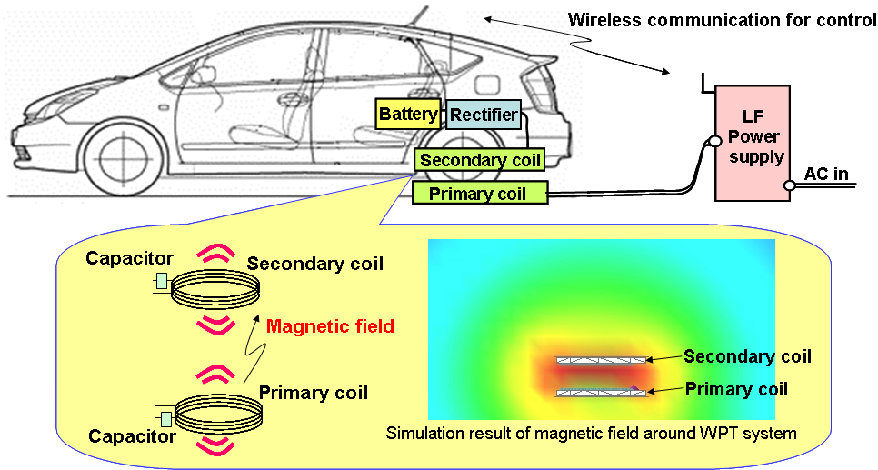

Figure 2.1 Example of a WPT system for passenger EVs

## 2.2 Buses and trucks

In order to run heavy duty vehicles such as an electrical bus, the infrastructure of the system is to embed electric strips in roadbeds that magnetically transmit energy to battery-powered vehicles above. The bus can move along the electrical strips without any stopping for charging its power, known as on-line electric vehicle (OLEV). Furthermore, the bus can be charged a stopping condition in bus stop or bus garage. The online bus at an amusement park or at the city is the first system operated in the form of EV for heavy duty vehicles in the world.



Figure 2.2 Technical characteristics of an online electric vehicle

The design of magnetic field from transmitting coil to receiving coil is the key in WPT system design for maximum power and efficiency.

First, the magnetic field should be in resonance by using resonant transmitting and receiving coils to have high power and efficiency.

Second, the magnetic field shape should be controlled, by using magnetic material such as ferrite‑core, to have minimum magnetic resistance in the path of the magnetic field, for lower leakage magnetic field and higher transmission power.

It is called as SMFIR (shaped magnetic field in resonance).

Radiation measurement methodologies WPT EV systems for the heavy-duty vehicle are specified in CISPR/B/672/DC.



Figure 2.3 Example of an online electric vehicle

# 3. Standardization status

## 3.1 APT countries

## 3.1.1 China

Regulatory standards and requirements are currently discussed and developments are in progress in local municipal bureaus, industrial groups, and WPT-related national committees.

**3.1.2.1 Local Standards Status**

(1) Shenzhen

Market and Quality Supervision Commission of Shenzhen Municipality issued a series of local standards including 10 parts in August 2015.

–SZDB/Z 150-2015, EV WPT System

Part 1 – General Requirements;

Part 2 – Communication protocols;

Part 3 - Requirements for wireless power transfer;

Part 4 – Interfaces;

Part 5 – Safety and Security;

Part 6 - Control and management system;

Part 7 - Electric energy metering;

Part 8 - Ground facilities;

Part 9 - On-board equipment;

Part 10 – Charging Stations

(2) Chengdu

Chengdu Bureau of Quality and Technical Supervision issued 2 local standards in June 2016.

* DB510100/T 205.1-2016, EV WPT System Part 1: Technical Requirements
* DB510100/T 205.2-2016, EV WPT System Part2: Equipment and Charging Station Requirements

(3) Shanghai

Shanghai Municipal Bureau of Quality and Technology Supervision issued 2 local standards in June 2017.

* DB31/T1054-2017, EV WPT System Part 1: Technical Requirements
* DB31/T1055-2017, EV WPT System Part 2: Equipment Requirements

(4) Guangdong

Administration of Quality and Technology Supervision of Guangdong Province is approving a series of provincial standards including 10 parts and will issue them soon.

* DB44/T XXXX –XXXX (to be released), EV WPT System

**3.1.2.2 Group Standards Status**

Wireless Power Transmission Alliance (WPTA) finished a series of group standards in December 2016.

* Magnetic Coupled Wireless Power Transfer
* Communication Protocols
* Safety Requirements
* Requirements and Test Methods for Electromagnetic Compatibility
* Requirements and Test Methods for Electromagnetic Field Radiation
* Interfaces
* Ground Facilities
* On-board Equipment
* Management System

**3.1.2.3 National Standards Status**

1. National Technical Committee of Auto Standardization (NTCAS (SAC/TC114))

NTCAS set up a new WG on EV WPT under TC114/SC27.

2 national standards for EV WPT system are planned:

* *General Requirements*, which is being approved by SAC
* Electromagnetic Compatibility Requirements and Test Methods, which was proposed in early 2017

1. China Electricity Council (CEC)

CEC set up a new WG on EV WPT under NEA/TC3.

3 national standards for EV WPT system since 2016 are planned:

* Special Requirements
* Electromagnetic Exposure Limits and Test Methods
* Communication Protocols between On-board and Ground Equipment

## 3.1.2 Japan

The WPT-Working Group of the BWF (Broadband Wireless Forum, Japan) is taking responsibility for drafting WPT technical standards utilizing the ARIB (Association of Radio Industries and Businesses) drafting protocols.

As of September 25th, 2017, the ARIB Standard STD-T113 “*WIRELESS POWER TRANSMISSION SYSTEMS*” have comprised WPT technologies intended for mobile applications only. Once a WPT specification for EV applications is developed in global basis in IEC 61980 and ISO 19363, the WG is going to draft a WPT standard for EVs. Technical regulatory requirements for standardization are introduced in section 4.1.

## 3.1.3 Korea

MSIT (Ministry of Science and ICT) and its RRA (National Radio Research Agency) are government agencies in charge of WPT Regulations in Korea. And the main standardization organizations developing the standards for WPT are shown in the table below.

Table 4.1 Standardization activities status in Korea

| Name | URL | Status |
| --- | --- | --- |
| KWPF | http://www.kwpf.org | Study area  - spectrum related to WPT  - regulatory related to WPT  - WPT based on magnetic resonance  - WPT based on magnetic induction  - Use Case  - Service Scenario  - Functional Requirement  - In-band communication for WPT  - Control for management of WPT |
| TTA | <http://www.tta.or.kr/English/index.jsp> | Study area  - Use Case  - Service Scenario  - Efficiency  - Evaluation  - In-band communication for WPT  - Control for management of WPT  - WPT based on magnetic resonance  - WPT based on magnetic induction  - Multi-device charging management  - RF beam WPT using 2.4GHz ambient WiFi signals for battery-less IoT devices |

## 3.2 IEC CISPR

In CISPR (Comité International Spécial des Perturbations Radioélectriques), WPT is taken by CISPR SC-B (Interference relating to ISM radio frequency apparatus, and to overhead power lines, etc.) for discussion. The other SCs D (electric/electronic equipment on vehicles), F (household appliances, lighting equipment, etc.) and I (information technology equipment, multimedia equipment and receivers) are also considering WPT.

SC-B formed a Task Force in June 2014 intended for specification development. Amendment to CISPR 11 for including the emission requirements in the frequency range 9 kHz to 150 kHz for power electronic WPT including EV is expected to be published by not later than 2019.

It must be noted that the scope of CISPR 11 is for ISM, currently there is no ISM band in the RR for 9-150 kHz.

In CISPR, Table A in CISPR/B/663/CD lists the following frequency ranges and typical usage for WPT.

|  |  |
| --- | --- |
| Frequency range (kHz) | Typical WPT usec |
| 19 to 25 | Local WPT via an air gap in cm range, throughput power up to 200 kW – automated in-plant transportation systems, trams and electric buses |
| 36 to 40 | Local WPT via an air gap in cm range, throughput power up to 200 kW – automated in-plant transportation systems, trams, and electric buses |
| 55 to 65a | Local WPT via an air gap in cm range, throughput power up to 200 kW – automated in-plant transportation systems, trams, and electric buses |
| 79 to 90b | Local WPT via an air gap in cm range, throughput power up to 22 kW – electric passenger vehicles |
| 1. It should be noted that 60 kHz is being used as a standard frequency and time signal service. 2. Candidate WPT frequency range for global harmonization. The frequency range of 79 kHz to 90 kHz is being considered for Electric Vehicles (see the Preliminary Draft New Recommendation ITU-R SM.[WPT](2015)). 3. The power for WPT systems is given for information only and is not related to any limits. | |

## 3.3 Other global/regional orgs (e.g., IEC/ISO, SAE, ETSI, …)

Many international and regional organizations are dealing with WPT standardization for EV applications and their relevant activities, which are summarized in Table 3.1.

Table 3.1 WPT standardization for EV applications and their relevant activities

| **Name of Organization** | **Activities** |
| --- | --- |
| ITU-R SG1 WP 1A / WP 1B | Revision to Report ITU-R SM.2303-1 (WPT NON-BEAM) for the study on Question ITU-R 210-3/1 was completed at WP 1A and subsequently approved at SG1 in June 2017.  Report ITU-R SM.2392 (WPT.BEAM.APPLICATIONS) for the study on Question ITU-R 210-3/1 was approved in June 2016.  Draft New Recommendation on WPT frequency range was adopted at SG1 for the approval process in June 2017.  WP 1A and WP 1B decided to continue the Rapporteur Group (RG-WPT) activities on developing content for deliverables related to Question ITU-R 210-3/1 and WRC-19 agenda item 9.1, issue 9.1.6.  WP 1B continued consideration of issue 9.1.6 at its meeting in June 2017. The work plan on this issue, the working document towards draft CPM text and the working document towards a preliminary draft new Report ITU-R SM.[WPT-SPEC-MNGM] were revised as appropriate. |
| IEC 61980  (IEC TC 69/WG7) | IEC TC 69 (Electric road vehicles and electric industrial trucks) WG7, together with ISO TC22 (Road Vehicles) SC37, discusses WPT for a vehicle.  – IEC 61980-1: General Requirements (Published in July, 2015)  – IEC 61980-2: Communication (Under development)  – IEC 61980-3: Magnetic Field Power Transfer (Under development)  85 kHz band (81.38-90 kHz) will be specified as the system frequency for passenger cars and light duty vehicles in IEC 61980-3.  Publications of TS (Technical Specifications) of the IEC 61980-3 and IEC 61980-2 as well as Edition 2 of IEC 61980-1, IS are planned to be by the end of 2017. |
| ISO 19363  (ISO (TC22/SC37)) | ISO 19363: Magnetic field wireless power transfer – Safety and interoperability requirements  – The SC37 was established in early 2014  – Target is to develop a standard which specifies requirements for the vehicle-side parts  – A close synchronization with IEC 61980 and SAE J2954  85 kHz band (81.38 - 90 kHz) is specified as the system frequency for passenger cars and light duty vehicles.  Publication of the PAS (Publicly Available Specification) has been done on January 2017, followed by the upgrading to IS (International Standard) by the end of 2018. |
| ETSI TC ERM | – ETSI TC ERM has recently published a technical report (TR 103 409) titled “System reference document (SRdoc); “Wireless Power Transmission (WPT) systems for Electric Vehicles (EV) operating in the frequency band 79-90 kHz”. This SRdoc must now be considered by CEPT who will consider WPT-EV systems and look at co-existence with radiocommunication systems.  – ETSI TC ERM has recently approved a final draft version of a new Harmonized Standard (EN 303 417) for the ETSI EN approval procedure (ENAP), which is supposed to specifically treat requirements for WPT systems (instead of EN 300 330 – Non-specific short range devices, which was used for WPT systems in the past, but is not applicable anymore to WPT systems as of the latest revision). EN 303 417 will now undergo further scrutiny and possible changes, Publication of the document is forecast for July 2017. Creation of EN 303 417 has triggered drafting of a new systems reference document (TR 103 493) which in time will be also considered by CEPT. |
| SAE (Society of Automotive Engineers) | The SAE International J2954™ Task Force for Wireless Power Transfer for Electric and Plug-in electric vehicles was established in 2010.  The SAE International published “SAE TIR J2954 Wireless Power Transfer for Light-Duty Plug-In/ Electric Vehicles and Alignment Methodology” in May 2016, which establishes 85 kHz band (81.38 - 90 kHz) as a common frequency band for wireless power transfer for all light duty vehicle systems up to 22kW. The TIR (Technical Information Report) specifies two power classes (3.7 kW and 7.7 kW). Two more classes of higher power levels up to 22 kW are given for future revisions.  SAE International is a global association uniting over 128,000 engineers and technical experts in the aerospace, automotive and commercial-vehicle industries.  See <http://www.sae.org/news/3415/> and <http://standards.sae.org/j2954_201605/>. |
| CJK WPT WG | The working group on WPT of the CJK Information Technology Meeting.  Shares information in the region to study and survey on low power and high power WPT  – Released CJK WPT Technical Report 1 in April 2013  – Released CJK WPT Technical Report 2 in Spring 2014  – Released CJK WPT Technical Report 3 in May 2015  – Finalized and released CJK WPT Technical Report 4 in August and September 2017, respectively |

Source: Approved revised version of Report ITU-R SM.2303-1 (to be published as SM.2303-2), APT/AWG/REP-62(Rev.1), CJK WPT Technical Report 4

# 4. National regulations on WPT for EV application in some APT member countries

## 4.1 China

In China, regulatory standards are currently discussed in WPT-related national committees.

CCSA initiated a study item on WRC19-Issue 9.1.6 in TC5 WG8.

It sends Liaisons to CEC and NTCAS for survey of EV WPT system working frequency.

* CEC is reviewing and will respond to CCSA
* CEC held a workshop for frequency range selection. 81.38-90 kHz was agreed then.

For WPT frequency range 79 – 90 kHz, CCSA conducts sharing and compatibility studies with incumbent systems below:

* Loran C
* Standard Frequency and Time Signal
* Broadcasting

## 4.2 Japan

In March 2016, new rules on the “Type Specification” of the “Equipment Utilizing High Frequency Current” for WPT for EVs using 79 - 90 kHz became effective. The “Equipment Utilizing High Frequency Current” is defined in the Radio Law of Japan and is under a regulatory scheme different from that for radio stations. The new rules allow equipment installation without individual permission by the administrator if the equipment conforms to the “Type Specification” and is in compliance with the rules. Regarding WPT for EV applications, emission limits are shown in Table 4.1 in accordance with frequency ranges designated.

Prior to the completion of the new rule development, the Ministry of Internal Affairs and Communications (MIC) of Japan completed studies on the impact of every proposed WPT system to incumbent radiocommunication systems. Details can be found in Section 6.

In specifying conductive and radiated emission limits, CISPR standards were referenced in light of international regulatory harmonization as shown in Table 4.1. For some specific use cases against the incumbent spectrum use, additional domestic coexistence conditions derived from the impact study were proposed and agreed.

Table 4.1 Emission limits for WPT for EV applications in Japan

|  |  |  |  |  |  |  |  |
| --- | --- | --- | --- | --- | --- | --- | --- |
| **WPT target application** | **Conductive  emission limits** | | **Radiated emission limits of fundamental wave** | **Radiated emission limits in other bands** | | | |
| **9-150 kHz** | **150 kHz - 30 MHz** | **79-90 kHz** | **9-150 kHz** | **150 kHz - 30 MHz** | **30 MHz - 1 GHz** | **1-6 GHz** |
| WPT for EV charging | Not specified | 0.15- 0.50 MHz:  Quasi-peak 66- 56 dBµV (linearly decreasing with log (f)  Average 56- 46 dBµV (linearly decreasing with log (f),  0.50- 5 MHz:  Quasi-peak  56 dBµV,  Average 46 dBµV  5- 30 MHz:  Quasi-peak  60 dBµV,  Average  50 dBµV, except ISM bands | 68.4 dBµA/m  at 10 m. (quasi-peak) | 23.1 dBµA/m  at 10 m. (quasi-peak),  except  79-90 kHz | Taking basis on CISPR 11 Ed. 5.1, converting  to values at  10 m distance, linearly decreasing with log (f) from  39 dBµA/m at 0.15 MHz to 3 dBµA/m at 30 MHz (1).  Exception-1:  For 158- 180 kHz,  237-270 kHz, 316-360 kHz, and 3 965- 450 kHz, emission limits is higher than (1) above by  10 dB.  Exception-2:  For 526.5-1 606.5 kHz, –2.0 dBµA/m (quasi-peak) | Taking basis on CISPR 11 Ed. 5.1,  the following is applied:  30- 80.872 MHz: 30 dBµV/m;  80.872- 81.88 MHz:  50 dBµV/m;  81.88- 134.786 MHz: 30 dBµV/m;  134.786-136.414 MHz: 50 dBµV/m;  136.414- 230 MHz:  30 dBµV/m;  230- 1 000 MHz: 37 dBµV/m | Not specified |

## 4.3 Korea

Determination of frequencies for WPT systems for heavy-duty EVs is as follows. Candidate frequency ranges for WPT are discussed in IEC TC69, CISPR/B/AHG4, ETSI 330 300, and ITU-R SG1. Based on the table in section 3.1 (CISPR), Korea determined 20 kHz and 60 kHz frequencies as the heavy-duty WPT EV systems (so called OLEV bus), mainly uses 20 kHz. The maximum power is 100 kW. It could be at least higher than 50 kW.

# 5. Frequency Bands Studies for WPT in Some APT Member Countries

As of September 25 of 2017, no ISM-bands have been proposed for the use of WPT for EVs in APT and in ITU-R for regional and/or global harmonized frequency ranges. Therefore, we discuss only Non-ISM bands in this Report.

## 5.1 Light duty (Passenger) electric vehicles

Japan performed an in-depth spectrum study for WPT intended for electric passenger (or light duty) vehicles, where 79 kHz – 90 kHz, 52 kHz – 58 kHz, and 42 kHz-48 kHz were proposed, reviewed, and evaluated to coexist with the incumbent devices and systems in 2012. In addition, 140.91 kHz – 148.5 kHz was added as it was proposed in international standardization bodies. These candidate frequency ranges were selected from 20 kHz – 200 kHz frequency range for WPT for EVs considered at IEC PT61980, ISO 19363, and SAE J2954TF. These frequency ranges have advantages to achieve high energy transmission efficiency in higher power circuit design. Furthermore, less number of incumbent systems were reported globally.

These bands are not ISM bands and not allowed for the use of ISM type devices and high power-transmission equipment in general. Intensive survey of the current spectrum usage in the world and studies on the impact to the incumbent systems were carried out to narrow down candidate spectrum to the most suitable one(s). Figure 5.1 shows global spectrum use of incumbent radiocommunication services and systems. More background provided from Japan can be found in section 6.1. The result of studies concluded that 79-90 kHz is the most suitable band for WPT for EVs which demonstrated not causing harmful interference to other radiocommunication systems in both the WPT operation band and other all bands. In the impact studies, Standard-frequency and Time-signal services, Train-radio-control-systems, AM radio broadcast services, and Amateur-radio services were chosen and specifically examined in light of receiver sensitivities, field test, and prescribed operation requirements.

In November 2013, SAE, in which many Asian automobile OEMs participates, announced an agreement on frequency of operation and power classes for “WPT for EV. LIGHT DUTY VEHICLE WPT FREQUENCY 85 kHz BAND: (81.38 – 90.00) kHz” was agreed. As of June 2017, 79-90 kHz is proposed in ITU-R SG1 WP 1A and 1B. In IEC 61980 and ISO 19363, same or similar frequency range is assumed as the baseline of the operation band. Detailed frequency range is to be determined with respect to global harmonization demand.

In March 2016, MIC of Japan issued a new rule (technical conditions) specifying 79-90 kHz for WPT-EV operation for maximum 7.7 kW class.

As of September 2017, China Electricity Council (CEC) has agreed frequency range selection of 79/81.38-90 kHz. China Communications Standards Association (CCSA) is conducting sharing and compatibility studies of WPT using 79-90 kHz band with incumbent systems.

## 5.2 Heavy Duty Electric Vehicles

This category refers to use cases of buses and/or trucks which require higher transmission power (e.g., > 22 kW) than Light duty vehicles shown above.

China has not allocated dedicated spectrum for wireless EV charging. Chinese industry is using multiple frequencies that are generally lower than 100 kHz in the developments and trials.

In Korea, both WPT modes on driving and stopping have been developed by OLEV (OnLine EV) and are now in commercial stage. In May 2011, Korea government allocated the frequencies for OLEV to 20 kHz (19 kHz - 21 kHz) and 60 kHz (59 kHz - 61 kHz). Theses frequencies can be used for any type of vehicle whether it is heavy duty or light duty vehicle in Korea. However, it needs to harmonize the frequency band between Korea and Japan, China as well.

Table 5.1 below summarizes Non-ISM spectrum considered for WPT applications in the CJK countries. The tables contain various parameters and characteristics including candidate frequency ranges and key power transmission parameters for target applications. In addition, concerned incumbent systems are also shown. Coexistence studies should be performed against their operating conditions before a frequency range is designated.

20

100

80

60

40

19.95-20.05 kHz (20kHz, Global): Std freq and time signal (Note 1)

39 -41 kHz (40kHz, Japan): Std freq and time signal (Note 1)

49.25 -50.75 kHz (50kHz, Russia): Std freq and time signal (Note1)

59 -61 kHz (60kHz, Japan, UK, USA): Std freq and time signal (Note 1)

65.85 -67.35 kHz (66.6kHz, Russia): Std freq and time signal (Note 1)

68.25 -68.75 kHz (68.5kHz, China): Std freq and time signal (Note 1)

77.25 -77.75 kHz (77.5 kHz, Germany): Std freq and time signal (Note1)

140

120

160

128.6 – 129.6 kHz (129.1 kHz, Europe): Radio Ripple Control (Note 3)

135.7 – 137.8 kHz: Amateur radio (Note 4)

90 – 110 kHz : Maritime radio (LORAN-C) (Note 2)

99.75 - 102.5 kHz (100 kHz, China): Std freq and time signal (Notes 1)

148.5 – 283.5 kHz (Region 1): AM broadcast services (Note 5)

157.5 – 166.5 kHz (162 kHz, France): Std freq and time signal (Note 1)

1605.5 – 1705 kHz (Region 2): AM broadcast services (Note 5)

400

300

500

424 kHz, 490 kHz, 518 kHz : Maritime radio (NAVTEX) (Note 2)

495 – 505 kHz: Maritime radio (NAVDAT) (Note 2)

472 – 479 kHz: Amateur radio (Note 4)

525 kHz - 526.5 kHz (Region 2): AM broadcast services (Note 5)

526.5 – 1606.5 kHz (Global):

AM broadcast services (Note 5)

Frequency

(kHz)

138.5 – 139.5 kHz (139 kHz, Europe): Radio Ripple Control (Note 3)

* Note 1: Amplitude modulation (BCD); The clocks and watches that periodically receive digital signals of the standard time transmitted from the standard-time-signal transmitting stations to synchronize and adjust own time.
* Note 2: Pulse, FSK etc. Radio system that secures safety of vessel operation which is used at port and harbor or on the sea.
* Note 3: A radio system used for load / demand control of electricity, which communicates over the electrical distribution system.
* Note 4: Radio service with transmitter and receiver devices used for technology research and training of amateur radio operators.
* Note 5: Note 6: Amplitude modulation; Audio broadcasting service with receiver devices which use long wave or medium wave band.

Figure 5.1 Global and regional spectrum use of incumbent radiocommunication services and systems

Table 5.1 Non-ISM band frequency ranges considered for WPT systems for EV applications characterized by frequency ranges, key parameters, and concerned incumbent systems

|  |  |  |
| --- | --- | --- |
|  | Resonant magnetic induction for Electric Passenger Vehicles | Shaped Magnetic Field in Resonance (SMFIR) WPT for Heavy Duty Electric Vehicles |
| Frequency Range (including those under study) | Japan reported the following regulated frequency range:  79 kHz – 90 kHz  In China, as of September 2017, China Electricity Council (CEC) has agreed frequency range selection of 79/81.38-90 kHz. CCSA is conducting sharing and compatibility studies of WPT using 79-90 kHz band with incumbent systems. | Korea reported the following regulated frequency range:  19 kHz – 21 kHz,  59 kHz – 61 kHz |
| Application types | Electric passenger vehicle charging while parking (Static) | On-line Electric Vehicle (OLEV) (Heavy duty electric vehicle charging while in motion and stopping/parking) |
| Technology Principle | Resonant magnetic induction | Resonant magnetic induction |
| CJK countries under consideration | Japan issued new rules (technical conditions) for the WPT use in 79 – 90 kHz.  China (79/81.38-90 kHz under sharing and compatibility studies) | Korea |
| Power Range | Maximum 7.7 kW; Classes are assumed for passenger vehicle | * Minimum power: 75 kW * Normal Power: 100 kW * Maximum Power: On developing * Air gap: 20 cm * Time and cost saving |
| Advantage | Global harmonized spectrum  Higher power transmission efficiency | * Increased power transmission efficiency * Maximized air gap * Reduced audible noise * Effective shield design * Time and cost saving |
| Related Alliance/ international standards | * 81.38-90 kHz as the primary interest in IEC PT61980 (IEC TC69) and ISO PAS19363 (ISO TC22) * 81.38-90 kHz in agreement in SAE J2954 * 79-90 kHz is proposed in ITU-R SG1 WP 1A / 1B. |  |
| Domestic concerned incumbents for spectrum sharing | Japan completed studies on the impact studies for the following services:   * Standard frequency and time signal devices (40 kHz, 60 kHz) * Railway radio systems (10 kHz – 250 kHz) * Amateur radio (135.7 kHz – 137.8 kHz) * AM Broadcast (526.5 kHz – 1606.5 kHz)   China is taking sharing and compatibility studies to assess impact to the following incumbent systems:   * Loran C * Standard frequency and time signal devices * Broadcasting services | Fixed Maritime Mobile (20.25 kHz kHz) Maritime Mobile (20.25.5 kHz), Restricted to Hyperbolic Curve Radio-navigation(DECCA) (84 kHz – 86 kHz) |

# 6. Status of studies on the impact to the incumbent systems in some APT member countries

## 6.1 Impact studies in China

CCSA is conducting sharing and compatibility studies of 79-90 kHz band with incumbent systems shown below:

* Loran C
* Standard Frequency and Time Signal
* Broadcasting services

## 6.2 Study results on WPT for passenger EVs in Japan

Japanese national regulations for WPT systems for passenger (light duty) EVs had been published and put into force in March 2016. Since 2013 when this study on the WPT system impact has been initiated at the WPT-Working Group (WG) under MIC’s Committee on Electromagnetic Environment for Radio-wave Utilization, WPT systems for passenger EVs using 79-90 kHz range could have demonstrated performance not-causing unwanted effect to the concerned incumbent radio systems and services including Standard Frequency and Time Signal devices, AM broadcasting services, and amateur radios in the defined use cases. Subsequently, the WG reached an agreement on additional technical requirements not to cause harmful interference to railway wireless control systems.

This section describes the latest study results and methodologies taken in the studies on the impact of WPT for passenger EVs to the systems and services shown above.

The impact to the incumbent systems are currently studied in ITU-R WP 1A and WP 1B as well. Japan’s assessment methodologies and Japanese study results till 2016 are described in the new revision of Report ITU-R SM.2303-1 "Wireless power transmission using technologies other than radio frequency beam" (to be published as SM.2303-2) which was approved at SG1 in June 2017.

## Objectives and preconditions for studies

Seeing substantial increasing demand of WPT systems for passenger EVs, in 2013 the WG initiated studies on spectrum sharing for WPT for passenger EVs and impact to the incumbent radiocommunication services. The WG aimed to provide technical conditions for new rulemaking intended for WPT technologies including suitable frequency ranges and emission limits which shall not cause harmful interference to incumbent radiocommunication services. Key technical conditions agreed at the WG, such as frequency ranges and emission limits, must be agreed and accepted globally and / or regionally as well.

In the studies, existing radiated emission limits specified in current Japan’s radio regulations for inductive cooking heaters were the baseline specifications when considering radiated emission limits for WPT systems. So far, any harmful disturbances and / or electromagnetic interference to other radiocommunication systems from inductive cooking heaters have not been reported. In addition, the same situation is globally found because commercialized ISM devices and inductive cooking heaters are applying international standards, such as CISPR 11, Group 2, Class B, and/or CISPR 14-1. Specifically, almost same levels of radiated emission limits are adopted in Japanese regulations for inductive cooking heaters, CISPR 11, Group 2, Class B, and CISPR 14-1, which offers global harmonized protection of radio reception from interference sources including WPT systems.

WPT systems for passenger EVs are expected to be launched and commercialized mainly in urban areas. Therefore, radio environment characteristics and usage models in urban areas should correctly and suitably be chosen in the studies. For example, the required separation distance assumed for the radiocommunication device was 10 meters as specified in CISPR 11 Group-2 Class-B. Also, propagation loss due to walls of houses and buildings was assumed 10 dB referring to a Japanese domestic study. Furthermore, it should be noted that self-interference case was not taken into considerations, where self-interference means an event that unwanted emission from an owner’s WPT system interferes to the same owner’s wireless devices. Notably, for the impact study to AM broadcasting services, radiated emission limits from WPT systems should be lower than the environment noise level in urban areas; and then, Recommendation ITU-R P.372-13 as a global technical standard, was referenced to determine the radio noise characteristics. It was assumed that the separation distance in suburban areas was larger than those in urban areas while man-made-noise level in suburban areas goes lower.

While section 6.1 describes studies mainly from technical aspects, there may be other conditions when considering possibility of adverse impact to radiocommunication services, for example, relative location / orientation between the WPT systems and the radiocommunication devices, operation hour and its time distribution of the WPT systems and the radiocommunication systems, probability of unwanted-emission-concerned frequency channel selection of the radiocommunication devices in timing and geographical aspects, and so on. Therefore, a possibility to cause harmful interference to radiocommunication systems may be lower than technical study results. If the WPT system should cause unacceptable interference to the receivers, radio administrations shall provide necessary regulatory measures / orders to stop WPT system operation causing harmful interference to the other incumbent radio systems.

## 6.2.2 Assessment process

The WG performed studies on frequency selection for WPT systems and on the impact of WPT to the other incumbent radiocommunication services from 2013 to 2015. Assessment was made with proposed WPT operating frequencies. WPT for EVs was the most interested agenda item.

Assessment in the studies had the following steps:

1. First step: Survey on spectrum use and determination of candidate frequency ranges.

Survey the spectrum usage of incumbent radiocommunication services in the proposed WPT operating frequency ranges, adjacent bands, and other frequency ranges in which WPT harmonics may fall. These services may have any possibility to suffer service quality degradation caused by WPT systems. Determine candidate bands for WPT from relatively vacant spectrum.

1. Second step: Selection of preferential incumbent radiocommunication systems to protect.

Pick up incumbent radiocommunication systems which might be suffered from WPT in the candidate band(s). Prioritize the systems to protect by clarifying attributes of services in accordance with the following condition and/or usage situations:

* The frequency range category in the Radio Regulations (RR)
* Justifications for protection from the WPT system
* Mechanism to avoid harmful interference from WPT systems

Above considerations lead to selection of the preferential incumbent radiocommunication systems.

1. Third step: Assessment of WPT emission to the incumbent systems.

The impact of WPT systems to each selected incumbent radiocommunication services are assessed by simulation and/or measurement. In this step, the following points should be clarified.

* Frequency ranges of power transmission, power level, and any other parameters or characteristics that may influence to the incumbent radiocommunication services.
* Use cases of the incumbent systems with defining parameters including: operation period of time (in particular overlapped period in use with WPT), physical separation distance or positioning.
* Emission strength from WPT systems: The maximum emission strength should appropriately be determined for assessment referring to available regulations or draft document developed in CISPR/B.
* Test and verification: Unwanted emission strength calculated or measured at the concerned receiver shall not exceed the receiver sensitivity or shall not cause any operational failure. In addition, use case conditions such as use-time distribution, time-overlapping of operations, and practical device locations should be taken into consideration.

The advisability of mitigation of the impact should be discussed and judged by the result of the above-mentioned process. Frequency ranges with an adequate mitigation of impact verified and confirmed in the process could be recommended as the candidate frequency ranges for non-beam WPT for EVs.

## 6.2.3 Survey on spectrum use and determination of candidate frequency ranges

WPT frequency ranges for EVs are assumed to be in the frequency range below 150 kHz, considering discussions about WPT frequency in IEC TC 69/PT61980, ISO TC22/PAS 19363 and SAE J2954TF. Also, frequency ranges of harmonics were taken in consideration of frequency range selection. This survey covered frequency ranges below 1 MHz. The result of the survey of spectrum use is shown in Table 6.1 and Figure 5.1. Given the survey results in domestic and international spectrum availability and proposals of WPT systems for EVs, the following frequency ranges were chosen for assessment:

42-48 kHz (45 kHz band),

52-58 kHz (55 kHz band),

79-90 kHz (85 kHz band), and

140.91-148.5 kHz (145 kHz band).

Table 6.1: Spectrum use of incumbent radiocommunication services and systems

|  |  |  |  |  |
| --- | --- | --- | --- | --- |
| **Radiocommunication services and systems** | | **Frequency bands** | **Modulation** | **Remarks** |
| Standard frequency and time signal | | 19.95 kHz - 20.05 kHz (20 kHz, Global)  39 kHz - 41 kHz (40 kHz, Japan)  49.25 kHz - 50.75 kHz (50 kHz, Russia)  59 kHz - 61 kHz (60 kHz, UK, US and Japan)  65.85 kHz - 67.35 kHz (66.6 kHz, Russia)  68.25 kHz - 68.75 kHz (68.5 kHz, China)  77.25 kHz - 77.75 kHz (77.5 kHz, Germany)  99.75 kHz - 102.5 kHz (100 kHz, China)  157.5 kHz - 166.5 kHz (162 kHz, France) | Amplitude Modulation (BCD) | Clocks and watches periodically receive digital signals transmitted from standard frequency and time signal stations to synchronize and adjust their own time. |
| Ripple Control | | 128.6 kHz - 129.6 kHz (129.1kHz, Europe)  138.5 kHz - 139.5 kHz (139 kHz, Europe) | － | Radio systems used for load/demand control of electricity, which communicates over the electrical distribution system |
| Train protection automatic warning system | Automatic Train Stop (ATS) Systems | 10 kHz - 250 kHz (Japan) | － | Telecommunication systems which apply electric current to the coils installed along railroad tracks and detect electric current induced in the coils installed on train vehicles on the rail to control the trains. |
| 425 kHz - 524 kHz (Japan) |
| Inductive Train Radio Systems (ITRS) | 100 kHz - 250 kHz (Japan) | － | Signal transmission systems which use inductive coupling between transmission line which is installed along the railroad track and so forth and antennae which are installed on train vehicles. |
| 80 kHz, 92 kHz (Japan, only one route) |
| Amateur radio | | 135.7 kHz - 137.8 kHz | Amplitude Modulation, Frequency Modulation, Single Sideband, etc. | Systems for the amateur service as defined in No. 1.56 of the Radio Regulation, for the purpose of self-training intercommunication and technical investigations carried out by amateurs |
| 472 kHz - 479 kHz |
| Maritime radio | | 90 kHz - 110 kHz (LORAN) | Pulse Modulation, Frequency Shift Keying etc. | Radio systems used at port and harbor or on the sea in order to secure safety of vessel operation, etc. |
| 424 kHz, 490 kHz, 518 kHz (NAVTEX) |
| 495 kHz - 505kHz (NAVDAT) |
| AM broadcasting | | 148.5 kHz - 283.5 kHz (Region 1)  525 kHz - 526.5 kHz (Region 2)  526.5 kHz - 1606.5 kHz (Global)  1605.5 kHz - 1705 kHz (Region 2) | Amplitude Modulation | Systems for audio broadcasting services with receivers which use LF and MF bands. |

## 6.2.4 Selection of preferential incumbent systems to protect

As a result of survey of incumbent systems, the following four incumbent systems were selected for assessment of the impact of WPT for passenger EVs:

- Standard frequency and time signal services and systems (40 kHz, 60 kHz)

- Train radio systems (10 kHz - 250 kHz)

- Amateur radio (135.7 kHz - 137.8 kHz)

- AM broadcasting (526.5 kHz - 1606.5 kHz)

Train radio systems are operated in a unique environment. Therefore, they are not categorized clearly in Japan’s radio regulations. However, the WG decided the train radio systems to assess because it is a safety matter to prevent train service users from any accidents.

Ripple Control service is not operated in Japan and was put outside the scope.

## 6.2.5 Study on the impact of WPT systems for passenger EVs to the incumbent radiocommunication systems

(1) Determination of specifications of WPT systems for passenger EVs

Specifications of the WPT systems were determined as follows:

* WPT technology: Magnetic coupling (resonant magnetic coupling)
* Application: Electric passenger vehicle charging while parking (Static)
* Frequency range: 79 kHz - 90 kHz (so-called 85 kHz band)

In the first phase of discussion, four frequency ranges were proposed by industries. As the result of survey and discussion, 79 kHz - 90 kHz range was selected as the primary frequency range by referring to IEC and SAE discussion results in the view of global harmonization.

* Transmission power range: 3 kW-class and 7.7 kW-class; Classes are assumed for passenger vehicles

(2) Emission limits for assessment

Referring to the emission limits of FCC Part 18 as a global reference and Japan’s radio regulations for inductive cooking heaters, and also referring to CISPR 11 Group2 Class B for the frequency range over 150 kHz, the following emission limits of magnetic field were determined for assessment.

(a) WPT frequency range (frequency range used for power transmission)

68.4 dBμA/m@10m for 3 kW Tx Power

72.5 dBμA/m@10m for 7.7 kW Tx Power

(b) Frequency range from 526.5-1606.5 kHz (AM broadcasting services frequency range):

-2.0 dBμA/m@10m (same as the current Japanese emission rule)

(c) Other frequency ranges expect for 526.5-1606.5 kHz:

23.1 dBμA/m@10m

The above target emission limits were settled firstly, in the frequency ranges both under 526.5 kHz and over 1606.5 kHz. However, after discussion, it was approved to apply the limits of CISPR 11, Group 2, Class B in the frequency range over 150 kHz except for AM broadcasting frequency ranges.

## 6.2.6 AM broadcasting services

For co-existence between WPT systems and broadcasting services, the impact to broadcasting services should be discussed in any radio environments, such as rural, residence and urban areas. This section describes a study on the impact in urban and suburban areas conducted in Japan. Meanwhile, the European Broadcasting Union provides a study based on an analytical approach using the protection criteria of broadcasting service written in ITU-R Recommendations and Reports. It derives the maximum tolerable magnetic field from WPT at the broadcasting receiver in the LF and MF bands. The derived maximum tolerable magnetic field strengths are almost at same level as the environment noise level in quiet rural areas as described in Rec. ITU-R P.372-13. For details, please see Section 7.2.1 of the new revision of Report ITU-R SM.2303-1 (to be published as SM.2303-2).

WPT systems for EVs shall not cause harmful interference to an AM broadcasting receiver located at least within 10 meters distance from the systems based on the target radiated emission limits. Emission measurements using a WPT transmitter and WPT receivers on a mock wagon were performed under the agreed worst use case conditions, where the rotation angle of AM broadcasting receivers was selected and set to null direction to receive broadcasting signal considering antenna directive patterns. In addition, the AM receivers were located on the axis at which the strongest WPT unwanted emission waveform arrives considering WPT coil emission patterns. WPT’s 7th harmonic of *Fc* = 85.106 kHz falls into 594 kHz AM broadcasting channel, which covers a wide area of Kanto-region of Japan. Hearing (audibility) assessment was performed as well. A criterion for satisfactory mitigation of the impact of WPT for passenger EVs to AM broadcasting was confirmed.

Details are described below:

(a) Basic conditions of the impact study

At first, the WG clarified the following conditions and use cases for the impact study.

– Acceptable maximum emission (the target emission limit) is –2.0 dBμA/m@10m which follows the existing emission limit for inductive cooking heaters in the 526.5‑1 606.5 kHz range (AM broadcasting frequency range)

– Self-interference was not taken into consideration.

– AM broadcasting receivers are located inside houses or buildings. On the other hand, a WPT system for EVs is located outside of the houses or buildings. Propagation loss due to house walls should be considered.

– Separation distance between a WPT system and an AM broadcasting receiver is 10 m, under assumption that the nearest neighborhood house is located more than 10 m apart from the WPT owner’s house.

– Receivers are assumed to be located in a high-field strength area (receiving electric field strength is more than 80 dBμV/m), and a medium-field strength area (66 dBμV/m). The protection for the broadcast reception users in a low–field strength area (48 dBμV/m) is also important. However, the impact study in the WG focused on high-field strength and medium-field strength areas, because WPT systems are expected to gain in popularity in urban areas in the initial stage and then spread over other areas.

(b) Analytical study

In the next step, the impact of WPT for passenger EVs on AM broadcasting was studied by an analytical approach. In this step, the following criteria were agreed and taken.

– Acceptable radiated emission limits should be lower than environmental noise level in a particular area. An emission limit of 26.0 dBμV/m at 594 kHz is adopted by referring to the environmental noise of “City” described in Recommendation ITU-R P.372-13. This electric field strength (26.0 dBμV/m) is converted to magnetic field strength (–25.5 dBμA/m) as the acceptable maximum unwanted emission at the receiver.

– Propagation loss due to walls of houses and buildings between a WPT system and an AM broadcasting receiver is assumed to be 10 dB by referring to the reported results of MIC’s round-table conference concerning MF broadcasting pre-emphasis (Dec. 1983).

This analysis intended to assess the impact to the AM receiver in terms of magnetic-field emission by calculation when a measured unwanted emission strength was given and applied. For that purpose, the system model simulated the condition in (a) and other conditions were agreed; and then, unwanted emission strength at the receiver location was calculated. It was assumed that a WPT system for EV was located 10 m apart from the nearest neighborhood house in which the receiver was located. Furthermore, an AM broadcasting receiver was located at 50 cm inside from windows of the house. The WPT parameters such as radiated emission strength (i.e., –15.6 dBμA/m) and necessary conditions were the same as the WPT system shown as “Test Equipment B” for EVs described in Annex 3 to the new revision of Report ITU-R SM.2303-1 (SM.2303-2).

The following points were suggested in this analytical study:

– Calculated emission strength derived with the measured emission strength satisfies the acceptable unwanted emission strength.

– The measured emission strength used for calculation is lower than the target emission limit of –2.0 dBμA/m by more than 10 dB, which shows substantial clearance for emission to the limit. This number was supported because industries sensibly and commonly take account of uncertainty budget by 10 dB or more for their emission performance margin in their design and test stages.

– In practical condition, unwanted emission strength from WPT systems reaches to –25.6 dBμA/m (= –15.6 dBμA/m – 10 dB), which is nearly or less than the acceptable unwanted emission strength, –25.5 dBμA/m.

The above consideration was accepted by the WG. Thereafter, the agreed target emission limit of –2.0 dBμA/m in the AM broadcasting frequency range in Japan was confirmed to be the acceptable number and then approved as a new regulation concerning WPT.

(c) Magnetic field emission measurement

In order to confirm the result of the analytical study above, emission measurement using WPT test equipment and AM broadcasting receivers was performed. Conditions and methods were as follows:

i) Measurement set up

As mentioned above, the “Test Equipment B” for EVs, described in Annex 3 to the new revision of Report ITU-R SM.2303-1 (SM.2303-2), was used in this experimental test. The WPT frequency of the Test Equipment was 85.106 kHz. The transfer power was 3 kW at the input port of the transmission coil. The 7th harmonic of this WPT equipment was 595.742 kHz. Measured radiated emission levels of the WPT frequency and harmonics of “Test Equipment B” are plotted in Figure 6.1.

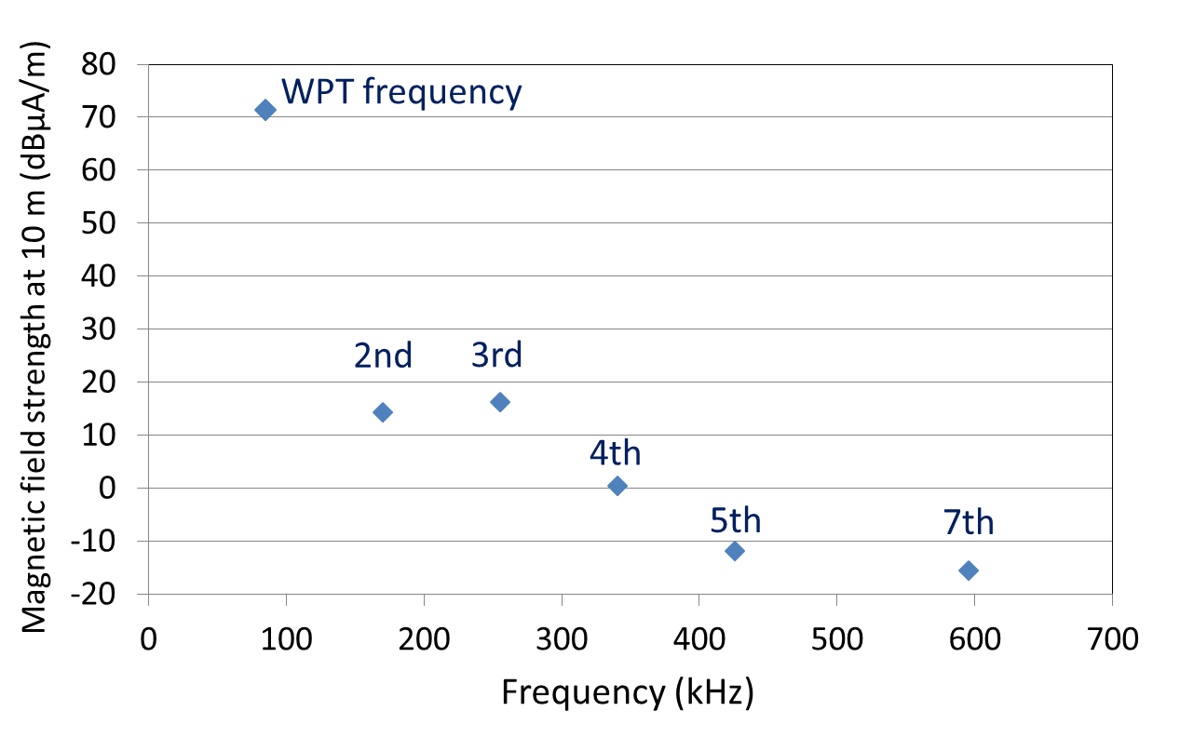

Notes: The 6th harmonic is not plotted as can be plotted below the bottom of the y-axis scale.

Figure 6.1: Measured magnetic field strength of fundamental and harmonic waves of “Test Equipment B” (Quasi-peak value)

(d) Audibility test

i) AM broadcasting receiver selection

Several types of AM broadcasting receivers, including high-end type and portable type were prepared for this experimental test.

ii) Date and place

Date of this experimental test is from 1st July to 2nd July, 2014. Open area test site of Telecom Engineering Center (TELEC) Matsudo Laboratory was used for this experimental test. TELEC Matsudo Laboratory is located in a general residential suburban area nearby Tokyo.

iii) Broadcasting service channel and frequency

In the Tokyo area, there is an AM broadcasting channel of NHK Radio 1 at 594 kHz. The frequency difference between NHK Radio 1 and the 7th harmonic of “Test Equipment B” is about 1.7 kHz. If the 7th harmonic of “Test Equipment B” is larger than environmental noise, we can hear noise of 1.7 kHz.

Test procedure was as follows:

• At first, received field strength of AM broadcasting, radiated emission strength of harmonics of WPT equipment and environmental noise level were measured by using a spectrum analyzer. In the measurement, the receiving antenna received vertical and horizontal directions of H-field. The WPT equipment was placed at the 90 degrees rotated direction which maximizes the received unwanted emission strength. From these checking operations which consider the polarization and the radiated emission directivity from the WPT equipment, the maximum unwanted emission strength can be realized. Figure 6.2 shows the condition of the worst case which demonstrates the maximum impact to broadcasting receivers from the WPT equipment in this experimental study. This figure illustrates the location of the AM radio broadcasting station, AM radio receivers and the WPT equipment, and also describes the relationship between the antenna pattern of radio receivers and the direction of the maximum emission from the WPT equipment.

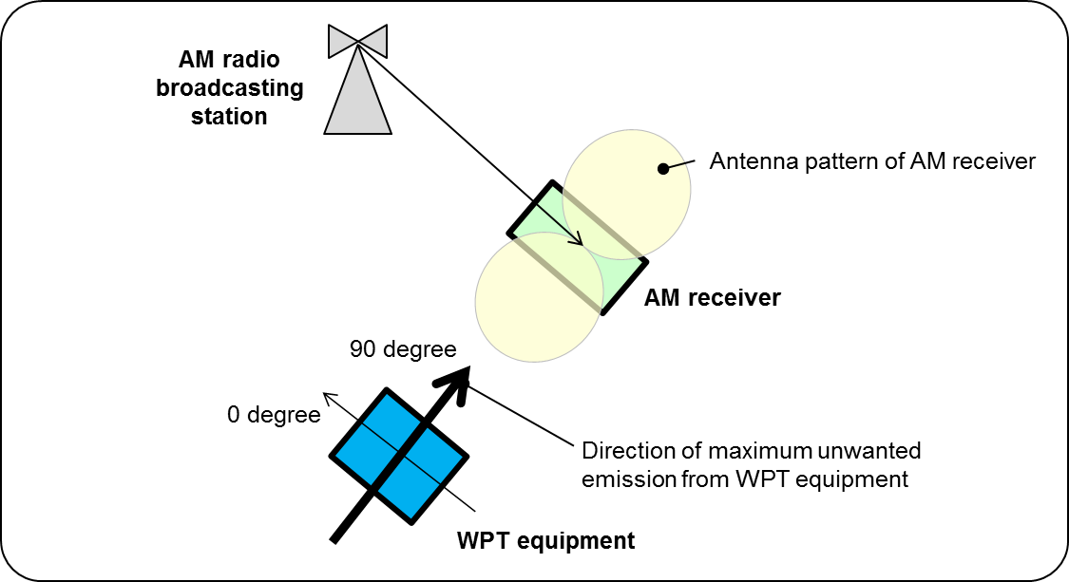

Figure 6.2: Measurement condition of audibility test

• Next, an audibility test was performed by the participants listening to the broadcasting programs at several different locations separated by different distances including 10 m and 3 m from the WPT equipment. In this audibility test, the separation distance of 10 m matches the required conditions for this impact study. The test of 3 m separation distance was done only as reference. In this test, the face direction and the rotation angle of broadcasting receivers were selected at the worst condition for broadcasting reception considering antenna directive patterns and polarizations of those receivers. At the same time, the face direction and the rotation angle of broadcasting receivers were also adjusted to maximize the interference emission from the WPT equipment.

iv) Test results

The measurement results of received electric field strength are shown in Figure 6.3. The field strength of AM broadcasting was about 100 dBμV/m and the environmental noise level was about 60 dBμV/m, which are much higher than the assumption described in (a). In this figure, electric field strengths where the WPT equipment is ON and OFF are described. The difference between the WPT equipment of ON and OFF conditions is not clearly found in this figure, because the environmental noise level is slightly higher than the 7th order harmonic from the WPT equipment.

The results of this audibility test were as follows:

• AM broadcasting receivers located at 10 m from WPT equipment

The tone noise could be recognized as a very small sound only in very silent broadcasting programs but never in normal audio programs. In general, the tone noise under this test condition deems not to disturb general broadcasting listeners listening radio programs.

• AM broadcasting receivers located at 3 m from WPT equipment

The tone noise can be easily caught when broadcasting programs are relatively silent, such as news programs. On the other hand, when broadcasting programs are busy, such as music programs, the tone noise cannot be easily caught.

(e) Assessment of study results

Under agreed test conditions and use cases assumed in urban area, magnetic field emission strength derived by analytical study and also that measured by a WPT-EV test equipment in a field measurement site showed acceptable (= non-harmful) level of emission received while settling the emission limit –2.0 dBμA/m in the AM broadcasting frequency range. In audibility assessment, It was confirmed that the tone generated by the WPT 7th harmonic falling in an AM broadcast channel in MF band was indistinct while listening to radio programs or obscurely audible during very quiet programs. It demonstrated little impact and no harmful interference to the AM broadcasting service. From this result, Japan's new regulations for WPT systems adopted this limit in the frequency range of AM broadcasting service.

This methodology for measurement and assessment must be useful for radio regulators who intend new rule making for WPT for EVs in urban area where Environment Category “City” in Rec. ITU-R P.372-13 can be applied.



Figure 6.3: Measured electric field strength of an AM broadcasting channel when WPT is ON and OFF

## 6.2.7 Standard frequency and time signal

WPT devices whose radiated emission are lower than the emission limits (See Section 6.1.5(2)) will not cause harmful interference, which is defined by C/I ratio derived from the minimum receiver sensitivity of the radio-controlled clocks/watches in agreed use cases. Separation distance of 10 m was used to assess the impact to those devices. Additional features of those devices, such as operation time not overlapping with WPT operation, variation of propagation direction of standard frequency and time signal services, and possible performance improvement of those devices were taken into consideration. By these discussions, the impact of WPT systems to radio-controlled clocks/watches has been confirmed to be small enough.

## 6.2.8 Amateur radio

The candidate frequency range for WPT for EVs, 79-90 kHz, does not overlap with and has enough separation from frequency bands for amateur radio services. Therefore, receiver sensitivity suppression (out-of-band) by interference is not taken into consideration. Radiated emission levels of harmonics (spurious emission) from WPT might need to be counted in case they fall into the amateur radio services bands. Considering the target emission level described above, candidate frequency range for WPT systems for EVs show acceptable system parameters to demonstrate possible non-harmful interference to amateur radio.

## 6.2.9 Railways control radios

In the studies on the impact to train radio systems, harmful interference in the actual use cases in operation was considered and discussed by simulation and measurements. The conditions for discussion were as follows:

* Frequency range for WPT should not overlap with those used for the train radio systems including Automatic Train Stop Systems (ATS) Systems and Inductive Train Radio Systems (ITRS).
* The separation distance to the ATS/ITRS devices, in which a WPT system does not cause harmful interference, should be less than the most critical threshold (approx.1.5 m) specified in the train systems building standards.

As the results of this impact study, the separation distance required to meet the condition was more than 5 m for ATS, and more than 45 m for ITRS, respectively. However, ITRS which uses the same frequency band as WPT for EVs is in operation in the very specific and locally limited areas. The impact to ITRS can be mitigated by cooperation between WPT industries and a railway operator. Therefore, the WG has decided that the above –mentioned separation distance should not be applied to Japan’s new regulations concerning WPT. As a result of discussions, a condition, that WPT systems for EVs should be located more than 5 m apart from train tracks, has been clearly described in the Japan’s regulations concerning WPT.

## 6.2.10 Summary of the studies

The WG concluded that WPT systems can be used without causing any operational errors on the selected incumbent radiocommunication services except for train radio systems. For train radio systems, malfunction occurrence caused by unwanted emission from WPT systems becomes negligible if the separation distance between WPT systems and train radio systems is larger than 5 m. This condition is clearly described in the Japan’s regulations concerning WPT. The emission limits for WPT for EVs described in Section 6.1.5 (2) were agreed at the WG, approved by the Information and Communication Council. A draft amendment of Japan’s radio regulations was approved by the Radio Regulatory Council, then published and put into force in March, 2016. In the Japan’s regulations concerning WPT, the radiated emission limit in the range of WPT operating frequency is 68.4 dBμA/m@10m regardless the WPT output power class, 3 kW or 7.7 kW.

## 6.3 Impact studies in Korea

Measurement methodologies used for the studies described in this section, measured data and technical information are introduced in detail in the new Revision of Report ITU-R SM.2303-1 (to be published SM.2303-2).

## 6.3.1 Introduction

Since Japan suggested an impact study for an interference between WPT EV frequencies and Japanese Standard frequency and time signal (60 kHz) in 2015, Korea has tried various impact case studies for many times.

The study items are as follows;

1. 60 kHz interference to Japanese standard frequency and time signal service
2. Using 19.98 kHz in Heavy-duty WPT EV (EV bus located in Gumi city)
3. Using the power level as 99.98 kW
4. Harmonic frequencies interference to EBU’s broadcasting service

## 6.3.2 The impact study for 60 kHz standard time signal to Japanese standard frequency and time signal service

Japan reported to ITU-R SG1 WP1A the co-existence study internally between WPT EV and other electronic devices in Nov 2014 written by Japanese language. It included also EMI and EMF issues.

Since ITU-R SG1 WP1A meeting in June 2015, Japan delegation of ITU-R SG1 insisted that NICT(Japan) uses 60 kHz as standard frequency and time signal from the Hagane-transmitting station located in Kitakyushu. Japan requested the interface and/or impact study between Korean heavy-duty WPT EV and Japanese standard frequency and time signal.

FIGURE 6.4

Electric field strength of 60 kHz standard frequency and time signal (source: NICT Homepage)

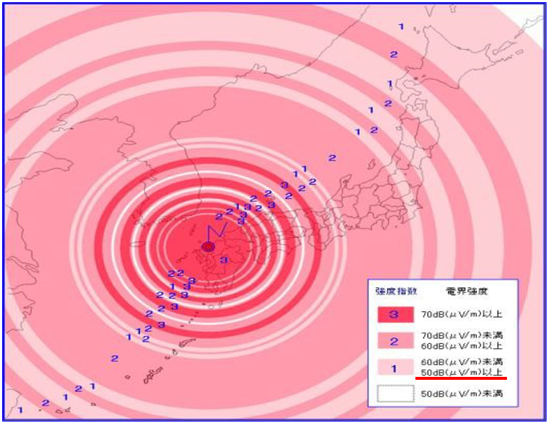

According to Electric field strength table of the 60 kHz (source: NICT homepage), the lowest level is 50 dB㎶/m. In this reason, the limitation of 60 kHz standard frequency and time signal is 50 dB㎶/m.

The real clocks used 60 kHz standard frequency and time signal is shown in Figure 6.5 and the test result is shown in Figure 6.6.

FIGURE 6.5

Real clocks used 60 kHz standard frequency and time signal

|  |  |
| --- | --- |
|  |  |

FIGURE 6.6

Test result of 10 m and 100 m based on 60 kHz standard frequency and time signal

|  |  |
| --- | --- |
| 10 m (charging) | 100 m (charging) |
|  |  |

At 10 m, the amplitude of 60 kHz is 55.85 dBuV/m and the value is greater than the limitation with 5.85 dB. At 100 m, the amplitude of 60 kHz is 15.37 dBuV/m and the limitation had a margin of 34.63 dB.

In a result, 100 m of separation distance is enough to protect the 60 kHz standard frequency and time signal clock from a heavy-duty WPT EV charging station. In practice, 50 m distance is acceptable to meet the 40 dBuV/m limitation.

## 6.3.3 Impact study for EBU Signal (148.5 ~ 283.5 kHz)

Since ITU-R SG1 WP1A meeting (WG1A-2, Document 1A/53-EBU) in 2015, European Broadcasting Union (EBU) insisted that European countries are using the broadcasting radio signal for special emergency. The LF frequency range is 148.5 kHz ~ 283.5 kHz.

Therefore, EBU proposed that it needs to take an impact study or harmonizing interference study for WPT EV frequency band not only 20/60 kHz but also 85 kHz.

Particularly, EBU recalled the concerns of Working Party 6A on the use of the LF bands for WPT in Region 1. Also, EBU noted the concerns expressed on frequency use for WPT in the LF bands by Working Party 7A. For detail, see Revision of Report ITU-R SM.2303-1, to be published as SM.2303-2.

According to the liaison letter of ITU-R WP6A in 4th August 2015, the maximum acceptable interference level from receiver is summarized in Table 6.2.

TABLE 6.2

The limitation level of Receiver at LF and MF

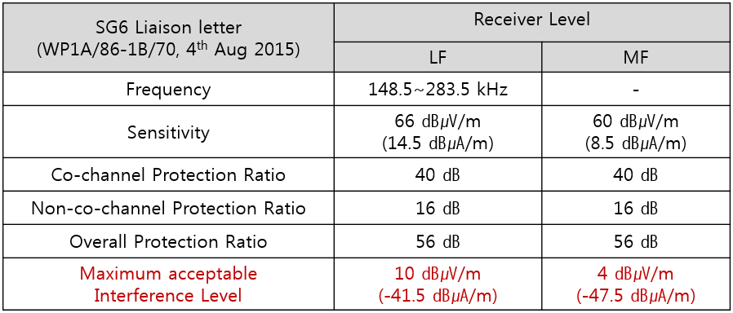

Test results are summarized in Figure 6.7.

FIGURE 6.7 Test results

1. Under ambient condition

|  |  |
| --- | --- |
| 130 kHz to 300 kHz @ 10 m (Ambient) | 130 kHz to 300 kHz @ 30 m (Ambient) |
| Peak: -9.58 [dB㎂/m @ 184.4](mailto:dB㎶/m@184.4) kHz | Peak: -15.23 [dB㎂/m @ 151.5](mailto:dB㎶/m@184.4) kHz |
| 130 kHz to 300 kHz @ 50 m (Ambient) | 130 kHz to 300 kHz @ 100 m (Ambient) |
| Peak: 3.1 [dB㎂/m @ 254.7](mailto:dB㎶/m@184.4) kHz | Peak: -12.48 [dB㎂/m @ 156.](mailto:dB㎶/m@184.4)6 kHz |

1. Under charging condition

|  |  |
| --- | --- |
| 130 kHz to 300 kHz @ 10 m (Charging) | 130 kHz to 300 kHz @ 30 m (Charging) |
| Peak: 41.78 [dB㎂/m @](mailto:dB㎶/m@184.4) 179.9 kHz | Peak: 24.77 [dB㎂/m @](mailto:dB㎶/m@184.4) 260.1 kHz |
| 130 kHz to 300 kHz @ 50 m (Charging) | 130 kHz to 300 kHz @ 100 m (Charging) |
| Peak: 9.63 [dB㎂/m @](mailto:dB㎶/m@184.4) 179.9 kHz | Peak: 12.51 [dB㎂/m @](mailto:dB㎶/m@184.4) 160.0 kHz |

1. Without any antenna cable

|  |  |
| --- | --- |
| 150 kHz to 300 kHz @ 10 m (without Ant’) | 130 kHz to 300 kHz @ 100 m (without Ant’) |
| Peak: -40.99 [dB㎂/m @](mailto:dB㎶/m@184.4) 170.8 kHz | Peak: -40.66 [dB㎂/m @](mailto:dB㎶/m@184.4) 154.93 kHz |

Under the ambient condition, there is no charging on the heavy-duty WPT EV because the maximum value is already more than 3.1 [dBuA/m @ 254.7](mailto:dB㎶/m@184.4) kHz at 50 m and the minimum value is -15.23 [dBuA/m @ 151.5](mailto:dB㎶/m@184.4) kHz at 30 m. It means that any value never meets the given limitation from EBU.

As it on charging mode, the maximum value is 41.78 [dBuA/m @](mailto:dB㎶/m@184.4) 179.9 kHz at 10 m and the minimum value is 9.63 [dBuA/m @](mailto:dB㎶/m@184.4) 179.9 kHz at 50 m. Needless to say, it exceeds significantly the limitation more than 80 dB.

Even without any antenna connection, the noise level from the test equipment (Agilent E4440A, High Accuracy Spectrum Analyzer) is higher than the given limitation.

Test results did not meet the given EBU limitation under any circumstance regardless of the given WPT charging conditions and environments.

# 7. Summary

In China, studies and regulatory standards developments for WPT for EVs are in progress in local municipal bureaus, industrial groups, and WPT-related national committees. China Communications Standards Association (CCSA) initiated a study item on WRC-19 Agenda Item 9.1, Issue 9.1.6. CCSA is exchanging information regularly with China Electricity Council (CEC) and National Technical Committee of Auto Standardization for survey of EV WPT system working frequency. CEC agreed on frequency ranges selection 79/81.38-90 kHz. CCSA is carrying out sharing and compatibility studies of WPT systems operating in 79-90kHz band with incumbent radiocommunication systems.

Japan issued new rules (technical conditions) on WPT for passenger electric vehicles which specifies regulatory requirements regarding frequency range, emission limits, and related requirements such as specifications for type-approvals for WPT system operation in March 2016. 79-90 kHz has been designated for WPT for EVs with other necessary requirements. In order to make acceptable rules not to cause harmful interference to incumbent radiocommunication services, Japan performed a broad range of studies on WPT frequency selection and the impact of WPT to the incumbent radiocommunication services. Those study results are introduced in this APT Report and also have been shared with external organizations including ITU-R SG1 WP 1A, WP 1B, and CISPR/B AHG4. Japan is a country advocating global harmonization of WPT specifications for EVs.

Korea provided Heavy Duty EVs (OLEV) technology and its requirements. 19-21 kHz and 59-61 kHz have already been designated for this technology in Korea. Impact study results to standard frequency and time signal are introduced. The results and measurement methodologies have also been introduced in IEC TC69, CISPR/B/AHG4, ETSI 330 300, and ITU-R SG1 WP 1A, WP 1B.

Finally, the Task Group points out the fact only three countries could provide specific information. That means that the WPT technology for EVs is in the early stage of study for many radio administrators in the APT countries. They may refer to this Report to leverage studies. WPT technology is a developing technology. This Report is going to be updated with the latest information to be provided by more number of APT countries.

____________