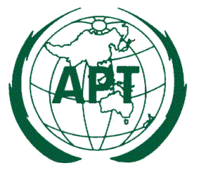

Ref: AWG/2014/AWG16-C1

16 April 2014
Dear Sir/ Madam,

Subject: Request of update information in APT/AWG/REP-15 (Rev.1)

APT Report on “Information of Mobile Operator's Frequencies, Technologies and License Durations in Asia Pacific Countries” (APT/AWG/REP-15(Rev.1)) contains information on the licensing of the terrestrial mobile cellular networks in the APT Member countries, such as:
- Operators’ name,
- Frequency band,
- Technology used in the frequency band,
- License duration.

During the 16th meeting of APT Wireless Group (AWG-16) held from 18 to 21 March 2014 in Pattaya, Thailand, it was agreed to update this APT Report in order to reflect the latest information of each APT Member country.
Therefore, APT Members are kindly requested to update information contained in APT/AWF/REP-15(Rev.1) relevant to your administration and return it to the APT Secretariat (Email: aptawg@apt.int) prior to the AWG-18 (February/ March, 2015). It is preferred that you provide the updated information comparing to the original texts in APT/AWF/REP-15(Rev.1) by using the track changes.
For your convenience, APT Report APT/AWG/REP-15(Rev.1) is attached.
I thank you in advance for your cooperation.
Yours sincerely,

(Original signed)

Toshiyuki Yamada
Secretary General

Attachment:

TO: APT Members

