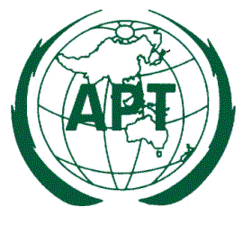

Ref: AWG/2014/AWG16-Q

16 April 2014

Dear Sir/ Madam,

Subject: Circulation of Questionnaires approved at AWG-16

Asia-Pacific Telecommunity (APT) organized the 16th Meeting of the APT Wireless Group (AWG-16) from 18 to 21 March 2014 in Pattaya, Thailand.

AWG-16 approved the following two questionnaires and agreed to circulate to the APT Members.

- Questionnaire on Usage of the Frequency Band 13.75-14 GHz in the Asia-Pacific Region;

- Questionnaire on Fixed Wireless Systems;

Your Administration is kindly requested to complete and return the attached Questionnaires to APT Secretariat (email: aptawg@apt.int) by the end of August 2014.

Yours sincerely,

(Original signed)

Toshiyuki Yamada
Secretary General

Attachment: Questionnaires

TO: APT Members

