APT REPORT ON

LICENSED-ASSISTED ACCESS (LAA) AND 5G NEW RADIO IN UNLICENSED SPECTRUM (5G NR-U) AS NATIONAL SOLUTIONS FOR ACCESSING SHARED SPECTRUM

No. APT/AWG/REP-104
Edition: September 2020

Adopted by

26th Meeting of APT Wireless Group
14 – 18 September 2020, Virtual Meeting

(Source: AWG-26/OUT-08)

APT REPORT ON

LICENSED-ASSISTED ACCESS (LAA) AND 5G NEW RADIO IN

UNLICENSED SPECTRUM (5G NR-U) AS NATIONAL SOLUTIONS FOR

ACCESSING SHARED SPECTRUM

Introduction
The LTE technology that underpins current 4G networks continues to evolve and offers new capabilities that improve mobile broadband service offerings and user experiences. New features are introduced and standardized into the cellular system by 3GPP via Releases. The initial LTE standard was introduced in 2009 in Release 8, and June 2018 is expected to see the most recent iteration, Release 15. Over the course of the past six releases, several new features have been standardized, including licensed-assisted access (LAA), enhanced LAA (eLAA), voice over LTE (VoLTE), carrier aggregation, HetNets, higher-order modulation, advanced multiple-input and multiple-output (MIMO), and LTE Internet of Things (LTE IoT). Combining such advances results in overall enhancements to LTE technology. For example, Gigabit LTE is now offering peak download speeds up to 2 Gbps per second –achieved by leveraging carrier aggregation, LAA, advanced antenna techniques (massive MIMO) and higher-order modulations (1024-QAM DL and 256-QAM UL) to increase capacity and coverage. Some of these advances require only mobile network operator actions for deployment, and others such as LAA and eLAA may require additional regulatory consideration.

In July 2020, 3GPP completed 5G NR Release 16 — the second 5G standard that will greatly expand the reach of 5G to new services, spectrum, and deployments. This is a major milestone for the entire mobile and broader vertical ecosystem, as this new set of 5G specifications unlocks many new 5G opportunities beyond the traditional mobile broadband services. Release 16 not only continues to enhance the solid Release 15 technology foundation to bring better 5G system performance and efficiency, it also delivers key technologies for transforming new industries.

To expand 5G’s reach beyond traditional public mobile networks, 3GPP completed two projects in Release 16 that are essential for new vertical deployments. The first is 5G NR-U, allowing 5G to operate in unlicensed spectrum. It defines two operation modes, anchored NR-U requiring an anchor in licensed or shared spectrum and standalone NR-U that utilizes only unlicensed spectrum, i.e., does not require any licensed spectrum. It Is the first time that 3GPP defines a cellular technology for “standalone” usage in unlicensed spectrum. Release 16 not only supports the existing global 5 GHz unlicensed band widely used by Wi-Fi and LTE LAA today and future unlicensed bands.

Scope
This report evaluates the potential of using Licensed-Assisted Access (LAA) and 5G NR-U as a mechanism for users / consumers in a country where suitable spectrum is available on a shared (unlicensed basis) in accordance with agreed standards to enable the deployment of LAA and 5G NR-U to increase network capacity, and improve consumer’s experience.

Vocabulary of terms
LAA Licensed Assisted Access
eLAA enhanced Licensed Assisted Access
3GPP Third Generation Partnership Project
CEPT European Conference of Postal and Telecommunications Administrations
ECC Electronic Communications Committee
ETSI European Telecommunications Standards Institute
FCC Federal Communications Commission
IMT International Mobile Telecommunications
ITU International Telecommunication Union
MNO Mobile Network Operator
RR Radio Regulation
UE User Equipment
5G NR-U 5G New Radio in unlicensed spectrum

References
ETSI EN 301 893
3GPP Release 13
3GPP Release 16

LAA and 5G NR-U Operation and Use Cases and regulatory regime
Spectrum resources across all spectrum bands and regulatory paradigms are needed to support LTE and 5G applications, services, and deployment models. Low bands below 1 GHz, because of inherent propagation characteristics are useful for longer range and in-building applications e.g. mobile broadband, and massive IoT use cases. Mid-bands between 1 GHz and ~7 GHz are useful for providing wider bandwidths for enhanced Mobile Broadband (eMBB) and mission critical applications, and high bands above 24 GHz (mmWave) allow extreme bandwidths. Access to this spectrum may be via exclusive licensing which allows the licensee a guaranteed quality of service. Unlicensed spectrum access allows users to take advantage of wider bandwidths when and where available. And shared spectrum access opens new sharing paradigms in time and geospatial domains.

The initial version of LAA standardized in Release 13 uses carrier aggregation in the downlink to combine LTE in unlicensed spectrum (5 GHz) with LTE in the licensed band. This aggregation of spectrum provides for a fatter pipe with faster data rates and more responsive user experience. For example, a mobile operator using LAA can support Gigabit Class LTE with as little as 20 MHz of licensed spectrum. By maintaining a persistent anchor in the licensed spectrum that carries all of the control and signaling information, the user experience is both seamless and reliable.

Figure 1: LAA carrier aggregation
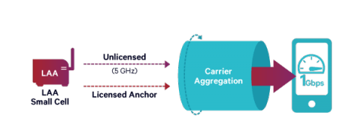
Source: Qualcomm, Incorporated

LAA is designed to coexist with Wi-Fi by dynamically selecting clear channels in 5 GHz to avoid Wi-Fi users. If no clear channel is available, LAA will share a channel fairly with others. This is accomplished by a feature called Listen Before Talk (LBT) standardized by ETSI in EN 301 893. Further, LAA releases unlicensed channels when there is low traffic. The second version of LAA, so-called enhanced LAA (eLAA), uses these same techniques for both downlink and uplink. It was standardized in Release 14.

In November 2015, the world’s first over-the-air LAA trial was held in Nuremberg, Germany. A wide range of test cases were completed: indoor and outdoor, different combinations of LAA, Wi-Fi, and LWA (LTE – Wi-Fi link aggregation) – both stationary and mobile, single and multiple users, handover between cells, and a range of radio conditions. The LAA test equipment complied with 3GPP Release 13 development and was particularly designed to meet global unlicensed band regulations, including LBT features using extended Clear Channel Assessment procedures and channel occupancy limits required in regions such as Europe and Japan. The trial results clearly demonstrated fair co-existence of LAA with Wi-Fi over all test cases. Actually the results show that LAA is a better neighbor to Wi-Fi than Wi-Fi itself. The trials also demonstrated some of the performance benefits of LAA over Wi-Fi such as improved coverage, higher capacity and seamless mobility.

Expanding 5G to operate in all spectrum types and bands will not only bring more capacity but also more flexible deployments. 3GPP Release 16 adds support for unlicensed spectrum for 5G NR (NR-U) that includes two modes of operation: license assisted access anchored NR-U, and a standalone deployment option that does not require any licensed spectrum. The anchored NR-U mode allows mobile operators to tap into unlicensed spectrum, such as the 5 GHz band(s), to boost 5G bandwidth, building upon what they are already doing with LTE LAA. The standalone 5G NR-U mode does not require licensed spectrum, which brings 5G benefits to a broader ecosystem, including mobile operators, service providers, wireless ISPs, and other 5G private network operators. 5G NR-U may be used to deploy 5G in unlicensed bands, such as 5 GHz, 6 GHz and 60 GHz.

Figure 2 5G NR-U supports two modes of operation and many deployment scenarios.
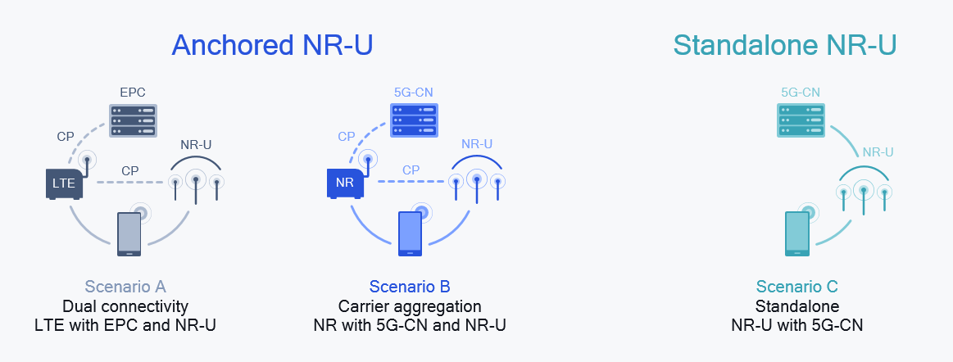

Stand-alone NR-U marks the expansion of cellular technologies standardized by 3GPP into stand-alone operation in unlicensed spectrum (i.e. without an anchor in licensed spectrum). Licensed spectrum is the cornerstone for ubiquitous mobile communication, but the ability to operate 5G NR stand-alone in unlicensed spectrum is a basic technology enabler that will be exploited by future use cases. This is not about creating a better Wi-Fi, but about serving unmet needs to expand the market for wireless communication to new verticals not having licensed spectrum such as:
- Local private 5G networks dedicated for a specific application such as mobile broadband for enterprises.
- Open mobile broadband 5G services offered by new service providers such as today’s cable operators and internet service providers or neutral host service providers in public venues such as sports stadiums and malls.
- More use cases that will be conceived in the future.
Figure 3: Possible NR-U use cases

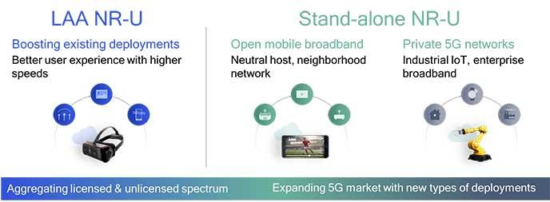
Anchored NR-U
The most common spectrum sharing method used by Wi-Fi and LAA in 5 GHz today is called Listen-Before-Talk with Load-Based-Equipment (LBT-LBE). This is an asynchronous sharing protocol, where each node contends for the channel independently of all other nodes, including nodes in the same network. Basically, before transmission, each node generates a random counter and starts channel sensing on each sensing slot. Every time when the node senses the channel to be idle on a given sensing slot, it reduces the counter by 1 and can only transmit when the random counter decreases to zero. This is a simple method that works in many cases but has shortcomings, especially when network load increases.
5G NR-U will support the same asynchronous approach when operating in existing unlicensed bands, such as the global 5 GHz band, to co-exist with today’s Wi-Fi and LAA.

LAA and 5G NR-U market updates
The use of unlicensed spectrum for delivery of LTE services is developing steadily and following the completion of the latest release by 3GPP, looks set to begin in the context of 5G networks too. A total of 42 operators around the world have been catalogued as investing in one or more of the various unlicensed spectrum approaches (LAA, LTE-U, LWA or LWIP) technologies in the form of trials, pilots, deployments and launches. There are nine deployed LAA networks (some with. Three are situated in the USA, two are in Turkey, with others in Hong Kong, Italy, Russia, and Thailand.

In addition to those operators that have launched services:
- twenty-eight other operators are trialing or deploying LAA technology in 17 countries.
- nine other operators are known to have invested in LTE-U in the form of trials or pilots.
- two other operators are known to have trailed LWA in South Korea and Taiwan.
- GSA has identified one previous eLAA trial in South Korea.

173 commercial devices that support LAA from 37 vendors have been identified. The large majority of those devices are phones, with CPE and router devices making up the next largest category. The arrival of 5G phones has provided a boost to the numbers, with 24 commercially available 5G devices now identified. A further 16 pre-commercial devices (not included in the counts above) have been announced that promise LAA support, so the importance of 5G devices will increase in the coming months as these devices come onto the market.

Operators planning to start trials or deployments of LAA will be encouraged by the increasing number of devices that are compatible with LAA, and those investing in 5G will be encouraged by the completion of 3GPP standards for use of unlicensed spectrum by 5G New Radio systems.

Further detail of some of the LAA trials and demonstrations is provided in the bullets below:
- Qualcomm Technologies, AT&T, and Ericsson Gigabit LTE with LAA demonstration – In September 2017, Qualcomm, AT&T and Ericsson announced their intent to demonstrate Gigabit LTE with LAA for the first time in the United States at the 2017 Mobile World Congress Americas event. The demonstration was intended to showcase high-quality 3D VR video streaming, and a comparison of file download speeds between a device supporting full Gigabit LTE with LAA as compared to an LTE device that did not support LAA.
- Qualcomm, Verizon, Ericsson LAA test – In August 2017, Verizon announced that it had reported downlink speeds of 953 Mbps in a joint trial with Qualcomm and Ericsson in Florida using LAA, as well as four-carrier aggregation, 4x4 MIMO, and 256-QAM. Verizon claimed the figure is the “fastest announced speed achieved in a real-world, dynamic network environment” using LAA technology. The carrier said the demonstration used all commercially available network components, including a cell site, hardware, software, and backhaul.
- Qualcomm, MTS, and Ericsson trial – In July 2017, Qualcomm and Ericsson, together with MTS, the largest mobile network operator in Russia, conducted the first successful live trial with a commercial small cell product of Rel-13 LAA technology in Russia. The demonstration was conducted in an MTS test lab over a live network.
- Qualcomm Technologies, MTN, and Huawei commercial LAA deployment in Africa – In May 2017, Qualcomm, MTN, and Huawei successfully completed Africa’s first commercial LAA deployment. Implemented in South Africa, tests were conducted by aggregating three component carriers involving 15 MHz of licensed spectrum in the 2100 MHz frequency band and 40 MHz of unlicensed spectrum in the 5 GHz frequency band. The tests demonstrated a downlink peak throughput of 400 Mbps.
- Qualcomm Technologies, AT&T, Ericsson, and Orange demonstration – In February 2017, Qualcomm, along with AT&T, Ericsson, and Orange announced plans for demonstrations designed to show that 1 Gigabit per second is achievable by aggregating up to 80 MHz in licensed and unlicensed bands. The demonstrations, held at the Mobile World Congress in Barcelona in February-March 2017, marked the first time proof of such speeds using carrier aggregation of licensed LTE and unlicensed spectrum on a commercial chipset.
- Qualcomm Technologies and SK Telecom first enhanced LAA and LAA trial – In September 2016, Qualcomm Technologies and SK Telecom announced the first over-the-air technology demonstration of Enhanced Licensed Assisted Access (eLAA) and LAA that utilizes both licensed and unlicensed spectrum at SK Telecom’s Corporate R&D Center in Bundang, Korea. eLAA technology increases data speeds in both uplink and downlink by aggregating licensed and unlicensed spectrum to create a wider data pipe in both directions. eLAA is an evolution of LAA, which used the unlicensed spectrum to boost the data speed in the downlink direction only. The demonstration employed licensed spectrum in the 2.6 GHz band and unlicensed spectrum in the 5 GHz band. LAA and eLAA were shown in multiple test cases to achieve 2x capacity in 5 GHz than a Wi-Fi-only baseline.

Status in other countries/regions outside of APT

7.1 International – ITU
According to the definition in Report ITU-R SM.2153, SRD devices are intended to cover radio transmitters which provide either unidirectional or bidirectional communication and which have low capability of causing interference to other radio equipment. LAA and eLAA fulfil this definition of SRDs. Such devices are permitted to operate on a non-interference and non-protected basis.

Best practice Regulation for LAA and 5G NR-U in APT
The AWG has already surveyed the operation of Short-Range Devices (SRDs) in Member States and published its findings as APT AWG Report REP-07 (Rev.5) (September 2017). An earlier revision of APT AWG REP-07 was summarized in AWG REP-35 “APT report on the frequency bands for harmonized use of Short-Range Devices (SRDS)” which showed that, amongst the APT Members that responded to the survey questionnaire, use of the bands 5150 – 5350 MHz, 5470 – 5725 MHz and 5725 – 5875 MHz was widespread and the bands 5150 – 5350 MHz and 5470-5725 MHz (i.e. commensurate with 3GPP bands 46a, b and c) were possible frequency bands for harmonization for SRD.
It is reasonable and appropriate to regulate LAA and 5G NR-U in a manner consistent with the existing regulatory regime for use of the 5 GHz Shared Band, by employing the same technical criteria currently in place for the 5 GHz Shared/unlicensed Band, spectrum regulators will not need to monitor new services subject to different criteria, minimizing the need for additional resources. At the same time, regulators will be enabling commercial deployment of innovative new technologies such as LAA and 5G NR-U and enhancing spectrum utilization. A general or class licensing regime, or use of license exemptions, or unlicensed provisions that include compliance with appropriate technical standards is a suitable approach to enabling the deployment of LAA and 5G NR-U.

As LAA and 5G NR-U were designed and standardized with contention protocols such as LBT, they will coexist with Wi-Fi (and other technologies), there is no requirement to provide LAA or 5G NR-U providers priority use of spectrum nor provide and protection from interference from other licensed services.

Summary
Regulators of APT Member states may potentially double the amount of spectrum available for the provision of public mobile services through the leveraging unlicensed Bands for LAA and 5G NR-U allowing mobile network operators (MNOs) to increase their network capacity, and improve consumer’s experience.

See “World’s first LTE Licensed-Assisted Access (LAA) over-the-air trial,” (February 17, 2016), available at https://www.qualcomm.com/news/onq/2016/02/17/worlds-first-lte-licensed-assisted-access-laa-over-air-trial.
LTE & 5G in unlicensed spectrum, GSA, August 2020
ibid
Qualcomm, “AT&T, Qualcomm, and Ericsson Showcase Gigabit LTE with LAA Technology at Mobile World Congress Americas,” (September 8, 2017), available at https://www.qualcomm.com/news/releases/2017/09/08/att-qualcomm-and-ericsson-showcase-gigabit-lte-laa-technology-mobile-world.
Wireless Week, “Verizon Closes in on 1 Gbps in LAA Tests with Ericsson, Qualcomm,” (April 3, 2017), available at https://www.wirelessweek.com/news/2017/08/verizon-closes-1-gbps-laa-tests-ericsson-qualcomm.
Ericsson, “MTS trials live Licensed Assisted Access,” (July 19, 2017), available at https://www.ericsson.com/en/press-releases/2017/7/mts-trials-live-licensed-assisted-access.
Huawei, “MTN, Qualcomm and Huawei Jointly Launch First LAA Commercial Network in Africa,” (May 17, 2017), available at http://www.huawei.com/en/press-events/news/2017/5/First-LAA-Commercial-Network-Africa.
Qualcomm, “First Joint Live Demonstration of Gigabit LTE Using Aggregation of Licensed and Unlicensed Spectrum with a Commercial Modem Chipset with AT&T, Ericsson, Orange and Qualcomm,” (February 22, 2017), available at https://www.qualcomm.com/news/releases/2017/02/22/first-joint-live-demonstration-gigabit-lte-using-aggregation-licensed-and.
Qualcomm, “Qualcomm and SK Telecom Announce First Enhanced Licensed Assisted Access (eLAA) Over-the-Air Trial,” (September 28, 2016), available at https://www.qualcomm.com/news/releases/2016/09/28/qualcomm-and-sk-telecom-announce-first-enhanced-licensed-assisted-access.

