

**APT REPORT ON**

**TECHNOLOGY AND SPECTRUM MANAGEMENT TECHNIQUES FOR IOT NETWORKS**

**No. APT/AWG/REP-105  
Edition: September 2020**

**Adopted by**

**26th Meeting of APT Wireless Group  
14 – 18 September 2020, Virtual Meeting**

***(Source: AWG-26/OUT-14)***

**APT REPORT ON**

**TECHNOLOGY AND SPECTRUM MANAGEMENT TECHNIQUES FOR IOT NETWORKS**

1 Introduction 3

2 Scope 4

3 Various IoT Networks and their requirements 5

3.1 Industrial IoT 5

3.1.1 Manufacturing 5

3.1.2 Utilities 9

3.1.3 Private Industrial Networks 10

3.1.4 Summary of Industrial IoT performance requirements 11

3.2 PMSE 12

3.3 PPDR 13

3.4 Examples – Business Impacts 13

3.4.1 Blisk 13

3.4.2 Mining 14

3.5 Summary 14

4 Spectrum Access Strategies 15

4.1 Use of Spectrum – Licensed/un-licensed 15

4.1.1 Exclusive Use of Spectrum 16

4.1.2 Light Licensing Use of Spectrum 16

4.1.3 License Exempt Use of Spectrum 16

4.1.4 Spectrum Sharing for Providing Local Area Services with QoS 16

4.1.5 Summary 17

4.2 Examples of availability of use of spectrum for local networks 17

4.3 Existing Spectrum Sharing Schemes 18

4.3.1 Licensed Shared Access (LSA) 18

4.3.2 Citizen Broadband Radio Service (CBRS) with Spectrum Access System (SAS) 19

4.3.3 Summary 20

5 Mechanisms in the context of different IoT Networks 21

5.1 MNO-offered services locally 22

5.2 Leasing 23

5.3 Local Licensing 24

6 Conclusion 24

# Introduction

There is a need for secure, ultra-reliable, low latency and predictable wireless connectivity for verticals, such as manufacturing industries, mining, process industries and utilities that are operating in locally confined geographical areas. These aspects has led to the use of IoT technologies in licensed spectrum because licensed spectrum rights has exclusive rights to the spectrum making it appealing for long-term investments. Getting access to licensed spectrum is therefore of interest. 3GPP has developed NB-IoT and LTE-M as well as the 5G NR components that can be used in IoT networks. Provisions has been taken to be able to do in-band operation between LTE and NR, see [1].

It is predicted to be around 4.1 Billion of cellular IOT connections by 2024. This may potentially provide a 5G service creation revenue potential for operators of 619 Billion by 2026 of which e.g. manufacturing may have around 20% share [2, 3]. See Figure 1.

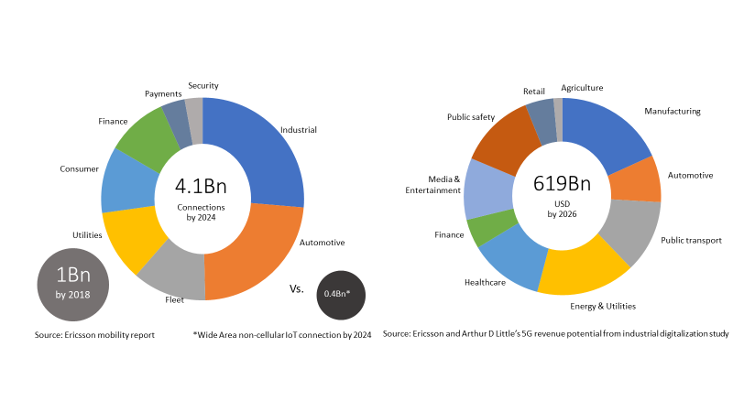

Figure 1: Number of predicted connections and revenue potential.

This report will describe use cases for verticals and their performance requirements with focus on manufacturing. A number of possible spectrum access strategies to support the technical requirements, as well as business requirements, is then described together with an architecture for accessing spectrum for local wireless networks providing connectivity to verticals.

# Scope

This report covers technologies and solutions to enable spectrum access for IoT networks. Current situation and potential applicability of mechanisms such as licensed shared access (LSA) for national spectrum management within the Asia Pacific region are described. Some application domains envisaged for such networks are typically deployed by industries/verticals, e.g. Creative- and Culture Industries, Factory and Process Automation, eHealth, Public Protection and Disaster Relief (PPDR) stipulating demanding QoS requirements (availability, reliability and latency) for wireless communication. This report will support the development of Industry 4.0 in APT Member countries.

# Various IoT Networks and their requirements

## Industrial IoT

Industrial IoT has many diverse and demanding requirements depending on the use cases. Figure 2 shows a comparison between industrial communication for Industry 4.0 and mobile broadband. As can be seen the latency and reliability requirements are typically much higher for Industrial IoT than for mobile broadband. The high interest in 5G from industries has resulted in a creation of 5G-ACIA[1] (5G Alliance for Connected Industries and

Automation) with aim to ensure that industrial needs are adequately considered in 5G from a standardization and technical view as well as regulatory and business aspects.

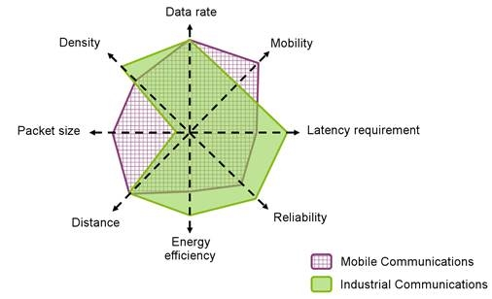

NOTE: Source: VDE/ITG Positionspapier Funktechnologien für Industrie 4.0. [Funktechnologien für Industrie 4.0: "VDE Positionspapier, ITG AG Funktechnologie Industrie 4.0", June 2017.]

Figure 2: A comparison between mobile broadband requirements and Industrial communication requirements [4].

### Manufacturing

Manufacturing involves many different applications. It can be the use of AGVs (Automatic Guided Vehicles) transporting goods between different places in a factory area. It can also be wireless communication for robotic control. It is in these cases necessary for low or ultra-low latency and reliable, noninterrupted communication to avoid accidents and halts in production. However, not all use cases in a factory are “critical” and not all use cases will be executed via wireless communication but avoiding cables will make it easier to change layout of a factory. Figure 3 shows an example of different smart manufacturing use cases such as collaborative robots, AGVs tracking and logistics and audio/video applications (including AR/VR).

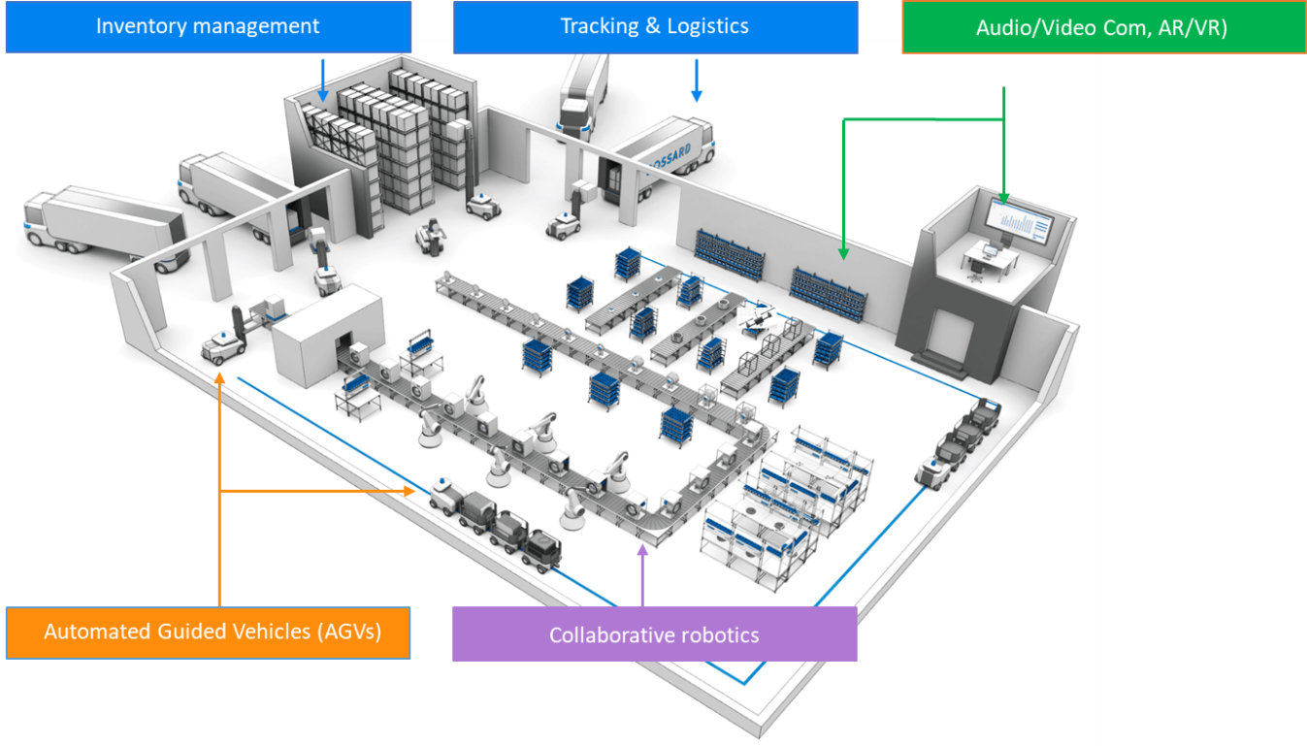

Figure 3: Smart manufacturing use cases

The current wireless communication use cases are today typically of less critical nature, such as monitoring or parametrization. In automotive factories the traffic consists mainly of real-time traffic, which is carried by protocols with highly integrated protocol stack (e.g., Profinet Real-Time stack). The TCP/IP protocol stack is mainly used for carrying messages pertaining to startup configuration, notifications and non-critical alarm messages; with preventive monitoring, this type of traffic will increase. Hence connectivity requirements are very use case and application specific. A wireless factory network needs to support service differentiation to serve the different use cases efficiently (the assumption that one connectivity network shall support all cases – is not true today). Co-existence and integration with existing connectivity solutions is necessary and capillary networks also need to be considered for example for sensor networks. The expectation from industry verticals on the introduction of e.g. 5G mmWave communication is: high performance, high user density, precise device localization, reduced risk of interference and malicious attacks (i.e., due to propagation properties). The wireless factory is also a step closer to a fully flexible production/assembly line, for example moveable assembly lines with AGVs (already here reliable wireless technology is a necessity) from assembly station to assembly station.

Below is a list of use cases considered representative for the manufacturing industry and also use cases that could benefit from wireless communication:

* Robotized assembly line
* Programmable Logic Controller (PLC) to robot controller communication
* PLC to PLC communication
* Robot controller to robot communication
* Real-time manufacturing process optimization
* Automated Guided Vehicles (AGV)
* Automated Storage and Retrieval Systems (AS/RS)
* Monitoring and preventive maintenance
* Critical monitoring and emergency shut down
* Mobile Augmented Reality (AR)

The most critical use cases may only need to be supported in certain physical locations of the factory. Latency is expected to be the dominating factor on whether a use case can be deployed using LTE or whether NR is required (or whether none can meet the required latency).

The main drivers for wireless connectivity are:

* Replacing (or avoiding) cables, which are costly to deploy and maintain/troubleshoot.
* Connecting machines or parts of equipment that are impossible or impractical to connect by wire (e.g., fast-moving parts).
* Preventive maintenance and big-data analytics, by connecting large numbers of sensors cheaply.
* Further, the industry expectation, implementing 5G technologies within Operational Technologies, is economy of scale.

**Technical Requirements (on-premise)**

The following lists the main currently known requirements. One example of additional requirement is capacity. Capacity requirements are not specified currently but may have an impact on both amount of spectrum needed and radio/network deployment.

* *Latency* providing a guaranteed upper bound is essential for critical automation use cases; packets need to arrive on time, otherwise they are considered lost. Some cases may require a latency less than 1 ms. Hence the use-cases are very industry dependent. High synchronicity may also be required in use cases with less stringent latency requirements.
* *Throughput:* moderate data rates required for the communication with the Motion Control and Condition Monitoring.
* *Reliability*: defined as the percentage value of the amount of sent network layer packets successfully delivered to a given node within the time constraint required by the targeted service, divided by the total number of sent network layer packets (according to 3GPP).
* *Availability:* the requirements are generally high for use cases impacting the production – production downtime costs money, and factories might operate 24/7.
* *Positioning*: can be leveraged in process automation, for diagnostics and condition monitoring as well as motion control. Some manufacturers claim that high precision indoor localization is an enabler for autonomous driving within factories.
* *Degree of Mobility:* the ability to move freely throughout the factory floor. It gives an indication of the likelihood of experiencing handovers if the factory floor is covered by multiple radio cells.

Many of these requirements are the result of the fact that the communication system is required to support many use cases which require fully deterministic traffic.

An example from a car manufacturer: An assembly has 4000 clients out of which 500 require a latency below 1ms. The Chassis production has 1000 robots/120 PLCs, 10.000 clients with 100 Mb/s.

Availability 99.99% are mostly acceptable. Some production companies believe that requirements of 99.999% come from theoretical approaches. Companies claiming requirements to 99,9999% etc. drive cost to a level where there is no business to make anymore.

Table 1

|  |  |
| --- | --- |
| **Summary of Technical Requirements** | |
| **Latency** | **1 ms to 10 ms** |
| **Throughput** | **1kbps to 10 Mbps** |
| **Reliability** | **10-3 to 10-9** |
| **Availability** | **99.99% to 99.9999%** |
| **Positioning** | **1 cm to 50 cm** |
| **Mobility** | **Static or limited** |

**Requirements from Verticals**

The starting point for factory automation is full control of the Operational Technology (OT) parts, since that is already the case today and it is considered essential to fulfill 24/7 performance targets. This full control may change, but it is considered a profound change, so it will take considerable time and effort.

*Local survivability* for parts of the system requiring redundancy, failover times in the order of 100ms would be required for real-time control and communication. Failure to fulfill the use case requirements will typically lead to production stop for the machines affected or the whole production cell - frequent loss of connectivity can therefore have big negative cost impacts. Some claims are:

* Production engineers must be in the control loop e.g., for safety applications, identifying fast & unexpected movements / rotations possibilities.
* URLLC and multi-link connectivity are a must

*Local content:* Production data may not leave the factory premises (also known as data protection) – local termination of user plane data will be required

*Local management:* OSS and network observability must be suitable for a non-MNO type of network operator/owner, for example it must be made easy to integrate with the verticals business and operational processes, that includes integration both with OT equipment and factory IT systems.

*Life Cycle Management (LCM):* Long-term availability of components, networks and services, self-management -> high ease-of-use during whole lifecycle. Several industry verticals require an LCM in the range of 20+ years.

*Integration*: The 3GPP based system needs to be integrated to wired OT system as well as to other wireless connected devices (LoRA, wirelessHart etc.) through gateways. Transport of Industrial ethernet frames will be required to integrate with existing systems. This requirement is also about integration with vertical’s business and operational processes, that includes integration both with OT equipment and vertical’s IT systems.

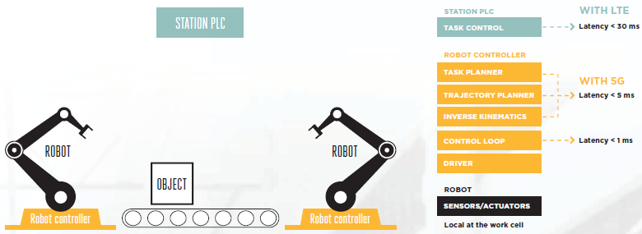

Figure 4: High-level latency requirements for different tasks for robots (from GSMA Industrial Iot Case study: Ericsson smart Factory, 2018. See [4])

### Utilities

Power networks are one example of a utility. Sub-stations in power networks is one example of an IoT network where sensors monitor the electrical signals in the transformers while circuit breakers on switch yard and protection relays are used to control the circuits. These are located on the switch yard and Relay room. The data is collected and used to control the substation and connection to the outer world. Using a SCADA system (Supervisory Control And Data Acquisition) for sending data the maximum one-way delay for transferring the sampled values from the sending to the receiver in charge of the control is around 3.5 ms. That is, there is a low latency requirement for sending sampled values over the radio.

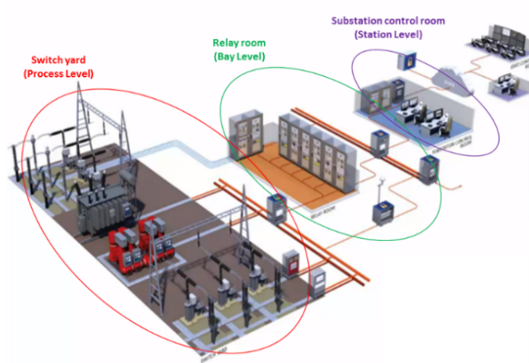

Figure 5: An example of a utility

### Private Industrial Networks

Private networks are designed and deployed by enterprises to optimize or enable business processes. Broadly, there are three drivers to deploy a private mobile network:

* To guarantee coverage: Often in locations with harsh radio frequency (RF) or operating conditions or where public network coverage is limited / nonexistent (e.g., remote areas).
* To gain network control: For example, to apply configurations that are not supported in a public network. Security and data privacy are also important. The ability to retain sensitive operational data on-premises is crucial to high tech industrial companies.
* To meet a performance profile: Specifically, a profile that will support demanding applications. 5G NR has a clear performance advantage over LTE and Wi-Fi in cyber-physical industrial systems.

Private LTE systems takes advantage of the global LTE ecosystem, which benefits from high volume, standardized technology, and well-established suppliers able to design and deploy networks. The scale economics and interoperability benefits of global 3GPP technologies also apply to sector-specific equipment, and well-developed supply chains and established best practices are now in place in many sectors. For example, devices such as sensors, automated guided vehicles (AGVs), security cameras, safety equipment etc. are now available with integrated LTE.

Many industrial applications can be supported on LTE. However, where users have more demanding performance requirements – in terms of availability, reliability, latency, jitter, device density, throughput, etc. – 5G NR is better suited to their needs than LTE. 5G NR includes innovations in the radio domain and system architecture that make it better able to meet the requirements of high-performance industrial applications. These include the following:

* In the radio domain, flexible numerology, Ultra-Reliable Low Latency Communications (URLLC), spatial diversity, positioning, quality of service (QoS), spectrum flexibility, etc.
* At the system level, capabilities such as network slicing, improved security, new authentication methods, edge deployment, application programming interface (API) exposure, etc.

For these reasons, where users have demanding applications, 5G NR will be adopted in the industrial sector over other wireless technologies.

Mobile network operators should be able to support the above presented Massive IoT performance in combination with enhanced mobile broadband (eMBB) and Critical IoT use cases. To allow this, 3GPP Release 15 supports a close coexistence between NR, LTE-M and NB-IoT. The specifications allow the three technologies to:

* operate in the same frequency band,
* configure the same physical layer numerology, i.e. sub-carrier spacing,
* align the uplink and downlink transmissions in time and frequency, and,
* reserve NR time-frequency resources dedicated for LTE-M and NB-IoT transmissions.

Figure 6 illustrates the concept of LTE-M and NB-IoT operating within an NR carrier by means of reserving resources for their transmissions.

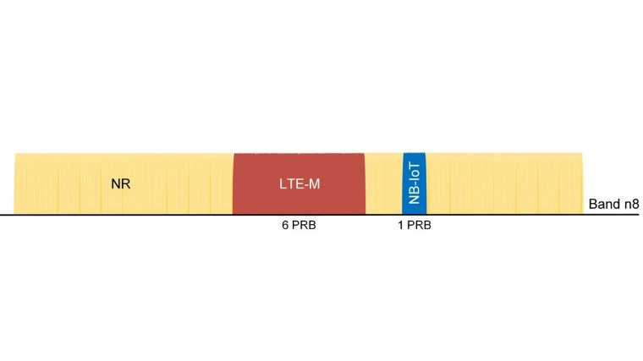

Figure 6: NR, LTE-M and NB-IoT coexisting in the same frequency band (5MHz spectrum in band n8 – as an example)

In summary, LTE-M and NB-IoT meet the IMT-2020 and 3GPP 5G requirements for Massive IoT and support seamless coexistence between NR, LTE-M and NB-IoT. This makes LTE-M and NB-IoT today’s most prominent and futureproof 5G Massive IoT technologies.

### Summary of Industrial IoT performance requirements

A summary of the requirements can be found in Funktechnologien für Industrie 4.0: "VDE Positionspapier, ITG AG Funktechnologie Industrie 4.0", June 2017, shown in Tables 2 and 3 as taken from the ETSI TR [6]. The 3GPP TS 22.104 [7] contains an extensive list of requirements.

Table 2: Overview of different use-cases and requirements for industrial communication - 1

|  |  |  |  |  |  |  |  |
| --- | --- | --- | --- | --- | --- | --- | --- |
|  | Monitoring & Diagnostics | | Discrete Manufacturing | | Logistics and Warehouse | | |
| Key Performance Indicator | General | Condition  Monitoring | General | Motion  Control | General | AGV | Cranes |
| Latency/Cycle Time | > 20 ms | 100 ms | 1 ms - 12 ms | 250 μs - 1 ms | > 50 ms | 15 ms - 20 ms | 15 ms - 20 ms |
| Reliability | 1 - 10-4 | 1 - 10-5 | 1 - 10-9 | 1 - 10-9 | > 1 - 10-2 | > 1 - 10-6 | > 1 - 10-6 |
| Data Rate | kbit/s - Mbit/s | kbit/s | kbit/s - Mbit/s | kbit/s - Mbit/s | kbit/s - Mbit/s | kbit/s - Mbit/s | kbit/s - Mbit/s |
| Packet Size | > 200 Byte | 1 - 50 Byte | 20 - 50 Bytes | 20 - 50 Bytes | < 300 Bytes | < 300 Bytes | < 300 Bytes |
| Communication Range | < 100 m | 100 m - 1 km | < 100 m | < 50 m | < 200 m | ~ 2m | < 100 m |
| Device Mobility | 0 m/s | < 10 m/s | < 10 m/s | < 10 m/s | < 40 m/s | < 10 m/s | < 5 m/s |
| Device Density | 0,33 - 3 m-2 | 10 - 20 m-2 | 0,33 - 3 m-2 | < 5 m-2 | ~ 0,1 m-2 | ~ 0,1 m-2 | ~ 0,1 m-2 |
| Energy Efficiency | n/a | 10 years | n/a | n/a | n/a | < 8 h | n/a |

Table 3: Overview of different use-cases and requirements for industrial communication - 2

|  |  |  |  |
| --- | --- | --- | --- |
|  | Process  Automation | Augmented  Reality | Functional Safety |
| Key Performance Indicator |
| Latency/Cycle Time | 50 ms - Xs | 10 ms | 10 ms |
| Reliability | 1 - 10-5 | 1 - 10-5 | 1 - 10-9 |
| Data Rate | kbit/s | Mbit/s - Gbit/s | kbit/s |
| Packet Size | < 80 Byte | > 200 Byte | < 8 Byte |
| Communication Range | 100 m - 1 km | < 100 m | < 10 m |
| Device Mobility | Generally static, otherwise < 10 m/s | < 3 m/s | < 10 m/s |
| Device Density | 10 000 / Factory | > 0,33 - 0,02 m-2 | > 0,33 - 0,02 m-2 |
| Energy Efficiency | 10 years | 1 day | n/a |

## PMSE

##### ***3.2.1 Use case – Live Performance***

The use case 'Live Performance' involves several wireless microphones (handheld or body-worn) used to capture the artists voice or the sound of instruments, several stereo in-ear monitors (IEM), at least one mixing console and a Public Address (PA) system. This use case is described in the ETSI TR [6].

A typical scenario is for instance a concert, where an artist on stage is using a wireless microphone while he/she is hearing theirself via the wireless IEM system. The audio signal from the wireless microphone is streamed to one or more mixing consoles, where different incoming audio streams (e.g. from different music instruments, choir) are being mixed. After mixing, several audio streams can be generated, e.g. PA mix, individual IEM mixes for the artists or recording mixes. From those, IEM mixes are wirelessly transmitted to the artist and musicians while most of the other mixed signals are streamed via wired connections.

Depending on the type of event, the number of active wireless audio links or the data rates of the respective wireless audio streams may vary. However, the requirements regarding latency and reliability remain principally the same for all kind of live events/productions. Reliability is an essential feature because during live productions one cannot afford repeating audio transmissions until it is error-free. Low latency is an essential feature because in this use case source and sink of the audio transmission can be co-located, think of an artist equipped with wireless microphone and IEM. Because the artist receives audio of the environment also via its cranial bone, very low end-to-end delay (i.e. from the wireless microphone to the mixing desk back to the IEM) is needed.

Table 4 summarizes the KPIs of the PMSE use case Live Performance.

Table 4: KPI Requirements for the: Live Performance use case, as described in [8]

|  |  |
| --- | --- |
| KPI | Requirement |
| End-to-end delay | < 4 ms |
| User data rate | The user data rate per audio link can vary depending on the application but will stay constant during operation:  150 kbit/s - 4,61 Mbit/s |
| Control data rate | ≤ 50 kb/s  Data rate per control link |
| PER | The PER of the system is required to be below 10-4 for a packet size of 1 ms. Depending on the error concealment the following exemplary error distribution may be tolerable:   * maximum continuous error duration = 30 ms * consecutive minimum continuous error-free duration = 100 ms |
| Number of audio links | 50 - 300 simultaneous |
| Event area | ≤ 10 000 m2, indoor and outdoor |
| Mobile user speed | ≤ 14 m/s |

## PPDR

In emergency situations a private network may be utilized to enable communication in a limited local area.

It would need to be granted licensed dedicated spectrum in that area. (eLSA, see section 5, could be used to free already used spectrum if necessary and regulatory legal in a country).

## Examples – Business Impacts

### Blisk

A Blisk [9] is a turbomachine component comprising of both a rotor disk and blades. It consists of a single part, instead of an assembly of a disk and individual, removable blades. To manufacture this requires high precision and rework is needed in ~ 25% of the cases. By having real-time monitoring and control of the process (only possible by wireless communication) the number of rework cases can drastically be reduced. The latency requirement is 1 ms and this can be provided by 5G [9].

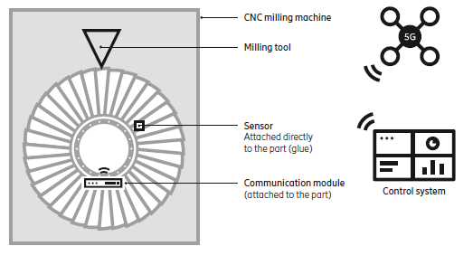

Figure 7: Blisk

### Mining

Mining [10] provides many different use cases for wireless communication. Figure 8 suggest a calculated gain of 2.5 million Euros in the Boliden Aitik mining from automation of drill rigs.

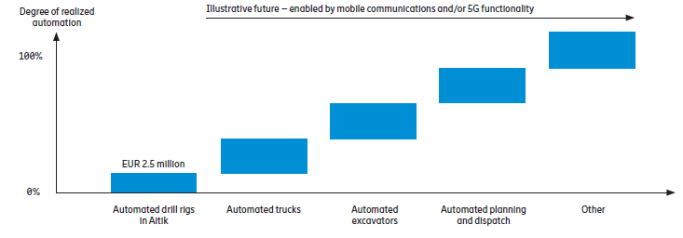

Figure 8: Degree of automation in a mine

## Summary

Figure 9 shows a simplified view of different applications need of coverage versus latency. Many of them require local coverage, around 1 km or less, and a latency ranging from less than 1 ms to 100 ms.

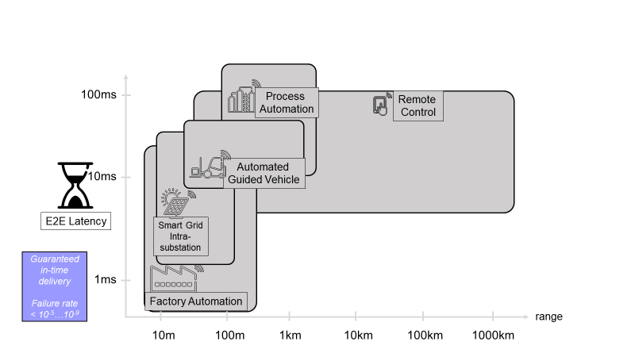

Figure 9: A simplified view of different use case requirements.

The status in factory automation is shown in Figure 10 where LTE can provide connectivity for some use cases. It also indicates that with the additional support for lower latencies provided by 5G all use cases may use and benefit from wireless connectivity.

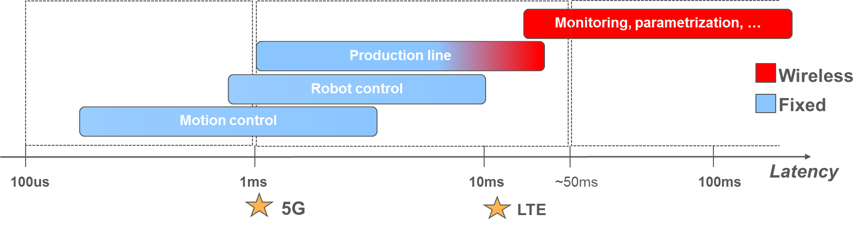

Figure 10: Examples of different uses cases. Showing existing use of LTE with the extensions of 5G to support also the lower latencies.

Since the availability of frequency bands have increased and now goes from below 1 GHz up to mmWave there will be different ways of using the different bands for an operator, i.e. a communication service provider (CSP). Figure 11 shows how this flexibility in frequency bands can be utilized efficiently in terms of coverage, reliability, latency, spectral efficiency, and capacity. For local spectrum the sub-6 GHz spectrum combined with mmWave provides good properties regarding coverage and capacity.

Figure 11. Leveraging CSPs’ flexible spectrum assets with or without local spectrum for industry digitalization [11]

The previous sections describe the use cases for a factory, mining facility, processing plant etc., identifying the need for low latency and, predictable and high availability connectivity. This implies that the networks need to ensure a high QoS. If wireless communication is to be used, the spectrum access allocation method needs to enable this. Section 4 will discuss these aspects.

# Spectrum Access Strategies

## Use of Spectrum – Licensed/un-licensed

ECC Report 132 [12] discusses use of terminology in a general sense. It is however noted that the licensing and access to spectrum is a national decision and some of the described strategies might not be allowed in all countries. Sections 4.1.1, 4.1.2 and 4.1.3 provides a high-level overview of some of the regulatory options for use of frequencies, while clause 4.1.4 describes sharing options in the context of *local high QoS wireless networks*.

### Exclusive Use of Spectrum

The allocation of dedicated spectrum is typically done in use cases requiring QoS and interference protection. The allocations are typically national coverage or regional coverage. An operator has exclusive rights to a spectrum block in a certain geographical area. The RF protection limits to adjacent frequency blocks is typically defined by a spectrum emission mask, also called Block Edge Mask (BEM) in Europe. The bands identified for IMT are examples where this allocation method is used. In the ECC Report 132 [12], this type of licensing is denoted individual license.

### Light Licensing Use of Spectrum

The term Light licensing is not clearly defined. The terminology in ECC Report 132 [12], Table 1, defines two different categories of Light licensing. The two variants are:

1. Light licensing can mean that there is no need to do any planning and there are no restrictions in number of users but there is a need to notify or register with the regulatory authority. QoS cannot be guaranteed as there are no limits of the number of users. It is therefore considered as a General authorization scheme.
2. Light licensing can also mean that frequency planning/coordination is needed and limitations of the number of users in same area can be imposed. The use may be authorized by the national regulatory. Thus, this type of light licensing scheme can be categorized as an individual authorization but with a simplified procedure for issuing the license compared to individual licensing. QoS could therefore be possible to support.

### License Exempt Use of Spectrum

Following the terminology in ECC Report 132 [12], Table 1, the term license exempt is defined as no need to do any frequency planning/coordination and no requirement to notify the regulator when using such spectrum. Thus, there are no limitations in the number of users in the same area using same frequency, and no need to acquire a dedicated license to be permitted to use a portion of a licensed band. Unlicensed bands are examples of licensed exempt use. QoS cannot be guaranteed as there are no limits on the number of users sharing the band.

### Spectrum Sharing for Providing Local Area Services with QoS

The focus in this framework is on licensed bands and possible ways to introduce local area services. It will also facilitate wide availability of equipment since the frequency bands are also used by Mobile Network Operators (MNOs) in case of e.g. IMT-bands.

The possible sharing methods for providing local area services focusing on QoS are:

1. Mobile network operators can offer dedicated local area services using their licensed frequencies.
2. Mobile network operators can lease out part of their spectrum locally to local area service providers.
3. Spectrum licensed to local area service providers:
   * Sharing the band by offering services in many different local areas nationally.
   * Example of local area definitions are e.g. real estate boundaries.
4. Part of the licensed band is using light licensing with control and limits on use, see clause 4.1.2, bullet b):
   * QoS can be difficult to guarantee, unless the networks are non-overlapping or can be controlled to provide a certain QoS guarantee.
   * Sharing the band by offering services in many different local areas nationally.
   * Example of local area definitions are e.g. real estate boundaries.

The possible spectrum access options in 1 to 4 above for QoS enabled local networks can be achieved using alternatives 1 to 3 only. It may also be possible to use the controlled light licensing method, as described in number 4 above, given that the needed level of QoS can be provided and guaranteed. However, there is uncertainty based on the fact that knowledge of the real deployments and actual traffic cannot be known with enough accuracy such that the control can be made efficient. Note that in real-world deployments combinations may be possible where e.g. 1) and 3) is used in a local deployment when an MNO provides roaming services and other expertise as well as enabling even higher capacity in terms of spectrum availability.

### Summary

The basic spectrum access methods which provide local IoT services are (see Figure 12):

1. Mobile network operators can offer dedicated local area services using their licensed frequencies
2. Mobile network operators can lease out part of their spectrum locally to local area service providers
3. Spectrum can be licensed to local area service providers

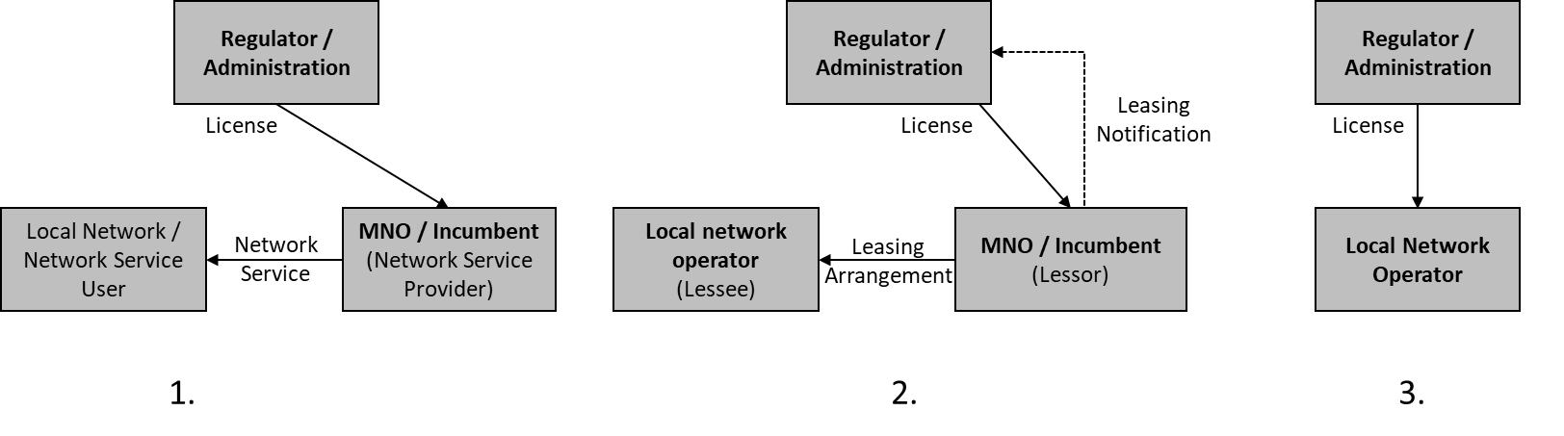

Figure 12: Three basic spectrum access methods for local IoT services. 1) MNO offered service, 2) Leasing of spectrum, 3) Local license.

## Examples of availability of use of spectrum for local networks

There are several countries that have begun to consider licensed spectrum as part of industrial digitalization and industrial applications (see Figure 13). Germany has allocated local licensed spectrum in 3700–3800 MHz band range to industries for their applications already in 2019. Japan announced the allocation of the 28 GHz band. Other countries, like France and Italy, are looking primarily at allocating spectrum to mobile network operators, who then need to ensure the availability of spectrum for industries. Thus, the regulators have taken different paths on how to allocate spectrum for industries as well the frequency bands to use.

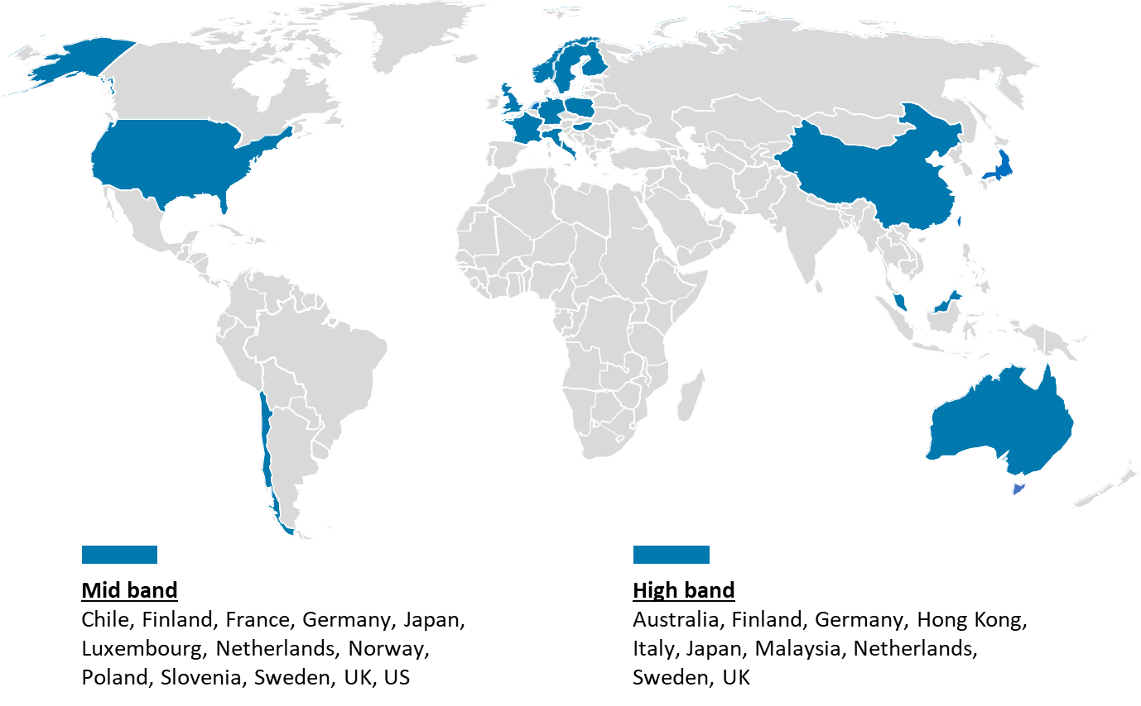

Figure 13: Examples of spectrum for industries, ongoing or allocated, as of May 2020 [11].

## Existing Spectrum Sharing Schemes

### Licensed Shared Access (LSA)

The LSA concept, described in APT AWG report 68 [13] and also in CEPT in [14], is a complementary spectrum management tool that fits to an "individual licensing regime". LSA foresees the introduction of new users (licensees) in a frequency band while maintaining incumbent services in that band. At first, an appropriate 'sharing framework' is to be defined by the Regulator, also known as a National Regulatory Authority (NRA), including all relevant stakeholders. Here, a set of sharing rules constitutes the regulatory and legal basis that ensures QoS levels for all authorized users.

LSA focuses on nation-wide, long-term sharing arrangements between incumbents and LSA licensees. The deployment of an LSA system requires the introduction of two new architecture building blocks: the LSA Repository and LSA Controller (see Figure 14a). The LSA Repository holds information such as spectrum resources for sharing, protection requirements of incumbents, LSA usage rights and sharing conditions in general. The LSA Controller is a management entity relaying this information to licensee networks it is connected to.

In CEPT countries the first practical use case of LSA is to access the spectrum for mobile broadband services (MFCN) in the 2.3 GHz – 2.4 GHz band.

ETSI proposed in [14] the LSA system architecture depicted in Figure 14b. Based on the work in ETSI, 3GPP opened a new study item [16] considering the impact of LSA on their specifications. Several trials have successfully proved the applicability of respective technologies [17], [18].

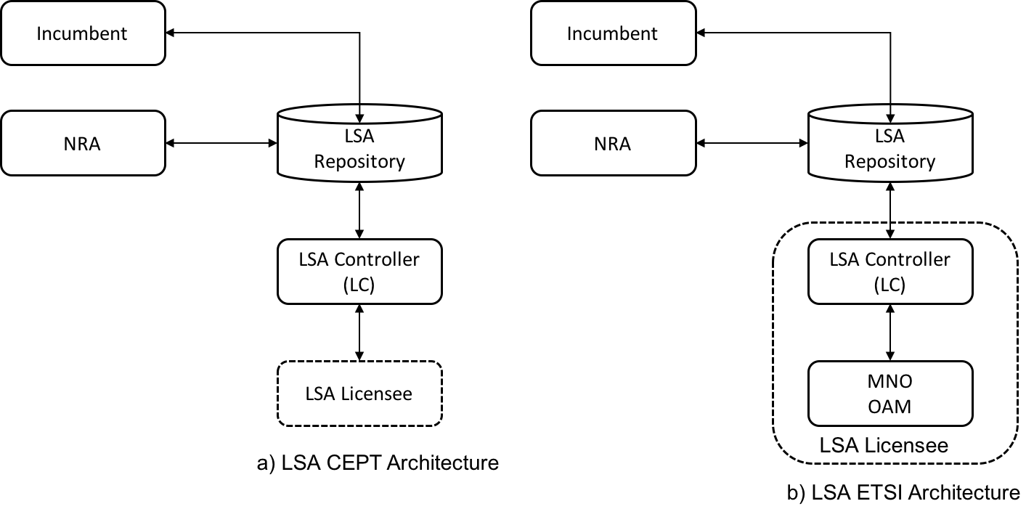

Figure 14: a) Baseline LSA architecture as described by CEPT in [13];   
b) Baseline LSA architecture as defined by ETSI for mobile broadband applications   
in the 2,3 GHz - 2,4 GHz band [14]

For scenarios with multiple LSA licensees, some differences exist between CEPT and ETSI architectures. The ETSI architecture foresees the presence of one LSA Controller per LSA licensee. In contrast, in the CEPT architecture, one LSA Controller may manage the access of multiple LSA licensees to the band.

### Citizen Broadband Radio Service (CBRS) with Spectrum Access System (SAS)

In the US, a new spectrum sharing approach called Citizens Broadband Radio Service (CBRS) to enable deployment of relatively low powered network technologies in the band 3 550 MHz – 3 700 MHz was introduced by the Federal Communications Commission (FCC) [19]. It has been further refined, changed and amended several times see e.g. [20 21]. CBRS introduces a 3-tier spectrum sharing method, which differentiates three levels of spectrum users:

* Tier 1: Incumbent Access (IA), users will be protected from harmful interference coming from Tier 2 and Tier 3 users.
* Tier 2: Priority Access (PA), users acquire PA licenses (PALs), valid for a single geographical service area, through a competitive bid process. PA users are protected from harmful interference coming from Tier 3 users.
* Tier 3: General Authorized Access (GAA), users can access any portion of the band not assigned to a higher tier. They may also operate opportunistically on unused PA channels. GAA users have no interference protection.

The band 3 550 MHz - 3 650 MHz would be dedicated to the PAL and if not used by PAL GAA users may be able to use it. The band 3 650 MHz - 3 700 MHz would be exclusively used only as GAA.

The CBRS architecture is shown in Architecture Figure 15 and contains following main functional entities and interfaces:

* Spectrum Access System (SAS) is a geo-location based database system that will manage the spectrum resources in the 3 550 MHz to 3 700 MHz band in 10 MHz blocks called channels based on knowledge of the base station sites, relevant configurations, and operational parameters.
* CBRS Device (CBSD) defines a Base Station which temporarily transmits at the CBRS spectrum based on a grant and transmission authorization provided by the SAS.
* Domain Proxy (DP) is an optional entity and acts on behalf of multiple CBSDs for a coordinated CBSD-SAS communication.
* Environmental Sensing Capability (ESC) monitors for incumbent radar activity in coastal areas and near inland military bases and acts as detection for spectrum resource usage of an Incumbent.
* CBSD-SAS interface is a standardized interface that allows CBSD registration and temporarily spectrum access for CBSD based on SAS management.
* SAS-SAS interface is a standardized interface which allows to offer competitive SAS services by different SAS operators even for the same spectrum resources (area and frequency band). Via the SAS-SAS interface a SAS informs other SAS systems on respective spectrum grants to guarantee the correct handling of PAL and GAA users according to the FCC rules, for instance to support the protection of PAL users from GAA users.

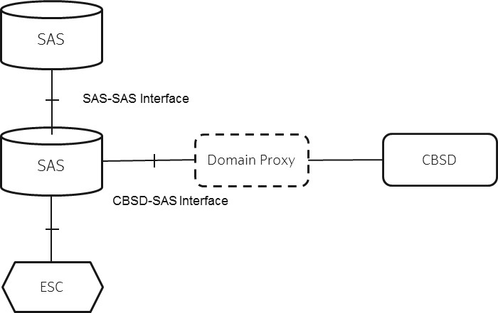

Figure 15: CBRS Architecture

A PAL is built upon the US county grid and defines a 10 MHz channel for a license area of one county. A priority access licensee is allowed on the one hand to aggregate up to four 10 MHz channels in a license area, on the other hand to form a service area which contains multiple adjacent license areas. The number of PALs per county is limited to seven.

Based on this, the PAL holder may establish a so-called PAL Protection Area (PPA) that defines an area within a service area for protecting the exclusive use of channels based upon the acquisition of the PAL rights. There may be more than one PPA in a service area. Within this scope, another operator can lease any portion of a priority access licensee's licensed geographic area for any bandwidth or period under a light-touch leasing process with a simplified FCC oversight [20].

### Summary

The LSA is based on licensed type of access mechanism allowing for the individual networks to plan their network individually and since the requirements and operation of many of the use cases requires high reliability and low latency connectivity in local areas, evolving based on LSA seems natural.

CBRS is providing a dynamic use of unlicensed and licensed operation in same band while protecting incumbents with large licensing areas. The CBRS system complexity increases compared to LSA since the spectrum use is under control of a central spectrum resource manager which controls the radio network nodes’ possibilities to transmit as well as the actual use of spectrum depending on the neighbouring networks situations and the incumbents. This may not provide a long-term predictable and reliable use of spectrum and therefore it may not attract long-term investments.

# Mechanisms in the context of different IoT Networks

In section 4.1, four possible spectrum sharing schemes for providing local area services focusing on QoS were identified. From those four schemes, the following three are considered of main interest:

1. Mobile network operators can offer dedicated local area services in their licensed frequencies
2. Mobile network operators can lease part of their spectrum locally to local area service providers
3. Spectrum can be licensed to local area service providers

All three spectrum sharing schemes supports access to frequency bands with or without Incumbents. Depending on the frequency band, respective protection measures, e.g. as defined for LSA in [13], [14], may be needed to guarantee QoS for local high-quality wireless networks and incumbent networks. LR and LC functionality are included in the repository and controllers, as described below.

Some local high-quality wireless networks scenarios may require the parallel use of different spectrum sharing schemes, and therefore, may need to combine the use of different functional architectures. For instance, the operator of a large industrial plant may request the use of licensed spectrum following scheme 3 above in local automation cells for motion control applications, while it may run monitoring and maintenance applications as local services within an MNO network (following schemes 2 or 1).

A relevant sharing approach for providing local area services focusing on QoS is the LSA [13] approach. The bottom line of LSA is that it aims to ensure a certain level of guarantee regarding radio spectrum access and protection against harmful interference for both the incumbent and LSA licensees, thus allowing them to provide a predictable QoS.

For locally confined and temporally flexible spectrum sharing system, the current LSA method needs to be evolved on LSA System level. Also, the regulatory framework needs to be considered. Some aspects to consider on the regulatory and LSA System levels are detailed below.

**Regulatory level:**

* Opening and using the LSA method to include vertical sectors players
* Using appropriate frequency bands and establishing a Sharing Framework for the vertical sector players
* May allow additional sharing methods like leasing of spectrum resources
* Simplification of the LSA License process to handle a high number of vertical sector players

**LSA System level:**

* Establishment of allowance zones, each describing a locally confined deployment area, such as an area bounded by a property, where the licensee has the right to transmit at a defined frequency range until the allowance time expires
* Locally confined deployment areas may be indoor and/or outdoor
* Deployment durations may range from several hours to several years, i.e. supporting flexible spectrum allocation procedures for LSA spectrum resources
* Channel arrangements should be deterministic and predictable (e.g. fixed channel plans) to satisfy the stringent QoS requirements of local high-quality wireless networks

The definition of an allowance zone, i.e. a local area, can be mapped to the land ownership, property. This would provide clear border delimitations between local areas avoiding the problems of use of “free polygons” which could lead to issues of overlapping area requests as well as spectrum hoarding when requesting an area larger than needed that could block others. A factory, process industry, mine etc. are typically located within a property or may also cover adjacent properties.

In the following, section 5.1 to 5.3 provides examples of functional architectures that may enable the use of the three spectrum sharing schemes for local high-quality wireless networks. In section 5.1 three deployments variants, A) to C), are shown for MNO offerings. Sections 5.2 and 5.3 shows functional architectures in an LSA ETSI framework for leasing and licensing cases respectively. We will use the term evolved LSA (eLSA) to indicate the added functionality support compared to LSA.

In ETSI, the System requirements and the System architecture and high-level procedures have been specified for eLSA [22, 23]. Work on specifying the protocol(s) are ongoing with a target completion date end of 2020.

## MNO-offered services locally

This can be done though slicing or similar techniques and is implementation specific. Three possibilities A, B and C are shown in Figure 16 to exemplify different business cases.

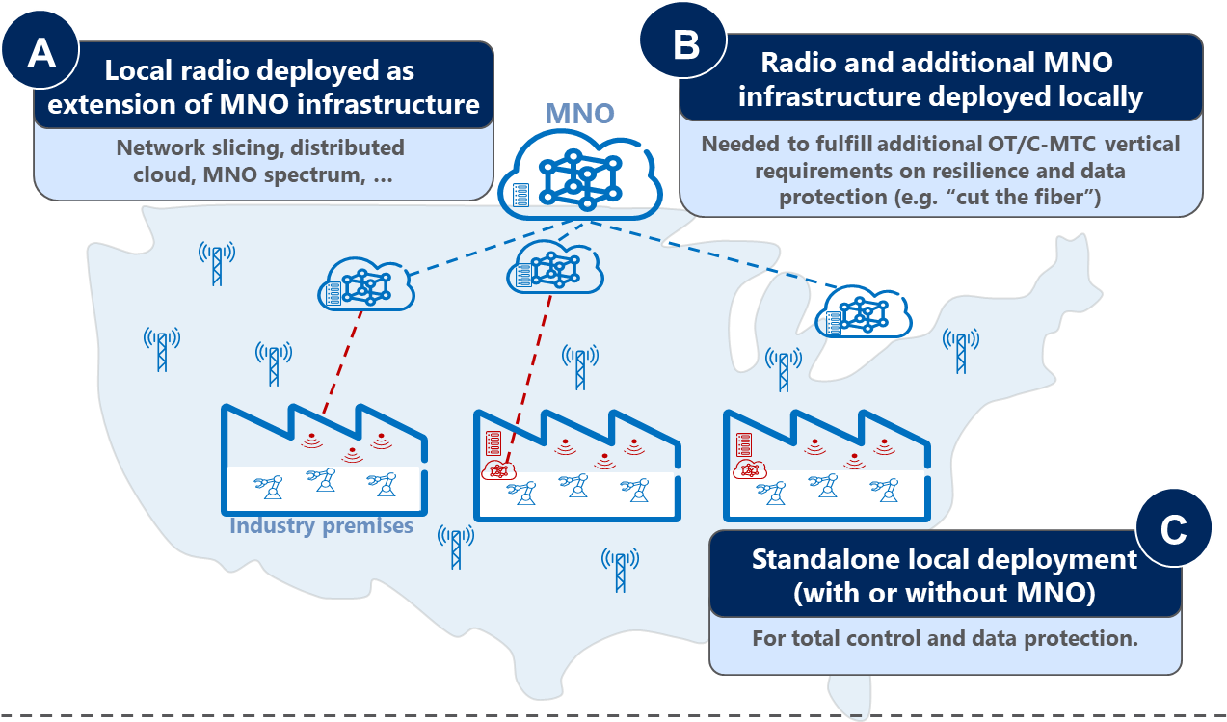

Figure 16: MNO offering of Services with different possible network node implementations.

## Leasing

The Incumbent domain is the operator that will lease out part of its spectrum to a Local network operator. The local network operator may use a third party that will provide the eLSA controller functionality acting on its behalf. The Pre-availability Check enables the Local network operator to check that a lease can be obtained that fits its requirements before investing in equipment and deploying the network.

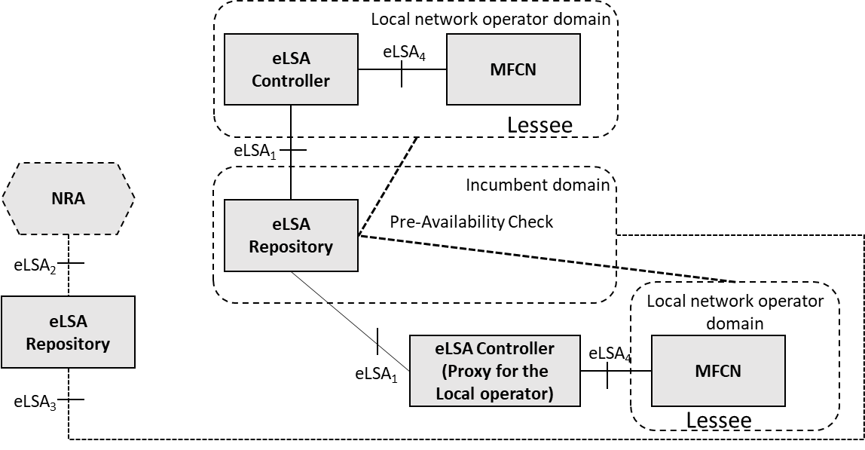

Figure 17: The eLSA architecture for leasing of spectrum.

## Local Licensing

The local network operator would be provided license over the evolved LSA1 interface. The licensing conditions will also be provided. The Pre-availability Check enables the Local network operator to check that a license can be obtained that fits its requirements before investing in equipment and deploying the network.

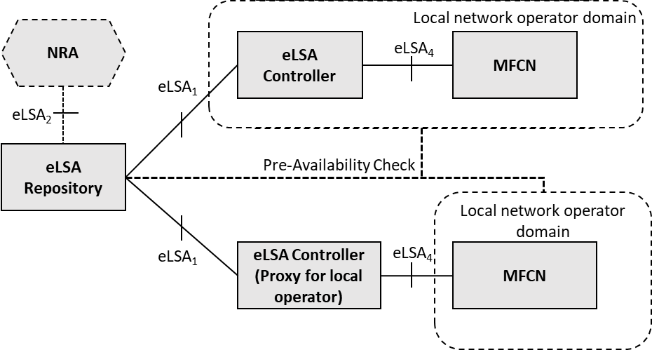

Figure 18: The eLSA architecture for local licensing

# Conclusion

Industry 4.0 and other QoS demanding applications need stable and predictable service provisioning, incentivizing long term investments. There is a higher interest in industry to use licensed spectrum to provide a high-quality, reliable and low-latency service provisioning if cables should be replaced by wireless connections. This report describes means to provide access to licensed spectrum for local area use. This can be done by evolving the LSA system, as described in APT report 68, to also include local area spectrum allocation mechanisms.

**References**

[1] GSMA, “Mobile IoT in the 5G future - NB-IoT and LTE-M in the context of 5G,” April 2018.

[2] Ericsson Mobility Report, 2018

[3] The 5G business potential (SECOND EDITION), October 2017

[4] VDE/ITG Positionspapier Funktechnologien für Industrie 4.0. [Funktechnologien für Industrie 4.0: "VDE Positionspapier, ITG AG Funktechnologie Industrie 4.0", June 2017.

[5] GSMA Industrial IoT Case study: Ericsson smart Factory, 2018

[6] “Feasibility study on temporary spectrum access for local high-quality wireless networks,” ETSI TR 103 588 V1.1.1 (2018-02)

[7] 3GPP TS 22.104, “Service requirements for cyber-physical control applications in vertical domains”.

[8] PMSE-xG White Paper, <http://www.pmse-xG.research-project.de>

[9] A case study on real-time control in manufacturing, Ericsson Consumer & IndustryLab Insight Report April 2018

[10] A case study on automation in mining, Ericsson Consumer & IndustryLab Insight Report June 2018

[11] 5G spectrum for local industrial networks, Ericsson White Paper, June 2020

[12] ECC Report 132: "Light Licensing, Licence-Exempt and Commons", June 2009

[13] APT Report 68, "Authorized/Licensed Shared Access as a National Solution to Access Spectrum for IMT,” 09/2016

[14] ECC Report 205: "Licensed Shared Access (LSA)", February 2014, CEPT WG FM PT53

[15] ETSI TS 103 235: "Reconfigurable Radio Systems (RRS); System architecture and high level procedures for operation of Licensed Shared Access (LSA) in the 2 300 MHz - 2 400 MHz band"

[16] 3GPP TR 32.855 (V1.0.0) (02-2016): "3rd Generation Partnership Project; Technical Specification Group Services and System Aspects; Telecommunication management; Study on OAM support for Licensed Shared Access (LSA); (Release 14)".

[17] Ericsson, RED Technologies, and Qualcomm Inc. conduct the first Licensed Shared Access (LSA) pilot in France (http://www.redtechnologies.fr/)

[18] D. Guiducci et al.: "Sharing under licensed shared access in a live LTE network in the 2.3-2.4 GHz band end-to-end architecture and compliance results", 2017 IEEE International Symposium on Dynamic Spectrum Access Networks (DySPAN), Piscataway, NJ, 2017, pp. 1-10

[19] FCC 15-47: "Amendment of the Commission's Rules with Regard to Commercial Operations in the 3550- 3650 MHz Band", April 2015

[20] FCC 16-55: "Order and Reconsideration and Second Report and Order, Amendment of the Commission's Rules with Regard to Commercial Operations in the 3550- 3650 MHz Band", May 2016

[21] FCC 18-149: “Report and Order, In the Matter of Promoting Investment in the 3550-3700 MHz Band”

[22] ETSI TS 103 652-1, “evolved Licensed Shared Access (eLSA); Part 1: System requirements”

[23] ETSI TS 103 652-2, “evolved Licensed Shared Access (eLSA);

Part 2: System architecture and high-level procedures”

1. <https://www.5g-acia.org/>