|  |  |  |
| --- | --- | --- |
| APTlogogreen3 | **ASIA-PACIFIC TELECOMMUNITY** | |
| **The South Asian Telecommunication Regulator’s Council (SATRC)** |  |
|  |  |

**satrc report on**

**growth of mobile value added serivices**

**Prepared by   
SATRC Working Group on Policy, Regulation and Services**

Adopted by  
**15th Meeting of the South Asian Telecommunications Regulator’s Council**05 – 07 August 2014, Paro, Bhutan

**Table of Contents**

**Chapter 1 Introduction**

* 1. **Background –growth and development of telecom sector and specially mobile and broadband wireless systems**
  2. **Definition of MVAS**
  3. **Need/Importance /factors influencing the growth /key drivers of MVAS**

**Chapter 2 Types/Classification of MVAS**

**2.1 Basic classification**

**2.2 Popular MVAS examples**

**Chapter 3 MVAS Ecosystem/Value chain and technology platforms for access**

**3.1 MVAS Ecosystem/Value chain**

**3.2 Technical Arrangement/VAS Platforms accessed by customers**

**Chapter 4 Challenges for MVAS, MVAS Business Model and the future of MVAS**

**4.1 Challenges/Hurdles for the Growth of MVAS**

**4.2 MVAS Business Model**

**4.3 Future MVAS: KEY GROWTH AREAS- SERVICES AND APPLICATIONS**

**4.4 Strategy for growth of MVAS**

**Chapter 5 MVAS in the SATRC Region**

**Chapter 6** **International Scenario on Mobile VAS**

**Chapter 7 Regulatory Framework for MVAS**

**7.1 Regulatory Issues for the development of MVAS**

**Chapter 8 Conclusion and Recommendations**

**8.1 Conclusions**

**8.2 Recommendations**

**References**

**CHAPTER 1**

**INTRODUCTION**

**1.1 Background –growth and development of telecom sector and specially mobile and broadband wireless systems**

The unprecedented and phenomenal growth of mobile phone has surprised all of us in the world. According to the GSMA Intelligence 2014, the global mobile connections as of Mar 2014 stands at 6,991,909,812, unique mobile subscribers stands at 3,434,318,632. The overall revenue/year for the FY 2012 is estimated to be $1.16T and the ARPU/month for the same FY is about $13.00.

This growth can be attributed to a number of factors-the mobile technology is becoming cheaper and cheaper due to economies of scale; conducive policy, legal and regulatory regimes are being adopted globally; the mobile handsets are becoming cheaper and affordable even for common man; mobile spectrums are being harmonized ensuring economies of scale; tariffs are decreasing; the concept that mobile service is a luxury is changing into the notion that it is a basic tool and moreover, mobile device is becoming a multi-functional gazette.

It looks like that the mobile industry, whose revenue model has been based primarily on voice traffic has started facing a serious challenge of declining Average Revenues Per User( ARPU), subscriber churn, saturation of mobile growth market etc.

Given the declining ARPU, increasing competition among operators, consumers’ desire of getting more from their mobile phone, to maximize revenue, to increase ARPU (Average Revenue Per User),to survive in competitive environment,to satisfy the growing demand of customers,to improve loyalty and to continue expansion among others, it is imperative for the mobile operators to focus on alternate revenue streams. While among the youth entertainment related services would be popular, the other consumers would also look for utility based services like location information, mobile commerce (MCommerce) for mobile transactions and local content rich services. These myriad of additional services beyond core voice services can be collectively known in the telecommunication parlance as value added services. These services provided through mobile connection can be called mobile value added services ( MVAS).

As the telecom industry sees a rapid decline in voice tariffs, it is looking at services beyond standard voice calls, or Mobile Value Added Services (MVAS) to propel it to the next level of growth. The industry is looking at various means to use MVAS as a growth driver and simultaneously as a key differentiator.

The mobile phone is coming of age as it becomes an integral part of our life, and its application extends from basic voice calling to instant messaging, calculator, mini camera, music player to an internet ready, application driven computing system. While the reach of the mobile phone is a force to be reckoned with and its potential to deliver services is immense, the range of services currently being offered in our market is certainly limited. However, the plethora of needs, from health and education to financial inclusion and governance, that it can serve are unlimited. That is where the MVAS is important for the entire telecom industry value chain including the governments and citizens.

**1.2 Definition of MVAS**

There is no unique definition of MVAS. A clear MVAS definition is not only required to clear the confusion among the MVAS providers but it will also have an impact on the dynamics of the entire MVAS value chain and ecosystem. A detailed definition of VAS will have an impact on the legal and regulatory issues surrounding MVAS.

Let’s look at different VAS definitions floating in the market.

**Basic definition of a VAS**

Value Added Service (VAS) in telecommunication industry refers to non‐core services, the core or basic services being standard voice calls and fax transmission including bearer services.

The value added service satisfies one or more of the following characteristics-

* Standalone in terms of profitability
* Stimulates incremental demand for core or basic services
* Do not cannibalize core or basic service
* May be sold at premium price
* Provides operational synergy with core or basic services

In the telecommunication industry, on a conceptual level, value-added services add value to the standard, spurring the subscriber to use their phone more and allowing the operator to drive up their Average Revenue per User (ARPU). For mobile phones, while technologies like SMS, MMS and GPRS are usually considered value-added services, a distinction may also be made between standard (peer-to-peer) content and premium-charged content. These are called mobile value-added services (MVAS) which are often simply referred as VAS. Value-added services are supplied either in-house by the mobile network operator themselves or by a third-party Value Added Service Provider (VASP), also known as a Content Provider (CP). VASPs typically connect to the operator using protocols like Short Message Peer-to-Peer Protocol (SMPP), connecting either directly to the Short Message Service Centre (SMSC) or, increasingly, to a messaging gateway that allows the operator to control and charge of the content better.

India,in its Unified Access Service License (UASL), has defined VAS as follows‐

“Value Added Services are enhanced services which add value to the basic teleservices and bearer services for which separate licence are issued”. In the context of India services like- Public mobile trunking service; Voice mail service; Closed users group domestic 64 kbps data network via INSAT satellites system; Videotex service; GMPCS; Internet; Audiotex; Unified messaging service are grouped under value added services (VAS). Similar is the case with Nepal.

The above definition supports a free market but can be broadened to incorporate new service categories and players in the supply chain.

* 1. **Need/Importance /factors influencing the growth /key drivers of MVAS**

While greater mobile penetration and rapid deployment of 3G/4G and BWA are a boost to service revenue for mobile operators there is growing awareness that a business model built on the promise of continued expansion of the subscriber base is neither sustainable, nor particularly profitable. Put simply, many mobile markets are moving towards saturation in terms of penetration of addressable markets. Growth has to come from new services and finding ways to wring new value out of their existing customer base. Average revenue per user (ARPU) has dipped, a development linked to the use of multiple SIM cards. The pressure is on mobile network operators to look for new and innovative ways to generate revenues and secure competitive advantage by satisfying (not just multiplying) their customer base. With tumbling voice tariffs contributing to declining ARPU rates, mobile operators are finding the solution in value added services (VAS). More and more mobile network operators are looking ‘outside the box’ for new ways to generate revenue, which include adding new interactive value-added services such as mobile TV, mobile payments, mobile wallet, airtime transfer or even free music downloads which encourage more data usage.

**The reasons for the increasing importance of MVAS can be attributed to the following factors-**

**Decrease in ARPU despite increase in MOU:** Though the subscriber base is growing at a rapid pace and has positively impacted industry revenues, operator margins also have shrunk owing to competition and lower “Average Revenue per User” (ARPU) as the major growth is coming from bottom of the pyramid. As ARPU declines and voice gets commoditized, the challenge is to develop alternative revenue streams and retain customers by creating a basis for differentiation in high‐churn markets.

**Need for differentiation:** There is a greater need among the telecom operators to

differentiate themselves from each other.

**Increased Number of Licensees:** With increasing number of licensees in the telecom space the average numbers of operators have increased to 5‐6 operators offering more choices to the consumer. Thus the competition among the operators has increased tremendously. Therefore it is very important for them to differentiate themselves from the others. Now that voice has got commoditized these operators are using MVAS for their differentiation and marketing these services heavily for creating awareness among the consumers.

**Decreasing Call Rates:** In order to attract consumers with relatively low purchasing powers primarily from semi urban and rural areas the operators have drastically reduced the call rates making it affordable to even the lower segment of society.

**Introduction of 3G/4G/BWA h**igh speed networks likely to drive adoption of VAS**:** The arrival of new technologies will give rise to greater competition as many new players may also join the telecom market. Therefore there would be a greater need to differentiate one self in order to attract new customers and retain the existing ones.

**Saturation in Metro and Urban Market:** The metro/urban areas offer high level of penetration and have significant mobile subscribers. In such a highly saturated market with the entry of MVNO’s the competition will get fierce. Therefore capitalizing on value added services will give operators opportunity to increase ARPU by providing premium services.

**Increasing need and demand from consumers:** In addition to the above supply side reasons the ‘pull effect’ from consumers asking for more than just basic telephony is also a key driver for MVAS services. Today most of the consumers are seeking more from their communication device apart from just mobility and desire to stay connected.

**Gaining Competitive advantage through customer loyalty**

Surprisingly, the chief motivation is not money. In fact, the top two business drivers for VAS are stickiness (as a means to grow customer loyalty) and improving the customer experience. This is followed more distantly by a focus on growing new revenue streams and extending business reach.

Increased availability of affordable multifunction handsets with enhanced capabilities there by m**aximizing the utility of the sophistication of mobile sets and the facilities it provides such as e**ase of use and increasing popularity and use of Social Media

**Using ICTs for socio-economic growth and good governance**: Government mandate for inclusive growth leveraging the increasing mobile phone, and network penetration as well as need for automation using Information and Communications Technologies (ICTs) for effective public service delivery

**CHAPTER 2**

**TYPES/CLASSIFICATION OF MVAS**

**2.1 Basic classification**

MVAS can be classified and grouped in a number of ways. In its relation to the requirement of the use of basic service, we can classify MVAS into tow broad categories-

* Independent or standalone. This is not required to be coupled with a basic

service. Example- Mobile Advertising is not dependent on voice calls.

* Dependent or non-standalone. This is required to be coupled with a basic

service. Example- In Voice Mail service, re-direction of call is dependent on basic

services.

All the value added services address some need of the end consumer whether it is

psychological, monetary or convenience. Based on the need fulfillment of the end user, we can group Mobile VAS into three broad categories.

• **Entertainment VAS ‐** The key differentiating factor of Entertainment VAS is the **mass appeal** it generates. These provide entertainment for leisure time usage. These not only generate heavy volume (owing to its mass appeal) but also heavy usage. An example of these kinds of services is Jokes, Ringtones, CRBT (Caller Ring Back Tone) and games. These services continue to be popular and have been key revenue generators and has the potential to remain a key contributor to Mobile VAS industry for the SATRC mobile VAS market.

To sustain the MVAS growth, it is the responsibility of the industry to keep

discovering/innovating killer applications like CRBT (Caller Ring Back Tone) at regular intervals.

• **Info VAS‐** These services are characterized by the useful **information** it provides to the end user. The user interest comes in from the **personal component and relevance** of the content. Apart from mobile, alternate modes are available to access Information VAS like Newspaper, TV, and Internet. E.g. of Info VAS is information on movie tickets, news, banking account etc. They also include user request for information on other product categories like real‐estate, education, stock updates, etc. Information VAS needs to target the right person at the right time with the right content.

• **mCommerce VAS (Transactional services)‐** These are the services which involve some transaction using the mobile phone. An example of this kind of service is buying movie tickets using mobile phone or transfer of money from one bank account to the other. These can broadly be classified into 2 types ‐ Mobile banking and Mobile payments.

Besides those classified and grouped above there is another set of MVAS category that is gaining importance not only from the industry and customer perspectives, but also from the social responsibility of the governments. This category of MVAS services can be grouped into what can be called **Utility MVAS**

**Utility MVAS (m-commerce, m-health, m-education & m-governance etc.)**

Presently, the Mobile Value Added Services market in our region is centered on entertainment, music and sports. It is generally the younger segment of the consumers who take maximum advantage of such MVAS. Increasing proliferation of mobile services has created an unique opportunity to deliver other utility MVAS to the masses through innovative applications. The mobile platforms world over are being used to provide financial and banking services, health services, tele-education and government services.

Telemedicine can possibly transform the health care sector in our region as all the countries face a scarcity of both hospitals and medical specialists. A large majority of our population still lives in villages, where healthcare facilities are poor. Primary Health Centres and Community Health Centres in the rural and remote areas can be empowered through mobile based telemedicine to provide better healthcare facilities.

M-Commerce services will enable both banking and payment services through mobile platform. With a large proportion of the population of our region still unbanked, mobile based banking services can lead to financial inclusion of the unbanked population as well as being a cost efficient channel for banks to provide financial services.

Most of the Governments in our region have made right to education to all. The formal institutional network to provide education is limited especially in rural and remote areas. Mobile based education can very effectively be used to supplement Government efforts.

Agriculture is another area where m-applications can effectively contribute. Be it advice on nature of crop according to type of soil, or protection of crop from insects and pesticides, m-applications can be handy.

Most of the Governments in our region have initiated the National e-Governance Plan, wherein many of the government services will be available to citizens online. Under National e-Governance Plan (NeGP), a massive countrywide infrastructure is evolving and large-scale digitisation of records is taking place to enable easy, reliable access to the citizens. Citizens will be getting the services delivered from various departments through State data centre or the data centres of the respective departments. Therefore a lot of data will need to be transacted between citizens and the data centres. With very poor PC penetration in our region, mobile can provide a perfect medium for delivery of government services to the common man.

The initiatives to provide various services using mobile applications have already started in our region, but they are very limited. The potential for utility MVAS can be leveraged to boost social and economic activities, governance, and enhance government citizen interaction. There is plenty of scope to develop and deploy Utility MVAS services in the SATRC countries. However, there are certain key challenges under each of these groups which are impediments to the growth of Utility MVAS. Utility MVAS also require deep collaboration between operators, MVAS providers, and the government.

**2.2 Popular MVAS examples**

The focus of the industry, so far, has been infotainment MVAS, but there is much discussion around other services which have a greater growth potential, and currently may not even exist. Some of these services are those in the ‘Utility

MVAS’ category: Mobile Value Added Services (MVAS) which seek to digitally empower citizens by providing efficient access to essential information and services and foster inclusive growth.

It has been observed through survey that SMS, Ring tones & Pictures download, video clips, information services, Internet/GPRS, third party conference, and chatting are the most frequently used value added services. Very few people rarely used services are city info line, contest in TV through SMS, MMS, and Quiz/Contest, opinion polls, voice based SMS and Tele-Horoscope/Tele-Astrology services. These are various valued added services offered by service providers.

A list of some Value Added Services provided by the telecom operators to the end users consists of including but not limited to-

News - e.g. Business, sports, politics etc.

Finance - e.g. Share market, foreign exchange etc.

Entertainment - e.g. Games, jokes, films etc.

Travel - e.g. Railway, airlines etc.

Download - e.g. Caller tunes, wallpapers etc.

Astrology - e.g. Horoscope

Contest - e.g. Reality shows

MMS - e.g. Picture messages, video clips etc.

E-mail - e.g. SMS, E-mail etc.

Music - e.g. Ring tones

Cricket - e.g. Score, video clips etc.

GPRS - e.g. Internet, chat etc.

Call Alert - e.g. Missed call alerts when mobile is switched off or busy

Health - e.g. Health tips, beauty tips etc.

M-Commerce - e.g. mobile transactions like mobile banking

Others - e.g. movies, music etc.

**CHAPTER 3**

**MVAS ECOSYSTEM/VALUE CHAIN AND TECHNOLOGY PLATFORMS FOR ACCESS**

MVAS seeks to digitally empower mobile users by providing efficient access to essential information and services and foster inclusive growth, even without physical access. Needless to say, the stupendous growth in the VAS sector

necessitates due tax planning and structuring of the plethora of complex business transactions amongst the various stakeholders in the VAS value chain like content creators, content aggregators, technology enablers, mobile operators, handset manufacturers etc.Typically, there are 2 ways in which content flows within the VAS value chain:

• Scenario 1: Where the user transacts directly with the content creator or the content aggregator directly for availing the VAS.

• Scenario 2: Where the user obtains the required content through the mobile operator and the mobile operator in turn contracts with the content creators, content

aggregators, technology enablers, as may be required.

3.1 **MVAS Ecosystem/Value chain**

A typical value chain in the MVAS industry encompasses content creators/providers, mobile advertisers, aggregators, technology enablers, telecom service providers and end users or subscribers as shown in the figure below. Content aggregation and provision of technology platform is usually performed by a single entity known as Value Added Service Provider (VASP). It is also to be noted here that in the value chain of MVAS, telecom service providers are very big entity in comparison to the content providers/content aggregators who are basically SMEs. Mobile handset manufacturers have also started playing an important role in the VAS value chain. Advertisers are also looking for higher delivery of marketing activities through mobile VAS platform.

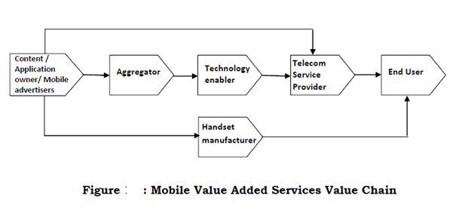

**(i) Content owner/ provider**

The first stakeholder in the value added services value chain is the Content Authors/Producers or copyright owners known as content owners. These entities provide the core content which drives the VAS – which may be owned or sourced by them. Examples include the music companies, movie production houses, media companies, TV channels etc. Their offerings include copyright of songs, entertainment news, movies, television listings, movie trailers, and promotional media content. Advertisers are also producing content for promotion and delivery of marketing communication to consumers through mobile VAS platform.

**(ii) Content Aggregators**

These are the companies that aggregate content obtained from various content owners/providers, convert it into the digital or any other suitable format and make it available to technology enablers (value added service providers) or telecom service providers.

**(iii) Technology Enablers**

These entities also called as Value Added Service Provider (VASP) provide the technology layer for the telecom networks, which in most of the cases also performs the task of Content aggregator. The technology layer often includes a VAS platform, Mobile Application development & hosting, MIS & reporting tools, operator billing, collection & payment settlement engine. Technology enabler may or may not be dependent on content developers, e.g. mobile phone back up facility does not require any content from the developer but the solution is directly provided to the telecom operator.

**(iv) Telecom Service Provider**

Telecom service providers own the access network & end users and also provide end-user billing & collection for the provision of VAS. They have commercial agreements or arrangements with the VASPs for providing the VAS.

**(v) Handset manufacturers**

In some cases the Mobile handset manufacturers have direct agreement with content owners or VASPs for content which are embedded in the handset or terminal device. An example of such content is games coming with the mobile handset. They also provide features such as on-device portals which are accessible through embedded links provided in the handsets.

With telecom industry going through significant changes, all the key players in the Mobile VAS ecosystem are looking for more efficient ways of dealing with the changes. The key changes riding the wave are:

- Network technology evolution bringing higher bandwidth

- Operating costs running high

- Advances in mobile and internet computing resulting in explosion of application developers

The need of the hour is to enable an efficient service delivery ecosystem that will achieve the following:

- Facilitate shorter concept-to-market timeframe for VAS applications and services

- Reduced capital/operational expense and improved margins for all players in the ecosystem

**3.2 Technical Arrangement/VAS Platforms accessed by customers**

Different technical arrangements or platforms are presently being used by telecom service providers for delivering Mobile Value Added Services based on the type of content. For example SMS are used for downloading monophonic ringtones, whereas WAP/GPRS platform is used for downloading polyphonic and true-type ringtones. Some of the MVAS delivery platforms are following:

(i) Short Message Services (SMS) – To process and deliver SMS based value added services SMSC Platform is used by the telecom service providers. SMS can be person to person (P 2 P) and person to application (P 2 A & A 2 P). The subscriber sends an SMS to the server, which then sends back an SMS to the subscriber with the service requested e.g. downloading ringtones, seeking information like news, cricket scores, subscribing to jokes and accessing other such services.

(ii) Interactive Voice Response (IVR) – This platform integrates computer and telephony to detect voice and touch tones using a normal phone call. The subscribers interact with an IVR system with or without embedded voice recognition technology for accessing VAS such as news, live talk to astrologer, movie information, jokes, listening to live commentary etc.

(iii) Wireless Application Protocol (WAP) and General Packet Radio Service (GPRS) – It is a service which enable users the access to Internet on the mobile. These include basically data based value added services such as Internet browsing, MMS, entertainment, download music/video/wall papers, Games and Mobile TV etc.

(iv) Unstructured Supplementary Services Data (USSD) - This is a method of transmitting information/instructions over GSM network. It is a session oriented service where user gets a flash message in real time. Services like content download, cricket updates, jokes, news alerts etc. can be acquired by subscribers using USSD.

(v) Call Management Services (CMS) – Services like missed call alerts, call forwarding, voice mail, incoming call block etc. are provided using this platform.

(vi) SIM Application Tool Kit (STK) – The SIM Application Toolkit allows for the service provider or a bank to house the consumer‘s mobile banking menu within the SIM card. STK is the most secure method for mobile banking. It allows the bank to load its own encryption keys onto the SIM card with the bank‘s own developed application. Thus the consumer‘s data can be stored on the SIM Card and the consumer can be authenticated on the handset prior to having to carry any data across the mobile network.

A summary of the VAS and the widely used access platforms are given in the diagrams below.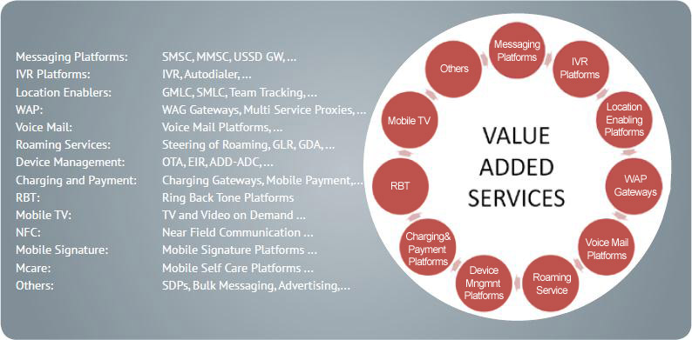

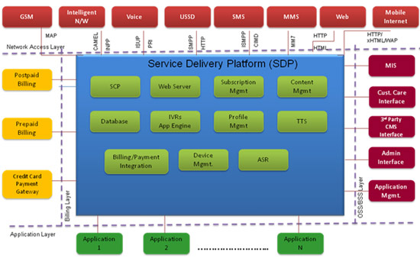

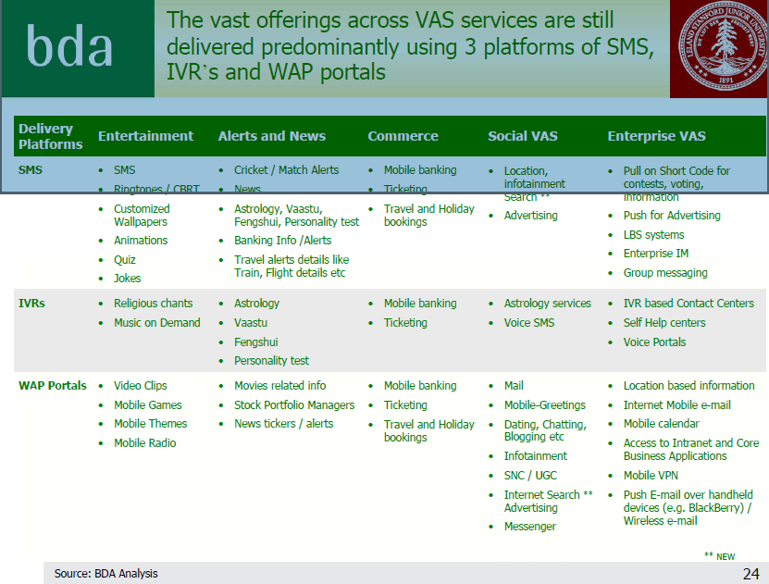

**CHAPTER 4**

**CHALLENGES FOR MVAS, MVAS BUSINESS MODEL AND THE FUTURE OF MVAS**

**4.1 Challenges/Hurdles for the Growth of MVAS**

While operators are betting big on the country’s increasing mobile data consumption, which is likely to be driven by the adoption of feature-rich content, the Mobile Value Added Services (MVAS) players cite loopholes which can potentially de-rail the anticipated data growth in the coming year. A closer picture of the issues bothering the MVAS industry includes but not limited to-

**Revenue sharing:** Many industry players believe that unfair revenue sharing between operators and application developers is a major challenge which discourages developers from innovation. The current business practices is an operator-favoring business-model of the MVAS industry and has emerged as a major challenge for the sector, since it eats up a fair share of the application developers revenue, hindering innovation in the segment.It is widely complained that the unfair proportion of revenue between MVAS players and operators blurs the possibility of a business case.

**Absence of localized content:**The second major issue which the industry believes could further deteriorate the MVAS growth in the region is the absence of localization. MVAS players can only reap actual benefits of the country’s data usage if there is a focus on innovation of more relevant and customized content in diverse countries of this region which as of now does not exist. *To fulfil the growing VAS demand, the current supply of VAS services, products and supporting infrastructure lack desired capacity.*Non emergence of killer apps and unavailability of language specific products and content has left behind a huge unmet demand that needs to be serviced. This will be even more important factor in rural VAS where large number of new users is getting added. These users will need content which would be:

• Relevant to their needs (local information, weather forecast, regional entertainment)

• Available in language they understand (regional or vernacular language)

There lies a huge potential in reaching out to the far-flung masses of our region who do not subscribe to the MVAS services because of the lack of local content.

**Impractical regulations: M**VAS players also blame regulations for the slow uptake of MVAS products. Many in the industry believe that any regulation which needs consumers’ written consent before activating any new service will be detrimental to the growth of the industry. But from the perspective of the consumer interests it is believed that such regulation will protect and benefit consumers.

**Customer Awareness:** Compared to the mobile penetration in our region and the number of MVAS users, it is evident that one of the major issues is the lack of consumer awareness about the potential benefits of the use of MVAS services. It seems that the concerned stakeholders.

**DEVICE AND TECHNOLOGY (OS COMPATIBILITY ISSUES)**

**Proper Handsets and Cost of Handsets:** Most of the low cost handsets are not able to support many of the regional languages. High end handsets are costly and are not affordable for mass market deployment. Entry of low cost handsets and some model has posed a new challenge. Many of these handsets have their own operating systems and technology unlike that used by branded players. It becomes difficult to create suitable MVAS that will run on the wide variety of handsets.

**Bandwidth Constraint:** Many of the feature rich content delivery via MVAS are constrained by the availability of sufficient bandwidth particularly in the 2G platform. However this problem could be overcome as most of the countries in our region are expanding the reach of 3G/4G and BWA services even in the far flung regions.

**PRICING :**While new services could fillip MVAS usage and eventually lead to higher revenues and ARPU, it will be necessary to price the offerings at a reasonable level. Setting appropriate pricing will be the most challenging for 3G/4G and BWA services that the providers have already introduced or planning to introduce in many countries in our region.

**Skill sets required in MVAS industry:** The skill sets required in the MVAS industry spans across multiple dimensions listed below-

* Content and Applications
* Programming Skills
* CTI – C - XML
* Application development – J2ME, Android, Symbian
* Web Technologies
* Telecom Knowledge
* Network
* Devices
* Product Engineering knowledge
* Business Analytics
* Vertical Specific Expertise
* Banking
* Education
* E-Governance Initiatives

Having these skill sets could be a major challenges for providing innovative and compelling services for the end users.

The challenges for the growth of MVAS accrues from multiple dimensions and are summarized below.

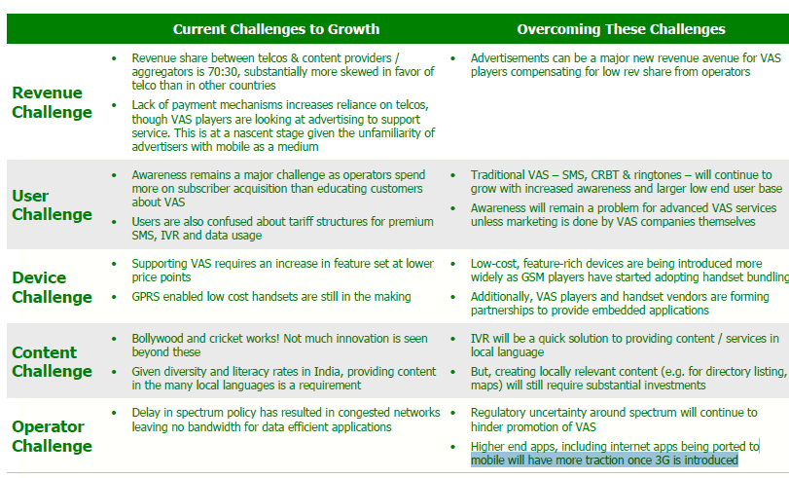

**Challenges for the growth of utility MVAS**

The major challenges for the growth of utility MVAS are lack of government initiatives, lack of consumer authentication infrastructure, lack of micro payments infrastructure, lack of regulatory framework or guidelines related to privacy, legal liabilities & dispute resolution mechanism etc. In addition to the above, some of the operational challenges encountered while deploying utility MVAS initiatives are:

* Inability to ensure relevance of service by understanding consumer needs
* Inability to keep products affordable
* Inability to obtain the right partners and build the ecosystem
* Inability to generate consumer awareness
* Need to make significant investments on business models which have a long gestation period
* Ensuring inter-operability of applications across operating systems/network architecture so as to not incur incremental set-up costs

While there are plenty of challenges that face the utility MVAS space today, the opportunities are enormous, given the increasing proliferation mobile phones even in rural & remote areas and the rapid development of technology including the foray of 3G and also BWA and 4G in many countries in our region.

**Challenges of the Key players in the MVAS ecosystem**

The major challenges faced by the key players in the VAS ecosystem are related to the cost of providing VAS applications and services to the subscribers and time to market these services. The specific challenges faced by each player are listed below.

**Telecom Operators**

* High hardware, software and licensing cost to buy, offer and maintain mobile VAS applications and services
* High capital/operation expense for offering mobile VAS applications and services
* Long concept-to-market timeframe impacting business

**Content Providers/Application Service Providers**

* High hardware, software and licensing cost to use mobile VAS application framework and building blocks in order to build and offer newer applications and services
* High hardware, software and licensing cost to support BSS/OSS functions for applications and services with Telecom operator or delivery channel provider.
* Long concept-to-market timeframe impacting the competitiveness and viability of small and medium Businesses

**4.2 MVAS Business Model**

Given the variety of network models that can be adopted and the potentially unfair revenue sharing schemes that are often controlled by the operator (at least during the inception period of the service provision), some degree of regulatory intervention will help balance the financial relationship between the

stakeholders. A policy free environment is perhaps the only way to reap the benefits of innovation; especially when introducing a new service. In this instance however, the lack of policy has created an unfair playing field (depending on the type of business model adopted). Therefore, although policy intervention may prove to be beneficial, striking the right balance is imperative.

The mobile content market is rapidly changing. To survive and remain profitable in this field it is vital to be able to think innovatively and adopt new business models. Combating the negative attitude towards SMS and banner ads creatively is another challenge service providers must be willing to face.

There are a multitude of business models that have evolved from three main paradigms for the delivery of value added services:

**1. Subscription model:** Users are partially (for premium content) or wholly charged a specific fee irrespective of actual usage.

**2. Advertising model:** Content and services are mixed with advertising material, often in the form of banner ads. These adverts may be the sole or major source of

revenue for the broadcaster.

**3. Merchant model:** This simply involves wholesalers and retailers who trade mobile content, goods and services.

A high-level analysis of the main models suggests the income streams are largely dependent on:

1. Network traffic: Certain models (especially advertising based) rely on the expansion of social networks driven by user recommendation.

2. Unique customer value: A key driver for subscription based models is to maximise the willingness to pay by creating high levels of unique customer value.

3. User mass: The merchant model is predominantly based on the premise of 3rd party trade; and therefore, requires a substantial user base in order to be lucrative.

Most other business models are variations of the subscription, advertising and merchant models. For example, the utility model employs metered or pay-as-you-

go system, while the info-mediary model uses valuable information about user behavior to reach a target user base. The affiliate model is a further variant of the utility model, where revenue share is based on the number of user clicks.

The MVAS market is basically a three-player market comprising of content owners, content aggregators/enablers and mobile operators. From this perspective there are two arrangements through which the content is delivered to end consumer.

**(i) On deck model**

In this model, the telecom operator undertakes the branding, marketing and selling of mobile VAS content. The billing is also done by telecom operator and it collects the revenue from subscriber. As a result, it retains the largest portion of revenue (60-65%) and the rest is shared among content aggregators and content developers. Presently, in the Indian market on deck value added services, service platform including gateway/middleware is provided either directly by the telecom service providers or by the Value Added Service Providers (VASPs). In the first case VASP only provides the content. In the second scenario VASPs provide technology platform along with content. Commercial arrangements exist between telecom service providers and Value Added Service Providers (VASPs) for providing these services. In some of the cases the VASPs do not own the contents but they have arrangements with the content providers/content developers or copyright owners known as content owners. In the commercial agreements, compliance to copyrights, digital rights management including sourcing of the content is the responsibility of VASPs.

**(ii) Off deck model**

In this model, the VASP sells content directly to subscribers. The content can be provided either through the operators' portal or through their short code. These short codes are uniform across all telecom service providers. The economics in this model are opposite to that of on deck model. In this model, content developers and aggregators retain 60-65% of revenue whereas 30-35% is being passed on to the telecom service providers.

Off-deck VAS provider needs to integrate with multiple operators to be able to use the same short code to provide services to subscribers across carriers. This can increase the cost and time of integration. Also, the operator has an influence on deciding the end user price as well as the potential revenue share expected by the VASP.

**4.3 Future MVAS: KEY GROWTH AREAS- SERVICES AND APPLICATIONS**

The new business models in the MVAS ecosystem cannot be sustained based on the traditionally popular services alone. New services need to be innovated and compelling services offered for the customers. In this section some of the key growth areas with services and applications will be explained.

Mobile operators across Asia Pacific are actively pursuing strategies around mobile payments and personalization to carve out a central position in the value chain and improve the customer experience. Interestingly, the end-game is not about generating new revenues. It’s about delivering a compelling customer experience in order to extract new value from existing customers. Additionally, it’s a sharp focus on VAS that mobile operators believe will separate the market leaders from the also-rans. As a result, they are completely confident that the threat from OTT players will diminish over the next few years, a shift that will see their own destinations and services dominate.

• Mobile payments: transactions and mobile commerce on behalf of third parties including application storefronts, mobile content providers and virtual goods merchants like Facebook

• Mobile Internet and personalization: managing and monetizing operator portals and destinations, and mobile content/advertising schemes

**Mobile marketing**

Mobile phones can also be an extremely cost effective communication channel as well as an efficient way of delivering a marketing message. Promotion through mobiles has emerged as an integral part of any brand’s marketing campaign today. It has become an important engagement tool for brands and aims to fulfill the gap that traditional media has been unable to bridge. With the increasing popularity of the Mobile Internet, this form of marketing is soon on the edge to achieve a significant reach.

**Mobile Advertising and Search**

The race is on to develop and deploy strategies aimed at advancing mobile advertising and search. It is believed that the subscribers would be willing to view mobile advertising in return for mobile content, applications and other perks. However mobile spam has could pose a negative impact on consumer acceptance of mobile advertising. Personalization is becoming the must-have feature of all the content mobile operators offer — and that includes mobile advertising, which is essentially just another form of mobile content.

Mobile Money /Mobile Payment

Mobile money is causing a significant transformation in how banked and previously unbanked people in emerging markets are conducting their financial activities. These services play a central role in extending the reach of formal financial services to the unbanked and financially underserved populations in emerging economies. Furthermore, the mobile phone is the first self-service banking channel for a substantial share of the already banked individuals. In some countries mobile money services have already matured to the extent that significant business opportunities are emerging for companies from adjacent industries, such as insurance providers and merchant acquirers. The number of active mobile money users in emerging markets is forecasted to grow from 61 million in 2011 at a CAGR of 36 percent to reach 381 million by 2017.

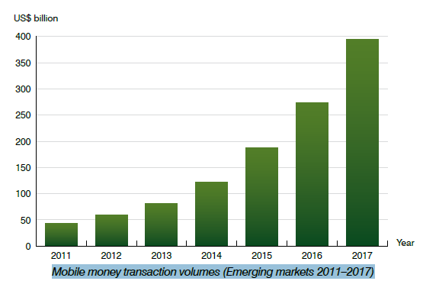**Berg**

The evolution of mobile money ecosystems in emerging markets is also driving the share of international money transfers that are sent to mobile money accounts. Berg Insight estimates that remittances sent to mobile money accounts will grow at a CAGR of 55 percent from US$ 850 million in 2011 to US$ 12 billion in 2017. In addition to money, value is also being transferred in the form of prepaid airtime. The value of airtime sent internationally has more than doubled year-on-year in the past years and is on track to double again in 2012. Berg Insight forecasts that the total value of international airtime transfers will grow from US$ 350 million in 2011 at a CAGR of 52 percent to reach US$ 4.4 billion in 2017.

So far as the revenues from mobile payments is concerned, the following are the key areas where the operators can focus-

* Billing on behalf of app stores (e.g. Android marketplace, Nokia Ovi)
* Pre-paid top ups
* Virtual goods (e.g. Facebook credits, gifting, online gaming content)
* Bill payment
* Money transfer (peer to peer)
* Ticketing/parking e.g. transportation, movies)
* Merchandise purchases (e.g. at the point of sale or over the air)

The major benefits that the organization being involved in mobile payments achieve could be summarized as-

* New revenue streams
* Better customer retention
* Enhanced customer experience /improved loyalty
* Provides for better competitive position
* Maintains a leading edge in changing m-commerce environment
* More profitability

Not adapting to the growth of mobile payments could result in

* Failure to adapt to changing customer demands
* Marginalization in the market
* Revenue loss
* Loss of competitive edge
* Lead to decline in market image
* Become just a pipe provider

**Mobile Wallet Services**

Berg Insight believes that the emergence of mobile wallet services will be the most significant development in the payments industry during this decade. Mobile wallet services will change both offline and online commerce by enabling new shopping experiences for consumers and by creating an unprecedented opportunity for retailers and brands to interact with their customers while purchase decisions are being made. However, the mobile wallet market is still in its infancy and the wallet services need to develop substantially before this vision can become reality. Nevertheless, the market is now moving rapidly and commercial rollouts of numerous NFC and non-NFC wallet services are underway. The required infrastructure for mobile wallet services is being rolled out and key partnerships are being formed between mobile network operators, financial institutions, retailers and other companies. This will result in a proliferation of mobile wallet services during the next few years, which will be a very important time during which wallet operators have an opportunity to learn and improve their services. Berg Insight anticipates that only a limited number of wallet services will survive in the long term due to network effects. Mobile wallet operators that do not enter the market early risk falling behind and may find themselves struggling to gain critical mass. Berg Insight expects that 2016–2017 will be the first years in which mobile wallets approach mass market penetration and more than ten million new wallet users will then be added on an annual basis. The number of active mobile wallet users is projected to increase from 0.5 million in 2012 to 42 million in 2017, whereas the in-store payments volume will grow from well below € 0.1 billion in 2012 to € 45 billion in 2017.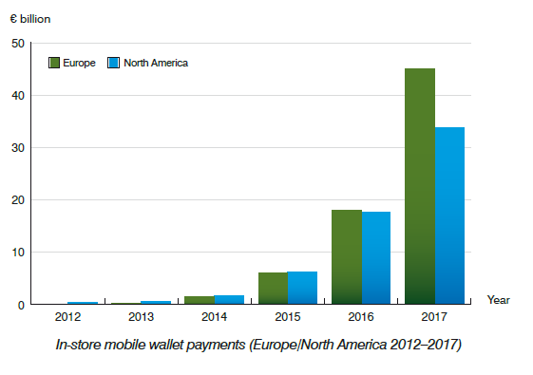

**Opportunities beyond the urban Consumer**

Addressing the rural market is likely to require a new way of developing and delivering services and content, and in particular working with the not-for-profit sector to build the use of data services to help rural populations manage their lives more effectively. In addition, services outside the urban areas will have to be created in a number of languages and provide locally relevant content such as agricultural commodity prices, weather information and access to official services and information. Telcos and others may also take the opportunity to develop their corporate social responsibility work in both rural and urban areas by providing free information services for issues such as healthcare.

**Enterprise services**

A major potential – and to date largely untapped – market for VAS is in the provision of services to enterprises. From simple applications such as using SMS for scheduling appointments to streaming product videos to a salesperson’s mobile phone, the applications are wide ranging and could offer considerable first-mover advantage for service providers who can address this market quickly.

**Innovative services, profitable growth and high performance**

Most of the countries in our region offer unique marketplaces. They have the simultaneous characteristics of mature and developing markets, with affluent and sophisticated consumers alongside those living in developing rural markets. Creating relevant and appealing VAS that address the needs and desires of those different markets is an exciting opportunity for service providers and media companies looking for ways to create profitable growth and high performance. Innovation of services and the capabilities that underlie them will be critical to making the most of this opportunity. New partnerships and alliances are likely to be a distinct feature of a successful approach to a market that is only just beginning to reveal its potential.

**MOBILE APPLICATIONS ( Apps)**

The success of Apple’s Application Store has not only established the salability of mobile applications, but has also shown that the most excellent applications offer the potential to generate large amount of revenues.

 [Portio Research](http://www.portioresearch.com/en/blog/2013/fast-growth-of-apps-user-base-in-booming-asia-pacific-market.aspx) (March 2013) estimated that 1.2 billion people worldwide were using mobile apps at the end of 2012. This is forecast to grow at a 29.8 percent each year, to reach 4.4 billion users by the end of 2017. Much of this growth will come from Asia, which will account for almost half of app users in 2017.  
There are 6.8 billion mobile subscriptions worldwide, according to the [ITU](http://mobithinking.com/mobile-marketing-tools/latest-mobile-stats/a#subscribers) (February 2013) – that means approximately 17 percent of mobile subscribers use apps.

**Users of mobile apps worldwide by region 2012-2017 according to Portio Research**

|  |  |  |  |
| --- | --- | --- | --- |
|  | | | |
|  | **2012** | **2013** | **2017** |
| **App users worldwide** | 1.2 billion | N/A | 4.4 billion |
| Asia Pacific | 30% | 32% | 47% |
| **Europe** | 29% | 28% | 21% |
| North America | 18% | 17% | 10% |
| **Middle East & Africa** | 14% | 13% | 12% |
| **Latin America** | 9% | 10% | 10% |
| **Source: ©** [Portio Research (March 2013)](http://www.portioresearch.com/en/blog/2013/fast-growth-of-apps-user-base-in-booming-asia-pacific-market.aspx) | | **via: ©** [mobiThinking](http://mobithinking.com/mobile-marketing-tools/latest-mobile-stats) | |

**In most countries apps are popular with smartphone users, but not as popular as SMS or mobile Web.**  [Nielsen Mobile Consumer Report](http://www.nielsen.com/us/en/reports/2013/mobile-consumer-report-february-2013.html) (February 2013) indicated that in all 10 countries surveyed, smartphone vendors use SMS more than apps (despite the hype around messaging apps). Results suggest that in Brazil and Italy, smartphone users prefer apps to mobile Web; in Australia, India, South Korea and Turkey, app and Web usage is comparable; in China, Russia and UK mobile Web is preferred to apps; and in the US, mobile Web is much more popular than apps (20 percent higher).

**The table below gives an overview of all the activities performed by smartphone users at least once a month, according to Nielsen**

|  |  |  |  |  |  |  |  |  |
| --- | --- | --- | --- | --- | --- | --- | --- | --- |
| **Country** | **SMS** | **Web** **browsing** | **Email** | **Social** **networking** | **Apps** | **Streaming** **music** | **Instant** **messaging** | **Video/** **mobile TV** |
| Australia | 94% | 60% | 55% | 58% | 59% | 21% | 33% | 19% |
| Brazil | 85% | 69% | 66% | 75% | 74% | 39% | 57% | 43% |
| China | 84% | 75% | 58% | 62% | 71% | 59% | 67% | 39% |
| India | 45% | 15% | 17% | 26% | 13% | 11% | 15% | 8% |
| Italy | 89% | 37% | 51% | 47% | 49% | 26% | 35% | 17% |
| Russia | 95% | 68% | 55% | 59% | 64% | 41% | 34% | 36% |
| South Korea | 93% | 80% | 52% | 55% | 81% | 40% | 70% | 44% |
| Turkey | 78% | 37% | 33% | 69% | 38% | 22% | 50% | 9% |
| UK | 92% | 66% | 68% | 63% | 56% | 20% | 37% | 19% |
| US | 86% | 82% | 75% | 63% | 62% | 38% | 28% | 28% |
| **Source: ©**[**Nielsen, (February 2013)**](http://www.nielsen.com/us/en/reports/2013/mobile-consumer-report-february-2013.html) | | | | | | | **via: ©** [mobiThinking](http://mobithinking.com/mobile-marketing-tools/latest-mobile-stats) | |

**Research suggests that for activities such as shopping consumers prefer Web to apps.**

**Analyst estimates for downloads of apps in 2013 range from 56 to 82 billion. In 2017, there could be 200 billion downloads.****Analysts estimate that app revenues could be US$20-25 billion in 2013; this could triple by 2017; but app users are increasingly reluctant to pay for apps and the revenues are not equally distributed among app publishers.**

**Increasingly the lion’s share of revenues go to fewer and fewer big publishers.  
Number of applications responsible for 10 percent of revenues and downloads in Apple App Store and Google Play, according to Disimo is given in the table below-**

|  |  |  |  |  |  |  |  |  |
| --- | --- | --- | --- | --- | --- | --- | --- | --- |
|  | **November 2012** | | | **January 2012** | | | | |
|  | **10% of app store downloads** | **10% of app store revenues** | | **10% of app store downloads** | | | **10% of app store revenues** | |
| **Apple iPhone** | 31 apps | 7 apps | | 30 apps | | | 7 apps | |
| **Apple iPad** | 31 apps | 6 apps | | 20 apps | | | 6 apps | |
| **Google Play** | 22 apps | 4 apps | | N/A | | | 4 apps | |
| **Source: ©** [**Distimo (December 2012)**](http://www.distimo.com/publications) | | | | **via: ©** [**mobiThinking**](http://mobithinking.com/mobile-marketing-tools/latest-mobile-stats) | | | | |
| **Downloads of mobile apps from all stores worldwide, 2010-2016 according to Gartner** | | | | | | | | |
|  | **2011** | **2012** | **2013** | | **2014** | **2015** | | **2016** |
| **Free downloads** | 22.1 billion | 40.6 billion | 73.3 billion | | 119.9 billion | 189 billion | | 287.9 billion |
| **Paid-for downloads** | 2.9 billion | 5.0 billion | 8.1 billion | | 11.9 billion | 16.4 billion | | 21.7 billion |
| **Total downloads** | 24.9 billion | 45.6 billion | 81.4 billion | | 131.7 billion | 205.4 billon | | 309.6 billion |
| **Percentage free downloads** | 88.4% | 89.0% | 90.0% | | 91.0% | 92.0% | | 93.0% |
| **Source: ©**[**Gartner (September 2012)**](http://www.gartner.com/newsroom/id/2153215) | | | | | | **via: ©**[**mobiThinking**](http://mobithinking.com/mobile-marketing-tools/latest-mobile-stats) | | |

**Games are the most popular type of app with the users. They also make the most money.**While  [Distimo](http://www.distimo.com/publications) (2012 Year in review) estimates that most downloaded apps are games (33 percent); widgets (8 percent); entertainment (7 percent); social (5 percent); lifestyle; music; photography; productivity (all 4 percent); tools; communication; utilities (all 3 percent). Games also dominate app revenues, [Portio Research](http://www.portioresearch.com/en/blog/what-apps-are-people-using.aspx) (April 2013) calculates that top categories (by number of apps) on the Apple App Store: games (17 percent of all apps in store); Google Play: games (15 percent); BlackBerry World: books (15 percent), games (9 percent); Windows Phone Store: entertainment (19 percent), tools & productivity (15 percent), games (12 percent).  
The second most popular app category, overall, after games is messaging apps, also known as over-the-top (OTT) apps, according to Portio. It is estimated that there are at least 1 billion OTT messaging apps users around the world. The most popular of these are: Facebook Messenger (700 million users worldwide); WeChat (300 million); What’sApp (200 million); Viber (175 million); Line (100 million); Kakao Talk (70 million); BBM (60 million); iMesssage (45 million); ChatON (10 million); Skype (10 million).

Increased smartphones adoption and growing mobile internet penetration have led operators to increase the value added services they offer to their subscribers. Operators across the region now offer mobile services related to:

* **Health:** MNOs have partnered with healthcare companies to help users find hospitals, schedule appointments,get medical advice, and facilitate their treatment.
* **Education:** Partnering with various NGOs, MNOs now offer real-time interactive courses, IVR-based education, and additional initiatives aimed at underprivileged children.
* **Commerce:** Mobile payment systems have already taken off in India, encouraging telcos to offer other services such as microfinance, retailing, and mobile wallet.
* **Infotainment:** Users can subscribe to various infotainment services, receiving everything from sports scores and travel updates, to ringtones and mythological stories, all on their mobile phones.
* **Agriculture:** Services for farmers help provide them access to market conditions, commodity prices, weather updates and more.

These services, and more, have led to a steady increase in MVAS revenue over the past few years.

**4.4 Strategy for growth of MVAS**

In the last section we explored the MVAS growth areas. They however require strategic effort for the growth to be achieved. In this section we will explain the key strategies that could be adopted by the key stakeholders for the growth of MVAS.

While there is no single prescription for a VAS strategy, the following could be considered the key elements for success.

1. **Integrate the Ingredients** – The customer experience is essential for the success of any new service, and the mobile VAS experience is dictated by how well you integrate what we call the “4 P’s” of the Digital Mix: The Pipe (network), The Pod (device), The Panel (user interface) and The Programs (content & applications). It is the blend of all of these ingredients that makes a successful experience.

2. **Embrace the Ecosystem** – With several large global players and hundreds of small local innovators,the odds are heavily stacked against a single company having all of the expertise in house to provide and sustain the innovations needed to deliver a portfolio of VAS services. Cooperation between content providers, device makers, application developers and operators is vital to create the most effective business models. Operators can play a potentially central role in this ecosystem through leveraging their own unique capabilities and providing leadership on key issues such as pricing and payment transparency, security of copyright and content.

3. **Think Segment, not Product** – Rather than focus on a search for a single blockbuster product, a better approach is to look at the needs of specific segments and assemble a portfolio of VAS products, internal and from third parties, which meet those needs. Deep insight into the sub-segments is key, blending data-driven analysis, local market knowledge and creative thinking from within and outside the company.

4. **Get sticky** – VAS can provide the opportunity and means for differentiation. Sticky services help to lock in customers by helping them manage their lives through services such as address book storage, SMS back up, and a range of personalized content and social networking tools. Operators can mine customer data to generate insight about the types of service bundles that would suit specific customer segments and use these to help drive retention.

5. **Start simply** – The development of VAS should start with simple, reliably delivered services. The most successful experiences give customers a “story”,progressively building in new functions and features over time and focusing on the “Pareto of Life”: 80 per cent of customers just want 20 per cent of the functions… so do those few things very well and don’t over-complicate the range of options.

6.**Be innovative and understand the change:** Existing focus on Audio, Text based content will look – like era of only Radio, Newspapers & Pagers. We are in the New era of Color TV, Video content. The TVs enabled limited number of people to watch TV programmes. Mobiles can enable billions of users to watch TV. Mobile could be the LCD screen for those who are otherwise deprived of watching TV. It implies that the VAS providers should focus on Multimedia content.

**7. PAR TNER:** Partnerships enable users to get the latest content services quickly, which involves a significant revenue share. Operators can create partnerships with content distributors and publishers, which will also benefit from entering the mobile market. This can not only reduce subscriber churn, but can also create stickiness and even drive customer acquisition. For example, Sprint launched Sprint Music Plus, a new application promising subscribers a single, streamlined destination to purchase and discover full-track downloads, ringtones, and ringback tones. It was created in partnership with a digital entertainment services provider, and not only offers subscribers music but also creates an opportunity to increase revenues from personalization services.Collaboration with handset manufactures, applications stores and application creators would allow the Mobile Operators to retain their importance in the VAS ecosystem.

**8. TARGET THE FEATURE PHONE MAR KET:**In mature markets there are very few adjacent players that offer VAS for feature phones. This is a market that is clearly in the hands of the operators, so creating services for this demographic would be beneficial.

**9. MOVE FIRS T:**Operators already have access to a large subscriber base and a strong billing relationship with their subscribers, and are therefore well-placed to make the most of the first-mover advantage by launching quality services aimed at a specific market

**CHAPTER 5**

**MVAS IN THE SATRC REGION**

**Afganistan:**

Afghan mobile network, Roshan has launched a mobile service, branded as Malomat, that provides pricing information to farmers and distributors to assist in buying and selling goods at fair rates. The service has been set up with assistance from USAID and the Global Development Alliance (GDA).

Malomat will initially cover 11 provincial wholesale markets using mobile phones with Interactive Voice Response (IVR) technology and SMS. Once developed further, the project will expand to other provinces and incorporate additional commodities, with a focus on reaching rural communities in remote areas of the country.

**Bangladesh:**

BTRC issued a LICENSING GUIDELINES FOR TELECOM VAS OPERATOR LICENCE in 2012. Guidelines have been formulated taking into account the objectives of the Government to facilitate development of services (of Open/Universal/Platform Independent, not any operator/system dependent) beyond standard voice calls and fax transmission (but

not IP based solution) such as Content Provider, Application Developer, SMS contents, ring

tones, wall papers, games, java/software applications, software/application/service gadgets,

desktop/web applications, International Connection (RUIM/SIM etc.) Distribution,

Domestic/International Calling Card Service, Domestic/International Recharge, IVR, ITFS,

LTFS, MMS, RBT, e-services (i.e. e-governance, e-commerce, etc.), m-services (i.e. mcommerce,m-banking, m-web etc.), virtual phone, Services dealing with Network APIs etc.

and all these content, content provisioning platform, equipment, systems, SDP (Service

Delivery Platform), CMS (Content Management Systems) and/or any other related

service/content/application approved by the Commission as used by telecom subscribers.

These guidelines were issued to meet the following objectives :

(i) To provide user friendly and affordable Telecom Value Added Services to the

common people of the country;

(ii) To promote software/application development entity and transfer of technology;

(iii) To create a competitive market for the Telecom VAS Operators with level playing

field;

(iv) To provide impetus to local Telecommunication/ICT entrepreneurs to venture for

diverse telecommunication business;

(vi) To ensure enhanced growth of data communication services in the

Telecommunication/ICT sector of Bangladesh; and

(vii) To enhance export of Telecommunication based IT enabled services from

Bangladesh and to create market for such services at home too.

In Bangladesh the following VAS services are being offered-[Advanced Network Services](http://www.dialogic.com/en/solutions/mobile-vas/services/advanced-network-services.aspx)( Call Block, Missed call Alert, Pay for me, Balance Transfer) , Mobile Backup [Entertainment](http://www.dialogic.com/en/solutions/mobile-vas/services/entertainment.aspx) (Wall paper, Horoscope, Jokes, life style, News, games) [IVVR](http://www.dialogic.com/en/solutions/mobile-vas/services/ivvr.aspx), [Messaging](http://www.dialogic.com/en/solutions/mobile-vas/services/messaging.aspx) (push-pull service ), [Mobile Commerce](http://www.dialogic.com/en/solutions/mobile-vas/services/mobile-commerce.aspx)(Mobile Banking, Utility bill payment via mobile), [Mobile CRBT](http://www.dialogic.com/en/solutions/mobile-vas/services/mobile-crbt.aspx)(Ringtone, Songs download), [Multimedia(video download, Mobile TV, Songs), Conferencing and Collaboration](http://www.dialogic.com/en/solutions/mobile-vas/services/multimedia-conferencing.aspx), [Public Safety](http://www.dialogic.com/en/solutions/mobile-vas/services/public-safety.aspx)(different kinds of information provided by VAS operators), [Video Conference](http://www.dialogic.com/en/solutions/mobile-vas/services/video-conference.aspx)(Video Call ), [Voice SMS](http://www.dialogic.com/en/solutions/mobile-vas/services/voice-sms.aspx)( Voice Chat). No legal or regulatory requirements to be satisfied for offering VAS in Bangladesh. Hence no fees to be paid to the government or regulator for that matter. It has been estimated that about 33% of the subscribers use some sort of VAS services. In terms of revenue only 5% of the revenue comes from VAS. 95% of the revenue is still contributed by voice traffic. Bangladesh has recently prepared the draft guideline for VAS service provider, made necessary consultation with stake holders. It has also encouraged to introduce unique VAS services to attract subscribers. Efforts have been made to decrease the VAS service price for the subscribers and also brining schemes for subscribers friendly VAS service mechanisms.

There are two ways to get short code for VAS. One is from Regulator by paying the short code allocation of fee and the other way is VAS can get a short code from operators by bilateral arrangement.

Normally operators has to take necessary approval from regulator to provide VAS service. But if the tariff is in a certain level then operators do not need to take any tariff approval, they just provide intimation to the regulator.

Revenue Sharing depends on operators-VAS bilateral arrangement and agreement.

Some of the VAS providers provide utility service but percentage of these type of services are very few. Most of the VAS provider provide entertainment, news, games, wallpapers type services.

**Bhutan:**

Bhutan does not have a VAS licensing regime, however, VAS could be provided with ICT service licence. Bhutan does not also have a VAS Regulations but they are subjected to Quality of Service regulation.

Even though there is no specific VAS license, the regulator ( Bhutan InfoComm and Media Authority) issues ICT licence which allows operators to provide VAS.

At present, internet services, web-hosting, international VoIP, Internet messaging services etc. are being provided. The only requirement for providing VAS service is that the operators need to hire their international bandwidth from one of the licensed ICT service providers (cannot have their own international gateway). The fees for ICT service license is Nu. 10,000 (USD 162). The ICT service license is valid for five years.

To encourage the Growth of VASs Industry, Bhutan is thinking of lowering the licence fee.

There is no mechanism to allocate the short codes and Bhutan is developing the short code allocation mechanism soon.

At present, all ICT services provided by licensed service providers including VAS need their tariff to be endorsed by the regulator.

The concept of revenue sharing in the VAS ecosystem is not yet applicable.

At present, Bhutan is developing m-applications with the support of ITU. However, m-health and m- wallet are already implemented.

M-wallet: Bhutan Telecom Ltd, in partnership with Bhutan National Bank (BNB) and Bank of Bhutan (BoB), has launched easy and remote recharge of any B-Mobile prepaid number by using the subscriber’s bank account. Through this application, B-Mobile subscribers can top-up any prepaid number via their mobile handset by using the BNB account directly or transfer money from one bank account to another. This service is free of charge and is available 24/7 for any B-Mobile subscriber in 12 places – Thimphu, Paro, Wangdue, Phuentsholing, Bumthang, Damphu, Gelephu, Gomtu, Mongar, Trongsa, Trashigang, and Samdrup Jongkhar.

The Department of Medical Services, Ministry of Health, has launched Health Help Centre (HHC), a 24x7 healthcare service. This service could be availed across Bhutan by dialing 112 from mobile or fixed-line phone. HHC provides paramedic service and medical advice. If a case is non-emergency and minor aliment, e-prescription would be sent to the caller’s mobile phone or email address.

**India:**

In 2010 the Mobile VAS constituted 7 -10% of total telecom revenue for Indian operators.P2P SMS constituted 45% of VAS revenue in 2010 the growth was majorly driven by reality shows like Indian Idol/KBC etc. The sector employed close to 12,000 people and showed steady growth of jobs.Digital music (including CRBT and ringtones) constitutes 35% of VAS revenue.CAGR of 44% was observed during 2007 – 2010. Growth acceleration began in 2009, as various challenges were overcome, size of mature user base increased, and telco focussed on high end user. ABCD (Astro, Bollywood, Cricket, and Devotional) continued to be killer services -though some investment started developing local apps or even utility based services. Revenue share between telcos & content providers / aggregators is about 70:30, substantially more skewed in favor of telco than in other countries – further aggravated by lack of payment mechanisms. SMS/IVR/Music downloads/Internet Apps/Search will see an upsurge; Services like m-banking,3G and mCommerce will start seeing gradual growth. Almost half of Indians use ULCH (Ultra Low Cost Handsets)

Entertainment (Songs, Ringtone, CRBT, Games,Jokes etc);Information (news alert, stock prices, Transaction alerts etc);Utility Services allowing transactions on Mobile ( purchase of Tickets or other Goods etc ) Communication and Social VAS

( SMS, IM, Networking etc);Enterprise VAS (CRM etc. ) remains major MVAS portfolio in Indian market.

Multilingual content, application support around languages, killer applications and readiness of handsets could drive over INR 55,000 crores of VAS revenue by 2015. With the launch of 3G services and high bandwidth BWA/LTE services, VAS currently has reached its inflexion point. The constituents of VAS ecosystem such as mobile operators, content creator, handset manufacturer will need to show greater collaboration to achieve full potential of VAS.

India's Mobile Value Added Service (MVAS) market was expected to reach INR 293 billion (US$4.55 billion) by the end of 2013, up from INR 260 billion in 2012, registering a Y-o-Y growth of 15 percent, according to a IAMAI-IMRB report.

The growth rate can be attributed to the rising adoption of mobile internet in India.

According to the report, MVAS for the enterprise market is estimated to grow by 25 percent to reach INR.600 crores by the end of FY2013. Further, the report finds that the enterprise market is expected to grow by 30 percent in FY 2014 to reach INR 780 crores.

According to the same report , falling prices of handset, device capabilities and cheaper data accessibility are the primary drivers for the growth of enterprise MVAS market.

The major categories of the MVAS services in the Enterprise segment are CRM (Customer Relationship Management Solutions); Corporate Communications; Cloud based Services and Web Conferencing.

MVAS INDUSTRY SIZE



Research has forecasted that Mobile VAS has the potential to be an INR 671 Bn business by 2015, contributing to 31% of total wireless telecom revenues in India.

Music Industry alone earns close to INR 350-400 Cr from Mobile VAS ecosystem.

In all over 10,000 direct jobs (VAS companies) and 100,000 in-direct jobs (content creation, gaming, mobile internet etc) have been created across various sectors.

TechNavio's analysts forecast the Mobile VAS market in India to grow at a CAGR of 22.13 percent over the period 2013-2018. One of the key factors contributing to this market growth is the increasing adoption of smartphones and tablets. The Mobile Value Added Services market in India has also been witnessing the increasing funding for mobile governance applications from the Government of India. However, the lack of awareness among individual users could pose a challenge to the growth of this market.

TechNavio's report, the Mobile Value Added Services Market in India 2014-2018, has been prepared based on an in-depth market analysis with inputs from industry experts. The report covers the Mobile Value Added Services market in India market landscape and its growth prospects in the coming years. The report also includes a discussion of the key vendors operating in this market.

According to Wipro report, due to rising penetration of handsets, India'sMVAS market is expected to almost double to $9.5 billion by 2015 compared to last year.

The report, 'Future Thought of Business (FTOB): MVAS', added that MVAS market will grow at a compound annual growth rate of 25 per cent between 2012 and 2015 to reach $9.5 billion in 2015 from an estimated $4.9 billion in 2012.

However, the basic informational mobile services are set to decline in India.

The report recommends that Content and VAS technology could focus on the consumer experience and developing personalised content and original equipment manufacturers could innovate with lost cost smartphones and mobile devices to drive penetration.

The research focused on the mEducation, mEntertainment, mFinance and mHealth application areas and found that there is pent up market demand from consumers for sophisticated mobile services in India. The report indicated that the market's full potential can be realized if a collaborative effort across mobile network operators, telecom equipment vendors and mobile service content providers is ensured.

**Iran:**

Iran does not have a VAS licensing regime. No VAS licenses are issued. However VAS regulation does exist. VAS Providers at present are providing services such as SMS, GPRS, VoIP, M-payment etc. No separate license fees required for providing VAS. Hence there is no license duration as well. The revenue generated from Voice Services is estimated to be about 360 million $. The contribution of VAS in the total revenue has not been calculated.

To encourage the growth of VAS market, the operators are encouraged to use technologies that have more VAS. There are many steps to the growth of m-banking and also other mobile VAS.

**Maldives**

The Maldivian regulator has not issued any regulatory guidelines or framework for MVAS. However it is seen that the MVAS services are growing. The following are some of the examples of MVAS offering in Maldives.

Ooredoo Maldives (previously referred to as Wataniya Telecom Maldives) is a leading mobile operator on the Maldives. Jinny Software, a leading global supplier of mobile messaging, mobile security and signaling management solutions to wireless carriers has announced the deployment of a VAS Consolidation project at Ooredoo.Part of the Ooredoo Group of companies, Ooredoo Maldives provides mobile 3G+ and 4G services with the latest technology and enhanced services across the country. Jinny has delivered a complete suite of Value Added Services including SMSC, MMSC, Voice Mail, Missed Call Notification, USSD and Caller Ringback Tone services. The deployment has delivered significant reductions in capital and operational costs, as well as significantly reducing the hardware footprint for Ooredoo Maldives. Deploying and launching the very latest messaging services on the Jinny platform enables Ooredoo Maldives to provide the best user experience and highest quality of service for their customers. The other mobile operator Dhiraagu offers a set of MVAS solutions to the customers. They include Dheenee Khazana Via 122; on SMS, on MMS,Islamic Content etc. Dheenee Khazana is about "Get inspired. Say a prayer!"- share with a friend. Or simply send them a nice Madhaha. Enjoy and share religious sentiments.

SMS Info Service can be used if someone needs to check Hospital duty Or prayer times or want to surprise your loved ones by going to the airport to receive them, but don't know the arrival time.

The Call Me Back service can be used to "Send request for Call Me Back alert!"

Out Of Office service can be used If you are on the go and outside network coverage area, or need to switch the phone off, just let your friends know. This allows to have a personalized SMS sent automatically to anyone who used their mobile phone to call you. The personalized SMS can be sent to all callers or just to a selected few.

Phone Meeting service can be used if too many people who need to be given the same message at the same time or need to plan an event or discuss an issue with many people or if they are just too busy or out of town but still need their input. All can be connected. You can have up to 30 participants in a meeting.

Video Call service can be used when you can't be with your loved ones, choose the next best option, choose video calls.

Conference Calling service allows you to join with 2 others anywhere in the world in the same conversation. You just have a three-way conference call and talk to your friends at the same time.

**Nepal:**

In Nepal, Nepal Telecommunications Authority does not issue any VAS license as such but provides implicit authorization through the process of tariff approval which is mandatory. There is no separate VAS Regulation. Nepal Telecommunications Authority, the telecom regulator of Nepal is responsible and authorized to issue VAS related authorizations/license. Missed Call Notification, Call Ring Back Tone, Short Message Service, Interactive Voice Response, m-banking etc. are the major VAS services available in Nepal. It is a simple implicit authorization through Tariff approval of VAS services for Mobile operators-so no separate VAS license fees is charged. However VAS in NTA refers to licenses other than voice telephony –fixed and mobile –which is not relevant in this case. It is estimated that less than 5% of total telecom users are using VAS services in Nepal.Percentage of VAS Revenue estimated Less than 0.5% which approximates to NRs 31,500,000 (1USD=NRs 95). There is an indication that VAS industry is growing. NTA has felt the necessity to have a regulatory framework for VAS service. This will provide a transparent and conducive environment for the growth of VAS industry in Nepal.

**Pakistan**

Cellular VAS Licensing & Registration Regulations 2007 is in operation in Paksitan.

LDI, LL and Cellular Licensees need only permission from Authority to provide VAS services. However the third party i.e. Value Added Service Provider need License or Registration from the Authority.

There are three categories of value added services license or registration in Paksitan-

i . DATA CVAS LICENSE

ii. VOICE CVAS LICENSE

iii. CVAS REGISTRATION

The industry growth for MVAS is quite significant in Pakistan.

**Srilanka**

Sri Lanka does not have a VAS Licensing Regime. Hence VAS Regulations is not applicable.

There is no any VAS licensee but Telecommunication Regulatory Commission of Sri Lanka is the authority to issue License.

At present the following VAS services are being provided-[Advanced Network Services](http://www.dialogic.com/en/solutions/mobile-vas/services/advanced-network-services.aspx)( Call Block, Missed call Alert, Credit Transfer) , Mobile [Entertainment](http://www.dialogic.com/en/solutions/mobile-vas/services/entertainment.aspx) ( Horoscope, life style, News) [IVVR](http://www.dialogic.com/en/solutions/mobile-vas/services/ivvr.aspx), [Messaging](http://www.dialogic.com/en/solutions/mobile-vas/services/messaging.aspx) (Twiter), [Mobile Commerce](http://www.dialogic.com/en/solutions/mobile-vas/services/mobile-commerce.aspx)(Mobile Banking, Utility bill payment via mobile), [Mobile CRBT](http://www.dialogic.com/en/solutions/mobile-vas/services/mobile-crbt.aspx)(Ringtone, Songs download), [Video Conference](http://www.dialogic.com/en/solutions/mobile-vas/services/video-conference.aspx)(Video Call ), [Voice SMS](http://www.dialogic.com/en/solutions/mobile-vas/services/voice-sms.aspx)( Voice Chat) Skype services etc..

Approximately 20 to 25 % of the subscribers are using VAS services depending on the type of services.VAS contributes 2-6% of total revenue generated by telecom operators depending on the type of network and services.

There are two ways to get short code for VAS. One is from Regulator by paying the short code allocation of fee and the other way is VAS can get a short code from operators by bilateral arrangement.

Normally operators have to take necessary tariff approval from regulator to provide VAS service.

Revenue Sharing depends on operators-VAS bilateral arrangement and agreement.

Some of the VAS provider provide such utility service but percentage of these type of services are very few. Most of the VAS provider provide entertainment, news, games, etc..

**CHAPTER 6**

**INTERNATIONAL SCENARIO ON MOBILE VAS**

Revenues from mobile value added services (VAS) are forecast to see a seven per cent decline in CAGR in Europe over the next five years, according to Ovum. The analyst firm also expects mobile VAS revenues to grow at a slower pace over the next five years globally.

Worldwide, mobile VAS revenues are expected to grow at a CAGR of ten per cent from 2013 to 2018, according to Ovum’s market forecast, driven predominantly by the African and Asia-Pacific markets.

Other regions will fair better. Mobile VAS revenues are expected to grow at a CAGR of 13 per cent in Asia-Pacific and 12 per cent in the Middle East and Africa. Ovum said that the African market shows the greatest potential, given that it is still in the early stages of development and currently has lower revenue base than the rest of the world.

The high growth in Africa will be propelled by services based on mobile entertainment and mobile utility, said Ovum. The region’s growth is also heightened by the fact that Africa is a mobile-first market, which leads to more services being consumed on mobile than on the PC.According to Ovum's research, telcos in North America and Asia-Pacific are attempting to grow VAS revenues by creating a range of new VASs.

The mobile VAS market is dynamic, and allows telcos to innovate and find new revenue-generating services. Over the next five years, this innovation will focus mainly on mobile payments, connected home, security, and utility services. In the following paragraphs the advanced MVAS services being offered and adopted in the international markets are analyzed.

[**Mobile payments expected to reach $30.5 billion by 2021 (UK)**](http://www.itu.int/ITU-D/ict/newslog/Mobile+Payments+Expected+To+Reach+305+Billion+By+2021+UK.aspx)**:**

Industry sources claim that owing to rapid technology upgradation and the increase in the number of smart phone users, British consumers are likely to spend as much as $30.5 billion by 2021 on purchases through their mobile handsets. As per reports, the mobile purchases currently account for $1.8 billion, with almost $417 million comprising of mobile sales from the food and groceries category.

Sources claim that mobile commerce is expected to grow by 55 percent over the next five years. In order to better provide mobile payment services to their customers, network operators O2, Everything Everywhere and Vodafone joined forces to offer users a single system of paying for goods and services via mobile phones.

[**Using Smartphones for Medical Diagnosis**](http://www.itu.int/ITU-D/ict/newslog/Using+Smartphones+For+Medical+Diagnosis.aspx)**:**

New research from the University of Calgary's Faculty of Medicine shows that doctors can make a stroke diagnosis using an iPhone application with the same accuracy as a diagnosis at a medical computer workstation. This technology can be particularly useful in rural medical settings. This allows for real-time access to specialists such as neurologists, regardless of where the physicians and patients are located.

Scans were read by two neuro-radiologists, on a medical diagnostic workstation and on an iPhone.

[**Estonians Vote in Parliamentary Election by Mobile Phone**](http://www.itu.int/ITU-D/ict/newslog/Estonians+Vote+In+Parliamentary+Election+By+Mobile+Phone.aspx)

TeliaSonera's subsidiary, the mobile operator EMT in Estonia, has created a world's first mobile identification service which makes it possible to vote via a mobile phone. The service enabled the citizens of Estonia to cast their vote to parliamentary elections via their mobile phone - for the first time in the world.

TeliaSonera's subsidiary EMT has created a Mobile ID-service that enables verification of people's identity over the Internet, digital signature, and now casting votes electronically as well.

[**Text Messaging Helps Thousands of Iraqi Refugees in Syria Receive UN Food Aid (Syria / Iraq)**](http://www.itu.int/ITU-D/ict/newslog/Text+Messaging+Helps+Thousands+Of+Iraqi+Refugees+In+Syria+Receive+UN+Food+Aid+Syria+Iraq.aspx)

Tens of thousands of Iraqi refugees in Syria will now be able to receive United Nations food aid by exchanging coupons sent to their mobile telephones as the first such electronic food voucher system in the world moves beyond its pilot phase to embrace those living outside Damascus, the capital.

Under the voucher project, which has proved effective in feeding refugees in cities where food is available on the market but out of their economic reach, beneficiaries receive a text message providing a code enabling them to cash in all or part of the virtual voucher at selected Government shops. Started October,2013 with 1,000 refugee families in Damascus, it has now been extended to more than 9,600 families, or about 32,500 Iraqis, who can exchange the voucher, worth $30 per person per two-month cycle, for more than 15 different commodities such as rice, lentils, chickpeas, oil, canned fish and sugar, as well as cheese and eggs, fresh produce that cannot usually be included in conventional aid baskets.After each transaction, another text message will be sent informing them of their remaining balance will.

[**Report Predicts 894 Million Mobile Banking Users by 2015**](http://www.itu.int/ITU-D/ict/newslog/Report+Predicts+894+Million+Mobile+Banking+Users+By+2015.aspx)

According to a new research report by Berg Insight, the worldwide number of users of mobile banking and related services is forecasted to grow from 55 million users in 2009 at a compound annual growth rate (CAGR) of 59.2 percent to reach 894 million users in 2015.

Over the past year many of the leading players in both the telecom industry and the financial sector have intensified their efforts to bring financial services to the world's unbanked population. Asia-Pacific is expected to become the most important regional market, accounting for more than half of the total user base. Mobile banking is also anticipated to play a key role in bringing financial services to people in the Middle East and Africa. In Europe and North America, the technology will mainly serve as an extension of existing online banks as mobile handsets become more widely used for Internet access. By 2015, Berg Insight forecasts that mobile banking will attract 115 million users in Europe and 86 million users in North America.

In addition to traditional retail banking, the report also identifies international money transfer as an important revenue source for mobile industry players. Berg Insight forecasts that 3-15 percent of the international money transfers currently handled by various formal or informal agent networks will be carried out using a mobile handset by 2015, generating US$ 1.2-6.2 billion in service revenues.

[**The Mobile Phone That Could "Read Lips"**](http://www.itu.int/ITU-D/ict/newslog/The+Mobile+Phone+That+Could+Read+Lips.aspx)

Researchers at Germany's Karlsruhe Institute of Technology (KIT) have developed a method for mobile phones to convert silent mouth movements into speech. The technology is based on the principle of electromyography, that is the acquisition and recording of electrical potentials generated by muscle activity. This muscle activity is measured in the face and converted into speech.

The user can speak into the phone soundlessly, but is still understood by the conversation partner on the other end of the line. As a result, it is possible to communicate in silent environments, at the cinema or theater, without disturbing others. Another field of use is the transmission of confidential information.

For the transmission of passwords and PINs, for example, users can change seamlessly to soundless language and, hence, transmit confidential information in a tap-proof manner.

[**UK Bus Company Starts Accepting Mobile Tickets**](http://www.itu.int/ITU-D/ict/newslog/UK+Bus+Company+Starts+Accepting+Mobile+Tickets.aspx)

A UK bus company, Arriva has launched a mobile ticketing service, which the company says is believed to be the largest deployment of its kind in the world, covering approximately 1,000 routes served by Arriva's regional fleet of 4,500 buses. It will enable passengers to use their mobile phones to purchase tickets and then display them to the driver.

Arriva has worked in partnership with Concept Data Technologies and mBlox to create the m-ticketing service, which is a free to download mobile phone application. Once downloaded it allows people to purchase a range of tickets. Tickets can be bought either directly through the application via a registered card or by purchasing credit from any PayPoint outlet either by cash or card.

People using the m-ticketing service can save also 10 per cent off Arriva four-weekly saver tickets.

**CHAPTER 7**

**REGULATORY FRAMEWORK FOR MVAS**

The Value Added Services industry in this region is at a developing stage. In the present scenario, there are quite a large number of small and medium sized content aggregators and technology enablers called Value Added Service Providers (VASPs). Such Value Adder Service Providers generally depend on the facilities provided by the telecom operators. Effective cooperation and collaboration amongst various stakeholders is a key factor to form a healthy value chain of value added services. Looking at the potential of MVAS, there is a need to develop a suitable framework which will enable consumers to access variety of value added services, promote entrepreneurship and at the same time create additional revenue streams for the service providers. While developing any regulatory framework for Mobile VAS, the following issues need to be sufficiently addressed.

**7.1 Regulatory Issues for the development of MVAS**

**Regulatory Practices**

In terms of regulation of Mobile VAS, we could find countries where there is No Regulation to countries where license is required to provide such services. In some countries simple registration and authorization with and from the Telecom Regulator or the concerned authority and compliance of the guidelines prepared by

the regulator or the authority is required. In yet another countries registration with Industry body and follow guidelines formulated by the industry itself is the norm.

Today the various MVAS entities are still struggling with issues such as the correct definition of MVAS, the roles and responsibilities of each entity in the value chain, revenue sharing arrangements between them and other critical issues such as regulation of the MVAS market etc.

**Regulatory Issues**

**Licensing**

In most of the countries in this region, different categories of licenses have been issued at different times. Accordingly licensing conditions have undergone changes with market and technology evolution. There is no uniformity in the licensing conditions with regard to provision of value added services and even in the definitions of Value Added services themselves.

It is evident that the current provisions of Value Added Services in the existing licensing frameworks is not sufficient and there is a need to bring a new regulatory framework for the promotion and harmonious development of MVAS in this region.

Presently, MVAS industry in this region is young and evolving. In many countries in our region MVAS providers are not regulated or licenced and mainly they act as service partners of telecom service providers. The telecom service providers are the core in the value chain as they own network infrastructure and have a large customer base. VAS providers aggregate different type of content and enable the content suitable to be transported on mobile network. Both telecom service providers and VAS providers complete the value chain for providing VAS to customers. Telecom service provider and VASPs enter commercial agreements for provisioning of MVAS. There is no standard format of agreement and, telecom service providers being the core of the MVAS value chain, usually dominate in finalising the terms and conditions of the agreement.

In view of the growing significance of value added services, possibilities of various new/enhanced value added services in 3G, BWA and Next Generation Networks (NGN) environment, it may be appropriate to consider whether the licensing system is to be resorted for licensing of mobile value added service providers. Migration to NGN could change the existing service providers‘ business models. The service independence from core network in case of NGN could encourage Value Added Service Providers to launch innovative services and sector specific solutions. A possible consequence of such new developments may change service provisioning profile. A sizable number VASPs providing many innovative applications & value added services could emerge and traditional network service providers may become pure access providers. This could change the business model of the existing telecom service providers to an extent, which may require regulatory measures.

In view of the growing and likely unprecedented expansion in these services and their contribution to the revenue stream of telecom service providers, the importance of bringing a suitable framework cannot be over-emphasised. The framework could ensure a level playing field and transparency between content providers/aggregators and telecom service providers.

There are divided views on the issue of bringing independent MVAS provider under licensing regime. One of the key arguments in favour of a licensing regime for value added services is to ensure that consumer interests as well as the interest of smaller VASPs are safeguarded. The licensing will allow the independent MVAS providers to seek interconnection with QoS from telecom service providers. As a licencee they can also approach the telecom regulator as well as the dispute settlement tribunal in their respective jurisdictions for resolving their issues. On the contrary it is argued that looking at the large number of entities involved, some of them being very small, it may be difficult to bring them under licensing regime.

Further it is argued that by bringing these small entities involved in MVAS value chain will unnecessarily burden them with the various obligation attached to a licence. At times this may be counterproductive and suppress innovative entrepreneurship. The debate is always going on.

**Revenue sharing**

Presently telecom service providers and VAS providers enter into mutual commercial agreements for provisioning of value added services. These agreements contain various terms and conditions including the conditions as to how the revenue generated through provision of MVAS will be shared between VAS providers and telecom service providers.

Content is an important ingredient for plethora of value added services being provided by telecom service providers. For these services, the telecom service providers mainly depend upon the VASPs but concerns have been raised by some of the stakeholders that VAS providers do not get commensurate returns.

It is reported that Mobile service providers dominate the MVAS market to a significant extent, by determining MVAS service fees, by selecting VASP according to their service portfolio they want to offer, by excluding service providers who do not generate sufficient revenues, by monitoring service contents and by controlling service access and billing.

According to various reports, telecom service providers typically retain the bulk of the revenue (around upto 60% to 65%) from MVAS depending on the type of content that is being delivered to the users. The rest of the revenue is shared among copyright owners, content developers, content aggregators, and technology enablers. According to market reports, in case of content with copyright, the mobile service provider is reported to get 60% revenue; a technology enabler gets 15% while content developer and aggregator together gets 15% share in MVAS revenue. The copyright owner gets balance 10% of MVAS revenue. In case of content without copyright, mobile service provider is reported to receive 65% of the revenues, a technology enabler gets 20% and balance 15% goes to content developer and aggregator. However, these are not the standard percentage of revenue share and vary across the service providers based on the mutual commercial agreements and type of content.

It is said that the telecom service providers justify their revenue share with 3 costs – cost of building the market (i.e. entry & licence fees, branding, customer acquisition etc.); cost of usage of the infrastructure, interconnection and finally cost of billing and collection.

On the contrary the content providers/content aggregators (VASPs) severely complain and express their concerns that they do not get adequate share as telecom service providers retain large share of revenue earned through mobile Value Added Services. As per them it makes return on investment (ROI) of VASP unattractive, not enough to encourage faster capital investments required to grow the VAS industry to the desired level. In the absence of a suitable revenue share for both VAS provider and service provider the development of VAS, which is essential both for development of the economy as well as the telecom sector, could suffer.

Adequate revenue share for VAS providers could make the market attractive for the entry of many entrepreneurs in the VAS business. On the other hand, better margins from MVAS for telecom service providers could meet the revenue gap from core services and attract investment in the network expansion.

The revenue share may also be dependent upon a number of factors such as the nature of technology, utility of content, demand from the customers and innovation involved. There may be some VAS which may involve higher degree of innovation and utility than some other applications which could be commoditised. In this scenario it may be necessary that the innovative VAS solutions be rewarded suitably so as promote innovation. Accordingly, revenue share could become a function of the innovation and utility involved in the concerned VAS.

**Standardization of Short Code Services**

One of the primary requirements for provisioning of Mobile Value Added Services is to get a short code. There is no uniformity in the process of allocation of short codes for MVAS. There is also no similarity on who assigns short codes and what process is followed for the assignment of such short codes to the MVAS providers. There is also no similarity on whether one has to pay for getting a short code. How many digits are being used for short codes is also varying from country to country-however 4 digit or 5 digit short code is normal. There is no timeline in which such short codes are given to the MVAS providers.

A framework having well defined procedures and parameters (like fee, timeframe) for allotment of code) is desirable for speedy rollout of the value added services. To enhance competition in development and provisioning of innovative services, the short-code ownership and service agreements with service providers could be decoupled. The short-code numbers could be obtained centrally so that one short-code number is active across all network operators. These short codes could be enabled through standard procedures across all networks.

**Open access to VAS**

There could be different modes of access to contents by customers. Based on the control of telecom service provider on access to content, following three models are possible:

(i) Walled Garden

(ii) Open Access

(iii) Semi-walled Garden

In the walled garden scenario, users can only access content on a mobile service provider‘s platform. The selection and placement of content is controlled by the mobile service provider. Telecom service providers decide what goes through their network and what does not. Customers need to choose only from the services available from service provider‘s platform at a price fixed by the service provider.

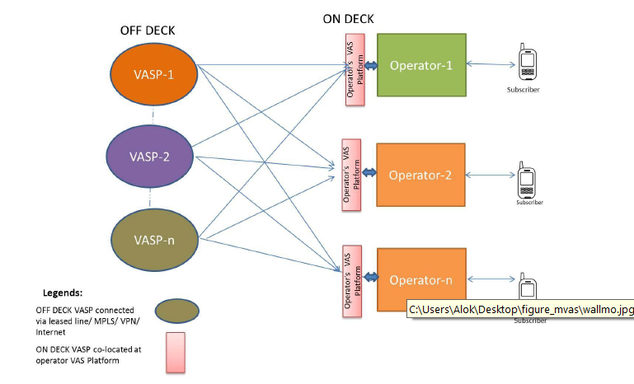Fig. Walled Garden Model

Presently in many of the countries in our region generally walled garden approach is prevailing. Mobile value added services are carried under the banner, brand and name of the service providers and the role of a VAS provider is that of a content aggregator making the content suitable for accessing through mobile network. The telecom service providers invest in promoting, branding and billing the value added service along with taking care of customer service. Off deck content, accessed over network, is also routed through the operator platform. VASPs need to host their content with each service provider separately. If the content of a VASP is provided off deck through network, connectivity need to be established with each operator separately. Agreements will be made with each operator for offering the VAS content.

Some of the services which are integrated on call-to-call basis such as caller ring back tune (CRBT), SMS person-to-person will generally be in the domain of telecom service providers. However, the value added services such as music, games, news, entertainment, M-commerce etc. can be directly marketed by value added service provider. It will be desirable that consumers can access any content and service of their choice, and not be limited to just the selections decided by the telecom service providers. Open or non-restricted access allows a user to obtain content from any provider offering mobile content. This content can be accessed independent of the mobile service provider‘s platform, through a link to any of the third-party content provider, through a Web browser on the mobile handset, by sending a SMS or accessing IVR. In an open access environment services and applications are decoupled from the network complexities, facilitating applications/content based services to be provided easily and also enabling third party application service providers to compete with the telecom service providers in the provision of services making the network more open. Open access can promote innovation and can lead to development of various applications depending on the customer needs.

In such an open access environment consumers pay the access/carriage charges to the telecom service provider and for the content, charges will be paid directly to the value added service provider. Direct payment to VASP will require some delivery mechanism to make the payment for example online payment through credit card, net banking or mobile banking, which are very limited in our region at present.

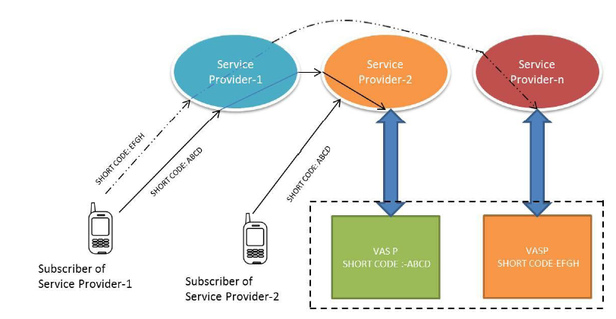Fig. Open Access Model

In the absence of adequate payment infrastructure, VASPs need to approach the telecom service providers for collection of VAS charges from customers. For post paid the VAS charges are added along the bill. Since majority of the customers fall in prepaid category, VAS charges are deducted from the prepaid balance. This limits the ability of the VASP to operate independent of the service provider and hence can limit the entrepreneurial activity. For provision of open access to customers, it will be desirable that services offered by VASPs under off deck model are decoupled from telecom service provider so that VASP need not to approach and integrate with each service provider. A possible approach to decouple the services of VASP is shown in the Figure below-

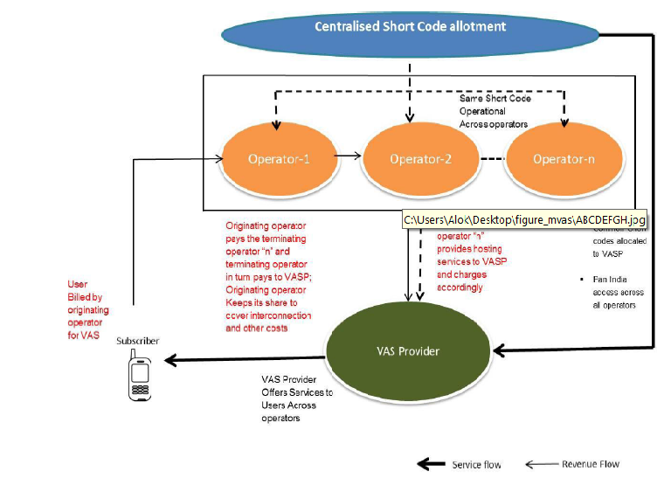**Fig. Service & Revenue flow in Open access model**

In this approach VASP can limit his installations to single location requiring integration with only one service provider of his choice. Customers can access this VASP from any other service provider‘s network through a uniform short code. The originating operator collects the charges from the customer and passes on to terminating operator after deducting the charges like billing, customer care, interconnection etc. Terminating operator in turn passes the revenue collected from originating operator to VASP after deducting its charges like transit charges. This arrangement will require a common short code to be used across service providers. All service providers will be required to route the short code to the terminating operator where VASP has hosted its content. This arrangement is shown in Figure- above. Under this approach VASPs will be free to host their service under any operator. Customers also will be free to choose any VAS from any VASP, irrespective of VASPs‘ location. This will increase competition among VASPs for providing relevant content at right price and also between service providers for providing best hosting rates to VASPs bringing efficiency in the system, which in turn could boost MVAS market.

In the semi-walled garden scenario users can access both, the content available on the mobile operator‘s platform, as well as directly from other value added service/content providers. Users often have easier access to the content on the operators' platform, but will likely demand access to content beyond that selected by the mobile operator.

Some other regulatory issues for the development of MVAS includes but not limited to-

* Leverage of the Mobile Operators
* Fair Access
* Cooperation among different regulators
* Consumer Protection
* Transparency in sharing usage and billing information
* Copyrights
* Local Content
* Subscription and Un‐subscription Procedure
* Issuance of Short Code
* Low End‐Sets

**CHAPTER 8**

**CONCLUSION AND RECOMMENDATIONS**

**8.1 Conclusions:**

Whether we have any kind of licensing or regulatory framework in place or not Mobile VAS is a growing and the growth will continue and our region has a great potential for greater growth for a number of reasons.

Given the declining ARPU, increasing competition among operators, consumers’ desire of getting more from their mobile phone, to maximize revenue, to increase ARPU (Average Revenue Per User),to survive in competitive environment, to satisfy the growing demand of customers, to improve loyalty and to continue expansion among others, it is imperative for the mobile operators to focus on alternate revenue streams.

While among the youth entertainment related services would be popular, the other consumers would also look for utility based services like location information, mobile commerce (mCommerce) for mobile transactions and local content rich services. These myriad of additional services beyond core voice services can be collectively known in the telecommunication parlance as value added services. These services provided through mobile connection can be called mobile value added services ( MVAS).

There is no unique definition of MVAS. A clear MVAS definition is not only required to clear the confusion among the MVAS providers but it will also have an impact on the dynamics of the entire MVAS value chain and ecosystem. Value Added Service (VAS) in telecommunication industry refers to non‐core services, the core or basic services being standard voice calls and fax transmission including bearer services.

The value added service satisfies one or more of the following characteristics-

* Standalone in terms of profitability
* Stimulates incremental demand for core or basic services
* Do not cannibalize core or basic service
* May be sold at premium price
* Provides operational synergy with core or basic services

The reasons for the increasing importance of MVAS can be attributed to the following factors-

* Decrease in ARPU despite increase in MOU:
* Need for differentiation:
* Increased Number of Licensees:
* Decreasing Call Rates:
* Introduction of 3G /4G services:
* Saturation in Metro and Urban Market:
* Increasing need and demand from consumers
* Competitive advantage through customer loyalty

The main business drivers for growing focus on value-added services can be listed as follows-

* Stickliness/growing customer loyalty
* Improving customer experience
* Looking to grow revenues in value-added services to offset declining voice revenue
* Ability to extend the business reach
* Desire for business growth
* Looking to get a return on 3G/4G investment
* driving the growth of new service offerings that address a broad range of customer needs and demands, producing an almost infinite array of applications, from games to productivity tools.
* value added services can enhance performance in other ways

MVAS can be classified and grouped in a number of ways. Independent or standalone MVAS is not required to be coupled with a basic service whereas dependent or non-standalone MVAS is required to be coupled with a basic service. All the value added services address some need of the end consumer whether it is psychological, monetary or convenience. Based on the need fulfillment of the end user, we can group Mobile VAS into three broad categories.

• **Entertainment VAS ‐** The key differentiating factor of Entertainment VAS is the **mass appeal** it generates. These provide entertainment for leisure time usage.

• **Info VAS‐** These services are characterized by the useful **information** it provides to the end user. The user interest comes in from the **personal component and relevance** of the content.

• **mCommerce VAS (Transactional services)‐** These are the services which involve some transaction using the mobile phone. The whole categories of utility MVAS can also be grouped in this category.

A typical value chain in the MVAS industry encompasses content creators/providers, mobile advertisers, aggregators, technology enablers, telecom service providers and end users or subscribers. Content aggregation and provision of technology platform is usually performed by a single entity known as Value Added Service Provider (VASP).

There are a number of challenges or hurdles to the MVAS growth. The issues include –revenue sharing, localized content, proper regulatory framework, mechanisms for the allocation and assignment of short codes and USSD codes, devices and technology, pricing and innovative skill sets etc.

To propel the growth of MVAS requires strategic efforts from all the stakeholders in the MVAS value chain.

The MVAS market is basically a three-player market comprising of content owners, content aggregators/enablers and mobile operators. There are two business models through which the content is delivered to end consumer.

**On deck model-** In this model, the telecom operator undertakes the branding, marketing and selling of mobile VAS content. The billing is also done by telecom operator and it collects the revenue from subscriber. As a result, it retains the largest portion of revenue (60-65%) and the rest is shared among content aggregators and content developers.

**Off deck model-** In this model, the VASP sells content directly to subscribers. The content can be provided either through the operators' portal or through their short code. These short codes are uniform across all telecom service providers. The economics in this model are opposite to that of on deck model. In this model, content developers and aggregators retain 60-65% of revenue whereas 30-35% is being passed on to the telecom service providers.

There are a multitude of business models that have evolved from three main paradigms for the delivery of value added services:

1. Subscription model: Users are partially (for premium content) or wholly charged a specific fee irrespective of actual usage.

2. Advertising model: Content and services are mixed with advertising material, often in the form of banner ads. These adverts may be the sole or major source of

revenue for the broadcaster.

3. Merchant model: This simply involves wholesalers and retailers who trade mobile content, goods and services.

Licensing, Revenue sharing, standardization of short code services , mechanisms to access to contents by consumers etc. are the major regulatory issues for formulating regulatory framework of MVAS.

From the study it seems that India is becoming a matured MVAS market compared to other countries in the SATRC region followed by Bangladesh and Pakistan. Rather than re-inventing the wheel, other member states of SATRC region who have not yet come up with any kind of MVAS regulatory framework can use those frameworks already used by these countries and customize them to suit to the specific legal, regulatory and operational framework of the respective member states.

**8.2 Recommendations:**

The governments and regulators should ensure that policy and regulatory framework is conducive for the growth of MVAS in our region as it has the highest potential for growth for a number of reasons.

1. Appropriate definition could be adopted for the purpose of regulation of Value Added Services. The definition should be such that it should not allow the VAS providers to operate services that requires specific licenses already covered under the existing legal framework. It should allow provisioning services enabled by technologies.
2. The VAS providers could be covered under Licensing through Authorisation. Appropriate terms and conditions could be imposed during authorization.
3. Short codes should be allotted centrally in accordance with the National Numbering

Plan. Short codes could be allotted to both VAS Providers and Telcos independently. Additional terms and conditions could be imposed to ensure proper management and regulation as well as monitoring of the use of short codes. Appropriate fee, one time and recurring charges, should be charged for allocation of common short code.

1. For spreading awareness regarding utility value added services in rural and remote areas,

awareness campaign for national projects such as e Government Master Plan or similar initiatves in different countries could be utilized.

1. Development of Value Added Services in local languages should be encouraged through suitable incentives.
2. The regulator could arbitrate on the revenue sharing between players in the VAS value chain.

____________________