INTERNATIONAL TELECOMMUNICATION UNION
 | Council Working Group for the Elaboration of the Draft Strategic Plan and the Draft Financial Plan 2016-2019 | Document:  Date:  Original English
3rd meeting, Geneva February 2014

asia-pacific telecommunity (APT)

APT View on the Draft Strategic and Finance Plan Documents under Council Working Group for the Elaboration of the Draft Strategic Plan and the Draft Financial Plan 2016 -2019

- INTRODUCTION:

The Council Working Group on elaboration of the draft strategic plan is working on the draft strategic plan document for ITU for 2016-2019. And a Correspondence group on the elaboration of ITU-D contribution to the ITU Strategic plan has also been working on contribution from ITU-D on the subject. APT Members acknowledge and appreciate the ITU initiative of public consultation in the preparation process of the SP-FP document.

This document provides the view of APT Members on the draft contribution, CWG SP-FP/3/4 (REV.2) of the Chairman of CWG SP-FP on the elaboration of the draft strategic plan and also on the document no. TDAG 13 – 18/22-E (Revision 2) (dated 17th December 2013) of the Correspondence group on the elaboration of ITU-D contribution to the ITU Strategic plan and other related documents. The said documents are well prepared reflecting process of strategic plan starting from identifying Global Challenges, Strategic goals and to execution.

However, to improve further on these documents based on RBB principles and in also line with the Terms of reference of CWG to have uniform structure, format and terminology is provided. In this regard, references were drawn from several documents provided under bibliography such as Secretary General - UN Reports on RBB/RBM, Joint Inspection Unit, UN reports on implementation of RBB/RBM, WSIS declaration, references from various other sources as reflected appropriately apart from Basic Texts of the Union.

The main body of the document provides important revisions proposed and a detailed justification for all the proposed revisions is enclosed in the document at Annexure with respective references to the documents referred under bibliography.
Contents

A. Global Challenges & ITU Strategic Goals 3
I. Global challenges 3
II. Deriving ITU Strategic Goals 3
B. ITU Vision & Mission Statements 3
I. ITU Vision 4
II. ITU Mission 4
C. Glossary for Strategic Plan (working version definitions) 4
I. Objectives 4
II. Expected Results 5
III. Outputs 5
IV. Performance Indicators 5
V. Key Performance Indicators 6
D. From Strategy to Execution 6
E. Need to work on Objectives and Expected results in the first step while working on SP-FP 7
F. Objectives proposed 7
G. Setting SMART Targets 8
H. Proposed structure of SP-FP 9
- Consultation………………………………………………………………………...9
- Bibliography 10

K. Annexure ………………………………………………………………………11-40

- PROPOSAL:

Global Challenges & ITU Strategic Goals

Ref: (Slide 28-31) Contribution by the Chairman of CWG SP-FP on the elaboration of the draft strategic plan – CWG SP-FP/3/4 (Rev.2)

Global challenges

- Inclusive Growth
- sPartnership
- Sustainability
- Innovation

Deriving ITU Strategic Goals

Global Challenge: Inclusive Growth
Strategic Goal 1: Enable and foster universal access to ICTs and their increased use by everyone to bridge digital divide .

Global Challenge: Partnership
Strategic Goal 2: Develop Key Partnerships with stakeholders in the ICT ecosystem in building the information society for all.

Global Challenge: Sustainability
Strategic Goal 3: Manage challenges resulting from ICT development.

Global Challenge: Innovation
Strategic Goal 4: Lead and Shape the ICT environment.

ITU Vision & Mission Statements

Ref: 1. Contribution by the Chairman of CWG SP-FP on the elaboration of the draft strategic plan – CWG SP-FP/3/4 (Rev.2) Slide 17,
- TDAG 13 – 18/22-E (Revision 2) (dated 17th December 2013) - section 3

ITU Vision

CWG Draft:

“An interconnected world, where information and communication technologies enable and accelerate social, economic and environmentally sustainable development for all”

Proposed Revision

“An information society, empowered by the interconnected world , where information and communication technologies enable and accelerate sustainable development for everyone”.

ITU Mission

CWG Draft:

“To enable, facilitate and foster sustainable development through affordable and universal access to telecommunication / Information and Communication Technology networks, services and applications.”

Proposed Revision

“To enable, facilitate and foster affordable and universal access to telecommunication / Information and Communication Technology networks, services and applications and their use for sustainable development through international cooperation ”

Glossary for Strategic Plan (working version definitions)

Ref: 1. Preliminary agreed Glossary of the strategic plan for the union for 2016-19 CWG SP-FP/3/5-E 20 November 2013
2. Document TDAG 13 – 18/22-E (Revision 2) (dated 17th December 2013),

Objectives

CWG Draft:

“Objectives refer to the specific aims of the Sector and Inter-Sectoral activities in a given period”

Proposed Revision:

“Objectives refer to the specific aims of the Sector and Inter-Sectoral activities to meet certain needs of identified end users in a given period”

Expected Results

CWG Draft:

“Expected results should reflect the desired outputs leading to the achievement of objectives. They should be evaluated against the actual results. They should be linked, where applicable, to the underlying objectives of the strategic plan”

Proposed Revision:

Expected results should reflect the desired outputs outcome involving benefits to end-users, expressed as a quantitative or qualitative standard, value or rate leading to the achievement of objectives. Accomplishments are the direct consequence or effect of the generation of outputs, and lead to the fulfilment of a certain objective. They should be linked , where applicable, to the underlying objectives of the strategic plan.

Outputs

CWG Draft:

“The outputs are the final tangible results, deliverables, products and services achieved by the Union in the implementation of the operational plans. Outputs are the cost objects and are represented in the applicable cost accounting system by internal orders.”

Proposed Revision:

“The outputs are the final deliverables, products and services achieved by a programme or subprogramme to the end users with an outcome in accomplishing the ‘Expected Result’, by the Union in the implementation of the operational plans. Outputs are the cost objects and are represented in the applicable cost accounting system by internal orders.”

Performance Indicators

CWG Draft:

“Performance indicators are the criteria used to measure the achievement of outputs or the objectives in the personal appraisal or activities of the work plans. These indicators may be qualitative or quantitative.”

Proposed Revision:

“Performance indicators are the criteria used to measure the achievement of Expected Results in the process of achieving the objectives in the personal appraisal or activities of the work plans. These indicators may be qualitative or quantitative.”

Key Performance Indicators

CWG Draft:

“KPIs are the criteria used to measure the achievement of outputs (or outcomes). These indicators may be qualitative or quantitative”

The above definition is proposed for reconsideration in view of no distinct difference in the definitions provided between Performance Indicators and Key performance Indicators.

From Strategy to Execution

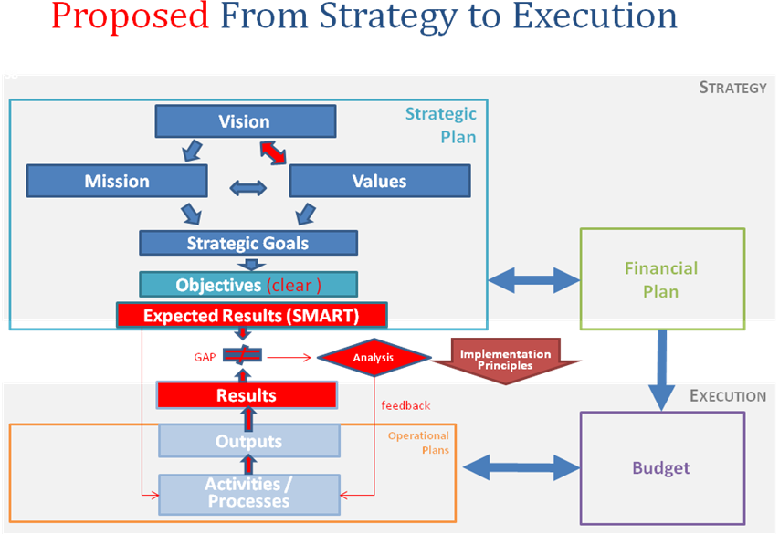
Ref: (slide 58) Contribution by the Chairman of CWG SP-FP on the elaboration of the draft Strategic Plan - CWG SP-FP/2/5

The following revisions are proposed to the schematic.

Need to work on Objectives and Expected results in the first step while working on SP-FP

Ref: 1. TDAG 13 – 18/22-E (Revision 2) (dated 17th December 2013)
- Preliminary agreed Glossary of the strategic plan for the union for 2016-19 CWG SP-FP/3/5-E 20 November 2013

In RBB, the program is formulated in order to meet a set of predefined objectives and expected results. It is clear that the expected results in turn would justify resources requirement which are derived from and linked to the outputs required to achieve the expected results. It means that the first step in RBB requires setting up the objectives and expected results. Then resource requirement is assessed / derived from outputs required to achieve such results. So, in second step, based on expected results, the outputs for the programs are set to achieve the results. Accordingly the Corresponding Group on elaboration of the ITU-D contribution may consider arriving at the expected results from the objectives first and then work on deriving outputs necessary.

The illustrative chart on page 4 of reference 1 above, under section 7 providing linkages between objectives and outputs should be a linkage chart between objectives and expected results. And there should be another chart enlisting outputs and expected results. The objectives and expected accomplishments/ results should display a cause and effect relationship. The expected result, namely, a concrete target within an overreaching objective, involving benefits or changes to end-user or beneficiaries, reached through the production of ‘Outputs’ (UN, Resutls based budgeting - Report of the Secretary General A/54/456, 1999)

Objectives proposed

Ref. 1. CWG SP-FP/3/4 (REV.2) Contribution by the Chairman of CWG SP-FP on the elaboration of the draft strategic plan
- TDAG 13 – 18/22-E (Revision 2) under section 6 on page 3

Corresponding Group on elaboration of the ITU-D contribution vide section 6 of reference 2 above, defined objectives and outputs for D sector. The objectives should spell out specific aims to be accomplished in a given period with clarity as elaborated under discussion on Objectives under section C 1 above. In their current form under section 6 (except the first objective), multiple objectives are merged necessitating creation of sub area objectives, (though in the current form they are construed as Outputs). To reiterate, the currently defined outputs are nothing but sub area objectives expressed in a statement form. The outputs are final tangible products and services such as deliverables of programs.

The currently defined objectives contain multiple distinct objectives but combined under single objective (extract from reference 2 above, reproduced below) are marked in different colours – red, blue, green. The Corresponding Group on elaboration of the ITU-D contribution may reconsider to revise the objectives distinctly.

- To foster international cooperation on telecommunication/ICT development issues.
  - [Results of World Telecommunication Development Conference (WTDC) / WTDC.]
  - [Results of Regional Preparatory Meetings (RPMs) / RPMs.]
  - [Results of Telecommunication Development Advisory Group (TDAG) / TDAG.]
- To create an enabling environment conducive to ICT development and to foster the deployment of telecommunication/ICT networks.
- Policy and regulatory environment.
- Telecommunications/ICT networks.
- To enhance the roll-out and the safe use of ICT applications and services.
- Building confidence and security in the use of ICTs.
- ICT applications and services.
- To build human and institutional capacity, promote digital inclusion and provide concentrated assistance to countries in special need.
- [Results of Study Group meetings / Study Group meetings.]
- Knowledge sharing.
- Digital inclusion.
- Special assistance to LDCs, SIDs and LLDCs.
- To strengthen climate change adaptation and disaster management efforts through telecommunications / ICTs.
- Climate change adaptation.
- Emergency Telecommunications.

Setting SMART Strategic Targets

Ref. Contribution by the Chairman of CWG SP-FP on the elaboration of the draft strategic plan – CWG SP-FP/3/4 (Rev.2) (Slides 68 onwards)

The targets set at global level or at ‘developing countries’ en block will not reflect the gaps in other groups such as Low income and Lower middle income group countries. The Telecommunications are well developed in developed countries and reasonably well developed in Upper Middle income countries. But the lower middle income and low income groups are experiencing a significant digital divide. Further, the ITU-D has a mandate for special focus on LDCs, LLDCs, SIDC etc. Hence, the targets may be considered with a focus on group wise, so that results could be monitored specifically.

Proposed structure of SP-FP;

Ref: Contribution by the Chairman of CWG SP-FP on the elaboration of the draft strategic plan – CLCWG SPFP2 – C – 005 PPT-E dated 5 January 2014 (slide 62)

As per the proposed structure of SP-FP, the situational analysis will provides inputs on implementation analysis of current SP, ICT environment and strategic risks. Though they are very relevant but not sufficient in framing the long term goals and objectives in fulfilling the vision and mission statements. Long view or Scenario Planning methodology is considered to take in depth assessment of future considering the uncertainties of the future.

The scenario planning is a methodology of investigation in strategic planning for decision makers in a dynamic market where economy, technology and new generation customer needs are changing significantly apart from changing structural aspects of the industry.

Consultation

The APT acknowledges the key role played by ITU in conjunction with other organizations continuously in enabling and implementing ICTs to bridge the digital divide through international cooperation. However, considering the enormous task ahead in making Telecommunications/ ICTs available to bridge the digital divide in all aspects to accomplish the vision and mission of ITU, if not taken up already, the formal consultation in preparation of Strategic Plan may also include UN and other International organizations working in ICTs in building strong partnerships and common strategy in line with the UN theme of ‘Delivering One’.

***

Bibliography

Besrest, V. (2012, 09 24). Results Based budgeting: Objectives, Expected Results and Performance Indicators. Seminar on Results Based Vudgeting: Objectives, Expected Results and Performance Indicators . Council of Europe.
Contribution, C. (2014, january). CWG SP-FP/2/5. CWG - Contribution by the Chairman of CWG SP-FP on the elaboration of the draft Strategic Plan - CWG SP-FP/2/5 .
Council Of Europe, C. (2005, May). Results Based Budgeting Manual. Results Based Budgeting Manual v 3.1 . Council of Europe.
CWG:SP-FP/3/5-E. (2013, November 20). Preliminary agreed glossary of the strategic plan for the union for 2016-2019. Council Worki-2019ng Group for the elaboration of the draft strategic plan and the draft financial plan 2016.
Godet, M. (1987). Scenarios and Strategic Management. Butterworth Scientific Ltd 1987.
JIU/REP/1999/3. Results Based Budgeting: The Experience of United Nations System Organizations. JIU, UN.
JIU/REP/2006/6. Results - Based Managment in the UN in the Context of the Reform Process. JIU, UN.
JIU/REP/2012/12, I. U. STRATEGIC PLANNING in UN System-JIU/REP/2012/12. Joint Inspection Unit, UN.
S13-CLCWGSPFP2-C-0004!!MSW-E. (2013). CONTRIBUTION BY THE SECRETARY GENERAL - REPORT ON SECRETARY GENERAL’S PUBLIC CONSULTATION ON THE 2016-2019 ITU STRATEGY. ITU.
Schwartz, P. (1996). The art of the long view. New York: currency doubleday.
UN. (1998). Results Based Budgeting - Report of the Secretary General A/53/500. United Nations.
UN. (1999). Resutls based budgeting - Report of the Secretary General A/54/456. United Nations.
UN-Report-A/53/500. (1998). Results Based Budgeting - Report of the Secretary General A/53/500. United Nations.

Annexure follows

K Annexure

Additional Details and Basis for the Proposed Revisions in the Main Document on Draft Strategic and Finance Plan for 2016-2019

Contents

Background 13
A. ITU Vision (Draft): 14
B. ITU Mission (Draft): 14
C. Identified global challenges: 15
D. ITU-wide goals: 17
E. Pre-Consultation with other UN System Organizations and other International organizations 20
F. Glossary of definitions of RBB/RBM: 21
G. From Strategy to Execution 27
H. Need for Clarity in defining Objectives 28
I. Global ICT Targets 30
J. Proposed Structure of SP 33
Bibliography 40

Index for Figures

Figure 1 Strategic Goals and Challenges 19
Figure 2 Starategy to Execution 27
Figure 3 Affordability Divide in ICTs 32
Figure 4 ICTEco Sysytem Dynamics 34
Figure 5 LOGFRAME 35
Draft Strategic and Finance Plan for 2016-2019

Background

The Council Working Group on elaboration of the draft strategic plan is working on the draft strategic document for ITU for 2016-2019. And a Correspondence group on the elaboration of ITU-D contribution to the ITU Strategic plan has also been working on contribution from ITU-D on the subject.

The Public consultation by ITU in preparation for the ITU’s strategy was highly relevant aiming to involve all the stakeholders in formulating the ITU strategy. Total 19 contributions have been received with the following break up.

  - Institutional: 5
    - 1 administration
    - 1 vendor
    - 3 civil society and NGOs
  - Individual: 14

Though the inputs presented in the document vide CWG SP-FP/2/4-E , 31 October 2013 are valuable, but the quantum of response, perhaps indicates the need for repositioning ITU in ICT ecosystem through enhanced collaboration with several other stakeholders. ITU being the preeminent SpecializedAagency in ICTs in UN system, collaboration with other agencies in UN and others need to be taken to a next level in building strong partnerships. The issue of partnership is further discussed in the challenges section etc.

The ITU and, in general, the UN System Organizations are implementing Results Based Management and Results Based Budgeting Concepts to bring in accountability and transparency in preparing the budget in a strategic manner. The UN report (UN, Results Based Budgeting - Report of the Secretary General A/53/500, 1998) has observed that in RBB, the program formulation will be based on Objectives and Expected results. The resources required are linked to the Outputs required to be produced to achieve the necessary Expected Results and in turn to accomplish the objectives. In building a coherent strategic plan, the clarity in the definitions is critical in assessing the accomplishments and moving towards the goals.

The RBB, which focusses on Results, is being implemented not only in UN system organizations and also in Corporate world with some variations in tenor. In this context, this document provides inputs on the draft contribution, CWG SP-FP/3/4 (REV.2) of the Chairman of CWG SP-FP on the elaboration of the draft strategic plan and also on the Correspondence group on the elaboration of ITU-D contribution to the ITU Strategic plan. These inputs are based on several documents under bibliography such as Basic Texts of the Union, Secretary General - UN Reports on RBB/RBM, Joint Inspection Unit, UN reports on implementation of RBB/RBM, WSIS declaration, references from various other sources as reflected appropriately.

ITU Vision (Draft):

Draft versions of ITU level Vision and Mission are provided vide documents viz. Contribution by the Chairman of CWG SP-FP on the elaboration of the draft strategic plan – CWG SP-FP/3/4 (Rev.2) Slide 17, TDAG 13 – 18/22-E (Revision 2) (dated 17th December 2013) section 3

ITU Vision (Draft)

“An interconnected world, where information and communication technologies enable and accelerate social, economic and environmentally sustainable development for all”

The vision is presented well, but still some improvement can be made to make it concise and crisp as follows. With regard to sustainable development, it may be relevant to refer to the UN document, Our common future - Report of the World Commission on Environment and Development, that defined the concept and framework of sustainable development, that include social, economic and environmental objectives. So, the vision mentioning social, economic and environmentally sustainable development will be a repetition as “sustainable development includes all these viz. Social, Economic and Environmental objectives”.

Further, the WSIS- Geneva declaration of principles delineate the ‘vision for information society, a global challenge in the new millennium’. The objective of interconnect world is to build the information society for accomplishing sustainable development for everyone in the society overcoming - ‘economic, ability, access to opportunity’ divides. Hence the following revision in the draft ‘Vision’ is proposed.

Proposed vision statement

“An information society, empowered by the interconnected world , where information and communication technologies enable and accelerate sustainable development for everyone”.

ITU Mission (Draft):

Draft versions of ITU level Vision and Mission are provided vide documents viz. Contribution by the Chairman of CWG SP-FP on the elaboration of the draft strategic plan – CWG SP-FP/3/4 (Rev.2) Slide 17, TDAG 13 – 18/22-E (Revision 2) (dated 17th December 2013) section 3.
“To enable, facilitate and foster sustainable development through affordable and universal access to telecommunication / Information and Communication Technology networks, services and applications.”
A vision of sustainable development has appropriately been taken care above as an objective through ICTs. However, the purpose of the organization under mission is to indicate why it (organization) exists or in other terms how it becomes a vehicle to accomplish the vision. So, the mission should focus on the purpose for the existence of the organization (ITU) to accomplish the ‘New World’ enshrined in the vision. If that is the case, ‘enable, facilitate and foster sustainable development’ should not figure out in the mission as the primary purpose. Rather it should be to “enable, facilitate and foster …. access to ICT networks … for sustainable development through international cooperation.

The ITU constitution while speaking on purposes of the union under article 1, the first aspect it mentioned is about “maintain and extend international cooperation..”. The ITU enables, facilitates and fosters everything through international cooperation only. Hence, including ‘international cooperation’ in the mission statement may be essential.

In other terms, under part III of Resolution 71 of PP10, the Mission is defined as “ Main task/key function of the ITU general Secretariat or any ITU Sector as set out in the ITU constitution and convention. In view of this, the Mission statement should bring focus on ITU’s key function and task to accomplish the vision of ‘sustainable development’. Sustainable development is not the main task or key function of ITU. The said key difference, to spell out on how ITU would like to accomplish the vision, necessitates to reword the mission statement as proposed below.

Proposed Mission statement:

“To enable, facilitate and foster affordable and universal access to telecommunication / Information and Communication Technology networks, services and applications and their use for sustainable development through international cooperation ”

Identified global challenges:

(Slide 28-31) Contribution by the Chairman of CWG SP-FP on the elaboration of the draft strategic plan – CWG SP-FP/3/4 (Rev.2)

The Chairman’s contribution on the elaboration of the draft strategic plan is very professional and it clearly shows the flow in the order of Global challenges, strategic goals and global targets etc., indicating seamlessly on how they are derived from each other.

It is pertinent that the global challenges, identified in the document, to be addressed in fulfilling the Vision and Mission should also be closely linked with the purpose of the Union delineated in the Article 1 of the Union’s constitution. The Challenges are rightly identified as Growth, Inclusiveness, Sustainability, innovation and, of course, they are not exhaustive. Further, there is concern of overlapping in the current challenges mentioned and need for inclusion of other challenges as well in the current proposal.

- Challenges – ‘Growth’ and ‘Inclusiveness’ together:

Let us take the challenges viz. Growth and Inclusiveness. When we look at the growth, growth of ICTs is majorly a challenge in developing countries only. The ICTs are already developed and are already in an advanced state in the developed countries that represent around 16% of world population. The growth either in mobiles or broadband , chiefly, will be coming from developing nations. Hence, it would be logical, that we could combine it in a single challenge as “Inclusive Growth” rather than separate challenges as ‘Growth, Inclusion’. This will help to spell out growth targets specifically as overall world growth is critically depending on the growth in developing countries. Additional relevant discussion on this subject is further presented under section H in setting the global ICT targets under Tables 1, 2 and Figure 3.

- New Challenge – Partnership:

The Annex to Resolution 71 (PP-10), vide paras 1.2 and 1.3, speaks about the transformed communications landscape. Apart from the critical need of raising resources to service development programmes, to continue to remain relevant in this transforming communications landscape, the ITU needs to establish strong partnerships with the relevant key players and international organizations going forward to fulfill its mission and its preeminent position.

Partnerships play a key role not only in filling the gaps in resources but also to position ITU in a leadership position to realize the vision of building the information society. During the recently concluded TDAG meeting, the AMS region has shared about the serious issue of lack of partnerships and majority projects are pending due to resource crunch. This is a major issue holding take off of several projects. The partnership is a biggest challenge among all and is critical for success of any program and fulfilling vision and mission of the Union. Further, considering the fact that the ICT ecosystem has several stakeholders, their participation and partnership is critical to forward ITU’s role in forwarding the vision of ‘Building Information society”. Quantum of participation in the public consultation process may be taken as an indication in this direction.

Hence, we propose to include the second global challenge as Partnership. This need is appropriately accentuated in the ITU Constitution that specifically brings focus on this in Article 1 a bis) “to promote and enhance participation of entities and organizations … and foster fruitful cooperation and partnership ..”. The TDAG document vide no. D10-TDAG18-C-0012!N1!PDF-E lists down several partnerships or MoUs that have been entered into by ITU viz. 2010-57, 2011-34, 2012-39, 2013 – 30 (till October 2013). However, the document provides only the details of agreements signed since 2010 and not the implementation details. Successful execution and sustenance of partnerships are critical and highly challenging.

Further, the main findings of the pubic consultation and overall suggestions for ITU Strategy 2016-2019 ( Document CWG SP-FP/2/4-E , 31 October 2013 ) mentions – “ A commonly proposed theme is that ITU’s work should be aligned with the global development agenda and ITU’s work should contribute in achieving the millennium/sustainable development goals….Several contributions suggested active collaboration and establishment of global ICT partnerships”. This is a relevant indication on need of the hour and to consider ‘building partnerships’, as an important challenge.
In view of above identified challenges such as ‘Inclusive growth, Partnership’, we may need to relook at the ITU-Wide goals.

ITU-wide goals:
The ITU-wide goals proposed to the Council Working Group on the Strategic Plan 2016-19 are to:
- Enable and foster access to and increased use of ICTs.
- Bridge the digital divide and provide broadband for all.
- Manage challenges resulting from ICT development.
- Shape and adapt to the changing ICT environment.

Proposed ITU-wide goals:

- Enable and foster universal access to ICTs and their increased use by everyone .
- Develop Key Partnerships with stakeholders in the ICT ecosystem in building the information society for all.
- Manage challenges resulting from ICT development.
- Lead and Shape the ICT environment.

The above proposed revisions are based on earlier discussions. They are schematically represented as follow.

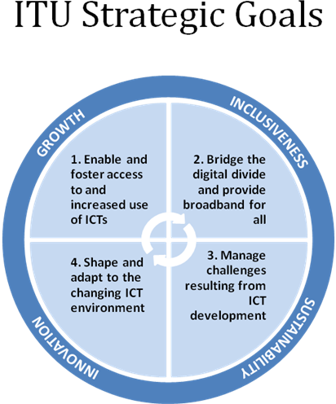

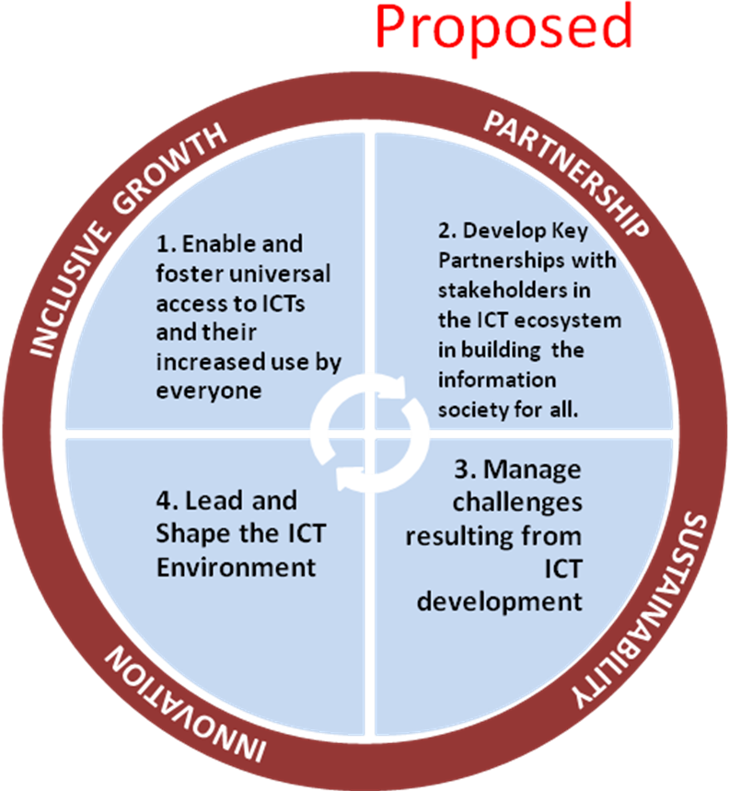
Figure 1 Strategic Goals and Challenges

Pre-Consultation with other UN System Organizations and other International organizations

The WSIS action lines and respective lead UN agencies have been identified in the Tunis Agenda. The ITU is leading some of the action lines (http://www.itu.int/wsis/implementation/facilitators.html) and other action lines are led by other UN agencies. ITU may consider it relevant to take inputs from other UN agencies working for ICTs for other WSIS action areas while preparing its strategic plan.

The UN Joint Inspection Unit has made an assessment in May 2012 on Strategic Planning (JIU/REP/2012/12) in various UN agencies. The ‘Overview of strategic planning processes and instruments in the united nations system’ (based on responses to JIU questionnaires and interviews, as of May 2012), has made certain observations for several UN organizations including ITU(annexure IV). The table has a specific column ‘prior Consultations’ with UN system Orgs and other Consultations. For ITU, it shows that there is NO consultation with other UN systems organizations. Considering the fact that the ITU is positioning itself as the specialized agency of UN in ICTs, it may be considered to take inputs / have pre-consultations appropriately with other UN agencies contributing in the areas of ICTs while formulating its strategic plan, as ITU’s proposed vision and mission is access and use of ICTs in sustainable development. Though there are meetings of WSIS Action Line Moderators/Facilitators, collaboration at Strategic plan level would be useful to bring focus on activities so that there is clarity on accountability on accomplishing expected results with little duplication.

As mentioned earlier, the UN Joint Inspection Unit (JIU/REP/2012/12) made certain recommendations in its report on Strategic Planning in the United Nations Systems. The first recommendation exhorts the Secretary General, UN for defining common goals for strategic planning as below:

“Recommendation 1

The Secretary-General, in his capacity as Chair of the Chief Executives Board for Coordination (CEB), drawing upon the support of the United Nations Strategic Planning Network and/or a CEB ad hoc task force, should review with the executive heads the respective strategic plans of their organizations with a view to defining a coherent overarching framework and common goals for strategic planning to ensure consistency and avoid the overlap of activities across the United Nations system”

As mentioned earlier, this is to reiterate that during the ITU’s public consultations ( CWG SP-FP/2/4-E , 31 October 2013 ) mentions – “ A commonly proposed theme is that ITU’s work should be aligned with the global development agenda and ITU’s work should contribute in achieving the millennium / sustainable development goals”. This further, accentuates the need for ITU taking the lead in strategic collaboration with other UN and other International organizations through suitable coordination mechanism.

Glossary of definitions of RBB/RBM:

Ref: 1. Preliminary agreed Glossary of the strategic plan for the union for 2016-19 CWG SP-FP/3/5-E 20 November 2013
2. Document TDAG 13 – 18/22-E (Revision 2) (dated 17th December 2013),

The document at reference 1, CWG SP-FP/3/5-E, provides the working version of various terms used in the SP-FP. To begin with, the Results Based Management and Results Based Budgeting are being percolated across UN agencies and ITU has also actively begun implementing RBB in its strategic planning.

The UN reports (UN-Report-A/53/500, 1998), (UN, Resutls based budgeting - Report of the Secretary General A/54/456, 1999) provide the definition of RBB as presented by SG, UN to General Assembly. In RBB, in the first place, the program formulation revolves around a set of predefined objectives and expected results/ expected accomplishments. The (CWG:SP-FP/3/5-E, 2013) has well captured the definitions of RBB and several others. However, there are a few definitions which may require relooking as below. For comparison, the definitions used by UN (UN, Resutls based budgeting - Report of the Secretary General A/54/456, 1999) are at Annexure II. Further, the JIU, UN report (JIU/REP/1999/3) has made an effort to compile the glossary used across several UN agencies is interesting and stimulating to look at several view points. The JIU report also espouses that ‘ the long-term objectives should be clearly formulated for the organization’. It is observed that in the case of MDGs, the goals are mostly of a general nature, whereas in RBM approach, the objectives should be SMART.

The UN report (JIU/REP/2012/12) made its recommendations in view of need for coherence and synergies in the activities of UN system entities, thus avoiding overlapping and duplication of services with the concept of ‘Delivering One’. It also felt that there is a need to harmonize the terminology and set up to the extent possible converging paths and methods for strategic planning.

Inputs on Glossary for CWG SP-FP/3/5-E 20 November 2013

i. Expected results is an important aspect in the RBB framework as the Objectives and Expected Results play an important role while formulating the programmes. The UN report (UN-Report-A/53/500, 1998) originally used the word ‘Expected Results ⁶’ and later it used ‘Expected Accomplishments⁷’, as both are not inherently different, in vide its later UN report (UN, Resutls based budgeting - Report of the Secretary General A/54/456, 1999). The UN report (A/54/456 on RBB) chose to use Expected Accomplishments in place of Expected results. It focuses on desired outcome expressed as a quantitative or qualitative standard, value or rate. Where as working version (below) is not conveying this specific characteristic. A clear guidelines for the formulation of objectives and expected accomplishments / results is provided in the annexure II of UN report (UN, Resutls based budgeting - Report of the Secretary General A/54/456, 1999). Perhaps this may provide some guidance.

Expected Results: Working version definition (CWG:SP-FP/3/5-E, 2013) as below.

“Expected results should reflect the desired outputs leading to the achievement of objectives. They should be evaluated against the actual results. They should be linked, where applicable, to the underlying objectives of the strategic plan”

Issues in the above definition:

- The working version does not speak about expression in terms of quantitative or qualitative standard, value or rate. The expected results must be specific and measurable.
- Further, the expected results may not reflect desired outputs but rater they reflect outcomes. The ‘Expected Results’ are the direct consequences or the effect of the generation of outputs leading to the fulfillment of an objective.
- The wording ‘where applicable’ does not arise, as the objectives are nothing but the impact of achieving expected results/accomplishments. Further, expected results/accomplishments are the necessary conditions for attaining those objectives.
- Either implicitly or explicitly, the ‘expected results / accomplishments’ should contain the identity of the end users.
- Need for uniformity in definitions in UN processes at least on important characteristics.

Proposed definition for ‘Expected Results’

It is proposed that the following definition may be considered after incorporating important characteristics (UN, Resutls based budgeting - Report of the Secretary General A/54/456, 1999).

Expected results should reflect the desired outputs outcome involving benefits to end-users, expressed as a quantitative or qualitative standard, value or rate leading to the achievement of objectives. Accomplishments are the direct consequence or effect of the generation of outputs, and lead to the fulfilment of a certain objective. They should be linked , where applicable, to the underlying objectives of the strategic plan.

- Outputs : Working version definition (CWG:SP-FP/3/5-E, 2013) as below.

“The outputs are the final tangible results, deliverables, products and services achieved by the Union in the implementation of the operational plans. Outputs are the cost objects and are represented in the applicable cost accounting system by internal orders.”

Whereas the outputs are defined in UN report (UN, Resutls based budgeting - Report of the Secretary General A/54/456, 1999) as below.

“Final product or service delivered by a program or subprogramme to end users”.

Proposed version: As mentioned earlier, the aaccomplishments/ results are the direct consequence or effect of the generation of outputs, and lead to the fulfilment of a certain objective. So, it is preferable to avoid any overlap between results and outputs. Further, The expected result, namely, a concrete target within an overreaching objective, involving benefits or changes to end-user or beneficiaries, reached through the production of ‘Outputs’ (UN, Resutls based budgeting - Report of the Secretary General A/54/456, 1999)

Proposed definition for Outputs:

“The outputs are the final deliverables, products and services achieved by a programme or subprogramme to the end users with an outcome in accomplishing the ‘Expected Result’, by the Union in the implementation of the operational plans. Outputs are the cost objects and are represented in the applicable cost accounting system by internal orders.”

- Performance indicators: Working version definition (CWG:SP-FP/3/5-E, 2013) as below.

“Performance indicators are the criteria used to measure the achievement of outputs or the objectives in the personal appraisal or activities of the work plans. These indicators may be qualitative or quantitative.”

The UN report (UN, Resutls based budgeting - Report of the Secretary General A/54/456, 1999) version of the definition is as follows;

“A feature or characteristic used to measure whether and/or the extent to which the expected accomplishment has been achieved. Performance indicators correspond either directly or indirectly to the expected accomplishment for which they are used to measure performance.”

Performance indicators are supposed to measure the extent of achieving the “Expected Accomplishments / Results” and not ‘Outputs’.

Proposed definition of Performance Indicators

“Performance indicators are the criteria used to measure the achievement of Expected Results in the process of achieving the objectives in the personal appraisal or activities of the work plans. These indicators may be qualitative or quantitative. Performance indicators correspond either directly or indirectly to the expected accomplishment for which they are used to measure performance”

“Specifying performance indicators helps check the feasibility of achieving objectives and results. Often, it is necessary to establish several performance indicators for one expected result. Together, several performance indicators will provide more reliable information on the achievement of an objective. In addition, the performance indicators form the basis of the reporting and management system to review the progress of the implementation of the budget and to make a final evaluation” (Besrest, 2012).

The performance report of 2012 (TDAG13-18/3 4th November 2013) is very detailed. But at the outset, it provides several details about various activities conducted and in some cases related to certain objectives. It does not speak about what extent the expected results are met through monitoring of key performance indicators. It speaks about that this is the way resources are spent. Though the activities are listed objective-wise, the presentation theme is more based on activities and not from the view point that activities are meant to achieve expected results and in turn accomplish objectives. This gap is arising due to the reason that ‘Expected Reasons, Performance Indicators’ are not SMART in real sense.

Performance Indicators are supposed to be SMART (CouncilOfEurope, 2005) - Performance Indicators assess or measure the effects of activities in an Activity Area. They should be SMART: Specific, Measurable, verifiable at an Acceptable Cost, Relevant, verifiable within a reasonable period of Time. Similarly other variations do exist in defining SMART.

- Key Performance Indicators : Working version definition (CWG:SP-FP/3/5-E, 2013) as below.

“KPIs are the criteria used to measure the achievement of outputs (or outcomes). These indicators may be qualitative or quantitative”

There is ambiguity between Performance indicators and Key performance indicators. The UN report (UN, Resutls based budgeting - Report of the Secretary General A/54/456, 1999) has only one item called “performance indicator”, which is used to measure whether the results have been achieved. Further, the CWG SP-FP/3/5-E defines both the terms ‘Performance Indicators and Key performance indicators’ in a same way. This requires to be discussed further to understand what distinct purposes they are going to serve.

- Objectives: Working version definition (CWG:SP-FP/3/5-E, 2013) as below.

“Objectives refer to the specific aims of the Sector and Inter-Sectoral activities in a given period”

Let us have a look at the Glossary of UN report (UN, Resutls based budgeting - Report of the Secretary General A/54/456, 1999) on how objective is defined.

“Something sought or aimed at. In programme budgeting, the term refers to an overall desired achievement, involving a process of change and aimed at meeting certain needs of identified end-users within a given period of time. Objectives can be met through the achievement of certain accomplishments”

Given period of time has been well incorporated in the ITU’s definition of objectives in the working version. However, leaving it at ‘ specific aims of … activities in a given period’ leaves the definition incomplete if it does not include what needs and who are the end users in its description. Hence, the proposed revision is as below.

Proposed Revision:

“Objectives refer to the specific aims of the Sector and Inter-Sectoral activities to meet certain needs of identified end users in a given period”

The RBB logical Framework (COE, 2005) has aptly described the RBB Logical Framework Matrix as explained in Annexure 1.

An example of Objective, Expected Result, Output:

As discussed above, there are a few important differences in the definitions from the UN glossary and the working definitions proposed in CWG’s working version. The ‘results’ or ‘accomplishments’ are direct consequences of ‘outputs’ and they need not reflect ‘outputs’ and , in fact, they reflect the outcomes. The ‘outcomes’ leads to achievement of ‘objectives’. The ‘expected results’ or ‘expected accomplishments’ will be comparable only with the ‘result’ or accomplishment and they don’t reflect the ‘output’.

For example, the program may have an objective of “To enhance safe use of ICTs in Schools during 2016-2019” and its one of the ‘Expected Results’ could be “Raising awareness on safe use of ICTs in 2% of schools in Low Income Group Countries”. Accordingly the program may commission a study to assess the current scenario in the target schools (Other activities to accomplish the ‘Expected Result’ could be dissemination of safe use of Internet in the target schools etc., which may have outputs such as Trainings and seminars in the target schools etc.). The activity i.e. ‘commissioning the Study’ may produce a ‘Current scenario document’ as an output. The outcome of the output is “availability of current situation of safe ICT use in schools”. This outcome of availability of current scenario is one of the many steps towards accomplishing the ‘Expected Result’ and in turn achieving the ‘Objective’.
Considering the fact that focus of RBB is on “Results Orientation’, there is a need to relook at this working definitions of ‘Expected Result’, ‘Output’, ‘KPIs’ etc. and to bring tangible nature as per above discussion in RBB terms (UN, Results Based Budgeting - Report of the Secretary General A/53/500, 1998).

Mechanisms of Accountability

Having clarity on ‘Expected Results’ and ‘Key Performance Indicators’ is critical as the RBB is expected to lead to an increased Organization’s accountability in achieving results. Mere formulation of KPIs without tangible parameters to measure the extent of accomplishments vis-à-vis with objectives, may not be conducive in terms of effectiveness of programs. Information systems, Knowledge and skills of staff are mentioned as necessary in this direction (UN, Resutls based budgeting - Report of the Secretary General A/54/456, 1999).

From Strategy to Execution

(slide 58) Contribution by the Chairman of CWG SP-FP on the elaboration of the draft Strategic Plan - CWG SP-FP/2/5

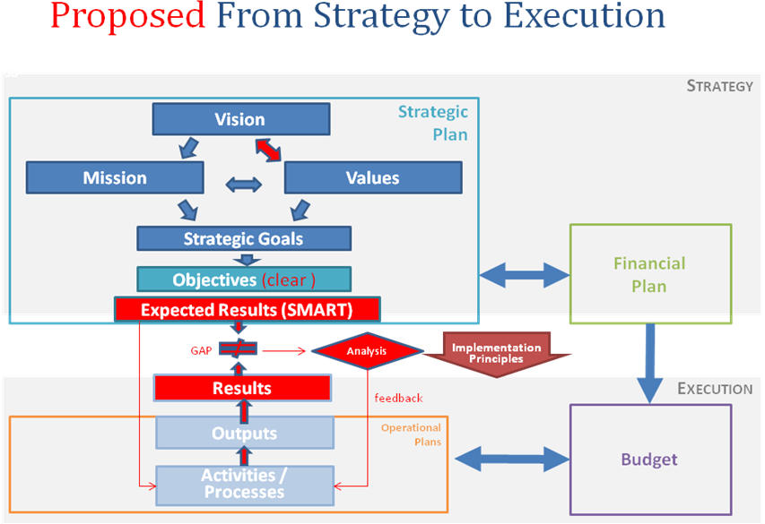

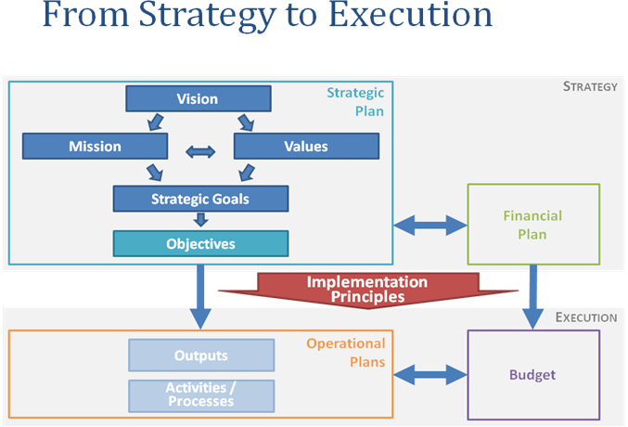
Figure 2 Starategy to Execution

Revisions proposed are ‘RED’ in colour. The gap between Plan and performance with loop back is important to assess to what extent, the objectives are being met and to make necessary changes in the operational plans accordingly.

Need for Clarity in Objectives

Ref: Contribution by the Chairman of CWG SP-FP on the elaboration of the draft strategic plan – CLCWG SPFP2 – C – 005 PPT-E dated 5 January 2014

i. Need to work on Objectives and Expected results in the first step while working on SP-FP.

It is clear that the expected results in turn would justify resources requirement which are derived from and linked to the outputs required to achieve such results. It means that the first step in RBB requires setting up the objectives and expected results. Then resource requirement is derived from Outputs required to achieve such results. So, in second step, based on expected results, the outputs for the programs are set to achieve the results. Accordingly the corresponding group may arrive at expected results from the objectives first and then should work on deriving outputs necessary.

The illustrative chart on page 4 under section 7 providing linkages between Objectives and Outputs should be a linkage chart between ‘Objectives’ and ‘Expected Results’. And there should be another chart enlisting ‘Outputs’ and ‘Expected Results’. The objectives⁵ and Expected accomplishments/ results should display a cause and effect relationship. The expected result, namely, a concrete target within an overreaching objective, involving benefits or changes to end-user or beneficiaries, reached through the production of ‘Outputs’ (UN, Resutls based budgeting - Report of the Secretary General A/54/456, 1999)

To elaborate further, Expected results or Expected Accomplishments are defined in UN Glossary that are expressed as a quantitative or qualitative standard, value or rate. The reference (UN, Resutls based budgeting - Report of the Secretary General A/54/456, 1999) states that they are the direct consequences or effect of the generation of outputs. Where as under part III of Resolution 71 (PP-10), the expected results are defined as - the Expected results should reflect the desired outcomes of the activities (outputs, which are sometimes referred to as “outcomes”). In fact the ‘Outcomes’ are distinct from ‘Outputs’. This distinction is well brought out in the document (CWG:SP-FP/3/5-E, 2013)as – ‘Outcomes provide an indication as to whether the objective is being achieved..”

ii. Objectives and Outputs (Draft) ITU-D contribution from Correspondence group

Ref:

  - CWG SP-FP/3/4 (REV.2) Contribution by the Chairman of CWG SP-FP on the elaboration of the draft strategic plan
  - TDAG 13 – 18/22-E (Revision 2) under section 6 on page 3

Correspondence group vide section 6 defined objectives and outputs for D sector. The objectives (though this requires further refinement) should spell out specific aims to be accomplished in a given period with clarity as elaborated under discussion on Objectives under section F 1 above. In their current form under section 6 (except the first objective), multiple objectives are merged so much necessitating creation of sub area objectives, (these are currently construed as Outputs). To reiterate, the currently defined outputs are nothing but sub area objectives expressed in a statement form. The outputs are final tangible products and services such as deliverables of programs.

The currently defined objectives, different objectives (below) marked in different colours – red, blue, green, may be considered to revise the objectives differently with clarity.

- To foster international cooperation on telecommunication/ICT development issues.
  - [Results of World Telecommunication Development Conference (WTDC) / WTDC.]
  - [Results of Regional Preparatory Meetings (RPMs) / RPMs.]
  - [Results of Telecommunication Development Advisory Group (TDAG) / TDAG.]
- To create an enabling environment conducive to ICT development and to foster the deployment of telecommunication/ICT networks.
- Policy and regulatory environment.
- Telecommunications/ICT networks.
- To enhance the roll-out and the safe use of ICT applications and services.
- Building confidence and security in the use of ICTs.
- ICT applications and services.
- To build human and institutional capacity, promote digital inclusion and provide concentrated assistance to countries in special need.
- [Results of Study Group meetings / Study Group meetings.]
- Knowledge sharing.
- Digital inclusion.
- Special assistance to LDCs, SIDs and LLDCs.
- To strengthen climate change adaptation and disaster management efforts through telecommunications / ICTs.
- Climate change adaptation.
- Emergency Telecommunications.

I. Global ICT Targets

Ref. Contribution by the Chairman of CWG SP-FP on the elaboration of the draft strategic plan – CWG SP-FP/3/4 (Rev.2) (Slides 68 onwards)

This section discusses the relevance of proposed growth and some of the inclusiveness target under the current gamut of consideration. The growth targets defined are:

Target item | Worldwide target by 2020
Households with Internet access at home | 60%
Individuals using Internet | 60%
ICT Price basket (IPB) | 40%

The proposed inclusiveness (not exhaustive) targets are:

Target item | Developing world 2020
Households with Internet access at home | 50%
Individuals using Internet | 50%
ICT Price basket (IPB) | 40%
Broadband service cost | < 5% monthly income
Table 1

As we have seen earlier, the RBM prescribes clear objectives and hence even the targets should provide more clarity and crisp in the period under consideration. If it is the case, let us see where we stand currently on above target figures and of course in a more microscopic manner. Considering that the objective of growth is primarily to reduce digital divide and equitable distribution of fruits of ICTs to all. It is observed that the digital divide is more prominent, when we analyze the figures based on countries’ income basis as follows.

ICT penetration based on Income

(comments for slides 70-72)

Figures from 2010 data  (% of world population) | Low income  (12%) | Lower middle income  (37%) | Upper middle income  (36%) | High income  (16%) | Schematic representation
Fixed phones (per 100) | 1 | 6 | 22 | 44 | 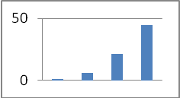
Mobile phone (per 100) | 33 | 72 | 84 | 111 | 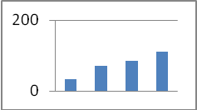
Households with internet access % | 2 | 8 | 25 | 74 | 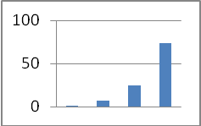
Individuals using internet % | 6 | 14 | 34 | 74 | 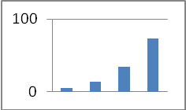

Table 2
The above table indicates critical areas of focus in Red and significant improvement wanting areas in Yellow. A schematic of the income group wise ‘digital divide’ is projected in the last column of the table. It is clear that the higher income countries have already accomplished the worldwide target of 60% (Green). Further, there is no catalytic role to be played by the ITU in this segment. Measuring targets at Global level, when ICT penetration of the High income group which is almost 16% of world population is already well above the target, may not appropriate So, the focus is to be brought onto other groups. Going further, measuring the target for the block of developing countries makes the requirement of low income group disguised. Hence, it would be appropriate to have the targets set for income group wise with clear objectives and SMART expected results, to enable appropriate allocation of resources. Once, the target group is clear, tangible KPIs can be set to measure the outcome of activities. Hence, it is proposed that the targets for Inclusive Growth should be set income group wise.

Similarly, let us see the ICT price sub-baskets income group wise. Affordability is one of the important considerations for ICT use. A comparative table is prepared below indicating, how much % of his/her income one has to pay for ICTs (Price baskets as a % of per capita income of the group). The staggering difference in affordability demands concrete measures to reduce digital divide and accentuates once again that the targets should be set income group wise to make objectives clear.

Sector ( price as % of GNI per capita per month) | Low income | Lower middle income | Upper middle income | High income
fixed telephone sub basket price as % GNI per capita per month | 20.38% | 3.70% | 2.04% | 0.65%
Mobile-cellular sub-basket price as % GNI per capita per month | 29.43% | 8.13% | 3.06% | 0.68%
Fixed-broadband sub-basket price as % GNI per capita per month | 124.53% | 23.66% | 3.67% | 0.81%
Table 3

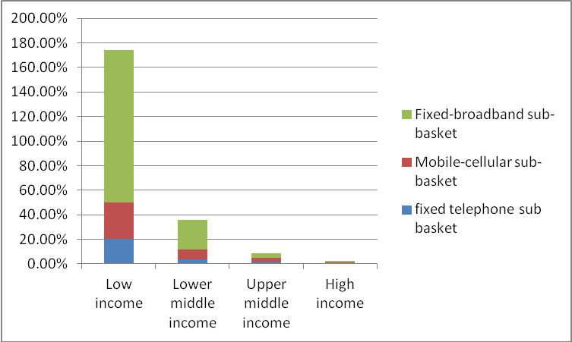

Figure 3 Affordability Divide in ICTs

J. Proposed Structure of SP

Ref: Contribution by the Chairman of CWG SP-FP on the elaboration of the draft strategic plan – CLCWG SPFP2 – C – 005 PPT-E dated 5 January 2014 (slide 62)

As per the proposed structure of SP, the situational analysis will provides inputs on implementation analysis on current SP, ICT environment and strategic risks. Though they are very relevant but not sufficient in framing the long term goals and objectives. Long view or Scenario Planning methodology is considered to take in depth assessment of future we are likely to walk into.

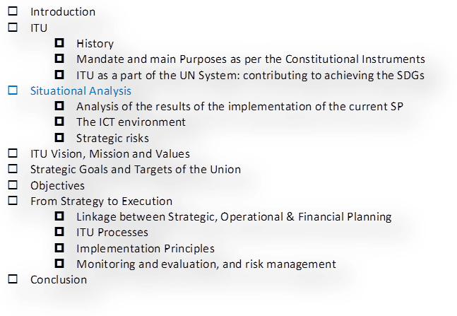
Need for Scenario planning in positioning ITU for future uncertainties

Taking a long view of decisions that need to be made today (Schwartz, 1996) was discussed using a method for investigating important decisions using scenario process. This is important for all decision makers in any dynamic market where economy, technology and new generation customer needs are changing in leaps apart from changing structural aspects of the industry. Experience has shown that looking into the future is most useful when it is the beginning, not the end, of a significant conversation (Schwartz, 1996).
Considering the dynamics of ICT eco system, situation analysis alone may not give insights to arrive at long term objectives and goals of ITU. From these long term objectives we derive further, the objectives for the 4 year cycles. Only some of the dynamic factors are illustrated in the diagram.
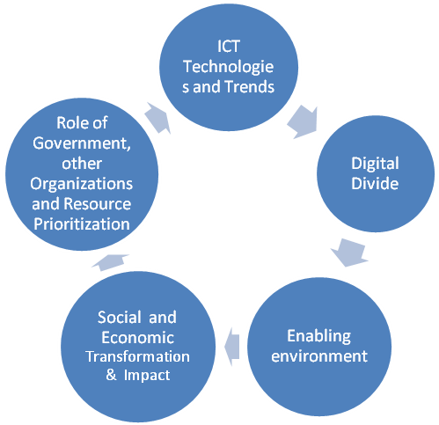
Figure 4 ICTEco Sysytem Dynamics
A Scenario based analysis depicts the description of a future situation together with the progression of events leading form the base situation to the future situation. The situational scenario presents a snapshot of future situations (Godet, 1987). The scenario planning is about making choices today with an understanding of how the possible paths might turn out. Further, the scenarios are vehicles for helping people to learn (Schwartz, 1996). The scenario process provides a context for thinking about the impossibly complex array of factors that affect any decision. Scenarios are stories about the way the world might turn out tomorrow and it is about making choices today with an understanding of how they might turn out (Schwartz, The art of the long view, 1996).
Proposal: It is proposed that a scenario based methodology, apart from situational analysis, may be considered in assessing the long term objectives and goals. Long view may provide multiple views about global challenges and efforts to accomplish goals from different dimensions.

Annexure 1
(CouncilOfEurope, 2005)

Figure 5 LOGFRAME

Annexure II

Annex I of (UN, Resutls based budgeting - Report of the Secretary General A/54/456, 1999)

Glossary of relevant terms

Activity
Action taken to transform resources (inputs) into outputs. Effectiveness The extent to which results are achieved.
Efficiency
How well inputs are converted to outputs.
End-user
The recipient or beneficiary of an output or result.
Evaluation
Determination of the relevance, effectiveness and impact of the outputs, projects, sub-programmes or programmes in the light of the objectives and expected accomplishments.
Expected accomplishment
A desired outcome involving benefits to end-users, expressed as a quantitative or qualitative standard, value or rate. Accomplishments are the direct consequence or effect of the generation of outputs, and lead to the fulfilment of a certain objective. Inputs Personnel and other resources necessary for producing outputs and achieving accomplishments.
Monitoring
Tracking and determining the actual delivery of an output in comparison with the commitments reflected in the programme budget.
Objective
Something sought or aimed at. In programme budgeting, the term refers to an overall desired achievement, involving a process of change and aimed at meeting certain needs of identified end-users within a given period of time. Objectives can be met through the achievement of certain accomplishments.
Output
Final product or service delivered by a programme or subprogramme to end-users.
Performance indicator
A feature or characteristic used to measure whether and/or the extent to which the expected
accomplishment has been achieved. Performance indicators correspond either directly or indirectly to the expected accomplishment for which they are used to measure performance.
Performance measurement
The determination of realized accomplishments in comparison with expected accomplishments, based on data collected for performance indicators for a given period of time or at a certain reference date.
Results-based budgeting
A programme budget process in which: (a) programme formulation revolves around a set of predefined objectives and expected accomplishments; (b) expected accomplishments justify the resource requirements which are derived from and linked to the outputs required to
achieve such accomplishments; and (c) performance in achieving expected accomplishments is measured by performance indicators.
Annexure III

Annexure II of (UN, Resutls based budgeting - Report of the Secretary General A/54/456, 1999)
Guidelines for the formulation of objectives and
expected accomplishments
1. Objectives
Objectives express what the Organization wishes to pursue, usually within a biennium or a four-year plan period, although the overall objective may also have validity over a longer period of time. They describe the underlying or overall rationale for implementing a programme or subprogramme involving a process of change and aimed at meeting certain needs of identified end-users. Objectives need to be set at the right level. The aims and purposes of the Charter of the United Nations are not objectives that can be attained within one biennium and are at too high a level of abstraction for programming purposes. Descriptions of mere activities, on the other hand, generally reveal no intention of accomplishing changes and do not provide an explanation of why an activity is implemented. Such descriptions would therefore be at too low a level. Moreover, issues such as how objectives will be pursued, that is, through the undertaking of activities and the production of outputs, should be kept distinct and separate from the objectives themselves. Objectives can generally be formulated along the following lines: to reduce/increase, to change, to make progress towards, to strengthen, to streamline, to promote/
increase support for etc. Objectives are not equivalent to activities when there is no explanation as to why the activities are implemented; for example, to provide advice to Member States, to provide support to the Secretary- General to assist committee etc.

2. Expected accomplishments
Expected accomplishments are the direct and often tangible effect or consequence of the delivery of outputs. They identify the benefits or changes that are expected to accrue to the users or beneficiaries of outputs. Generally, expected accomplishments of United Nations programmes will relate to changes in knowledge, skills, attitude, behaviour, awareness, condition or status. Expected accomplishments must be specific and measurable, that is, they should be able to set a quantitative or qualitative value to allow a meaningful comparison with realized accomplishments. Either implicitly or explicitly, expected accomplishments should contain the identity of the end-users.

Expected accomplishments should generally be formulated along the following lines: increase in the awareness (of end-users) of a particular issue; strengthened capacity (of end-users) to do a particular task; an increased number of (end-users adopting) implementing measures. The following are not expected accomplishments:

activities
(such as servicing of meetings, maintenance of Web sites, participation in the activities of other organizations, liaison with governmental officials, coordination, monitoring and analysis of developments, fund-raising etc.) and
outputs
(such as parliamentary documentation, field projects, seminars, provision of technical advice to Governments, press releases, electoral assistance missions etc.).

Expected accomplishments can, however, relate to changes in the quality, quantity or timeliness of activities and outputs. For example, a reduction of the backlog in the production of a recurrent publication, an improvement in the quality (or of the satisfaction of the end-users) of advisory services, a reduction in the costs or time required to provide technical advice etc.

- Relationship among objectives, expected accomplishments and outputs

In relation to objectives, expected accomplishments should always be of a more concrete, less abstract nature.

Moreover, objectives and expected accomplishments should display a cause and effect relationship: objectives should be considered as the impact of achieving the expected accomplishments. Conversely, expected accomplishments are the tangible outcomes that will lead to the achievement of objectives and are the necessary conditions for attaining the objectives.
Annexure IV

Table 4
ITU | Strategic Plan | Plenipoten-tiary Conference | Focusing resources and energy on working towards the same goals, assessing results and performance | 4 years | Corporate Strategy Division (CSD) of the Strategic Planning and Membership Department (SPM) and relevant bodies from each Sector | Yes | 2 years, aligned to Strategic Plan and Financial Plan | currently being implemented | Annual report on the implementa-  tion of the strategic plan | World sectorial Conferences | No | Member States  Sector Members and Associates (in total over 700, private-sector entities, regional telecommunications organizations and academia

Bibliography
Besrest, V. (2012, 09 24). Results Based Vudgeting: Objectives, Expected Results and Performance Indicators. Seminar on Results Based Vudgeting: Objectives, Expected Results and Performance Indicators. Council of Europe.
COE, C. o. (2005). Resulats Based Budgeting. COE.
Contribution, C. (2014, january). CWG SP-FP/2/5. CWG - Contribution by the Chairman of CWG SP-FP on the elaboration of the draft Strategic Plan - CWG SP-FP/2/5.
CouncilOfEurope, C. (2005, May). Results Based Budgeting Manual. Results Based Budgeting Manual v 3.1. Council of Europe.
CWG:SP-FP/3/5-E. (2013, November 20). Preliminary agreed glossary of the strategic plan for the union for 2016-2019. Council Worki-2019ng Group for the elaboration of the draft strategic plan and the draft financial plan 2016.
Godet, M. (1987). Scenarios and Strategic Management. Butterworth Scientific Ltd 1987.
JIU/REP/1999/3. (n.d.). Results Based Budgeting: The Experience of United Nations System Organizations. JIU, UN.
JIU/REP/2006/6. (n.d.). Results - Based Managment in the UN in the Context of the Reform Process. JIU, UN.
JIU/REP/2012/12, I. U. (n.d.). STRATEGIC PLANNING in UN System-JIU/REP/2012/12. Joint Inspection Unit, UN.
S13-CLCWGSPFP2-C-0004!!MSW-E. (2013). CONTRIBUTION BY THE SECRETARY GENERAL - REPORT ON SECRETARY GENERAL’S PUBLIC CONSULTATION ON THE 2016-2019 ITU STRATEGY. ITU.
Schwartz, P. (1996). The art of the long view. New York: currency doubleday.
Schwartz, P. (1996). The Art of the Long View. Currency Doubleday.
UN. (1998). Results Based Budgeting - Report of the Secretary General A/53/500. United Nations.
UN. (1999). Resutls based budgeting - Report of the Secretary General A/54/456. United Nations.
UN-Report-A/53/500. (1998). Results Based Budgeting - Report of the Secretary General A/53/500. United Nations.

This document was considered and accepted by consensus at the 4th APT Preparatory Meeting for WTDC-14 (WTD14-4) held in Pattaya, Thailand from 21 to 24 January 2014. The meeting was attended by the Administrations of Afghanistan, Australia, Bangladesh (People’s Republic of), Bhutan (Kingdom of), Cambodia, China (People’s Republic of), India, Iran (Islamic Republic of), Japan, Korea (Republic of), Malaysia, Maldives (Republic of), Mongolia, Nepal (Federal Democratic Republic of), Papua New Guinea, Philippines (Republic of the), Singapore (Republic of), Sri Lanka (Democratic Socialist Republic of), Thailand and Viet Nam (Socialist Republic of).
1. Sustainable development is development that meets the needs of the present without compromising the ability of future generations to meet their own needs. It contains within it two key concepts: the concept of 'needs', in particular the essential needs of the world's poor, to which overriding priority should be given; and the idea of limitations imposed by the state of technology and social organization on the environment's ability to meet present and future needs. 2. Thus the goals of economic and social development must be defined in terms of sustainability in all countries - developed or developing, market-oriented or centrally planned. http://www.un-documents.net/our-common-future.pdf
1. The purposes of the union are: a) to maintain and extend international cooperation among all its members states for the improvement and rational use of telecommunications of all kinds.
Telecommunication operators, service providers, policy-makers, consumers, civil society and other stakeholders are all responding and adapting to the social, economic and other changes driven by accelerating technological change and convergence in the transformed communications landscape. Among these technological developments, national and international policies, and the diverse interests of different stakeholders, ITU's vision is to strive to safeguard everyone's fundamental right to communicate by connecting the world. At this time of sweeping transformation of the industry, the Union needs a strong and effective strategic plan to help it respond more closely to the changing needs of its members and to prove its ongoing relevance in an all-IP world.
Results based budgeting, in the form proposed by the Secretary – General for implementation at the UN, is a program budget process in which : a. programme formulation revolves around a set of predefined objectives and expected results; b. expected results would justify resources requirements which are derived from and linked to the outputs required to achieve such results; and c. actual performance in achieving results is measured by objective performance indicators.
SMART: Specific, Measurable, Attainable, Relevant and Time-bound.
In relation to objectives, expected accomplishments should always be of a more concrete, less abstract nature. Moreover, objectives and expected accomplishments should display a cause and effect relationship: objectives should be considered as the impact of achieving the expected accomplishments. Conversely, expected accomplishments are the tangible outcomes that will lead to the achievement of objectives and are the necessary conditions for attaining the objectives.
Desired outcomes involving benefits to end-users/clients, expressed as a quantitative standard, value or rate. Results are the direct consequence or effect of the generation of outputs, leading to the fulfillment of a certain objective.
A desired outcome involving benefits to end-users, expressed as a quantitative or qualitative standard, value or rate. Accomplishments are the direct consequence or effect of the generation of outputs, and lead to the fulfilment of a certain objective.
Objectives refer to the specific aims of sectors and inter-sectoral activities in a given period (CWG:SP-FP/3/5-E, 2013) – A revised version is proposed in the earlier pages.

